Control System for a Bio-inspired Cuttlefish Fin Locomotion for An Autonomous Underwater Vehicle (AUV)

Kendra Kim, Arizona State University; Dr. Sangram Redkar, Arizona State University

Abstract

By utilizing fixed points dynamical analysis with applied statistical methods for further development of bio-inspired cuttlefish fin locomotion, underwater aquatic surveillance for exploration and security and safety missions can be accomplished with Autonomous Underwater Vehicles (AUV). Monitoring services that can be performed with a fishlike drone consider several factors, such as environmental impact and scientific and business concerns, while preserving ocean resources. The regression analysis examines the relationship between the current and the depth. This analysis will reveal the influence of depth on ocean currents. The ideal system should provide a low-cost, low-maintenance, high-endurance, and agile sensor platform to feed into the intelligent control system. Most aquatic dynamical models do not incorporate the buoyancy acting on the system and work with an undulating fin with a simple sinusoidal variation. The review of the dynamical analysis does include the buoyancy factor.
In this study, the authors focused on the fluid-structure interaction as the wave moves through the water, the fin's forward motion, and the AUV's buoyancy properties.

Introduction

In the review of swimming behaviors, developments in Lighthill's theory and results in Wu's theory are used to identify areas of opportunity to develop a novel solution.
In a design of the propulsion technology of the BCF mode by Chowdhury, an undulation simulation of a fish tail was explored. In this study, the swimming style of a fishtail has been proven to be efficient over large distances and produce impressive speeds (Chowdhury, 2011). The system is further explained in section 3, developments on Lighthill's theory (Lighthill, 1971). In the study of the braking performance of a biomimetic squid, various braking strategies were tested in terms of stopping ability and the forces acting on the controlled stage. The sizeable negative thrust produced by oppositely directed waves allowed for a short stopping distance and time. Therefore, under complex underwater conditions, the undulating fin propulsion system can effectively perform braking (Rahman, 2013). Development of innovative materials can be used for new actuators such as piezoelectric, ion-conducting polymer metal composite, and shape memory allow (SMA). Wang analyzed actuated SMA wires for propulsive thrust and propulsive efficiency (Wang, 2011).
This work only includes moving forward based on passing waves along the vehicle's body and does not include propulsion as a means of motion. The median paired fin locomotion fish has two types of pectoral swimming behaviors. The first is undulatory locomotion; a wave-like pattern studied for many years. The second is oscillatory locomotion, which is less commonly studied in the literature. This movement involves undulatory waves prorogated downward from the fish's anterior to posterior. This literature review explores both types of locomotion/ swimming maneuvers and mechanisms typically evaluated via experimental evidence and mathematical models. The shape of not only the fins but the body of the cuttlefish-inspired robot is also considered.

Swimming Behaviors

Two primary swimming behaviors are undulatory locomotion and oscillatory locomotion. Undulatory swimming in fish is principally based on Lighthill's 'Elongated Body Theory' (Lighthill, 1960) and Wu's 'Waving Plate Theory' (Singh, 2008). The general notations used for Lighthill and Wu's equations are presented in Table 1.

Table 1. The notation used in Lighthill and Wu developed equations.
M | Bending moment distribution
m_{b} | Mass distribution along the body (i.e., mass per unit length)
L | Lift on the body
ω | Angular frequency of imposed body-wave
⍴ | Fluid density

The elongated body theory concludes that a wave that increases the body's amplitude is laterally symmetric to enable forward motion. In response to this wave, the fish's body is shaped to minimize the lateral recoil from the movement. The undulatory swimming mode has longitudinal effects of flow separation that Lighthill addresses in a proposed combination of resistive/ reactive force theory (Lighthill,1960).
Lighthill's lateral motion takes the general form of an arbitrary continuous function of x and time t, shown in Equation 1.

$y=h_{y}(x,t),0<x<1$ (1)

This arbitrary continuous function allows the flow to be the sum of the steady flow around a straight fin and results in the displacements h(x,t). Equation 2 represents each cross-section move with lateral velocity relative to the free stream.

$ω=\frac{∂h}{∂t}+U\frac{∂h}{∂x}$ (2)

This velocity is used to determine the rate of change of momentum of the fluid passing to obtain the work rate by a fish's transverse motion. The work dependent on the tail conditions can be translated to thrust in Equation 3.

$\overline{P}=\frac{1}{2}m(l){\left[\overline{{\left(\frac{∂h}{∂t}\right)}^{2}}+U^{2}\overline{{\left(\frac{∂h}{∂x}\right)}^{2}}\right]}_{x=1}$ (3)

The model of steady-state swimming proposed by Lighthill required the rate of change of the lateral moment equal to the resultant of the lateral forces and the rate of change of angular momentum about the y-axis equal to the moment of lateral forces about the fixed axis (Lighthill, 1971). Further development extended to the slender body theory, where rough approximations can be determined, and Lighthill developed the large amplitude elongated body theory. Based on the following three principles, the instantaneous force on the fish is shown in Equation 4.

Principle 1: Water momentum near any fish sections is perpendicular to the backbone with a magnitude of velocity in that direction
Principle 2: Within a volume of fish's boundary at each instant, the thrust can be determined by considering the rate of change in momentum
Principle 3: Pressures generated by motions within the plane and the action of the results are to be taken into account, with the transfer of motion contributing to the momentum balance.

$\left(P,Q\right)={\left[mω\left(\frac{∂z}{∂t},\frac{∂x}{∂t}\right)-\frac{1}{2}mω^{2}\left(\frac{∂x}{∂a},\frac{∂z}{∂a}\right)\right]}_{a=0}$ (4)$-\frac{d}{dt}\int_{0}^{1}{mω\left(-\frac{∂z}{∂a},\frac{∂x}{∂a}\right)}da$

In the instantaneous force equation developed by Lighthill, the motion occurs in the xz-plane where a is along the backbone of the fish and a=0 is at the tail. Thus, the mean thrust can be found only in terms of the fish's tail. The recoil is minimized by having an anterior body portion with a cross-sectional depth larger than the tail fin. There is an opportunity for further development because the requirement of small curvature does not address the starts and turns of fish locomotion. The assumptions involving large lateral deformation and curvature do not address unsteady maneuvers.
This opportunity for addressing the assumptions is to have a realistic representation of environmental circumstances. Without a fundamental understanding of the control system, the applications of the AUV are limited. Expanding these assumptions to include the requirements of curvature to AUV will be able to maneuver in both starting motion, and managing turns. In the current state, the AUV is only managed at a level of maintainability once the motion has reached equilibrium. The unsteady maneuvers are not addressed based on how the fin is considered an infinitely thin plate of uniform density hydrodynamically. Due to the symmetry on the xz-plane and the xy-plane, the only breaking from the deformation is on the xy-plane. Assumptions of large lateral deformations suggest a force against the body in only the xy-plane that accounts for the translation along the y-axis but does not address the rotation about the z-axis.

Environmental Conditions

In addition to the swimming behaviors, the control system requires considering environmental conditions that can be estimated with the distribution parameters identified from the residual plot. The CORREL function expresses the coefficient of the two arrays. This function results in the east current having a -0.038 relationship to depth.

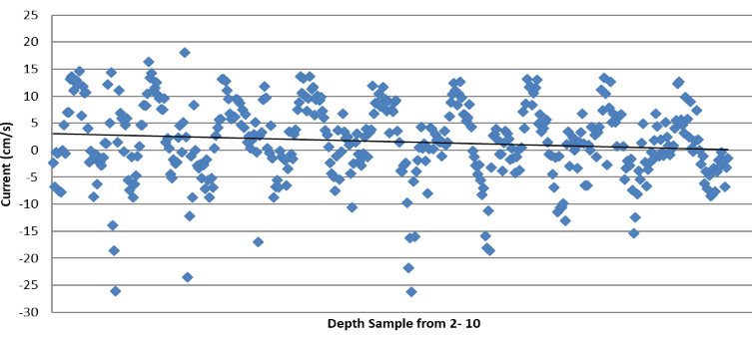
Figure 1. East ocean current vs. depth from 2-10

Figure 1 shows the current values across a depth sample from 2 to 10. At a lower depth, the current's magnitudes are higher and lower; however, as the depth increases, the current values come closer to zero. Due to the trendline decreasing and the current values coming closer to zero, another review of the current at lower depths was considered. Evaluating at greater depths will assist in the unmanned underwater vehicle application because the department of defense would need to be capable of having control and a variety of depths. Therefore, evaluating different depths will have a more practical application.

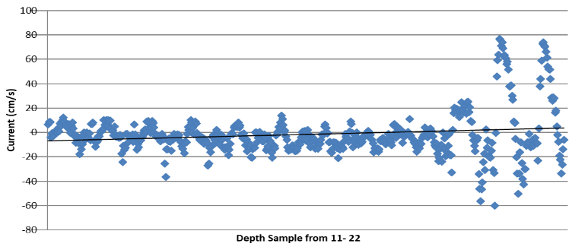
Figure 2. East ocean current vs. depth from 11-22

The continuation of the depth samples to an increased ocean depth. Figure 2 shows the ocean current from depth samples of 11 to 22. Opposite to the review from the depth trend line 2 – 10, the increased depth has a positive slope due to the currents being driven by the temperature gradients and density. The density-driven forces and gravity contribute to the fluctuation, as shown on the right side of the graph. The other consideration is that the temperatures are cold and therefore cause the density to increase. To verify this theory, the ocean currents are evaluated in a different direction, North. The evaluation at different directions is expected to show an opposite trend line due to the wind direction affecting the current at lower depth samples and the buoyancy requirements.

Table 2. Output summary of regression statistics evaluating north currents
Multiple R | 0.325793
R Square | 0.106141
Adjusted R Square | 0.104362
Standard Error | 5.733469
Observations | 1008

The output summary review includes a regression model analysis, and ANOVA details are considered in equation 5. The simple linear regression model starts with the study of multiple R. The multiple R is the correlation coefficient that shows that the positive relationship is moderate. If this value were one, then the relationship would be nominal. The coefficient of determination indicates that the depth of the current explains 10% of the variation of the current around the mean. Therefore, 10% of the values fit the model. In addition to only having one x variable, there are over 1,000 observations in the sample.
The second part of the output is the comparison, where the sum of squares is divided into individual components- the review of ANOVA, including the sum of squares, regression MS, Residual MS, overall F test for the null hypothesis, and Significant F. The last section of the output summary exposes specific information about the components, in this case, the east and north current. In addition to the p-value for the hypothesis test, the lower boundary for the confidence interval is the lower 95%, and the upper boundary for the confidence interval is the upper 95%. The most valuable part of this is determining the linear regression equation. This is the y = slope * x + intercept as equation 5.

y = 11.02 - EastCurrent * 0.01 + NorthCurrnt * 0.15 (5)
the degree of freedom is the sum of squares divided by the mean of squares. Since there are 1008 observations, the sum of squares of residual was adjusted to equal 1005 based on the regression fixed values. The df(regression) equals the number of predictor variables. The df(residual) is the sample size minus the number of parameters being estimated. With parameter tests using alpha = 5%, the two-fail distribution of 2.5% is the critical value. This distribution is used when the p-value is less than alpha, and the confidence interval does not contain the hypothesized mean and is considered significant. When the parameter is close to being less than alpha, it is borderline significant. When the p-value is greater than alpha, there is a risk, meaning it is the least significant parameter. And when the p-value is less than alpha, this is significant, and the zero values are the most significant. The 95% confidence interval for both parameters is 1.96 from the t-table. Therefore, the intercept and the north current are significant. When the p-value is greater than alpha, there is a risk, which means it is the least significant parameter, the east current.

Buoyancy Fixed Point Analysis

After reviewing the swimming behaviors and evaluating the environmental conditions, the cuttlefish dynamics model utilizes table 3 variables to analyze buoyancy.

Table 3. The notation used in Buoyancy fixed point analysis equations.
A | Amplitude of undulation
k | Spatial frequency
w | Temporal frequency
M | Mass of cuttlefish
V_{g} | Volume of cuttlefish
D | Drag force
Rho | Density of fluid
Rho_{c} | Density of cuttlefish
U | Stream velocity

$y=Asin\left(kx-ωt\right)$ (6)

When applying Newton's 2nd Law to equation 6. The resulting equations provide the motion.

$M\ddot{x}=\frac{ρAb_{m}}{kL} \left(\frac{A^{2}ω^{2}}{2}-\frac{U^{2}A^{2}k^{2}}{2}\right)-\frac{1}{2}C_{D}ρS\dot{x}$ (7)

$M\ddot{y}=-ρ_{c}V_{g}+{ρV}_{g}=(ρ-ρ_{c})V_{g}$ (8)

The equations are rewritten as equations of motion as a 3-dimensional dynamical system. It is similar to the previous dynamical system except that there's a y-component to the motion now due to the weight of the cuttlefish and the buoyant force.

${\dot{x}}_{1}= ζ+ \sqrt{\frac{2ρAb_{m}}{kLC_{D}ρS} \left(\frac{A^{2}ω^{2}}{2}-\frac{U^{2}A^{2}k^{2}}{2}\right)}$ (9)
$\dot{ζ}= -\frac{2}{M}\sqrt{\frac{2ρAb_{m}C_{D}ρS}{kL} \left(\frac{A^{2}ω^{2}}{2}-\frac{U^{2}A^{2}k^{2}}{2}\right)ζ}$ (10)
${\dot{u}}_{y}= -ρ_{c}V_{g}+{ρV}_{g}$ (11)

The only major shift in this system is that there's a linear growth in the 3rd dimension of this dynamical system which means that the topological properties are somewhat similar to the previous one.

$U_{y}={(ρV}_{g} - ρ_{c}V_{g}) t$ (12)

The eigenvalue analysis of the system yields three eigenvalues to this system as expected:
$$λ = 0, -2\sqrt{C_{1}C_{2}},k$$ (13)

Where $k =(ρ - ρ_{c})V_{g}$ (14)

Looking at the system's dynamic behavior, there is a clear indication that the system will behave quite similarly in the presence of buoyancy. We can neglect buoyancy only when the density of the cuttlefish is much more significant than water, which is usually not the case. Control volume of water stored in cuttlefish UUV design to improve the controllability of the cuttlefish, which is very similar to the submarine model. This detail is used in the software simulation that establishes the incompressible flow.

Software Simulation

Software simulation developed for the cuttlefish fin is established with the model of a fin, shown in Figure 3, that is attached to a fluid structure to run fluid into the system (inlet) and out of the system (outlet). The pressure method describes total pressure under certain conditions. First, the pressure is calculated at the boundary based on the fixed total pressure to evaluate the velocity.

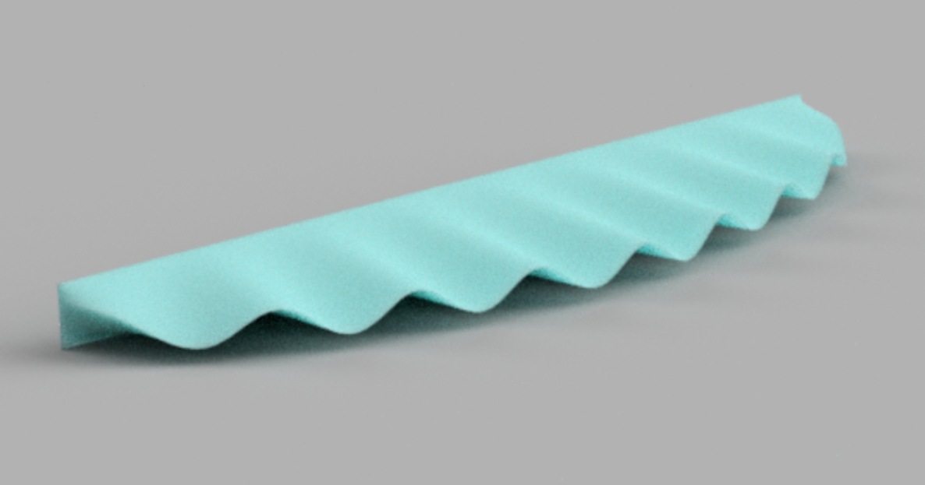
Figure 3. model of the cuttle fin used in the Simscale simulation.

Simulation and development of fluid-structure interaction are used through the controller model to showcase stable conditions. It is based on creating a volume for the liquid to move in to show the fluid-structure interaction as the wave moves through the water. The dynamic condition will showcase the interaction, and having an additional representation will ensure a more accurate environmental condition evaluation. It was completed with a box that is 10x as large for the fluid to have turbulences and capture deviations so that they can be accounted for in the simulation. To ensure that the fin is being utilized as expected, the back face does not allow fluid to bypass

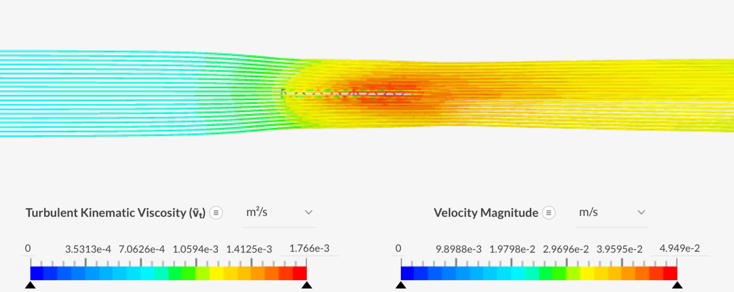
Figure 4. Full fluid flow against the cuttlefish tin

The simulation utilizes an incompressible simulation of flow/ fluid, which can simulate the flow of a single fluid. In this simulation, the fluid density variations are negligible, and the fluid can be approximated as incompressible.
The settings of the material set in water in the simulation model are a Newtonian viscosity model with a kinematic viscosity of 9.338e-7 m^2/s and a density of 997.3 kg/m^3.
The simulation works to a global variable in the x direction of a 0.25 m/s velocity.

Conclusions

In conclusion, the software simulation confirmed the motion and buoyancy variable in the cuttlefish fin application. In addition, the non-linear model utilized in this system includes an architecture that considers environmental conditions and fluid-structure interactions that can be used to develop a small-scale model to confirm the overall system architecture.

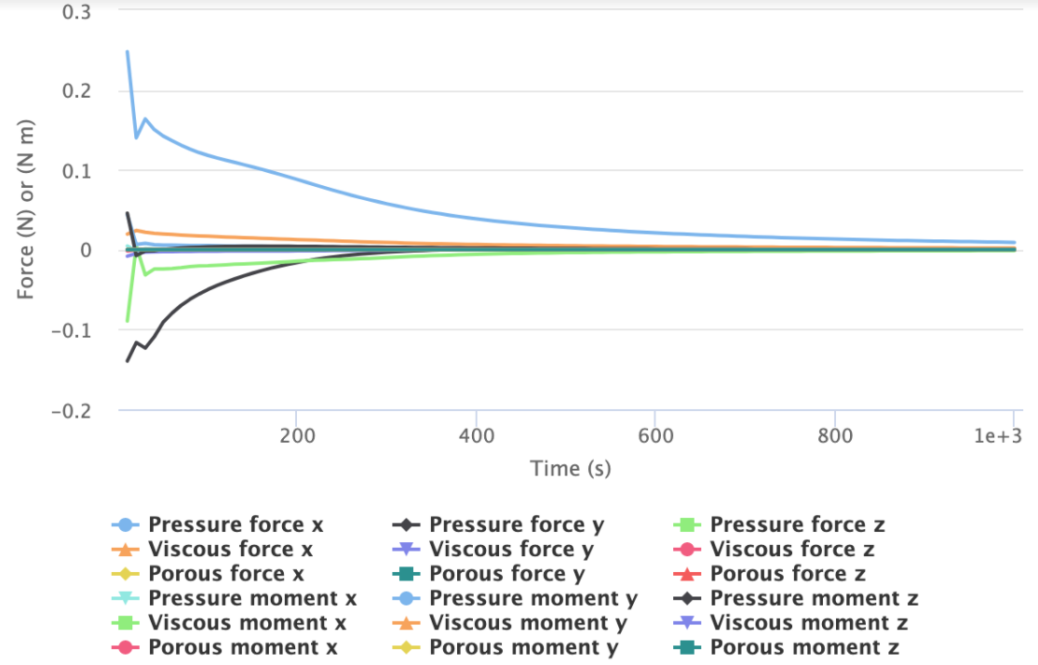
Figure 5. Graphical representation of simulation with forces and moments.

Figure 5 showcases the impact in the z direction of pressure, viscous, and porous forces. Figure 5 also shows the z direction of pressure, viscous, and porous moments. As expected in the equations showcased in the fixed point analysis, this is significantly lower than the x and y coordinate systems but still had consideration upon fluid impact and started to normalize over time.

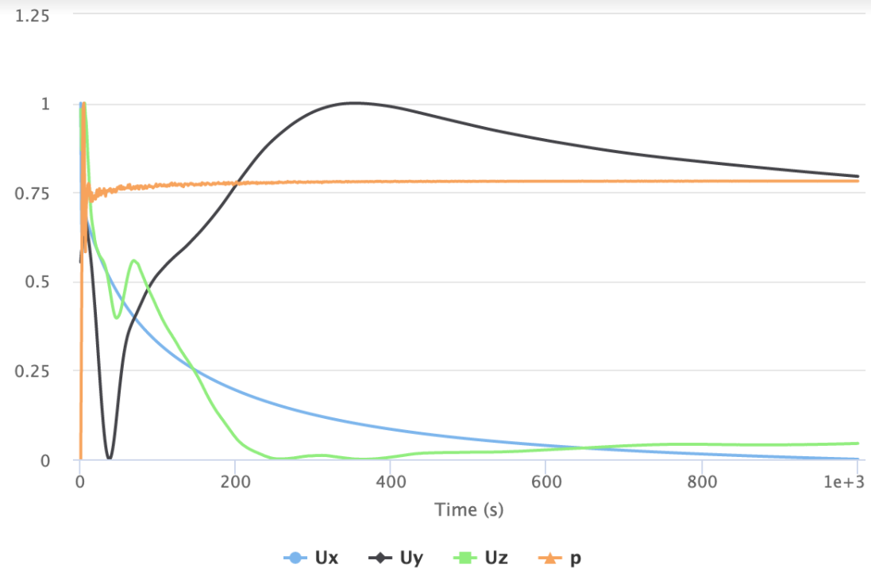
Figure 6. pressure (p) and velocity (U).

Figure 6 showcases the impact in the z direction of velocity and pressure, emphasizing the importance of buoyancy as described in equation 13.

References

Behbahani, S., Wang, J., Tan, X. (2013). A dynamic model for robotic fish with flexible pectoral fins. IEEE/ASME International Conference on Advanced Intelligent Mechatronics, Wollongong, NSW. pp. 1552–1557.
Chowdhury, A., Prasad, B., Kumar, V., Kumar, D., Panda, D. (2011). Design, Modeling and Open-loop Control of a BCF Mode Bio-mimetic Robotic Fish, p. 6.
Crout, R., Leung, P., Brown, A., Krumm, J., and Li, C. (2012). Complexity of near-bottom ocean currents in the northern Gulf of Mexico from a sea-bed ADCP," in Oceans, pp. 1–5.
Cook, S., and Peart, L. (2008). Current and future directions in ocean education at the Consortium for Ocean Leadership," in OCEANS. pp. 1–3.
Dobson, C. (2013) The Challenger Glider Mission: A global ocean predictive skill experiment," in OCEANS - San Diego, pp. 1–8.
Duda, T. (2014). Issues and progress in the prediction of ocean submesoscale features and internal waves," in Oceans - St. John's, pp. 1–9.
He, J., Zhang, Y. (2015). Development and Motion Testing of a Robotic Ray, J. Robot., vol. 2015, pp. 1–13.
Hill, S. (1998). Large Amplitude Fish Swimming, p. 209.
Imamura, J., Takagi, K., Waseda, T., Kiyomastsu, K. (2016). Kuchinoshima Island ocean current measurements for Kuroshio Current energy - IEEE Conference Publication.
Koike, K.,and Sato, T. (2004). Numerical reproduction of middle-scale deep ocean current," in Oceans MTS/IEEE Techno-Ocean (IEEE Cat. No.04CH37600), vol. 3, pp. 1521-1525 Vol.3.
Krylov, V. (2016). On the effects of elastic nonlinearity on aquatic propulsion caused by propagating flexural waves." Department of Aeronautical and Automotive Engineering, Loughborough University, Loughborough, Leicestershire, LE11 3TU, UK
Lighthill. M. (1971). Large-amplitude elongated-body theory of fish locomotion. Proceedings of Royal Society, 179, 125–138.
Lighthill, M. (1960). Note on swimming of slender fish. Journal of Fluid Mechanics, Part 2, 305–317.
Liu, F., Lee, K., Yang, C. (2012). Hydrodynamics of an Undulating Fin for a Wave-Like Locomotion System Design, IEEE ASME Trans. Mechatron., vol. 17, no. 3, pp. 554–562.
Otake, M. (2010). Electroactive polymer gel robots: modelling and control of artificial muscles. Berlin: Springer Verlag.
Pieterkosky, S., Cavanaugh, C., Thompson, L. (2017) FaaS — Fish as a service biomimetic fish drone for ocean monitoring," in OCEANS - Anchorage, pp. 1–4.
Peter, B., Ratnaweera, R., Fischer, W., Pradalier, C., Siegwart, R. (2010). Design and evaluation of a fin-based underwater propulsion system. IEEE International Conference on Robotics and Automation, Anchorage, AK, pp. 3751–3756.
Rahman, M., Sugimori, S., Miki, H., Yamamoto, R., Sanada, Y., Toda, Y. (2013). Braking Performance of a Biomimetic Squid-Like Underwater Robot, J. Bionic Eng., vol. 10, no. 3, pp. 265–273.
Riffi, M., Bouzidi, M. (2015). "Discrete cuttlefish optimization algorithm to solve the traveling salesman problem," in Third World Conference on Complex Systems (WCCS), pp. 1–6.
Schulkin, M. (1980). Acoustics and Properties of the Ocean, in OCEANS, pp. 6–6.
Singh, K. (2008). Hydrodynamics of Flexible Manoeuvres in Fish, p. 229.
Susheelkumar, C. (2018). Design and development of an unmanned underwater vehicle (UUV) in the form of a cuttlefish. Proceedings of the ASME International Mechanical Engineering Congress and Exposition IMECE2018 November 9-15, Pittsburgh, PA, USA.
Williams, S. (209). Surveying nocturnal cuttlefish camouflage behavior using an AUV, IEEE International Conference on Robotics and Automation, 2009, pp. 214–219.
Wang, Y., Wang, Z., Li, J. (2011). Initial Design of a Biomimetic Cuttlefish Robot Actuated by SMA Wires, Third International Conference on Measuring Technology and Mechatronics Automation, vol. 2, pp. 425–428.
Wang, J. (2014). Robotic fish: development, modeling, and application to mobile sensing. p. 182.
Willy, A., Low, K., (2005). Development and initial experiment of modular undulating fin for untethered biorobotic AUVs. IEEE International Conference on Robotics and Biomimetics - ROBIO, pp. 45–50.
Wang, R., Wang, S., Wang, Y., Tang, C., Tan, M. (2018). Three-Dimensional Helical Path Following of an Underwater Biomimetic Vehicle-Manipulator System. IEEE J. Ocean. Eng., vol. 43, no. 2, pp. 391–401.
Yumori, I. (1981). Real Time Prediction of Ship Response to Ocean Waves Using Time Series Analysis," in OCEANS. pp. 1082–1089.
Yeh, P., Alexeev, A. (2016). Biomimetic flexible plate actuators are faster and more efficient with a passive attachment, Acta Mech. Sin., vol. 32, no. 6, pp. 1001–1011.
Zhou, H., Hu, T., Xie, H., Zhang, D., Shen, L. (2010). Computational and experimental study on dynamic behavior of underwater robots propelled by bionic undulating fins. Sci. China Technol. Sci., vol. 53, no. 11, pp. 2966–2971.

Biographies

KENDRA KIM is an industry professional pursuing a Doctorate in Systems Engineering at Arizona State University. Kendra received her BSE in Electrical Systems Engineering with a secondary focus in Robotics from Arizona State University and her MS in Systems Engineering from Arizona State University. She has extensive experience in electronics manufacturing for Aerospace, and her interests include complex control systems and bioinspired engineering. Kendra may be reached at klkim@asu.edu

DR. SANGRAM REDKAR is an Associate professor at Arizona State University and works in robotics, dynamical systems, and controls. He can be reached at sredkar@asu.edu

