Industry 4.0 Integration in a Manufacturing Engineering Graduate Certificate and MS Degree

David Labyak
Michigan Technological University
dmlabyak@mtu.edu

John L. Irwin
Michigan Technological University
jlirwin@mtu.edu

Abstract

Industry 4.0 topics are integrated into the newly established graduate certificate in Manufacturing Engineering (CME) and Master of Science in Manufacturing Engineering (MSME). The SME Four Pillars of Manufacturing Engineering inspired the curriculum design. The courses are offered Online suited for industry professionals and graduates from electrical or computer engineering, materials science and engineering, manufacturing/mechanical engineering and engineering technology degree programs.

The MSME has 16 required credits including topics of: statistics, safety, leadership, tolerance analysis, communications, and industry 4.0. The remaining 14 credits are elected from emphasis areas in additive manufacturing, manufacturing systems and operations, product tooling and assembly engineering, quality engineering, manufacturing sustainability, advanced materials and manufacturing processes, cyber physical systems, or others to be determined by the graduate degree advisor. Discussed here is the design, development, and assessment of the Industry 4.0 Concepts course. Course assignment and student course evaluation data are used to assess the level of meeting the course learning outcomes.

Industry 4.0 Concepts is a three-credit course that explores topics such as smart factories, cyber physical systems, proactive maintenance, computer simulation, horizontal and vertical integration, and barriers to implementation. The course is designed so that students will accomplish four main learning outcomes. These are to illustrate how the interconnection of machines, devices, sensors, and people connect the Internet of Things (IoT) and Internet of People (IoP) to form the Internet of Everything (IoE). Demonstrate how Information Transparency is accomplished through tasks from the virtual and physical world. Propose Decentralized Decisions based on the interconnection of objects and people, along with Information Transparency. And to assess the shifting role of humans operating machines towards a strategic decision-maker and problem-solver role.

Introduction – Industry 4.0 Trends

Industry 4.0 is integrated into the components of advanced manufacturing such as; smart manufacturing, modeling, simulation, additive manufacturing, and advanced materials (see Figure 1). The fourth industrial revolution coined as Industry 4.0, is a popular advanced manufacturing topic with several workshops, conferences and seminars offered worldwide. Industry 4.0 STEM education research calls for a revision of manufacturing related curriculum (Alasti, 2021), (Das, Kleinke, Pistrui, 2021). The advanced manufacturing landscape is changing exponentially, and manufacturing education is striving to keep up with these rapid changes. Industry 4.0 is the key to future success in advanced manufacturing (Kota, Mahoney, 2018), (House, 2018), (Huderson, et al., 2022).

Advanced Manufacturing

Additive Manufacturing

Manufacturing Systems and Operations

Product Tooling and Assembly Engineering

Quality Engineering

Advanced Materials and Manufacturing Processes

Figure 1 – Advanced Manufacturing Components

The Four Pillars of Manufacturing Knowledge (SME, 2011) that is used to guide manufacturing curriculum also includes Industry 4.0 topics. The Four Pillars are aligned with the ABET Accreditation standards for Manufacturing Engineering (ABET, Inc., 2022), and SME Body of Knowledge (SME, 2020), which has a new focus area that was added for “Digital Enterprise”. This area focuses on the increasing impact that digital technologies have in manufacturing featuring expanded coverage of topics such as the Industrial Internet of Things (IIoT), data science, digital performance management, artificial and augmented intelligence, machine health/asset optimization, digital twins, and digital threads.

The graphic representation of the Four Pillars is depicted as a structure including foundation, and the supporting pillars (see Figure 2). Industry 4.0 topics that have been integrated into the MSME curriculum are Tolerance Analysis/GD&T (Product Design knowledge block), Rapid Prototyping (Process Design knowledge block), and the topics in the Automated Systems and Controls knowledge block are related to Industry 4.0.

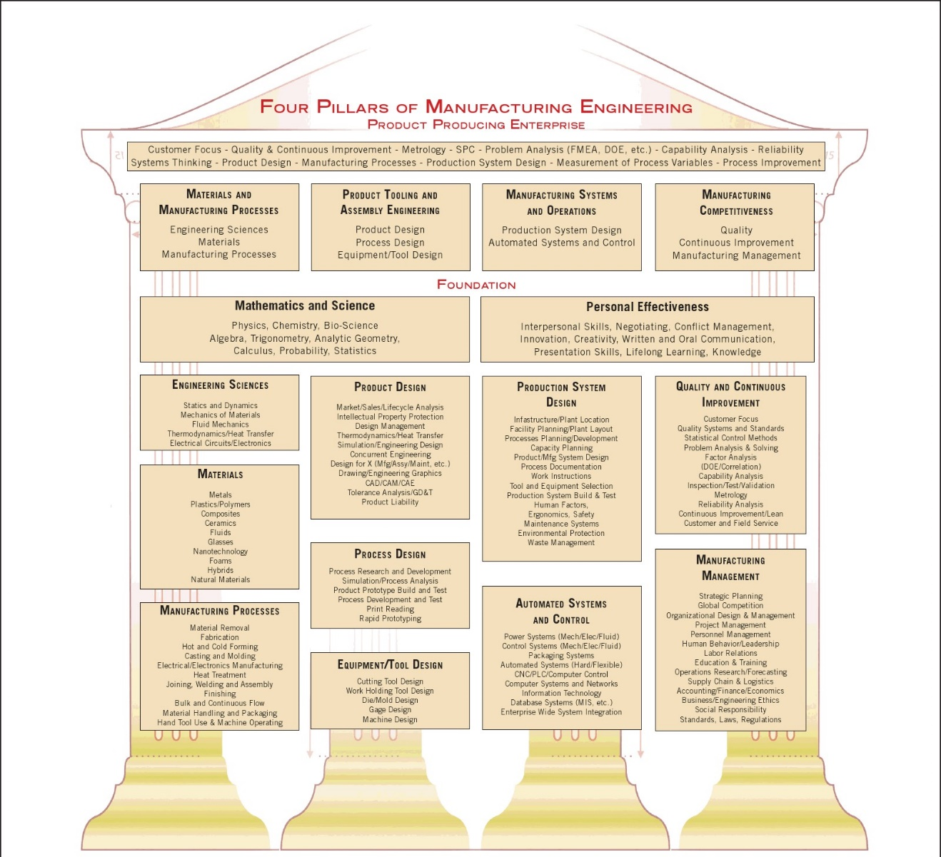

Figure 2: SME Four Pillars, SME (2011)

Development of the Four Pillars was initiated by the Society of Manufacturing Engineers (SME) through its Center for Education in the white paper (SME, 2012). Lead author, Robert L. Mott, is Professor Emeritus of engineering technology at the University of Dayton, and at that time was a member of the Steering Committee of the SME Manufacturing Education & Research Community (SME-MERC), and Senior Staff of the NSF-sponsored National Center for Manufacturing Education located at U of D. Later, several manufacturing education researchers, (Mott et al., 2012), (Nutter, Mott, Williams, & Stratton, 2013), (Nutter, Jack, 2013), (Mott, Jack, 2013), (Mott et al., 2013), (Yip-Hoi, Newcomer, 2015) used the SME Four Pillars as a curriculum development model for manufacturing engineering and manufacturing engineering technology degree programs.

The SME Four Pillars is currently in the process of being reviewed and updated by advanced manufacturing experts to include modern Industry 4.0 topics (Irwin, Johnson, Marzano, 2022). In 2021 SME administered an online survey to approximately 350 subjects with 75 returned, yielding a response rate of approximately 21%. The Automated Systems and Control knowledge block is of most relevance to Industry 4.0 topics (see Figure 3).

Figure 3: Survey Results - Automated Systems & Control knowledge block

The topic with the most suggested edits was “Computer Systems & Networks”. The suggestions provided were:

- Real-time Analytics & Optimization
- Include closed-loop adaptive, artificial intelligence, integrate deep physics with manufacturing
- Incorporate Smart Factory + Operations Technology & Information Technology
- Computing and communication architectures and technologies
- Computer Systems, Networks, and Cyber-Security
- Real-Time Machine Control and Machine Management
The survey also requested suggestions for additional topics for the Automated Systems & Control knowledge block. The topics suggested were:

- Smart System Integration
- Include Edge and Cloud integration
- Factory & Supply Chain Optimization
- Enterprise-Wide Systems and technologies (Advanced systems control and coordination, Plant-floor information systems, Cybersecurity)

Context of the Study

The CME and MSME are offered in the Department of Manufacturing and Mechanical Engineering Technology (MMET). The nine-credit Online CME was introduced in 2021 fall semester. The CME has two required courses (six credits) that are also required in the MSME. These courses prepare students to manage and/or provide leadership for teams to successfully implement manufacturing processes, and to communicate effectively utilizing the fundamental concepts of geometric dimensioning and tolerance analysis. Industry 4.0 Concepts is an elective course in the CME.

The 30 credit MSME was introduced in the 2022 fall semester. Nine of the required 16 credits are also required in the CME, (*). The 16 credits of required courses for the MSME are:

• Statistical Methods (3)
• Key Factors of Holistic Safety (1)
• Organizational Leadership (3)
• Tolerance Analysis with Geometric Dimensioning & Tolerancing (3)
• Industry 4.0 Concepts (3)
• Professional Engineering Communication (3) Or Engineering Research Communication (3)
(*) Bold text are also CME courses

Industry 4.0 related topics are integrated into the remaining 14 credits of courses chosen from emphasis areas such as: Additive Manufacturing, Manufacturing Systems and Operations, Product Tooling and Assembly Engineering, Quality Engineering, Manufacturing Sustainability, Advanced Materials and Manufacturing Processes, and Cyberphysical Systems.

Industry 4.0 Concepts - Course Design and Delivery

The Industry 4.0 Concepts course enrollment in spring semester 2022 was nine students.

A Canvas learning management system section was created for the enrolled students. All students enrolled were off campus in remote settings. The Canvas section was developed to allow students to access the course content at their convenience. The following methodology was used for the online setting.

- Recorded lectures to present course topics and content
- Reading assignments from available literature
- Discussion assignments on course topics and literature reviews
- Homework assignments
- Course quizzes and final exam
For the majority of the course, recorded lectures were used to present course topics and introduce the content covered. Presentation slides were used in conjunction with the recorded lectures. Reading assignments, from available research, were given to the students to review and then participate in a series of discussion postings. The discussions were used to make sure the students were completing the reading assignments, and to allow them to interact with each other.

Two homework assignments were collected during the course that covered machine learning using MATLAB. This software has built in functions that are specifically tailored for machine learning applications. The assignments were focused on how to use these functions.

Four periodic quizzes were given during the semester, and a final exam at the conclusion of the course. The quizzes were used to determine the students understanding of content covered in recorded lectures, and to make sure they were reviewing the posted material. This provided an alternative to just using online discussion boards. The final exam at the conclusion of the course provided an overall assessment for each student.

Industry 4.0 Concepts – Course Content

In this course, students examine Industry 4.0 as it relates to manufacturing. The fourth industrial revolution has begun with the introduction of machine intelligence and cyber physical systems that can communicate over the internet. Cyber physical systems enable the virtual world of computers and software to merge with the physical world through process management and feedback. This is a result of hardware being much more affordable, readily available software that can perform complex tasks, inexpensive computational storage, and a widespread internet. All of which connects machines, devices, sensors, data, and people.

Course Learning Outcomes:
- Illustrate how the interconnection of machines, devices, sensors, and people connect the Internet of Things (IoT) and Internet of People (IoP) to form the Internet of Everything (IoE).
- Demonstrate how Information Transparency is accomplished through tasks from the virtual and physical world.
- Propose Decentralized Decisions based on the interconnection of objects and people, along with Information Transparency.
- Assess the shifting role of humans operating machines towards a strategic decisionmaker and problem-solver role.
As it relates to manufacturing, students explore topics such as smart factories, cyber physical systems, proactive maintenance, computer simulation, horizontal and vertical integration, and barriers to implementation will be explored. As an example, connected sensors will integrate an Internet of Things (IoT) network on the factory floor collecting data that will be stored in the cloud and be processed with cloud computing. The large amount of collected data, i.e. Big Data; will enable the use of computing methods including artificial intelligence to study system energy efficiency, tool wear, preventive maintenance, and product quality management. The connected factory floor, in conjunction with the use of smart human machine interfaces (HMI’s), also enables the use of real-time data in automation, system integration, and supervisory control to minimize down-time. Furthermore, the collected data will enable the development of process emulators to simulate the steps of a process before the actual production begins to increase efficiency through intelligent routing.

Student Demographics

Of the students, eight graduate students were taking the course towards fulfilling their degree requirements, and one undergraduate student was taking the course for continuing education. All the students were working full time during the course; five were employed full time, and four employed as part of a co-op or internship program.

Table 1 - Student Demographics During Course Offering
Student Demographics (9 Students)
Type of Student
Graduate | 8 | Taking the course as part of degree requirement
Undergraduate | 1 | Taking the course for Continued Education
Student Major
MS Manufacturing Engineering | 5 | Currently enrolled at MTU
MS Mechatronics | 2 | Currently enrolled at MTU
MS Mechanical Engineering | 1 | Currently enrolled at MTU
BS Mechanical Engineering | 1 | Past Graduate of MTU
Student Employment Status
Full Time | 5 | Employed full time during course
Co-op/Intern | 4 | Employed as a Co-op/Intern during course
Full Time Student | 0 | Not employed during course

Results - Teaching Evaluations and Student Comments

At the end of the course, a course evaluation was given to the students enrolled in the online class. The overall response rate was 7/9, or 77.78%. There were 15 evaluation questions that were asked ranging from how the students understood the goals and objectives of the class, how the student’s effort in the course were adequate to meet the course objectives, their effort, as well as how the instructor communicated the material, how the instructor engaged student participation, instructor providing timely feedback on homework/assignments, and if the instructor created an atmosphere where ideas can be exchanged freely and easily. Questions were weighted from 1 – strongly disagree to 5 strongly agree, with 3 – neutral. The evaluation mean of the Seven Dimensions for the course was 4.04. The highest evaluation average was for how the instructor communicated the course material clearly. The lowest evaluation average was 3.71 for how the instructor engaged students by encouraging course preparation, reflection or other activities outside of class.

Table 2 – Student Evaluations - Seven Dimension Scoring
Student Evaluations - Seven Dimensions
Question |  | Response Average
1 | The instructor was enthusiastic about the subject matter of the course | 4.29
2 | The instructor communicated the course material clearly | 4.43
3 | The instructor engaged students by encouraging participation during class | 3.86
4 | The instructor engaged students by encouraging course preparation, reflection or other activities outside of class | 3.71
5 | The instructor provided timely feedback on my work (homework, assignments, exams, etc.) | 3.86
6 | The instructor displayed a personal interest in students and their learning | 4.14
7 | The instructor used technology appropriately | 4.00

Student comments for the course were limited, but also provide some helpful guidance in course improvement. One question in the evaluation was “What aspects of this course should I change to improve student learning?”. One comment suggested consistent schedule for assignments of reading/videos and more graded assignments such as every Sunday night or Monday morning. This was geared towards the student that is working full time as opposed to a traditional on-campus student. Another comment was a student wanting to see Zoom or other group gathering sessions where they could have a class discussion for each topic to exchange ideas rather typing comments in a reply or reflection posting. They felt more information could be exchanged through a group setting as compared to typing a response.

Another question was “As I, the instructor, prepare to teach this class again, what aspects of this course (teaching methods, assignments, areas of emphasis, etc.) should I preserve that effectively furthered your learning?”. Responses from this question were positive in that they liked the class, it was not repetitive, and there was no redundant busy work. Another student liked the use of multiple sources of videos and various research papers.

Discussion

The course evaluation and student comments will help in course improvement, although all comments were related to course delivery rather than course content. Since this course was offered online during the spring semester, the next time the course is offered these suggestions will be taken seriously to adjust the course to better align with non-traditional students. Having regularly scheduled group Zoom meetings was a great idea for one. This can provide an environment for students to learn from each other as opposed to typing a response which they think best fits what the instructor wants to hear. Timing for these online meetings is always a challenge, however, if an event schedule is posted early in the semester, it aids working professionals in time management. Additionally, having a regular and consistent schedule for non-traditional students helps them keep on track without having to consistently check the course schedule. They will know up front what to do when, so they can plan their week accordingly.

Conclusions

All students achieved all course learning outcomes at acceptable levels. The course received high student evaluation ratings with no comments pertaining to course content. Therefore, the course content seems to be enough to meet the learning outcomes. Since the topic of Industry 4.0 is an evolving topic, continuous updating of course material will be required. For instance, refreshing the list of research papers used for literature reviews.

The Industry 4.0 course is currently being offered as an asynchronous Online format only, but will have an on demand in-person component in the future. To prepare for the Online format there are efforts underway by the university’s Center for Teaching and Learning to coordinate all the Online courses with a standard format using Canvas. This will allow faculty and students to reach the goals according to the Quality Matters Program (2015) rubrics and standards to ensure that learners are engaging with high-quality courses.

To help integrate Industry 4.0 topics in future course offerings, course evaluations and student comments provide a helpful insight for what the students liked and disliked about the course. Since this course was mainly taken by working professionals, a consistent course and traditional face-to-face interaction was indicated as being important; even though it is offered as an online class. These suggestions will help steer the future course structure in order to provide improved learning outcomes.

References

ABET, Inc. (2022). Accreditation Standards and Program Criteria for Manufacturing Engineering and Similarly Named Programs. Washington, D.C.: ABET, Inc. Retrieved from http://abet.org/engineering-criteria-2022-2023/

Alasti, H. (2021, July). Turning a Legacy Robot to Collaborate to Fit in Industry 4.0 Demands Paper presented at 2021 ASEE Virtual Annual Conference Content Access, Virtual Conference. https://peer.asee.org/37941

Das, S., & Kleinke, D. K., & Pistrui, D. (2021, July). 2020 BEST PIC V PAPER WINNER - Reimagining Engineering Education: Does Industry 4.0 Need Education 4.0 ? Paper presented at 2021 ASEE Virtual Annual Conference Content Access, Virtual Conference. 10.18260/1-2--36545

Huderson, A., & Peiffer, E., & Shamsi, S., & Plaza, F., & Collins, E. (2022, August), FUTURE OF MECHANICAL ENGINEERING, MANUFACTURING ENGINEERING, AND MACHINIST ROLES FOR INDUSTRY 4.0. Paper presented at 2022 ASEE Annual Conference & Exposition, Minneapolis, MN. https://peer.asee.org/41625

House, W. (2018). Strategy for American Leadership in Advanced Manufacturing. Subcommittee on Advanced Manufacturing Committee on the Technology of the National Science Technology Council.

Irwin, J. L., Johnson, M. & Marzano, S. (2022, July). Four Pillars of Manufacturing Knowledge Revision and Validation Process. Paper presented at 2022 ASEE Annual Conference & Exposition, Minneapolis, MN.

Kota, S., & Mahoney, T. (2018). Reclaiming America’s Leadership in Advanced Manufacturing. Report number: MF-TR-2019-0401. MForesight.

Mott, R. L., Stratton, M. J., Jack, H., Gartenlaub, M., Bennett, R. J., Wendel, S., ... & Raju, V. (2012). The Four Pillars of Manufacturing Knowledge: Its Application to Engineering Technology Programs. Journal of Engineering Technology, 29(2).

Mott, R. L., & Jack, H. (2013, June). The Four Pillars of Manufacturing Knowledge Model–Illustrations of Mapping Curricula into the Model. In 2013 ASEE Annual Conference & Exposition (pp. 23-1202).

Mott, R., Bennett, R., Gartenlaub, M., Danielson, S., Stratton, M., Jack, H., ... & Waldrop, P. (2013, November). Integration of Manufacturing Into Mechanical Engineering Curricula. In ASME International Mechanical Engineering Congress and Exposition (Vol. 56277, p. V005T05A028). American Society of Mechanical Engineers.

Nutter, P., & Jack, H. (2013, June). An application of the SME four pillars of manufacturing knowledge. In 2013 ASEE Annual Conference & Exposition (pp. 23-149).

Nutter, P., Mott, R. L., Williams, C. R., & Stratton, M. J. (2013, June). Survey of Manufacturing Company Expectations Based on the SME Four Pillars of Manufacturing Knowledge. In 2013 ASEE Annual Conference & Exposition (pp. 23-1120).

SME (2012). A Strategy for Manufacturing Education. Dearborn, MI: Society of Manufacturing Engineers. Accessed from https://www.abet.org/wp-content/uploads/2015/04/workforce-imperative-manufacturing-education-strategy.pdf

SME (2020). Certified Manufacturing Engineering Technologist and Certified Manufacturing Engineer - Body of Knowledge 2020. Dearborn, MI: Society of Manufacturing Engineers. Retrieved from https://www.sme.org/globalassets/sme.org/training/certifications/technical-certification/technical-certification-body-of-knowledge.pdf

SME (2011). Four Pillars of Manufacturing Knowledge. Dearborn, MI: Society of Manufacturing Engineers. Retrieved from www.sme.org/fourpillars

Quality Matters Program (2015). About us: Quality Matters. Retrieved September, 2021 from https://www.qualitymatters.org/about

Yip-Hoi, D. M., & Newcomer, J. L. (2015, June). Conforming a New Manufacturing Engineering Curriculum to the SME Four Pillars. In 2015 ASEE Annual Conference & Exposition (pp. 26-393).

Biographies

DAVID LABYAK, PhD. is an Assistant Professor in the Manufacturing and Mechanical Engineering Technology Department at Michigan Technological University teaching in the area of Solid Mechanics. David brings his 23 years of professional industry experience from General Motors in manufacturing/process engineering, Copper Range Company and Raytheon Missile Systems in project engineering, and simulation
analysis at Great Lakes Sound and Vibration. Dr. Labyak can be reached by email at dmlabyak@mtu.edu.

JOHN IRWIN, EdD. is a tenured Professor, Mechanical Engineering Technology/Chair of the MMET Department in the College of Engineering, at Michigan Technological University. He has a Doctorate in Curriculum and Instruction from Wayne State University, Detroit, Michigan. He is PI for an NSF S-STEM grant until 2023. John is experienced in industry as well as the teaching profession with five years in engineering design, several years part time consulting in industry and over 30 total years of teaching. His research focus is on teaching and learning in computer aided design, analysis, & manufacturing subjects. Dr. Irwin can be reached by email at jlirwin@mtu.edu.

