Modeling of Passenger Postures for Predicting Driving Events using Support Vector Machine

|  |  |  |
| --- | --- | --- |
| 1st Praneeth Kumar Reddy Dendi  *Department of Computer Science*  *Kennesaw State University*  Marietta, GA  pdendi@students.kennesaw.edu | 2nd Sylvia Bhattacharya, PhD  *Assistant Professor*  *Electrical Engineering Technology*  *Kennesaw State University*  sbhatta6@kennesaw.edu | 3rd Khalil Alame  *Department of Engineering Technology*  *Kennesaw State University*  Marietta, GA  kalame@students.kennesaw.edu |

4th Hairston, William David, PhD

*Senior Principal Investigator*

*US Army Research Lab* Baltimore City County, Maryland william.d.hairston4.civ@army.mil

*Abstract*—The intent of replacing human drivers with fully automated systems is the future of the vehicular system. Our role in a car will be as a passenger only with no or very limited driving controls. However, current researches are mostly driver-centered, and very little knowledge is known about the passenger. This project is designed to investigate passenger posture to understand user preference on driving style during specific driving events. This work aims to present a method for the analysis of passenger sitting postures and the resulting interactions of the passenger body with the car seat. Firstly, we placed pressure sensors on the seat bottom and seat back for collecting the pressure values of the passenger when the car is on the ride. Secondly, we have designed a real road experiment for an hour where the passenger and driver are engaged in normal conversation while data is collected from passenger motion during lane change, acceleration, and braking car. The passenger motion has been used as classifying metrics for events such as lane changes, braking, and acceleration, using a Support Vector Machine. Throughout this paper, we will discuss how Automated Vehicles impact passenger posture and how we were able to achieve a 71% accuracy behind our findings. Index Terms—Sensors, Passenger, Postures, Support Vector Machine(SVM), Seat-Bottom, SeatBack

*Index Terms*—Sensors, Passenger, Postures, Support Vector

Machine(SVM), Seat Bottom, Seat Back

I. INTRODUCTION

In the twenty-first century, both academia and modern industries have turned their interests to AUTOMATED vehicle research. This field of research includes transportation systems, automotive engineering, human factors, information technology, control, robotics, communications, energy, security, and social sciences. While fully autonomous driving is the ultimate goal of AUTOMATED vehicle research, intermediate ”highly automated” vehicles or ”HAVs” are fully capable technologies constructed for driving independently in most conditions. These ”HAVs” are the stepping-stones to reaching fully automated vehicles and are expected to be commonplace in vehicles in the next several years. This decision was created by the National Highway Traffic Safety Administration (NHTSA) of the United States, when the ”Federal Automated Vehicles Policy” was announced in September of 2016. According to the Society of Automotive Engineers, or SAE, definitions, vehicles are divided into six levels depending on ”who performs what, when.” SAE Level 1 refers to ”driver assistance” systems, while SAE Level 4 refers to vehicles with ”high automation” that can handle safety-critical duties like steering, acceleration, and stopping. The transitional region between driver assistance and high automation are represented by SAE Level 2 (”partial automation”) and Level 3 (”conditional automation”). These levels help direct us in our findings.

In the future, the majority of vehicles on the road will be automatic vehicles, and many people entering vehicles will only be passengers. Passenger trust is more important to drivers. For example, when an unknown driver gets behind the wheel of the vehicle, the passenger feels uncomfortable and a little anxious about the ride. To find out what the passenger is truly feeling, there are several different approaches for monitoring the passenger and drivers’ behavior. In this paper, we will discuss purely the passenger’s motion in a ride that is about one and a half duration (moving car which is a real-time driving). Most of the research work is done on static posture analysis, which means that the person is sitting in a chair or seat and the person’s posture is noted accordingly. The tricky part of the posture analysis is in the dynamic seat sensors, which means when there is a passenger and driver, the drive starts from a starting point and ends at the same point. In this ride, the seat sensors, which are placed on the passenger seat, capture the pressure of the passenger’s body during the drive. Throughout this research, data is collected from a passengers’ seat sensors’ pressure data-set for when the passenger sits in the car up until when the passenger drops off from the car. This is a very new way of the data collection process. For the classification of posture, we used the threshold percentage value.

Throughout this research, data is collected for a passengers’ seat sensors’ pressure data-set for when the passenger sits in the car up until when the passenger drops off from the car. This is a very new way of the data collection process. For the classification of posture, we used the threshold percentage value.

II. BACKGROUND

1. A Sitting Posture Monitoring System (SPMS) uses a combination of IT technology and several sensors to evaluate a sitting person’s posture in real-time. By modifying the attitude of a sitting person, ergonomic interventions can lessen symptoms of discomfort. Machine learning algorithms have been used in many studies because of recent breakthroughs in this field. The technique proposed in this work has high accuracy in estimating posture, so we decided to implement it in our research. To do this, the load cell was installed into the seat frame of an existing office chair to create an SPMS. A body pressure distribution system (Pliance, Novel Corp., Munich, Germany) was also installed and placed on the upper section of the seat plate to assess body pressure distribution. Finally, an Arduino board was implemented to transport the SPMS load cells measured by the four load cells of the SPMS to a PC at a rate of one Hz. The data was produced by combining the six sitting postures and processing it from one to the next.

In our first experiment in the study, 24 healthy adult males (age: 27.6 5.6 years, height: 174.5 6.2 cm, and body weight: 71.9 8.7 kg) participated in the research. The participants were chosen in particular due to the lack of any serious musculoskeletal or neural abnormalities.

1. The BWR area was calculated from the preliminary test. RML was utilized to assess lateral leaning, which was broken down into LE, RI, and the other four posture categories. The conversion success of the sitting posture was used to determine the decision tree’s goal posture without machine learning. A nonlinear optimization problem can be solved by using the Karush–Kuhn–Tucker condition to minimize W. When using a kernel function with an SVM to classify nonlinear data, can be quite effective. A radial basis function can be employed to represent the kernel function in this investigation (RBF). Using this data, we implemented the use of a random forest, which is a set of decision trees created using a random selection of training data. With the smallest number of trees, we can determine the best results. To make the SVM a multi-classifier, the one-against-all technique was employed.
2. The authors suggest a ”soft authentication” approach. Pressure sensors were installed right on the seating face of a chair, preventing it from being moved. For five people, the identification rate goes from 78 percent to 98 percent, and for ten people, it ranges from 67 percent to 96 percent. When the participant begins to sit, the value rises quickly and then gradually decreases until it is nearly constant, then as they continue to sit on the chair and alter their posture, the sum of pressure values varies. Even unreliable parts, we believe, can offer information about their status. Some fundamental challenges are involved in posture classification. Different people would undoubtedly sit in various positions. We need to see if the weight change has a significant impact. With an increase in weight, the sensor values would either grow linearly or non-linearly.

A. Over 1.2 million people are killed every year on the world’s roads, making road traffic injuries the top cause of death worldwide. The majority of traffic collisions are caused by drivers who are not paying attention. Additionally, technologies for automated driving and driving assistance are being investigated and developed. Drivers’ primary tasks while driving are to push the accelerator, brake pedals, and operate the steering. While turning, braking, and changing lanes, the driver should also confirm the vehicle’s two sides and rears directly and regularly to ascertain the surrounding circumstances. The postures and pressure distributions associated with these primary driving postures are depicted in heat map distribution. Each person had more than 450 pressure distribution, thus being perfect candidates for how data is collected. 90% (*280=252) of the pressure data was used to train the SVM classifier. Additionally, 1028) pressure data were utilized as test data to determine the method’s correctness. The proposed approach can accurately predict the majority of postures. If we construct classifiers for each driver, we can also estimate these postures more precisely. Almost all of the data recorded for Posture 3, which had the participant look to the right, was predicted incorrectly (error rate: 0.98). However, for other postures, a classifier can accurately estimate the driving postures. An SVM-based classifier can be created utilizing data from several different driving positions. The produced classifier is highly accurate at classifying driving postures for the majority of driving positions so we utilized it to summarize that the majority of postures had an overall estimation error of only 20

1. Spring robot is an experimental self-driving vehicle featuring computers, sensors, and capabilities for communicating remote control, automatic braking, acceleration, and steering. Computer-controlled vehicles have been trained to accurately navigate and detect hazards on a range of road types using machine-learning techniques. To do this, lane modeling must make some assumptions about the real-world road structure. In a level ground plane, circular arcs can approximate lane boundaries. Lane-boundary models provide adaptation and robustness to a variety of road conditions, shadows, and noises, creating more environments to train the model and producing a more precise model. There are a tremendous number of pos- sible traits that could be utilized to detect numerous variables. In this study, we exclusively consider color aspects because color is the key factor in identifying lane markings. The trained algorithm is evaluated using photos captured by an onboard camera in our lab and photographs, given by Carnegie Mellon University’s Robotics Institute. Under a range of road surface types, lane structures, weather conditions, and noises, the accuracy and robustness of road-boundary recognition for an autonomous vehicle to calculate is a taxing operation. To address these issues, an effective method of implementing the RHT is utilized to maintain its high accuracy advantage.
2. In the second experiment of the study, tests were carried out on a total of 114 people (69 men and 45 women), all of whom were 32 years old (mean ±SD). To eliminate bias in participants’ behavior, no information regarding the smart chair or the existence of sensors was supplied to them prior to the test. The tests were carried out on a total of 114 people (69 men and 45 women), all of whom were 32 years old (mean ±SD). To eliminate bias in behavior, no information regarding the smart chair or the existence of sensors was supplied to participants before the test. The analysis was done using MATLAB on all of the participants’ postures during the tests.

There were intervals with a higher level of engagement and, as a result, a higher level of stress. The 50 percent of the range between Vmaxload and Vzero was chosen as the threshold for each test. The significance of associations was tested using Chi-square statistics. A value of 0.05 p 0.10 suggested that there was some curiosity but not enough proof, whereas p0.05 indicated statistical significance. All of the obtained data were analyzed by the algorithm for posture detection.

The system is based on the use of low-cost electronic equipment and inexpensive textile sensors that may be simply incorporated into the chair frame. When paired with wireless transmission, this system can create a final product that could be used in a workplace where stressful situations can arise inexplicably. In the module of the research paper, we discuss what methodology is used and how it is implemented for this research work.

III. METHODOLOGY

We used a classification method called support vector machine in this research. In a car simulator and on-road driving trial, we validate this strategy. Pressure data for a variety of driving postures can be measured in the car simulator. Simultaneous measurements of road noise and engine vibration will be made during the on-road driving experiment.

*A. Data Collection:*

Data collecting is essential for moving forward with any research and subject, whether it be in science, humanities, or business planning. The research’s long-term viability is jeopardized if the data collected is insufficient and untrustworthy. For this research work, The data is collected by a car ride where the sensors are placed on the seat back and seat bottom. Here in this car, the seat sensors are placed only for the passenger’s seat.

As shown in the figure the passenger and the driver will have a ride and EEG is placed on the passenger’s head. The seat sensors start recording the passenger when they sit on the passenger’s seat. The is not classified as we know that in real-world, we all sit for the ride and posture are automatic according to the passenger’s motion. Here in this experiment, we just recorded the values of the pressure sensors. The Fig.2 shows the MATLAB code for the seat sensors.

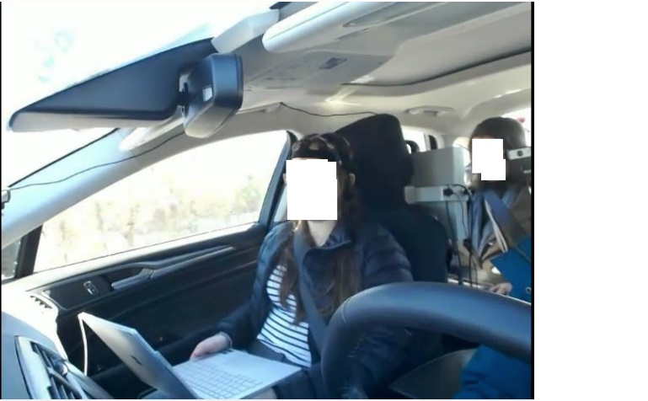

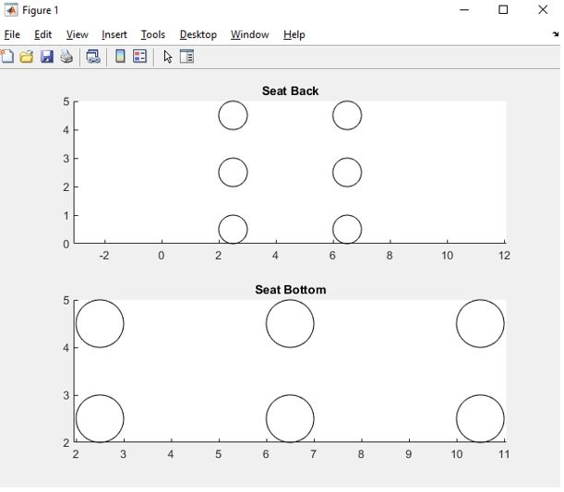Fig. 1. passenger view

Fig. 2. sensors positions by Matlab code

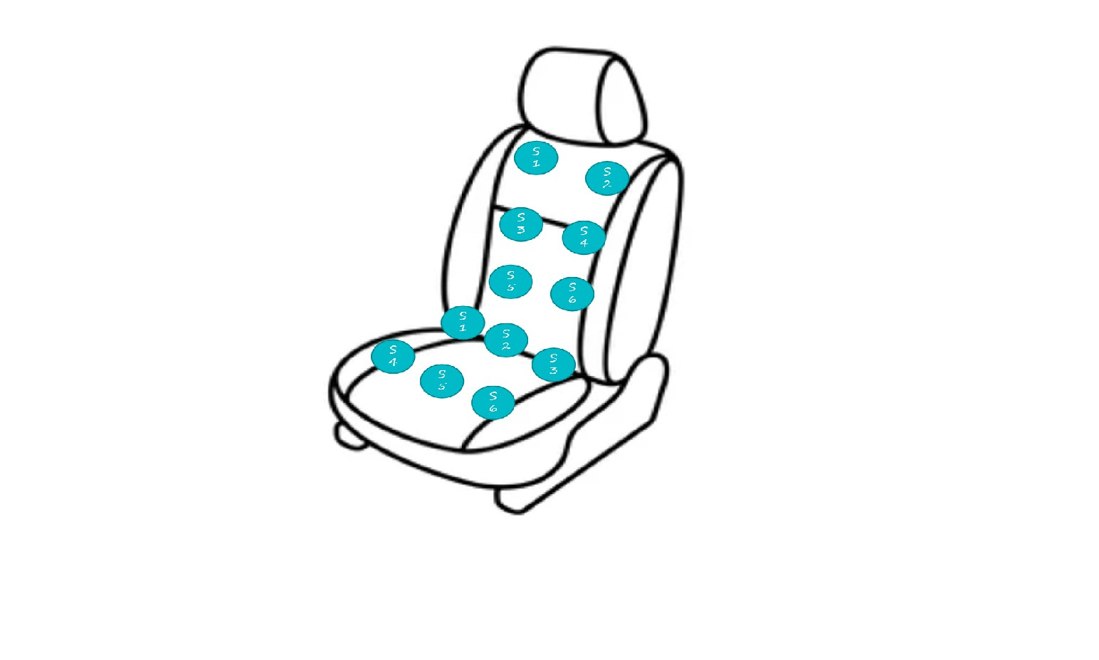

Fig. 3. sensors on car seat positions

Here in Fig.3 shows how the seat sensors look on the passenger seat in a car. As the above figure states that how the sensors at placed on the passenger seat. We have a total of six sensors at the back of the seat. Each row has two sensors. On the seat-back, the first two are placed on the top, approximately at the shoulder.

And the next three and four sensors are placed just below the first one. Then after the last two sensors are placed at bottom of the seat-back. When it comes to seat-bottom, here also we have a total of six sensors. Unlike the seat-back, the seatbottom has three sensors for each row. The first three sensors are just below the lap of the passenger. And the next three sensors are at the back of the passenger seat. After the data collection process, the next step is the analysis of the raw data. The analysis shows that the data is speaking about.

*B. Data Elaboration and Analysis:*

For this research, we use six seat-bottom sensors and six seat-back sensors Before we jump into the prepossessing step, the data is visualized. Here in Fig.3, the diagram shows how the seat bottom sensors pressure is distributed concerning the

Time UTC (YYYYMMDD HHMMSS.mmm). As the sensors are have different pressure values for the same period. This is because of the person’s body pressure on the sensors.

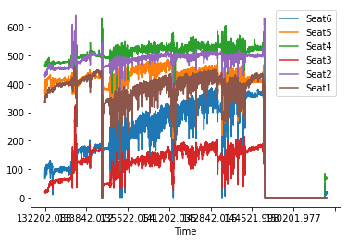

Fig. 4. Seat Bottom Sensors

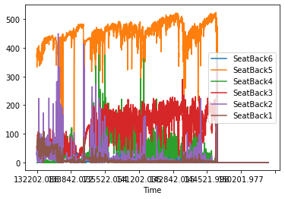

Fig. 5. Seat Back Sensors

In seat-back sensors, as in the visualization, it shows that some seat sensors’ pressure is very low when compared to other sensors at the same period.

1. *Data Prepossessing:*

Every data has some noisy data. Before we train a model, we have to remove this noisy data. Data that has a lot of noise is unusable, creating corrupt data. However, the term ”corrupt data” has been broadened to cover any data that machines cannot understand or interpret accurately, such as unstructured language. Noisy data is any data that has been received, stored, or modified in such a way that it can no longer be read or used by the program that created it. Noisy data increases the amount of storage space required unnecessarily and can also harm the findings of any data mining analysis. Statistical analysis can screen out noisy data and make data mining easier by using insights acquired from past data. Hardware problems,programming faults, and nonsense input from voice or optical character recognition (OCR) systems can all result in noisy data. Machine reading can also be hampered by spelling errors, industry abbreviations, and slang. In our experiment, the noisy data is that some sensors are not performed well while the passenger is on the ride. The sensor is recorded as a 0 value for some period of time.

1. *Posture Classification:*

Before we model the data set, it first needs to be labeled. The data set we collected is not a labeled one. For labeling the posture we used the threshold of seat sensors pressure. Here the threshold is the percentile of the pressure value at that time. To calculate the threshold of the back portion of the seat, we take the value of a specific backseat sensor minus the min of that same data set, divided by the quantity of the maximum value minus the minimum value of that same data set. The ”PV” variable in the formula accounts for the Pressure Value of the specific sensor, whereas the ”PVC” variable represents the column of Pressure Values pertaining to that said sensor.

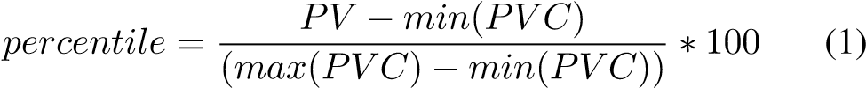

We calculated the percentile for each pressure value in the column. We create a new column with the respective column percentile and after this step, we have an extra column for each sensor. So the total columns are 24.

We have total of four event to be classified. They are lanechange, braking, acceleration, normal.

1. *Lane-Change:* The lane change is one of the causes of the passenger posture change. [10] When a passenger’s body pressure is more on the pressure sensors which are in the right position on the seat bottom then the passenger is leaning towards the right. In this situation, the car moves towards the left lane.
2. *Braking:* As in the real world scenario the passenger moves forward when a driver have a braking event. In our experiment, when a braking event is occurred then the pressure on the back seat sensors is more compared to normal.
3. *Acceleration:* Acceleration is one of the causes of the passengers’ change in posture. The acceleration is quite opposite to the braking event. Here in this paper, when there is an acceleration the seat-back sensors will lose pressure as the passengers’ body moves forward.
4. *Normal:* The back of your car seat should, in theory, reach shoulder height. In most cases, it will be acceptable if it is a little higher or lower but you may still rest into it. Most vehicle seats include headrests that can be adjusted. As the sitting posture is in a normal state when passengers state of action is normal. In our experiment, we consider when a passenger pressure value does not satisfy the condition the that record is considered normal posture.

*E. Classifier:*

Support vector machines (SVM) is a powerful supervised machine learning algorithm that is most widely used in classification as support vector classification (SVC) and support vector regression (SVR) applications. [8]SVMs are widely popular due to their ability to learn well with a small number of parameters, their robustness against various model violations, and computational efficiency compared with other methods. The support vector relates to points that are closest to the hyperplane, while the margins correspond to the distance between the support vectors. Support vectors are data points that are closer to the hyperplane and influence the position and orientation of the hyperplane. The SVM kernel is a function that takes low dimensional input space and transforms it into a higher-dimensional space, i.e., it converts a not separable problem into a separable problem. It is mostly useful in nonlinear separation problem.

In this study, we are using Arduino sensors to monitor different human body postures over time. While seating in a correct position with no motion, certain areas of the body will be in contact with the sensors and that pressure range is considered as the normal threshold and the normal posture. If there is a change in the range of pressure, it helps us to understand that there is a movement and the contact points of the body area changed with time.

In the train test split, Our SVM model is trained with 70% of data-set and tested with 30% of data. And the variable random state is assigned a value of 42. The kernel we used is the radial basis function. The radial basis function kernel, or RBF kernel, is a prominent kernel function in machine learning that is utilized in a variety of kernelized learning techniques. It’s especially popular in support vector machine classification. The fit() is the function which it takes X train and y train as an arguments to get fitted into the SVC (support vector classifier) model. For testing the accuracy of the model. The function called predict() can be used for finding the model accuracy. We use predict() function with an argument as X test. This function ends-up predicting with accuracy 71%.

ACKNOWLEDGMENT

The data that were used for this study were recorded under the auspices of the US DEVCOM Army Research Laboratory (ARL) Cognition and Neuroergonomics Collaborative Technology Alliance (Contract W911NF-10-2-0022; see more at https://www.arl.army.mil/cast/CaNCTA). The analyses described in this report are part of an ongoing collaborative effort that is supported in part by Kennesaw State University as well as funding from ARL’s Human Autonomy Teaming Essential Research Program (Contract W911NF-2020205). The author team would also like to both acknowledge and thank Dr. Joe Rexwinkle (ARL) for valuable comments and guidance during the preparation of this manuscript.

REFERENCES

1. J. Roh, H.-j. Park, K. J. Lee, J. Hyeong, S. Kim, and B. Lee, “Sitting posture monitoring system based on a low-cost load cell using machine learning,” Sensors, vol. 18, no. 1, p. 208, 2018.
2. D. Bibbo, M. Carli, S. Conforto, and F. Battisti, “A sitting posture monitoring instrument to assess different levels of cognitive engagement,” Sensors, vol. 19, no. 3, p. 455, 2019.
3. K. Kamiya, M. Kudo, H. Nonaka, and J. Toyama, “Sitting posture analysis by pressure sensors,” in 2008 19th International Conference on Pattern Recognition, 2008, pp. 1–4.
4. M. Ding, T. Suzuki, and T. Ogasawara, “Estimation of driver’s posture using pressure distribution sensors in driving simulator and on-road experiment,” in 2017 IEEE International Conference on Cyborg and Bionic Systems (CBS), 2017, pp. 215–220
5. Qing Li, Nanning Zheng, Senior Member, IEEE, and Hong Cheng, “Springrobot: A Prototype Autonomous Vehicle and Its Algorithms for

Lane Detection” IEEE TRANSACTIONS ON INTELLIGENT TRANSPORTATION SYSTEMS, VOL. 5, NO. 4, DECEMBER 2004

1. D. Bibbo, M. Carli, S. Conforto, and F. Battisti, “A sitting posture monitoring instrument to assess different levels of cognitive engagement,” Sensors, vol. 19, no. 3, p. 455, 2019.
2. Kazuhiro Kamiya, Mineichi Kudo, Hidetoshi Nonaka and Jun Toyama, ”Sitting posture analysis by pressure sensors,” 2008 19th International Conference on Pattern Recognition, 2008, pp. 1-4, doi: 10.1109/ICPR.2008.4761863.
3. W. Xu, M. Huang, N. Amini, L. He and M. Sarrafzadeh, ”eCushion: A Textile Pressure Sensor Array Design and Calibration for Sitting Posture Analysis,” in IEEE Sensors Journal, vol. 13, no. 10, pp. 3926-3934, Oct. 2013, doi: 10.1109/JSEN.2013.2259589.
4. Qing Li, Nanning Zheng and Hong Cheng, ”Springrobot: a prototype autonomous vehicle and its algorithms for lane detection,” in IEEE Transactions on Intelligent Transportation Systems, vol. 5, no. 4, pp. 300-308, Dec. 2004, doi: 10.1109/TITS.2004.838220.
5. Roh J, Park HJ, Lee KJ, Hyeong J, Kim S, Lee B. Sitting Posture Monitoring System Based on a Low-Cost Load Cell Using Machine Learning. Sensors (Basel). 2018 Jan 12;18(1):208. doi: 10.3390/s18010208. PMID:

29329261; PMCID: PMC5796304.