Comparison of 3D Scanning Techniques and Photogrammetry Tools

Noah Burchett
Western Kentucky University
noah.burchett318@topper.wku.edu

Abstract

Digital reproduction of complex shapes such as fossils, skulls, sculptures, and other flowing geometries is difficult. Optical methods such as 3D scanning and photogrammetry allow for capturing of such complex geometry that is nearly impossible to reproduce otherwise. Once 3D models are available, rapid prototyping (3D printing) allows for scalable and reproducible models quite easily. Three methods of capturing these geometries are evaluated in this study: two scanning systems and one photogrammetric camera software. The Revopoint 3D POP is a structured light scanner used in conjunction with a PC or mobile device, utilizing feature detection as the scanner is moved around the object, capturing a reasonable level of detail at the cost of an unrefined mesh. The Matter and Form V2 3D Scanner uses a built-in turntable to scan subjects with a laser line as they rotate. The multiple scans captured are merged to form a single digital model. 3DF Zephyr is a photogrammetry software used to build a digital model from a series of photographs taken of the sample in question. Digital photos were taken using an Olympus OM-D E-M5II in a rising spiral fashion then combined to create a 3D digital model. Human faces, statues, and concrete fragments were used to evaluate these techniques. Final results were 3D printed on the Ender 3 V2 for visual comparison. The goal is to increase the use of 3D scanning technology available to the university community.

Introduction

As engineers, the environment one operates in is important in most, if not all applications. One way to visualize this working environment is to model it, most commonly using Computer Aided Drafting (CAD) programs such as Solidworks or Autodesk products. However, complex geometries can arise that prolong this modeling process and produce error in these models that can complicate the design process down the road. To mitigate this problem, accurate models can be created using alternate means, such as scanning and photogrammetry. Fields ranging from biology and medicine to criminology and real estate all utilize this skill to recreate entities for the purpose of research, law enforcement, business, and more. These methods are also used in the aerospace, automotive, video game, and other industries to produce fast and accurate three-dimensional models. One outlet for these produced models is 3D printing, whether it be a resin or Fused Deposition Modeling (FDM) printer to reproduce these items in miniature to larger sizes.

In the early stages of this paper, a literature review was conducted to find papers discussing the scanners and methods used, but most papers only considered one system to objects but not each other. This study hopes to broaden interest in advanced 3D modelling tools, find a relatively cheap solution for universities to invest in, and show multiple objects being scanned by the three products and how they compare. This study is not to test the manufacture’s claims on precision of the digitized model produced but to report what the possibilities and limitations of each system are.

Criteria
This paper covers a series of scanners that were procured at different price points. The Revopoint POP 3D is the lower end of the price range observed at approximately $550 with the Matter and Form V2 scanner bringing the middle up to a price of $750. Finally, photogrammetry is rather fluid in cost in terms of hardware and software. The free version of the 3DF Zephyr software was used for photogrammetry in conjunction with an Olympus OM-D E-M5II camera with a Panasonic Lumix G Vario 1: 3.5-5.6 / 14-42mm lens. The total cost was estimated to be approximately $1000. This range was chosen as it was decided to be a small investment for labs or student prototyping centers to spend for future endeavors into 3D modeling and printing. After acquiring a point cloud of the subject, it will then be exported out to a Standard Tessellation Language format (also known as a .stl file) where it will be processed by Ultimaker Cura (Braam, 2022) with presets of 0.16 mm layer height and a set infill of 30% Gyroid. All the models produced were compared after being printed on an Ender-3 V2 with the same modifications used on all prints including upgraded bed, leveled printing surface, and upgraded aluminum extruder. Supports generated by Cura where removed and any residual markings from the removal tools or process then blended with the rest of the model via light exposure to heat introduced by a blowtorch. Filament and hue were kept constant using MatterHackers red polylactic acid (PLA) for most models, but variants in color appear in some cases and were concluded to not impact the comparison of the models. Additionally, differences in the coloration of 3D models are present but impact results superficially.

Background

3D scanners work by the principle of emitting a light source that can reflect off the subject, after which the displacement or voids of light are then transformed into varying depths. The scanner then reconstructs the object digitally, recreating 3-dimensional objects in a 2-dimensional plane by accounting for the reliefs of the subject and analyzing the deformation. The Revopoint POP 3D Scanner and Matter and Form V2 3D Scanner are both structured-light scanners, which use a small webcam in tandem with projectors to observe the distortion of horizontal and vertical bands of emitted rays. The individual scans collected are then merged; the Revopoint does so automatically (Revopoint, 2021) whereas the Matter and Form V2 3D Scanner must be done so manually using a base scan (Matter and Form, 2018). This process arguably gives more user input but can also lead to shrunken or misaligned models. Photogrammetry operates on a similar principle by taking overlapping photos and stitching them together based on camera location, distance, discernable features, and triangulation. All of these methods work on the same principle, gathering key points between observations or pictures and storing them in a dense point cloud. Once the capture of data is complete, the area in between the points is meshed with straight areas and a solid is formed. With more points, features like curves and complex geometries can be meshed with ease, whereas lesser points in the cloud lead to blocky or choppier features. This mesh can then be saved to other programs to be 3D printed.

Revopoint POP 3D

The Revopoint POP 3D scanner is a lightweight structured light scanner that detects features by introducing infrared light sources that safely bounce off the subject. The device is constructed out of two IR sensors on each side of the camera with an RGB sensor for texture information (Revopoint, 2021). The device can be connected via USB A or USB C to a personal computer or a mobile smart phone, which not only powers the device but also transmits captured data. To use the Revopoint POP, two pieces of software are used: Handy Scan and Handy Studio (During the writing of this paper, Revopoint released a new suite of tools including Revo Scan, Studio, and Calibrate that were not available during the conceptual or data collection phases of this report)(Revopoint, 2021). Handy Scan allows for communication between the scanner and the PC to collect data from the scanner, save the generated point cloud, or export a mesh to a Wavefront OBJ File or a Stanford Triangle Format (.obj or .ply respectfully) format. Handy Studio is used to edit the saved .obj or .ply as it has the capability to mesh, clip, fill, smooth, mirror, and export the subject to a .stl format (Revopoint, 2021). The exported .stl file is then processed by Cura to print on the Ender 3.

The Revopoint POP 3D scanner offers five distinct modes of scanning: Features, Marker, Face, Body, and Dark/Hair. The Features mode scans objects with distinct shape features such as sculptures or figures (Revopoint, 2021). Marker mode scans objects with fewer distinct features such as flat boards, balls, or bowls (Revopoint, 2021). Markers must be distributed evenly on the subject as the scanner generates point cloud data from the pattern of adjacent markers (Revopoint, 2021). Face mode is used to scan human faces, where exposure and gain are set accordingly to the face skin reflectivity (Revopoint, 2021). Body mode is best at scanning human bodies with gain and exposure being set automatically for the subject (Revopoint, 2021). Dark mode, which has the added title of Hair, can scan some dark objects like boxes and clothes but not objects like black leather shoes that absorb most light (Revopoint, 2021). All of these are available for the corresponding mobile phone version of Handy Scan which connects over a local mobile phone’s hotspot except for the Marker mode. The scanner captures eight frames per second while operating and merges the frames of data automatically as it goes (Revopoint, 2021). The subject being scanned can be stationary or placed on the included turn table that has fiducial targets and allows the subject to turn.

In terms of editing, Handy Scan allows users to completely erase the entire scan or the latest grouping of frames. Handy Studio allows users to clip the model via a drawn plane, fill any voids either by a curved or planar surface, smooth a mesh, or mirror the mesh. The editing abilities of the provided software are limited it lacks the ability to select individual points. This tool would be useful to erase one protruding error as small noise can break models rather than having to restart the scan from scratch if saved incorrectly.

The Matter and Form V2

The Matter and Form V2 scanner is a structured light scanner, akin to the Revopoint POP 3D, but implements the use of two Class 1 Lasers (as defined by IEC60825-1:2007) (Matter and Form, 2018). The device is a foldable system with one portion folding out to reveal the built-in 7” (approximately 18 cm) turntable on one side and the laser/webcam assembly on the other. The scanning assembly is located on a threaded shaft that turns to raise up to 9.8” (approximately 25 cm) and lower the scanner as the subject turns incrementally to scan all sides. An additional stipulation is that the object cannot weigh more than 6.6 lbs. (3.0 kg). The included software MF Studio has settings to scan at 5 fixed height intervals and control the rotation of the table (Matter and Form, 2018). Multiple scans are taken, cleaned, and merged together. The resulting mesh can then be exported to .ply, .obj, or .stl formats locally. To merge, the user manually overlays a secondary scan over a base scan and aligns it to the best of his or her ability. Selecting a different base scan can result in different alignments. MF Studio can be upgraded using the software +Quickscan, an add-on that can limit scanning to one laser and rotate the turntable constantly during a scan. It can reduce a usual hour-long scan and down to five minutes (Matter and Form, 2018). This decreases the overall operating time but leaves more noise to filter through after scanning.

The editing tools available are plentiful and helpful as they offer a plentiful variety to control and reconfigure scans. The brush tool selects and deselects points that can be deleted (referred to as “cleaning”). The brush tool works akin to a laser or drill: it has a set radius and will bore through everything in its path. This can be resolved by turning the scan and deselecting points that are to be kept. The program also features an adjustable noise filter that can select points within a certain noise radius. Lastly, MF Studio contains three different cropping tools: a radial tool and two plane erasure tools. The radial tool narrows the selection radius of points the higher it is turned. The plane tools erase data from the lowest point up (upward plane) or erase data from the tallest point down (downward plane). Whereas the Revopoint POP 3D has five different modes for scanning a multitude of surfaces, the Matter and Form V2 scanner has just one regular scan mode. Additionally, he instruction manual suggests avoiding metallic, reflective, clear, or dark surfaces as they might not be captured.

Photogrammetry (3DF Zephyr Software)

Photogrammetry consists of three key components: photo, -gram, -metry. Photo relates to how the subject is recorded (via a photographic picture), the ending -gram refers to something being written or drawn, and the suffix -metry meaning to measure. In essence, photogrammetry means to measure the subject by connecting or drawing a series of images together. Any device capable of capturing and storing pictures can be used; for this paper an Olympus OM-D E-M5II was used due to its high resolution of 16 or 40 MP. While other methods have a stationary sensor or camera to observe a rotating object, photogrammetry involves rotating the camera while the subject remains stationary. The photos of a given subject are taken in an upwards spiral fashion as it is optimal in capturing details in complex and obtuse geometries. With the ever-increasing resolution of cameras installed in smartphones, this method can be easily introduced to all who can unload photos to the program.

3DF Zephyr is a software that takes the sequence of photos taken of a subject and searches for matches between each picture to build a 3D mesh (3DF Zephyr, 2022). The Free version was used, which has limited editing and exporting tools compared to the paid versions, and can only handle up to 50 pictures at a time for reconstruction. In constructing and meshing the point cloud data, any unpictured or sparsely photographed features will be tessellated, thus exaggerating the missing space or making it appear jagged or abstract. To edit the generated model, 3DF Zephyr offers multiple smoothing options, filling holes selectively or to be watertight, and a plethora of clipping tools. These clipping tools use a plane, a box, a polygonal boundary, points from the cloud, camera viewpoints, triangles, or colors to edit the subject. The program can quickly measure and display characteristics like distance, elevation change, and inclination. Measurements can be used to determine the scaling factor between the sample and the model and can help edit a mesh closer to real proportions. This method may potentially produce models with altered dimensions due its imprecision but results can be improved by calibrating the camera used with a measuring rod.

Examples

The format will first show the subject before showing the digitized model from each method with additional notes in the sequence: Revopoint POP 3D, Matter and Form V2, and finally photogrammetry. The first sample examined was a concrete cornice trim fragment chosen due to its low reflectivity, textured top and sides, and a flat bottom that could rest on a turntable or observation platform. The subject can be seen in Figure 1 below.

a)
(a) The original concrete cornice trim fragment.

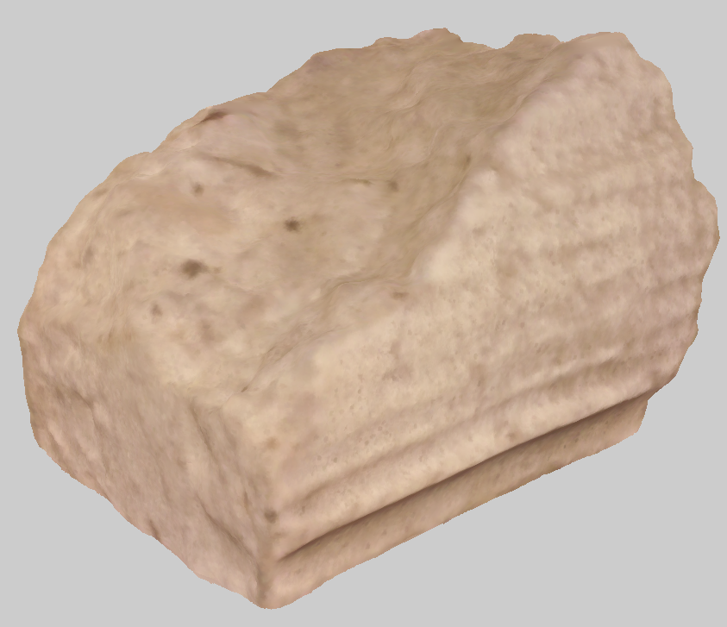
b)
(b) The Revopoint POP 3D model.
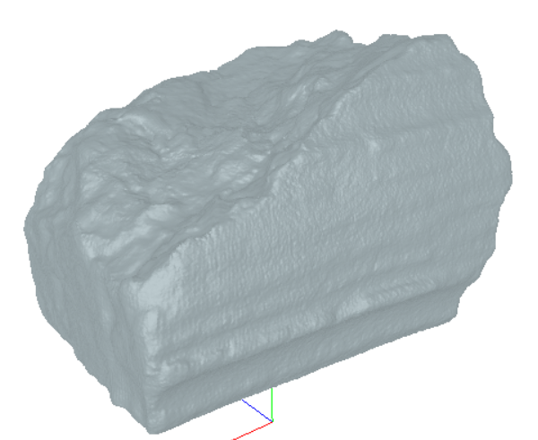
c)
(c) The Matter and From V2 model.
d)
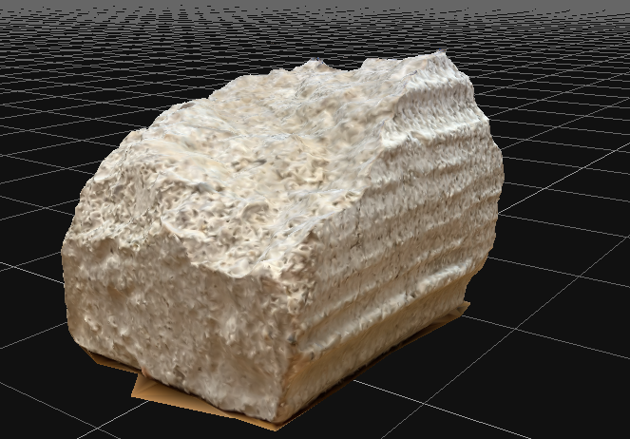
(d) The 3DF Zephyr model.

Figure 1. The first subject, a concrete cornice trim fragment, with the digitized models.

The two structured light scanners, the Revopoint POP 3D and the Matter and Form V2, were used in conjunction with a box composed of a cardboard shell lined with black foam to perform scans. The black foam absorbed any light and limited the scan outside interruptions. The box was light sealed so that the uncovered sections of the cardboard box wouldn’t be detected by the scanners. The Revopoint POP 3D had no issues arise during the scanning process for this sample. The adjustable tripod holding the scanner made obtaining various views simple as it was a matter of just adjusting the level while the sample turned on the table. While the texture mapping makes it harder to see the level of detail, the roughness of the rising middle section (denoted by the red solid circle in the figure below) is more rounded than the real subject. In addition, the bottom most groove (denoted by the blue dashed circle in the figure below) is completely missing, making the model shorter than the sample by two millimeters. The model with highlights can be seen below in Figure 2.

Figure 2. The Revopoint POP 3D model of the concrete cornice trim fragment with textures and highlighted sections.

The Matter and Form V2 scanner had no issues arise in the scanning of this piece. The sample was set upon a wooden block during the scanning process then edited out afterwards, this was implemented to allow for better capture of the subject’s underside. The side grooves are softer than the previous sample but shows more detail in the middle rock section (once again denoted by a red solid circle in the figure below) whereas the Revopoint POP 3D’s model was rounder in general. Additionally, it has a more accurate height, but reduced width of approximately one to two millimeters along the profile. The digitized model from this scanner can be seen below in Figure 3.

Figure 3. The Matter and Form V2 model of the concrete cornice trim fragment with highlights.

For photogrammetry, the sample was placed on a wooden observation platform with the photos taken in a circular and then rising pattern. The observation platform (a wooden stool) was used because it allowed the photographer to have easy rotation around the subject and allowed for the camera to have a constant radius away from the subject in the case of the circular pictures. The pattern allowed for the most capture of detail in the fewest number of pictures. 3DF Zephyr rejected no pictures and used all data in its reconstruction for this sample. In Figure 1d, some amounts of the wooden platform can be seen underneath the model as the software filled the holes by drawing on old textures. The 3D printed model was significantly smaller than the original, at an estimated 75% scale of the original sample. Where it lacks in dimensions, the model makes up for in detail as it has a greater level of detail than the Matter and Form V2 scanner’s mesh. It can be complimented for its textures as seen in the figure as it looks much closer to the original sample than the other models.

The next sample was a fragment of a tombstone statue that had a child holding onto an angel’s hand. This sample was chosen due to its low reflectivity and more complex geometries and pits (in comparison to the concrete cornice trim). As seen below in Figure 4a, the hand has a natural curved palm that leads to the clutched thumb: this is a natural location to check for tessellations in the scanners. While not seen easily, the fingers and curved surfaces have pits and chips that provide another spot to check for accuracy among the models.

a)
(a) The sample concrete statue fragment

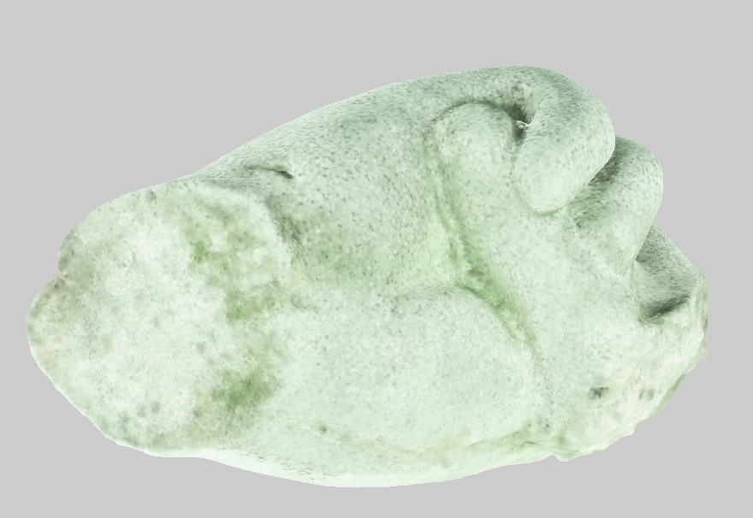
b)
(b) The Revopoint POP 3D model

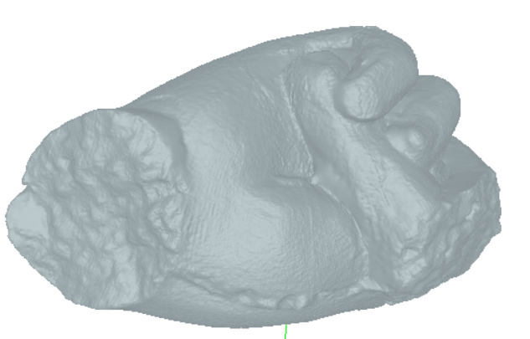
c)
(c) The Matter and From V2 model.

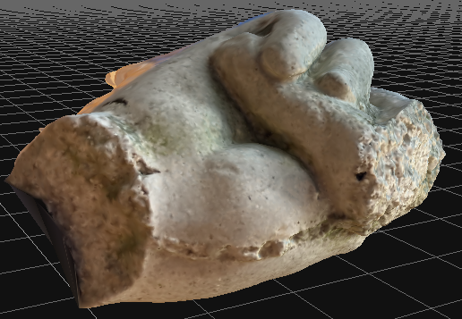
d)
(d) The 3DF Zephyr model.

Figure 4. The second subject, a concrete statue fragment, with the digitized models.

The Revopoint POP 3D had minimal issues arise during the process of scanning the fragment. The only inconvenience was that the tripod could not be placed so it could have an overhead view to catch the beneficial details to the model. To achieve this viewing angle, the operator picked up the tripod assembly and maneuvered it to the angles and recesses of the hand while the scanner was running. The final 3D print shows that minimal detail was lost and eradicated the texture coloring issue seen. Some noteworthy spots include exposed rocks and broken, smoothed sections. The finished model can be seen in Figure 4b with its off-color texturing. The Matter and Form V2 scanner had minimal issues in the scanning process as well. The limited motion of the table helped in some regards and hurt in others as shorter scans allowed for faster data capturing. However, the mounted, nonadjustable camera led to issues orienting the sample to obtain more data in smaller parts. This can be seen in Figure 5 as the crease where the thumb and the palm meet have significant tessellation, as seen in the red circle’s area. Additionally, the fingers had tessellations along their digits and several of the pits and recesses have been partially to mostly filled in the final print.

Figure 5. The Matter and Form V2 model with highlights around the tessellation between the thumb and the palm.

It was difficult to acquire photos of the hand statue fragment for photogrammetry. This was mostly due to the wooden stool having a recessed seat the fragment sat on, allowing the sample to rock and become reoriented while taking pictures. To combat this problem, clay was introduced to the base of the hand to hold it upright at the cost of detail at the base. This can be seen in Figure 6 as the clay-filled hole that resulted in a crescent shape (shown with the yellow dashed circle) of data missing in the final model. Additionally, some major tessellations can be seen as fins sprouting on backside of the model for no discernable reason. The final print also shows that the size is much closer to the original than the cornice trim was. Additionally, there is significant tessellation due to 3DF Zephyr rejecting some data and the fact that black clay was used to hold the hand in an upright position. Some of the tessellations can be seen on the left side of Figure 6 where the black clay was removed and the portion of the hand that contained rejected data.

Figure 6. Photogrammetry model of the concrete statue fragment with General/Deep Presets with highlighted lack of concise data due to clay.

The next subjects are a collection of human faces that volunteered their time to the paper’s progress. The first was asked to participate because he had light to dark hair. The second had brown hair while the last had darker hair and a beard with black rimmed glasses. To scan faces using the Revopoint POP 3D, the subject rotated slowly on an office chair while the scanner operated. An additional operator assisted in the case the model would have to be undone due to merging issues. The level of scanning was adjusted before letting the subject rotate further. One issue arose where the underside of the chin was not visible to the scanner and thus left an empty hole of data in the final point cloud. The model was open again and scanned to capture this area as can be seen in Figure 7 as the discolored portion.

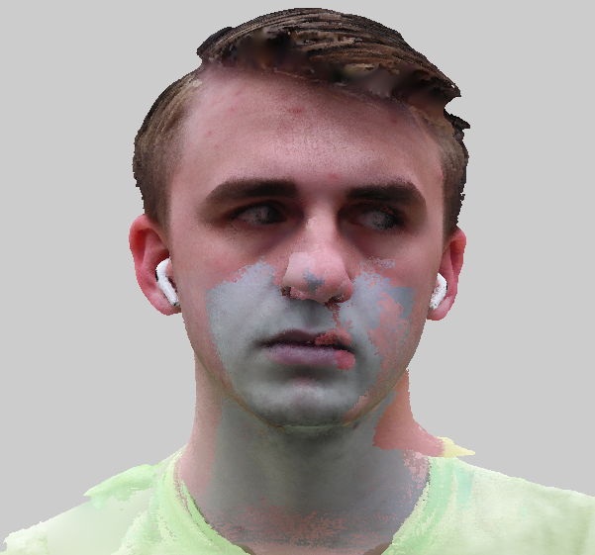

Figure 7. The First Face Subject with Revopoint POP 3D.

The second subject had an issue arise in which the chin was automatically matched to the cheek and not deleted before saving. As seen in Figure 8, the error appears to have created a secondary pair of lips, cheek, and chin on the subject’s face. This error made by the operating user rendered the scan irredeemable as the Revopoint cannot rollback after saving and closing a model. Handy Studio also cannot help as the limited editing tools cannot take away those imperfections. Clipping would remove most of the subject’s right side and leave some leftover noise on the left side and face. This is devastating as the scan had impressive features of scanning lighter brown hair and a dark black fuzzy coat to a level of accuracy not found in other subjects at this point.

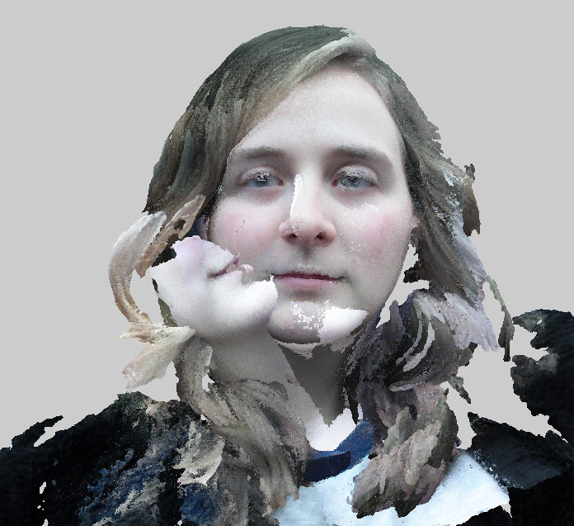

Figure 8. The Second Face Subject with Revopoint POP 3D.

Scanners have difficulties capturing dark details due to its nonreflective nature and merging issues. The third subject had significantly darker hair than the first two and dark rimmed glasses. The scan reflects this, as seen in Figure 9, as less of his hair was detected. Additional issues arose as the software merged the darker hair with the underside of his beard. However, as the scanner was moved different reflections came off the glasses rim and made it scannable. The same could not be said for his beard or hair.

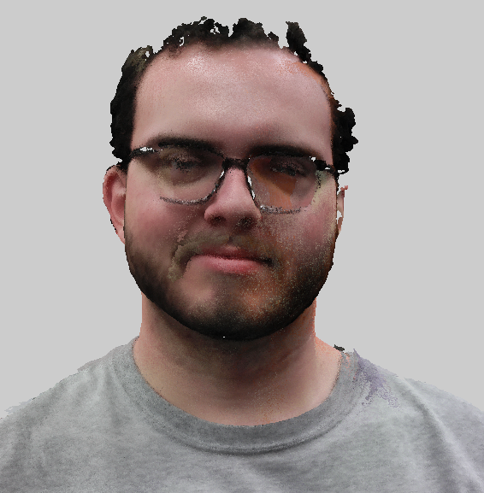

Figure 9. The Third Face Subject with Revopoint POP 3D.

The Matter and Form V2 scanner was not used to scan human faces but could as the laser is safe to the eyes. It would be nearly impossible to perform the scan due to the scanner’s rigid design; the subject would have to stick their head in the machine to scan. This process would prove convoluted in practice as many scans would be needed of multiple profiles and stitched together when other systems can operate for this specific purpose.
Photogrammetry could be used to test the modeling software’s ability to scan faces. The subject was instructed to sit in a chair while the photographer traveled around him. The model developed is lackluster as seen in Figure 10, even with several iterations of settings. The best model could only define the subject’s legs with his face being plastered on the wall behind him. It should be noted that the subject moved in between photos as evidenced by the pool of black where his sneakers were. 3DF Zephyr took half of the photos and was only able to produce the right side of the subject. Future tests of the software would be to repeat the process but instead have the subject stand against a wall and quickly take pictures at a closer radius.

Figure 10. The First Subject with photogrammetry.

The last set of samples analyzed for this paper is a series of statues located around Western Kentucky University’s campus: a rabbit statue, book statue, a running fountain, and the school’s mascot Big Red. These can be seen in Figures 11 with some notes being that the inscription on the fountain is only in appearance and is not physically engraved. The Matter and Form V2 could not be used to scan these samples again due to its design. While the Revopoint POP 3D scanner was marketed as useable indoors and out, in reality outdoor lighting conditions would severely interfere with the infrared sensor. Scanning of these statues were attempted in sunny, cloudy, shaded, rainy, and snowy conditions but no data could be collected with the mobile or desktop version of the software. Future attempts to test the Revopoint’s abilities outdoors could include scanning at night or by creating a dark environment by enveloping the sample in a dark box created with a hunting blind and black tablecloth.

a)
(a) Chauncey Too by Jim Budish in 2007.

b)
(b) “Books For Father” by Kevin Robb in 2008 outside of Gordon Wilson Hall.

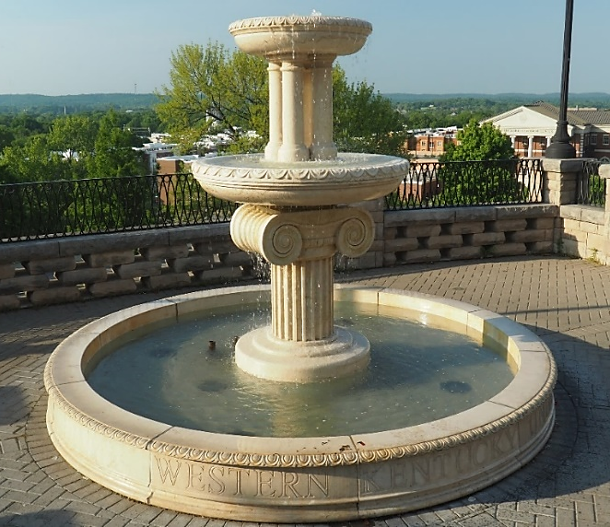
c)
(c) The Guthrie Fountain outside of Van Meter Hall.
d)
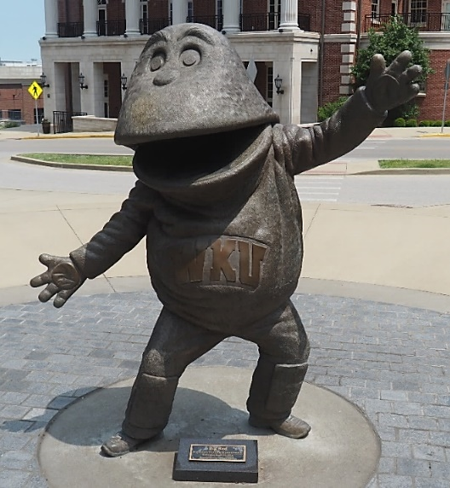
(d) The statue of Big Red sculpted by Russell Faxon in 1974.

Figure 11. The statues located around Western Kentucky University’s campus to be digitized.

Photogrammetry was able to handle all these statues with varying degrees of success. Figures will show the rabbit statue, book statue and the fountain while Figures 15-17 will focus on the different settings in 3DF Zephyr that facilitate differing Big Reds models. While the cornice trim and stone hand fragment were digitized using the “General” preset of settings, the outdoor setting and rejected photos from the data set led to the “Urban” preset. The first statue of the rabbit statue Chauncey Too resulted in a satisfactory model, capturing details in the scenery including the base with no distortion of the statue’s original shape. The model can be viewed in Figure 12 trimmed of the surrounding environment.

Figure 12. Chauncey Too model in 3DF Zephyr with Urban/Deep Presets.

The next statue, “Books For Father”, was taken on the same day as the previous statue in similar weather conditions. However, their locations differed as Chauncey Too was located in a dense section of trees that provided darker shading than the building shading “Books For Father”. With these facts noted, the digitized model shows a significant level of detail with some minor discrepancies in the crevice where the two book “pages” meet and at the statue’s base. Tessellation was present in the crevice of the pages resulting in a sphere while the rest of the statue appeared regularly. The base, as seen in the bottom right corner of Figure 13, has pits and jagged sections on all sides likely due to the polished appearance of the base as seen in Figure 11b. Additionally, the “pages” were smooth on the sculpture whereas the final mesh was stippled and bumpy.

Figure 13. “Books For Father” model in 3DF Zephyr with Urban/Deep Presets.

The Guthrie Fountain was photographed later in the afternoon and had several points of interest in the final model seen below in Figure 14. To begin, the top four smaller columns supporting the topmost dish are separated by gaps whereas the model has tessellated that area closed. This is due to a lack of data around each of the individual columns, which could be remedied by increasing the picture limit. The next point of interest is the water, one of the most difficult entities to digitize. It is present in the model but comes at the cost of engulfing some pipes and structures underneath it to nothingness. The deep pit at the bottom right side of the fountain may be a product of the sun’s glare in this area alone, resulting in erroneous data at this area alone. Aside from these issues, the texturing looks superb. The final 3D print of the fountain shows intricate details of the bottom column, ridges, and swirls. One detail that could not be recreated to much success was the lettering “Western Kentucky University”. As mentioned prior the letters do not recess into the material and is thus harder to digitize. It still makes a faint appearance in the final model.

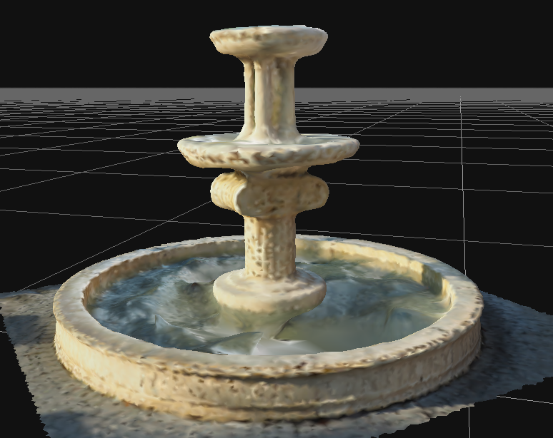

Figure 14. Guthrie Fountain model in 3DF Zephyr with Urban/Deep Presets.

A brief explanation of 3DF Zeyphr’s settings is in order to discuss the next three models. When creating a project, the settings are selected from a variety of options before any operations can commence. There are three kinds of settings categories for users: Presets, Advanced, and Custom (Custom was disregarded for this paper for clarity). In Presets, a user can select a category and the level of detail for that operation. Users can pick between preset categories of General, Ariel, Urban, Human body, Surface scan, and Vertical structures and then the presets of Fast, Default, and Deep for speeds. The user can choose these settings for camera orientation, dense point cloud collection, and surface reconstruction as seen below in Figures 15 and 16. Each category has certain advantages and disadvantages when compared depending on the subject matter of the photogrammetry. The Advanced options give a user more control of certain parameters in the digitizing process. As a trade, the more intense settings require more computing power and time. Figure 17 depicts the Big Red statue’s models using photogrammetry. Several different settings were used, resulting in drastically different processing times, from 5 minutes to over an hour.

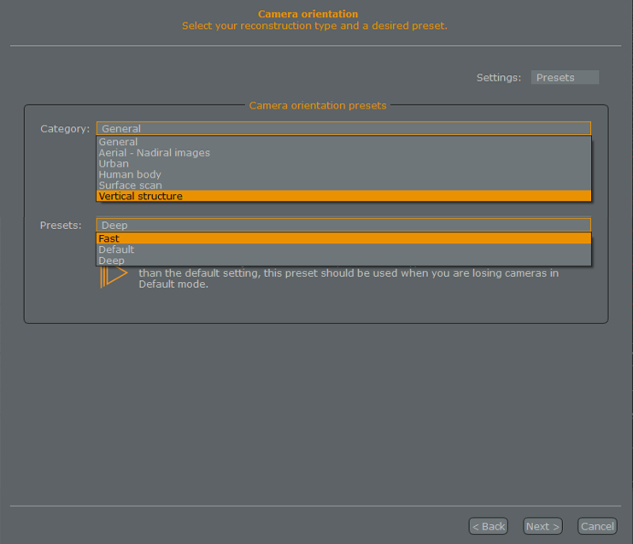

Figure 15. An example of Preset settings in 3DF Zephyr’s Project Wizard.

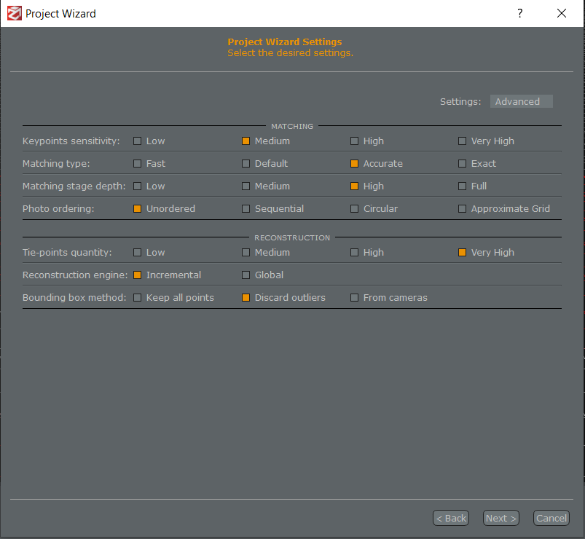

Figure 16. An example of Advanced settings in 3DF Zephyr’s Project Wizard.

a)
(a) Big Red model with General/Deep Presets.

b)
(b) Big Red model with Urban/Deep Presets.

c)
(b) Big Red model with Advanced Settings.

Figure 17. Big Red models made with different settings within 3DF Zephyr.

The first model of Big Red was run using General presets with Deep detail levels to capture as much detail as possible in a fast manner. The operation ran for five minutes in total and provided the results seen above in Figure 17a. Some tessellations and odd texturing can be seen in the right armpit, right hand, and mouth; otherwise, this model is excellent. The software did not accept the entirety of the provided data and may be a case for the issues listed above. The next model of Big Red was run using Urban presets with Deep detail levels to capture as much detail as possible. The operation ran for a total of thirty minutes, the results of which can be seen in Figure 17b. The model fixed some of the issues of Figure 17a such as decreasing the tessellation of the right hand, right armpit, and mouth. However, the model is significantly thinner than the original statue when turned to the side. No discernable reason can be given as the program accepted more of the photo set with the Urban preset than the General preset. Additionally, some tessellation can be seen on top of the head. The last model of Big Red was created using the Advanced settings by maxing out possible features such as key point sensitivity, matching type, and matching stage depth while leaving all other parameters at default. The resulting operation ran for a total of one hour and fifteen minutes. The results can be seen in Figure 17c.As can be seen, the program has created a giant chest cavity, an array of ghost faces, and an elongated mouth wrapped around its head. The top of the head appears to have extreme tessellation whereas the hands and fingers have been decreased to blobs. However, the backside of the Big Red model appears to be the best of the three. Additionally, the legs closely resemble the quality of the other two.

Conclusions

All these methods excel in different areas of 3D scanning and modeling: resolution, ease of scanning, model clean-up and processibility, or portability. For medium to larger sample scans taken indoors, the Revopoint POP 3D scanner excels as its feature recognition alignment saves ample time taking multiple scans as well as differing modes to scan different sample types. The Matter and Form V2 excels at scanning small objects. Its included software cleans the model faster than every other method. But, for most situations, indoors or out and small to large samples, photogrammetry is the most accessible method of modeling in comparison to the other tools mentioned in this paper. However, it relies heavily on focused, high-resolution pictures to create accurate models. With the issues arising in digitizing real objects, any of these systems are still advantageous to other labor-intensive methods with its low price point and barrier of entry. The downfalls of these methods are nothing more than the limited technology available to users. However, research should be conducted to find the optimal settings for each sample and how lighting conditions impact the final model. Lastly, expanding the reach of this research to include the Custom settings of 3DF Zephyr could provide additional insight as to how each mode compares. The addition of a new suite of tools from Revopoint holds promise as well as it may address the limitations of the editing tools discussed in this paper.

This technology advances with every passing quarter. For instance, Creality will soon release the CR-Lizard Scanner which could offer better, more affordable scanning to the community at large. Additionally, Epic Games and their acquired company Capturing Reality has announced plans to release the app RealityScan to the public which allows users to create high-fidelity 3D models that could be implemented with the Unreal Engine (Epic Games Introduces RealityScan App, Now in Limited Beta, 2022). The last major development during the writing of this paper has been the newly announced Nvidia 3D MoMa, an AI approach with inverse rendering that will allow for smooth implementation of user-generated models into graphic engines to change parameters such as material, light sources, and added physics (Salian, 2022).

Data Availability Statement

Data from this report including photographs, digitized models, and Cura G-codes will be made available upon request.

Declaration of Competing Interests

The authors declare that they have no known competing financial interests or personal relationships that could have appeared to influence the work reported in this paper.

Acknowledgements

This work funded in part by the James L. “Bud” Layne and his contributions to the Center for Project-based Learning at WKU. The author thanks many individuals who supported this study including Wade Decker, Chloe Henson, Austin Meredith, and Darren Tinker. Additional thanks to Professor Joel Lenoir who had the initial idea for this paper, gave encouragement to pursue such a task, and for the allowed digitization of multiple items found within his lab.

References

3DF Zephyr (6.506). (2022). 3DFLOW.
Braam, D. (2022). Ultimaker Cura (4.13.1). Ultimaker.
Epic Games Introduces RealityScan App, Now in Limited Beta. (2022, April 4). Epic Games, Inc.
Matter and Form. (2018). Matter and Form 3D Scanner V2 User Manual. https://matterandform.net/downloads/MFStudio_User-Manual_EN.pdf?2018-05-14.
Revopoint. (2021). POP 3D SCANNER User Manual. https://www.revopoint3d.com/wp-content/uploads/download/Revopoint%20POP%20User%20Manual_V2.2.0.pdf
Salian, I. (2022, June 21). AI in the Big Easy: NVIDIA Research Lets Content Creators Improvise With 3D Objects. NVIDIA. https://blogs.nvidia.com/blog/2022/06/21/inverse-rendering-3d-research-cvpr/.

Biography

NOAH BURCHETT is a senior mechanical engineering at Western Kentucky University as of the time of writing this paper. His research interests are in engineering modelling and simulations, data analysis, and curating topics and information for knowledge transfer at the undergraduate level. Noah PR Burchett can be reached either at noah.burchett19@aol.com or noah.burchett318@topper.wku.edu.

