**Review of Remote and Virtual/Augmented Reality Based Laboratory Platforms and Technologies**

**Faruk Yildiz, Sam Houston State University,** [**fxy001@shsu.edu**](mailto:fxy001@shsu.edu)**, 9362943774**

**Recayi “Reg” Pecen, Sam Houston State University,** [**regpecen@shsu.edu**](mailto:regpecen@shsu.edu)**, 9362944137**

**Ulan Dakeev, Sam Houston State University,** [**dakeev@shsu.edu**](mailto:dakeev@shsu.edu)**, 9362941201**

**Abstract**

Remote laboratory concept has been one of the important research items during the Covid-19 pandemic where most of the institutions moved their classes to online and/or remote modalities. The impacts of Covid-19 pandemics were unexpected and the preparation for the remote lab concepts were minimal where face-to-face laboratory experiments have been common among Science, Technology, Engineering, Math (STEM) programs. For those academic programs who were not prepared for remote and online laboratory delivery have struggled to find out ways on how to deliver traditional face-to-face laboratory experiments to their students remotely where major equipment was necessary to utilize. Recently, researchers and companies have been investigating and working on remote laboratory concepts and integration to the curriculum. The popularity of remote lab is increasing due to Covid-19 pandemic and the improved speed of internet but still doe does not have much attention and knowledge about this area. The objective to this paper is to find the best current resource available for remote learning lab for STEM majors. The goal is to find a program, company, or university resource exchange to find the best optimal sources for remote learning through virtual lab, via doing it through the computers and doing control systems via the laboratories.

**Introduction**

The improvement of the internet-based services and the speed opened new avenues to offer remote laboratory experiments with actual lab equipment and object of investigations. Traditionally, the laboratory experiments in STEM programs have been conducted in physical laboratory environments required student presence. In the remote lab concept, the physical laboratory equipment can be accessed via remote to conduct labs. Depends on the setup of remote lab environment, an interactive lab experiment offered to students where lab equipment (devices, instruments) can be accessed via web-based servers. The users can send control commands through web-based server to execute commands for their experiments and collect or visualize results without being near the actual lab equipment. Remote lab access still offers performing physical actions such us controlling with hands, pressing buttons, speaking to microphones, and turning knobs etc. With the integration of cameras and sensors, the users can receive feedback and visualize the activities for the lab experiments.

Remote labs offer a new way of implementing traditional lab experiments by allowing lab equipment and devices to be reached and utilized by students remotely through the Internet. The details including remote lab infrastructure, challenges to implement, existing options and feasibility for implementation, and advantageous/disadvantages the industry support will be covered in the paper presentation.

While researching this project, there are several scholarly articles that brought up the topic of remote learning. In this paper, the focus is on two major contributions for solving this issue on how to create an active learning environment remotely. One is a German university that used a software like *LabVIEW* to do the classes remotely online, they called it the *ELLI project* (Effective Lifelong Learning Inventory). The other work is a generic Human Machine Interface (HMI) project, which was completed in an Indonesian university focuses on an internet-based PLC software. There are current studies on Virtual reality (VR) technology, as well as cooperating with companies that will work with universities for students to do hands on learning experience at home. This study focuses on the PLC side of remote learning and applied to a hydraulic system to simulate the operation. They also used remote learning by virtual network computing (VNC) to have a communication base client with user and the server computer whenever they need to do lab work. Researchers at Southern Texas University have worked on how a remote laboratory was established and utilized [1-5].

Internet base learning environment has been the subject of several scholarly work as well as commercial products and services. For starters there is apparently a German collaborative program from three universities, which they are [2] *RWTH Aachen University*, *Ruhr-Universität Bochum* and *TU Dortmund University*. All located in the Federal State of North-Rhine Westphalia, and the program is called the ELLI project, “Excellent Teaching and Learning in Engineering Sciences.” What it does is supposed to enhance the learning environment from engineer students and better experience in remote lab. This technology is used in Labview and other robotic courses for students to take control of a lab work and remotely controlling the robot’s arm for example without the need to be face-to-face class.

Another study on how using a tool called NI ELVIS (Educational Laboratory Virtual Instrumentation Suite) is using Labview and Multisim for remote learning base. The system uses the Labview Remote base option by connecting to the internet and using WAN (Wide Area Network) to do lab remotely and connect to the machinery you need, best for control system engineer and electrical engineers [1].

Two recentarticles have raised the question on remote learning and its positive impact over traditional teaching practices and how we would adapt this remote technology easier for all institutions. Researchers studied how the technology would grow over time as people with families, jobs and other complications would affect the learning environment, and they showed that remote learning is becoming very convenient each year, specifically since the pandemic has started. Students in engineering majors have used NI LabVIEW and a generic PLC software to design and implement a remote digital tool called *weblab* using Unified Modeling Language (UML) for several engineering and technology-oriented curriculum [3-4].

A group of faculty members at Carnegie Mellon University have developed VR technology-based service to the public school system, called *xennial digital* that provided lessons and examples for students to work on remotely. This is a promising and inspirational idea to implement VR technology into engineering students to do assignments or lab work virtually in a fun way [9].

**Remote Lab Options**

One of the challenge universities have to overcome is the limited options faculty and students have to face when doing lab assignments. There are different remote options available for the universities to choose to help variety of engineering majors to overcome a barrier when conducting experiments without having face to face opportunities. A number of articles were published from 2008 to 2021 in the field of remote education using VR and AR technologies. The pandemic provided a lot of opportunities to fund these projects in many developed countries. Take home equipment, VR technology, internet simulation is just some of the ideas that have been applied to useful work for remote education. This paper will report the difference between multiple remote technologies to fit better for the needs of different learners.

Using a remote access software called *WebLab*, which was designed and implemented an easier way to expand the hardware and software for new lab experiments, provided students 24/7 access to learn at their own pace [3]. Compared with traditional National Instrument (NI)’s LabVIEW and myDAQ which require equipment in the labs, the *WebLab* has provided opportunities to emulate variety of engineering experiments without sharing or physically using equipment. However, lack of physical problem solving, and hands-on experience related with the instruments and equipment may still be a challenging problem to solve. Figure 1 depicts a *WebLab*-based functional block diagram that describes the layout of how students conduct an experiment to control water flow in tanks using a UML node.

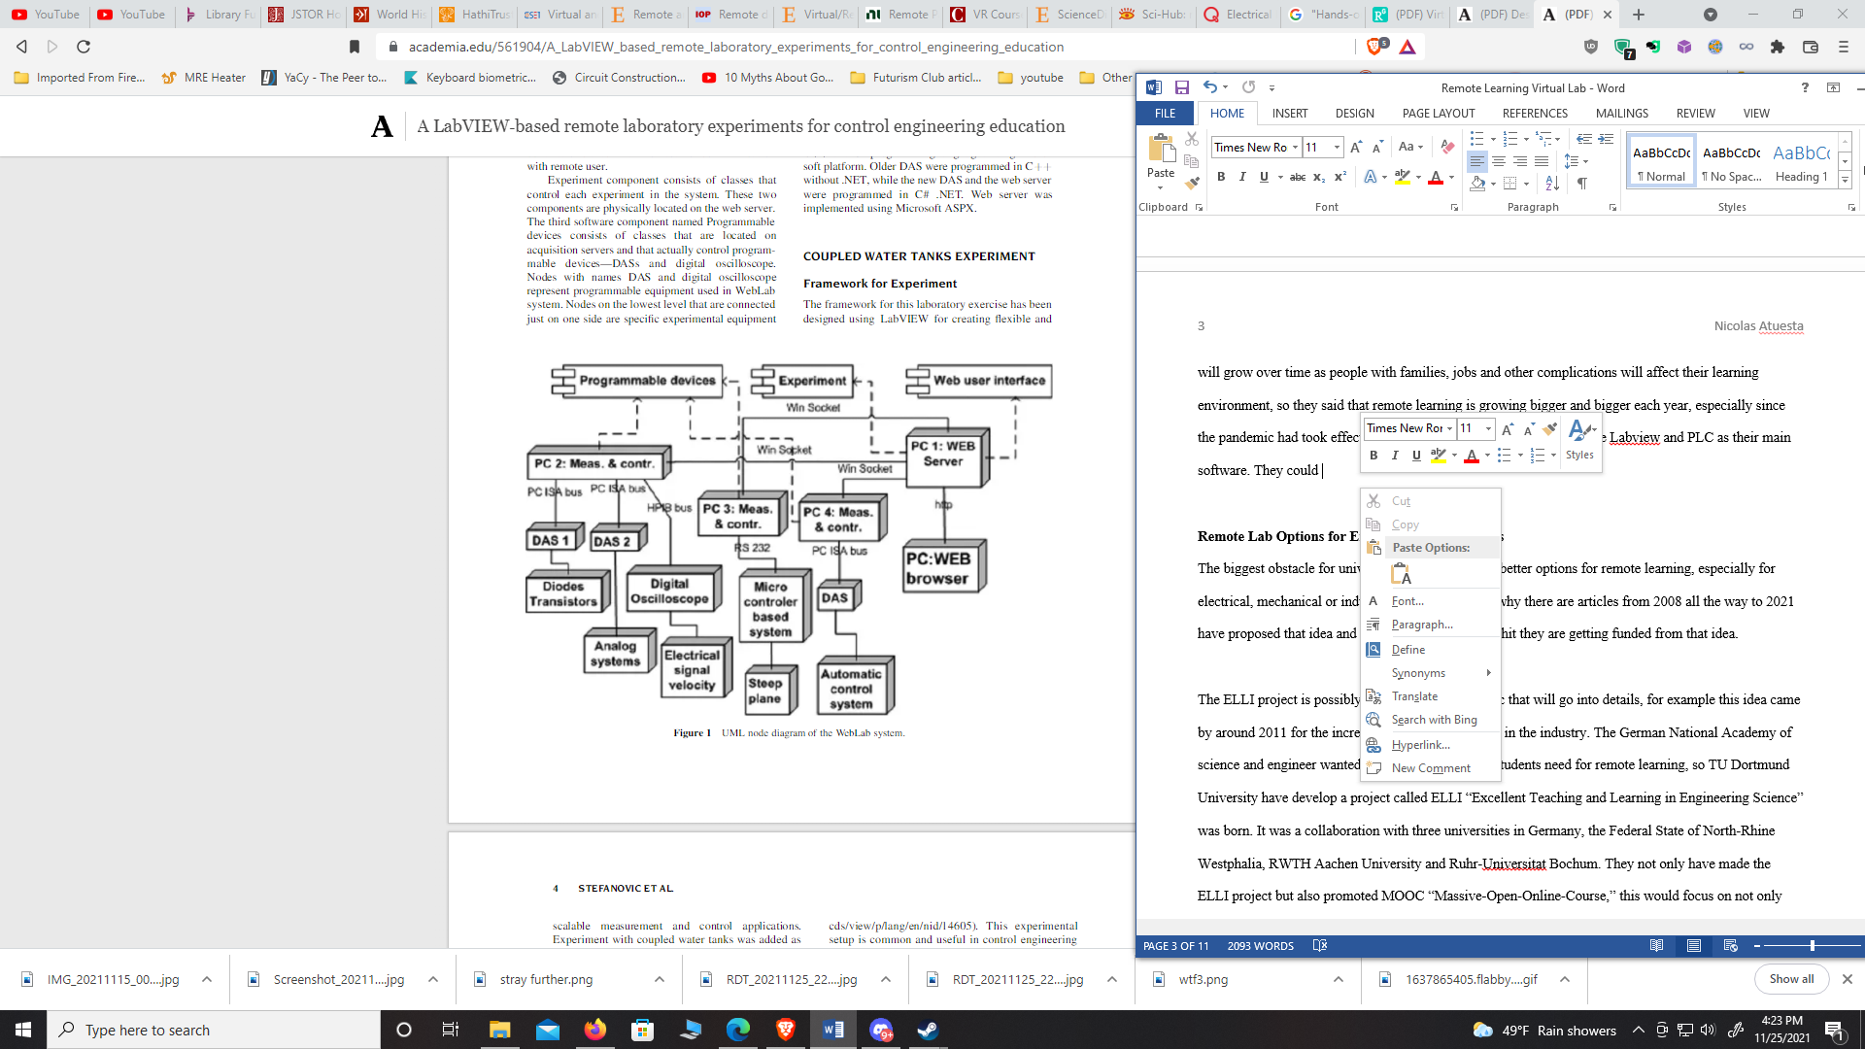

Figure 1. UML node diagram of a WebLab system to control water flow in tanks [3]

*ELLI* project is another remote learning platform developed at TU Dortmund University in Germany in 2011. ELLI is an acronym of “Excellent Teaching and Learning in Engineering Science” translated from German. A German National Academy of Science member engineer developed the *ELLI* project that supports students need for remote learning. This work included a collaboration with four universities in Germany, the Federal State of North-Rhine Westphalia, RWTH Aachen University, Ruhr-Universität Bochum, and the TU Dortmund University. The outcome of the *ELLI* project was establishment of well-designed platform, Massive Open Online Course (MOOC) for remote students worldwide. This work enhanced student success particularly during the pandemic providing students an easy access to engineering laboratories at any time of the day from their home computers as seen in Figures 2-3 [9-10]. 

Figure 2. Remote Laboratory at IUL: Lab Client (left) and testing cell (right) [9-10]

The industrial robot shown in Figures 2-3 robot is equipped with multiple cameras where and students who connected to the lab platform may easily observe all corners of the engineering lab precisely in real-time.

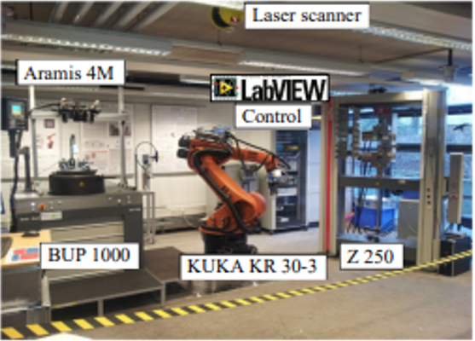

Figure 3. Tele-operative testing cell for material characterization [2]

Students can adjust the robot, modify the parameters or the specimen test that they are working on and download the test data to their own personal computers at remote location. This specific remote lab was first designed for mechanical engineering students, then further developed for electrical engineering students with feedback control system fundamentals. Students may use Graphical User Interface (GUI) to test the four corner regions including the parameter settings, experimentation actions, real time data processing, and experiment video stream in real-time. This work has resulted in a state-of-the-art simulation with almost all the advantages of face-to-face education that brought students to the laboratory environment virtually. Mechanical engineering students studied how to design a security component for a vehicle using Finite Element Method (FEM) to simulate a generic production process for manufacturing industry [9].

The remote technology can also be used in NI LabVIEW by using a PXI-system connecting in an NI platform to control all machines and peripheral equipment. Figure 4 shows functional block diagram of a safety system containing a PLC controlled camera system, emergency stop, and analog/digital measurement modules to complete the remote experiment successfully.

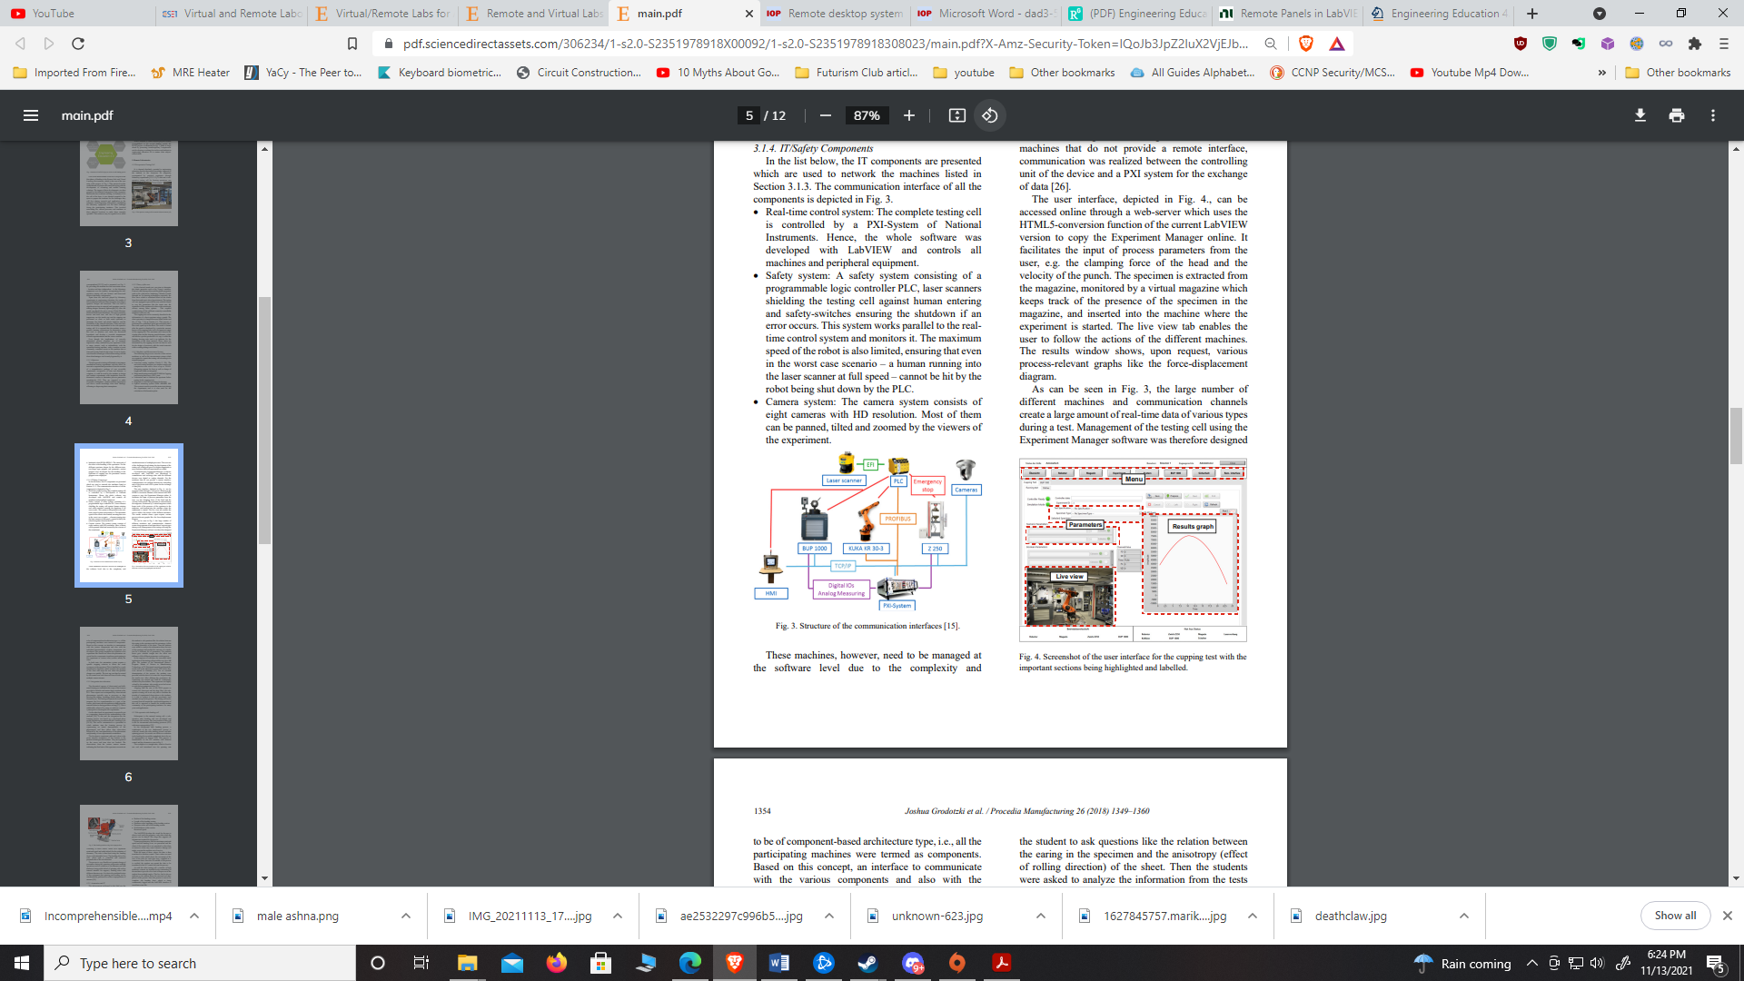

Figure 4. Structure of the communication interfaces [2]

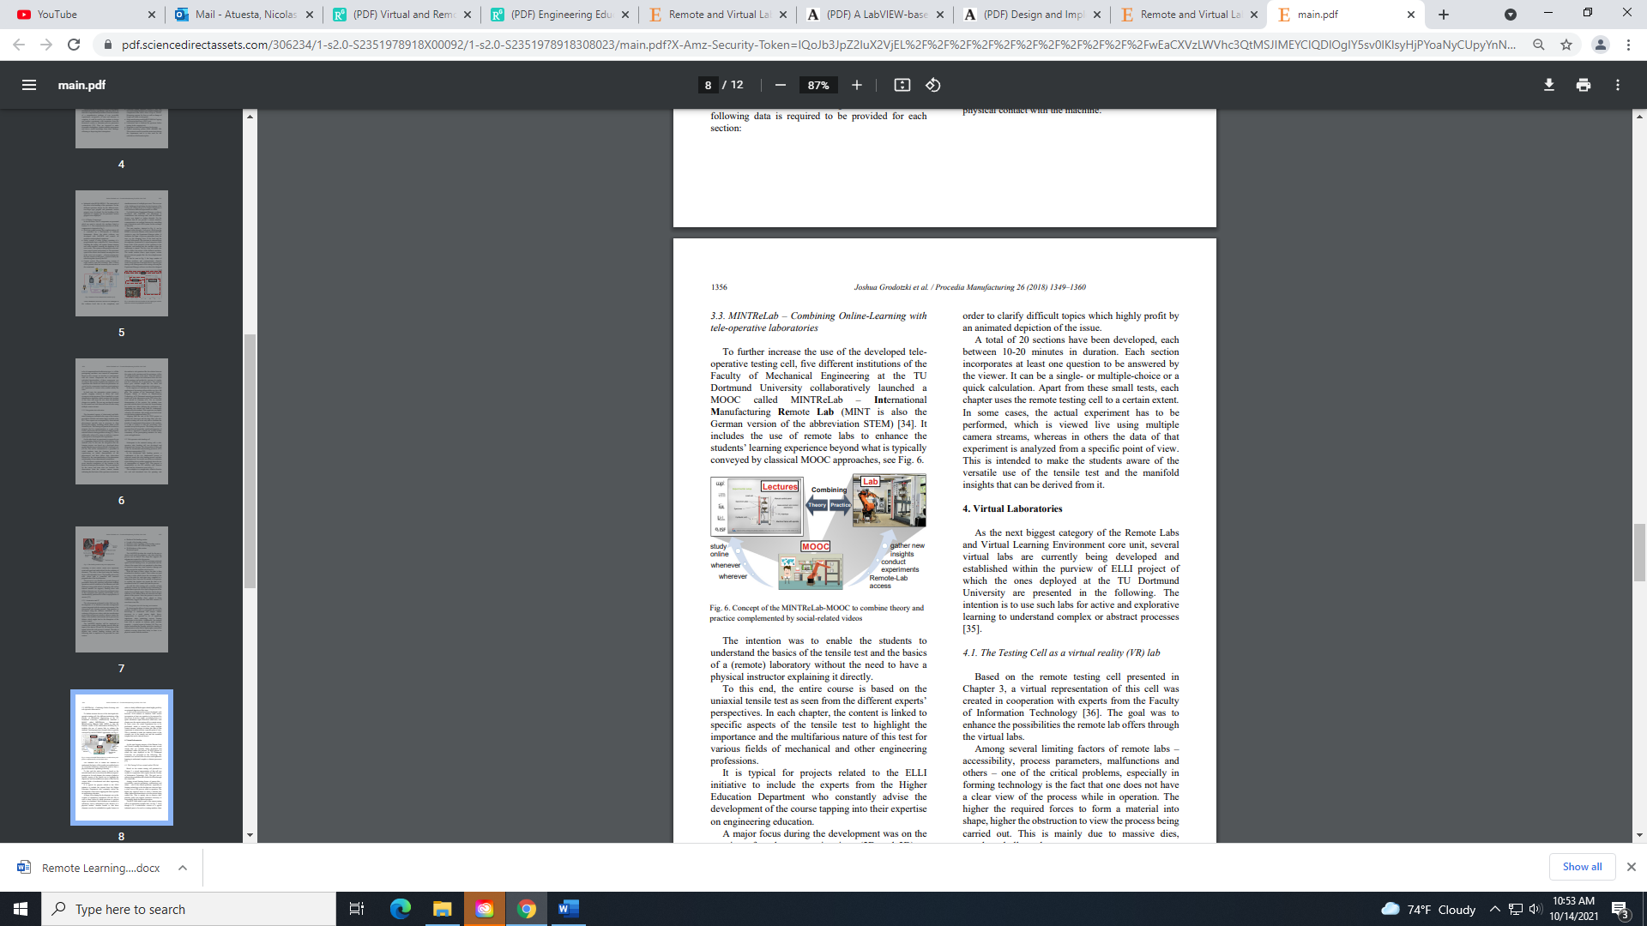The outcomes of both the *WebLab* and *ELLI* projects were very successful as they merged theory in lectures and the practical skills in the laboratory environment using remote lab concept and free resources provided by the MOOC. Unfortunately, both the *WebLab* and the *ELLI* projects have been utilized only in the collaborated institutions as well as designated German universities and the platform was not able to be applied to worldwide yet. However, these remote learning tools are simplified and learning impacts of the theory and the practice are provided freely with demonstration purposes with the name of MINT ReLab-MOOC as seen in Figure 5.

Figure 5. Concept of the MINT ReLab-MOOC to combine theory and practice complemented by simplified videos [2]

Figure 6 depicts a sample screenshot of the user interface for a cupping test with the laboratory project steps and major accomplishments are highlighted and labeled.

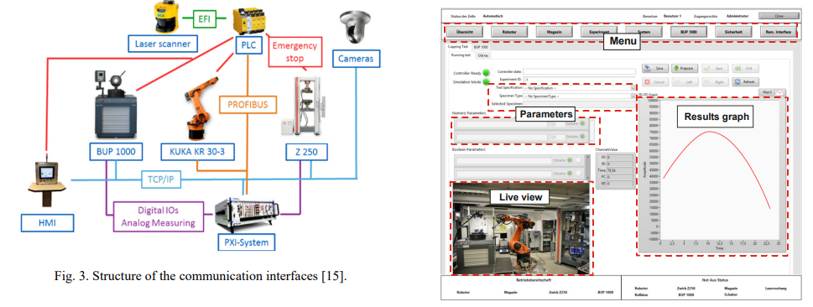Figure 6. Screenshot of the user interface for a cupping test with the laboratory project steps are highlighted and labelled [2]

Researchers at the University of Pendidikan inIndonesia introduced remote learning concepts for mechanical engineering students, specifically for those who study in hydraulics. They simply designed a Human Machine Intreface (HMI) platform and Internet of Things (IoT) for virtual laboratory-based experiments to eliminate Pandemic-related problems, challenges on student crowd in face-to-face education, and lastly reducing the cost for a major Hydraulics design laboratory [6].

The method was based on design of an actuator that can move on a PLC trainer using a conveyor and capacitive proximity sensor to provide students ability to precisely control on the HMI through the server computer. They used the local server publication to access the Internet by receiving the public IP address. A webcam camera connects a PLC module onto an Ethernet port to enable a basic remote learning as seen in Figure 7 [6].

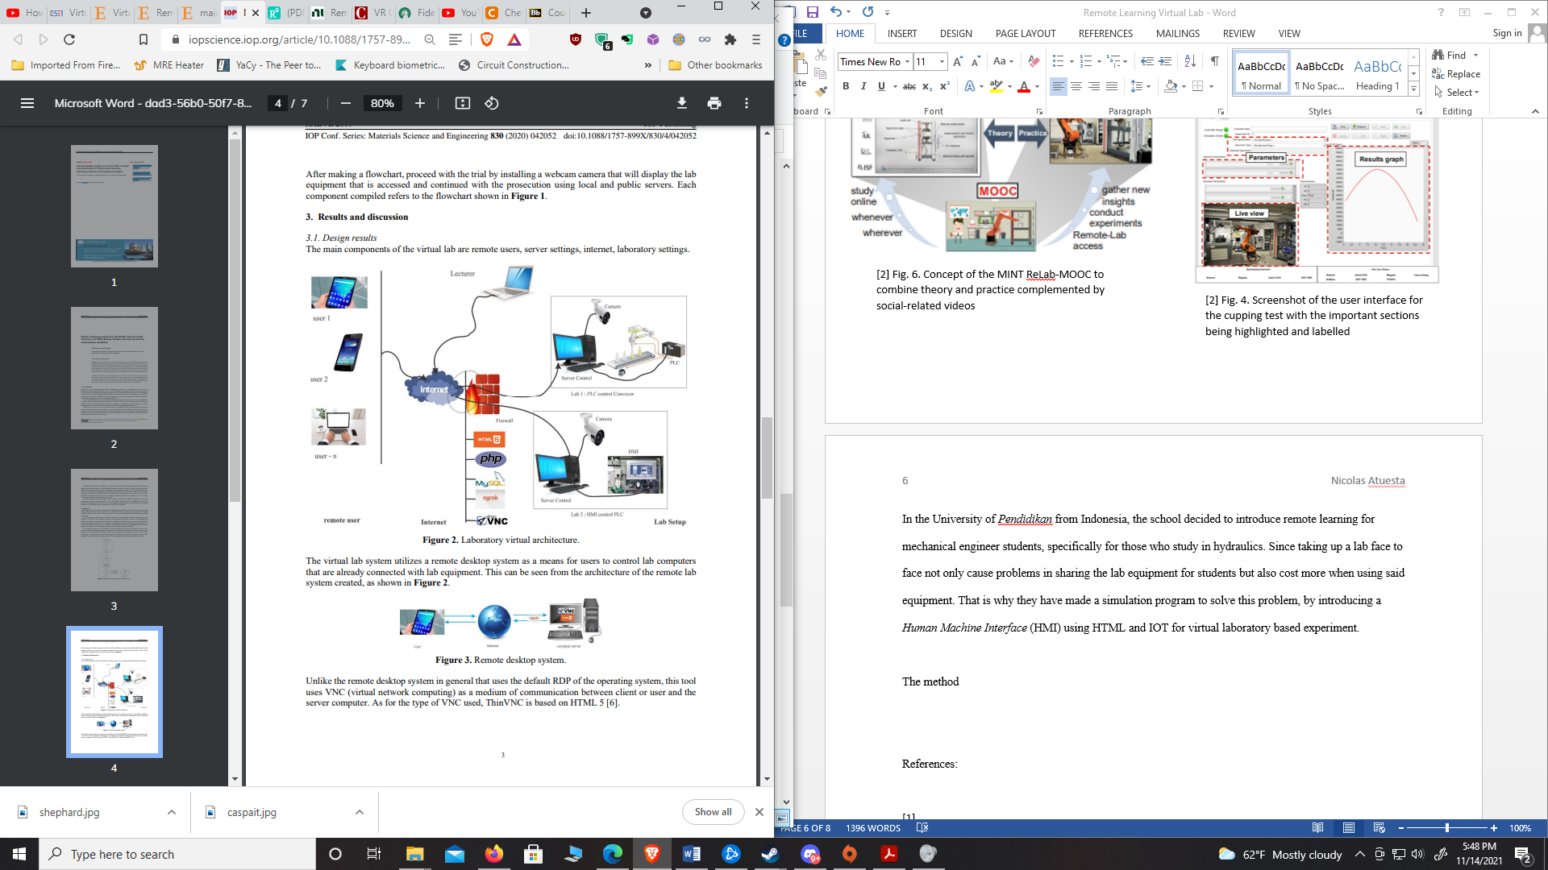Figure 7. Laboratory virtual architecture [6]

Due to the increased demand on remote learning concepts, this initial project produced very positive impacts in the academia. The results for the remote learning were essentially using the *ThinVNC* as a tool for web remote access client for easy-to-use communication with any browser plugin [6]. After installing the *ThinVNC* in personal laptop or computer that acts as a server, then students use a web browser to connect to the designated remote lab workshop and complete their work there. Students can also write a simple a PLC program as an interface to display their data and work their projects remotely. Students can design their HMI using a PLC programming and after they finish making the program, they would transfer to the Cx-Designer or Sysmac Studio app to display their simulation experiment. Once that is done, a GUI would pop up for the students to interact and initiate the experiment they are working. The student outcomes of the experiment in the virtual laboratory using HITML-5 and IoT were a success in that trial experiments for the students. Students reported no issue using the software and they have conducted their experiment with ease. The ultimate goal is to have an easier access through Remote Desktop System to conduct experiments at the comfort of their homes or anywhere in that matter.

**Virtual Reality Technology Option**

Remote learning doesn’t have to be restricted to online access or Zoom style teaching, it can also be something fun and entertaining such as VR technology. Since the pandemic hit more and more schools are consider different ideas and one idea that Professor Caspar from Carnegie Mellon University have decided to be experimenting on VR technology. By using the available resources VR is offering they can make virtual rooms and port their lecture in a virtual classroom setting to teach the class, one sophomore student named Nancy Zuo [10] majoring in cognitive science and a minor in human-computer interaction, had a VR headset and was interacting with other classmates in this experimental classroom setting.

There is already an increase of demand for VR learning, schools from across the nation have started to experiment VR remote learning such as a company called *xennial diaital* [11] is offering schools through K-12 to use their VR technology for learning math and science subjects. If universities that focus on engineering major students, there could be a very good demand on robotics and engineer professors that wanted to implement this technology to teach students to work on robotics or designing circuits via VR. *Sam Houston State University* already have a VR club and a building to host VR rooms, they could potentially have the funding to expand VR program to supply more VR sets for students and start remote learning or if students already have VR, then is better for both the students and the school. In fact during the interview, I had with Dr. Xuemin Chen from the Texas Southern University he published a paper that includes VR technology using a software called “Virtual Reality Modeling Language” (VRML) and Java 3D to simulate virtual lab experiments [12]. The purpose of it from his paper was to show how students can be encouraged to fail from their mistakes without causing any real harm to the equipment and to themselves, meaning they can conduct the experiment as many times as possible without worry about the consequences.

Lastly there is *Quanser* a company that focus on research and working with universities to provide lab works for students in focus on education. The universities can partner up this company to provide lab tools for students and they can use that lab equipment to work at home rather than in the lab.

**Conclusion**

This is all there is in remote learning options, the ELLI project and HMI is already implemented in their home countries but not world-wide. However, VR technology and hands on learning is available worldwide. The ELLI project has been very successful in their remote learning project in Germany schools, and they are open for the idea to share it in the EU. It might be possible if the states reach out to them and see what similar deal they could work on in that technology. Same with the Indonesian schools, they have been fine tuning their experiment and could be successful there and possibly over to the states as a collaborate effort for technology growth. The whole goal for every university worldwide is to enrich learning for all students for the best possible outcome in their curriculum and see what works and what doesn’t. There is an untapped market for remote learning, VR technology is showing that it is improving the technology more each year. The internet has vastly improved broadband speed doing remote learning, and the cost keeps going down due to those innovation improvements.

**References**

[1] Virtual and Remote Laboratory Development: A Review, Xuemin Chen & yongpeng Zhang. (March 2010). Texas Southern University <https://www.researchgate.net/publication/228988059_Virtual_and_Remote_Laboratory_Development_A_Review>

[2] Sciencedirect ELLI project Jushua Grodotzki, Tobias R. Ortelt, A. Erman Tekkaya. (3 August 2018.) TU Dortmund University, Institute of Forming Technology and Lightweight Components Dortmund, Germany. <https://www.sciencedirect.com/science/article/pii/S2351978918308023>

[3] A LabView-Based Remote Laboratory Experiments for Control Engineering Education

Miladin Z Stefanovic & Milan Matijevic. (February 2009). University of Kragujevac <https://www.academia.edu/561904/A_LabVIEW_based_remote_laboratory_experiments_for_control_engineering_education>

[4] *Design and Implementation of Web based Remote Laboratory for Engineering Education*

Prashant Kumar Tripathi, Jidhu Moham M, &KV Gangadharan. (February 2012). Department of Mechanical Engineering, National Institute of Technology Karnataka, Surathkal Mangalore, India. <https://www.academia.edu/3676034/Design_and_Implementation_of_Web_based_Remote_Laboratory_for_Engineering_Education>

[5] TSU Dr. Xuemin Chen Mission and Goals Page

<https://coset.tsu.edu/vrlab/>

[6] *Remote desktop system in IoT and HTML 5-based virtual laboratory for HMI (Human Machine Interface) practicum and hydraulic simulation* N.D Jayanto & J Kustija. (2020). IOP conference.

<https://iopscience.iop.org/article/10.1088/1757-899X/830/4/042052/meta>

[7] <https://www.elli-online.net/startseite.html>

[8] *Engineering Education 4.0*

Springer, Cham. (2016). Federal Ministry of Education and Research. Engineering 4.0 Excellent Teaching and Learning in Engineering Sciences.

[9] VR course Brings Remote Learners Closer Together Michael Henninger (October 23, 2020). Carnegie Mellon University. https://www.cmu.edu/news/stories/archives/2020/october/remote-learning-in-virtual-reality.html

[10]Xennial digital

<https://www.xennialdigital.com/xd-learning/#upcoming>

[11] Quanser, <https://www.quanser.com/>

[12] M. Fiorentino, G. Monno, A. Uva, Interactive “touch and see” FEM Simulation using Augmented Reality, International Journal of Engineering Education, 2009, 25, pp. 1124–1128.