Variation of Surface Hardness in 3-D Printed Jewelry; an Undergraduate Research Project
Hani Saad PhD
Professor, Department of Mechanical Engineering and Technology
Eastern Washington University
Email: hsaad@ewu.edu

Awlad Hossain PhD
Professor, Department of Mechanical Engineering and Technology
Eastern Washington University
Email: nhossain@ewu.edu

Maher Sarkis M.S.
Manufacturing Automation and Digital Transforming
Mahersarkis@hotmail.com

Elizabeth Jones
Undergraduate Student, Department of Mechanical Engineering and Technology
Eastern Washington University
Email: elizabeth.mclean2319@gmail.com

Abstract

This paper analyzed the variation in hardness of 3-D printed precious metals samples. The research was carried out by an undergraduate mechanical engineering student in her senior year. The hardness of different samples of 3-D printed jewelry pieces was measured at different locations. The exact composition of these samples was unknown as these were provided by a company that wished to keep it secret. However, they were created using DMLS (direct metal laser sintering) with atomized powder metal. The main objective was to determine if the hardness changes with location, this might be the case given the nature of the DMLS process. Many factors might affect the hardness, one of which is the cooling rate of the specimen. The samples had random geometric shapes, which can result in uneven cooling. The results obtained were analyzed to determine how much of a variance exist in the surface hardness. This information can eventually be used to ameliorate the process and obtain more uniform specimens.

Background

Hardness is mechanical property that represents the abrasion resistance. It is an alternative of a tensile test. Hence, hardness is also an indication of tensile strength of any sample. In other words, if we know hardness, then we can calculate the strength. A hardness test is represented in Figure 1. An indentor of specific shape and size is pressed against the material to be tested. From the amount of pressure applied and the geometry of the resulting indentation, hardness can be determined.

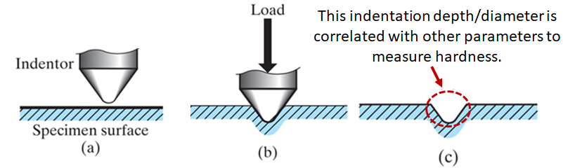
Figure 1. Standard methodologies or steps in hardness measurements. Photo credit: Pearson Publications.
There are many ways to measure hardness. For example, engineers can use Brinell or Rockwell method to measure hardness in macro-scale. In Brinell scale, we use a round steel ball with diameter of 10 mm as an indenter, where the applied load can vary from 3000 kg to 5000 kg. In Rockwell B scale, we can use a steel ball with diameter of 1/16 in as an indentor, where the applied load can be 100 kg. Figure 2 show a hardness tester similar to the one used in this experiment.

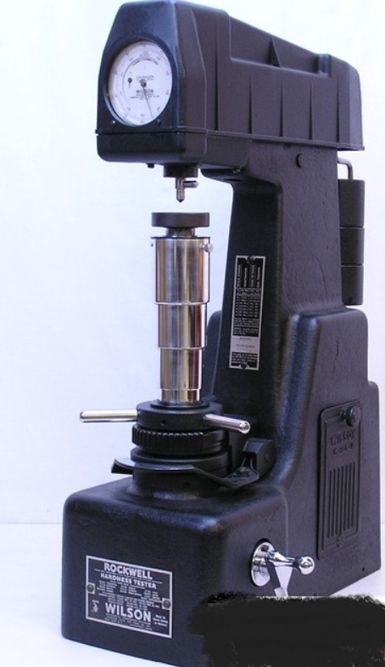
Figure 2. Wilson Rockwell Hardness Tester. Photo Credit: Brystar Metrology Tools (https://www.brystartools.com/)
Additive manufacturing is a process where by an object is created layer by layer by depositing or melting material using a three dimensional printer. The name 3-D printing is synonymous with additive manufacturing. Parts and/or molds can be created using this process, enabling both direct and indirect manufacturing. In the former case, the product is strong enough to be the actual piece, when this is not the case, the final product can still be used as a proof of concept or a prototype. In the case of indirect manufacturing, the 3-D printer is used to create a mold which is subsequently used to produce or cast the actual piece. However due to the nature of the process, and parameters such as cooling rate (Sachs et el., 2000) issues with homogeneity of the physical properties become an issue (KLA Instruments, 2022).

Direct Metal Laser Sintering (DMLS) is an additive manufacturing process that builds the desired products from a CAD file by selectively fusing material powder into thin layers (Xometry). In DMLS, layer-by-layer printing allows multiple parts to be combined during the printing process. With traditional manufacturing processes, the final products are machined or casted into several parts and then assembled. On the other hand, 3D Printing simply represents an “all-in-one” assembly that strengthens the finished product while reducing the weight and cost of production significantly.

Parts built with 3-D printing have found uses in the medical field (POM Group, Inc.), dentistry (Javaid and Haleem, 2019), aerospace industry (A.R. Thryft and J.L. LaGoy), military applications and has used different metals including precious ones for making jewelry (Nosheen et al., 2021, Cooper F., 2016, Yap and Yeong, 2014)

Working with precious metals can be challenging for more than one reason. The most obvious one is cost. This makes manufacturing very expensive and parts become difficult to obtain. In addition to this, technical issues resulting partly from the high thermal conductivities of metals such as gold and silver. Platinum is another metal than is used as well. It is very difficult to cast, but some companies were able to produce a density of 99.9% compared to 99.2% for a cast platinum (AMFG, 2018).

Three samples of DMLS 3-D printed jewelry samples were obtained, although their specific compositions and printing parameters were not provided. We were able to secure them through a fellow researcher, working on the feasibility of using additive manufacturing for creating jewelry pieces. This was part of his masters’ degree at ESCP (Ecole Superieure de Commerce de Paris), London. The exact sample compositions, and printing parameters were considered trade secrets and were not divulged. We do know that the parts were created using DMLS (direct metal laser sintering) by Cooksongold. The objective of this study was to analyze the variation of hardness values at different locations on both sides of the specimens. Given the nature of the process a variation in these values is expected.

Procedure

The procedure to measure the hardness is fairly straightforward. The student was trained on the proper use of the hardness tester. We used an analog Wilson Rockwell Hardness Tester that has been certified. Samples with known hardness were used as a test run or validation.
Measurements of hardness are done as follows (refer to Figure 3):
- Before starting the test, turn the crank handle of the depressor bar (A in figure 3) forward (CCW) ( the weights in the back of the device will lift ( B in Figure 3)).
- Set up the proper penetrator based on the hardness scale that has been used, refer to the settings on the tester ( C in Figure 3)
- Place specimen on the anvil (D in Figure 3), under the indentor.
- Elevate specimen using F in Figure 3, until the small pointer of the indicating gauge is nearly vertical and slightly to the right of the zero dot mark (E in Figure 3); then slightly more so the large pointer points vertically upward.
- Turn the zero adjuster gauge until the “Set” arrow on dial is exactly under the gauge pointer.
- Push down on depressor bar (A in Figure 3) to apply major load. The gauge pointer will move and eventually stop.
- Pull crank handle forward of the depressor bar (this will lift some of the load)
- Read the Rockwell Hardness Number based on the scale that has been used (B in Figure 3).
Hardness was measured at several points, trying to follow a grid whenever possible. Some of the samples had a triangular or random shapes and an effort was made to select points on the wider as well as the thinner parts of the sample. Hardness was measured on both sides of all samples having a constant thickness.
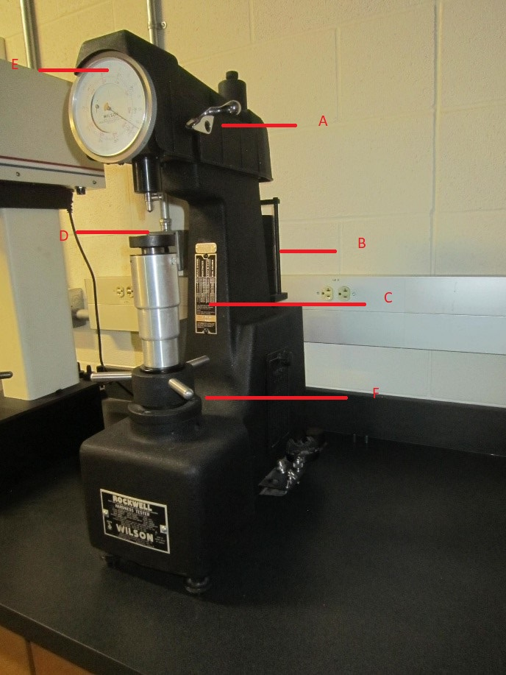

Figure 3. Hardness Tester Setup

Results

The results obtained and their respective statistical values are shown in the tables below. For example, Table 1 shows the hardness values in Rockwell B Scale of a sample with known hardness of 65 HRB (Hardness in Rockwell B Scale).

Table 1. Test run to validate Hardness Tester.

Sample with Known Hardness | Measured Values (HRB) |  |  |  | Average
66 HRB | 63 | 65 | 64.5 | 64 | 65.24
 | 65 | 65 | 65 | 66
 | 63.5 | 66 | 66 | 64.5
 | 65 | 64 | 65.5 | 66
 | Standard Deviation |  |  |  | 0.90

Figure 4 shows the Sample # 1 at both sides (Side A and Side B). The measurement points, where the hardness were measured, are shown in ink dot. Table # 2 and 3 are showing the hardness values of Sample # 1 at Side A and Side B, respectively. Table # 4 shows the average hardness calculation.
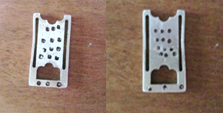

Figure 4. Sample # 1, showing both sides. Measurement points are shown with an ink dot.

Table 2. Hardness values of Sample # 1, Side A.

Sample # 1 | Hardness Values (HRB) |  |  |  | Average
 | Column # 1 | Column # 2 | Column # 3
Side A | 36.5 | 34 | 36 | 36.37
 | 34 | 34 | 33
 | 36.5 | 36.5 | 36
 | 38 | 40 | 42
 | Standard Deviation |  |  | 2.52

Table 3. Hardness values of Sample # 1, Side B.

Sample # 1 | Hardness Values (HRB) |  |  |  | Average
 | Column # 1 | Column # 2 | Column # 3
Side A | 31 | 30 | 29 | 29.95
 | 29 | 29.5 | 30
 | 29.5 | 27 | 29
 | 34 | 31.5 | 30
 | Standard Deviation |  |  | 1.69

Table 4. Average hardness values of Sample # 1, Side A and Side B.

 | Sample # 1, Average Hardness Calculation
Sample # 1 | Avg. Side A | 36.37 | Std. Dev, Side A | 2.62
 | Avg. Side B | 29.95 | Std. Dev, Side B | 1.69
 | Net Average | 29.55 | Net Std Dev | 2.16

Figure 5 shows the Sample # 2 at both sides (Side A and Side B). The measurement points, where the hardness were measured, are shown in ink dot. Table # 5 and Table # 6 are showing the hardness values of Sample # 2 at Side A and Side B, respectively. Table # 7 shows the average hardness calculation.
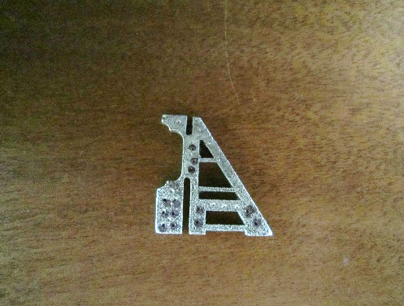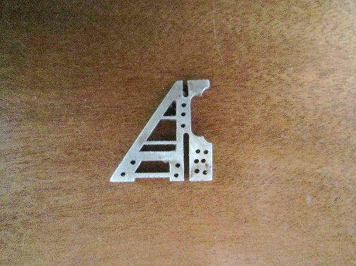

Figure 5. Sample # 2, showing both sides. Measurement points are shown with an ink dot.

Table 5. Hardness values of Sample # 2, Side A.

Sample # 2 | Hardness Values (HRB) |  |  |  | Average
 | Column # 1 | Column # 2 | Column # 3
Side A | 14 | 23.5 | 35 | 29.5
 | 23 | 21.5 | 36
 | 34 | 37
 | 28 | 43
 | Standard Deviation |  |  | 8.46

Table 6. Hardness values of Sample # 2, Side B.

Sample # 2 | Hardness Values (HRB) |  |  |  | Average
 | Column # 1 | Column # 2 | Column # 3
Side A | 44 | 25.5 |  | 31.64
 | 31 | 28.5 | 33
 |  | 32.5
 |  | 27
 | Standard Deviation |  |  | 5.66

Table 7. Average hardness values of Sample # 2, Side A and Side B.

 | Sample # 1, Average Hardness Calculation
Sample # 2 | Avg. Side A | 29.5 | Std. Dev, Side A | 8.64
 | Avg. Side B | 31.64 | Std. Dev, Side B | 5.66
 | Net Average | 30.57 | Net Std. Dev | 7.15

Figure 6 shows the Sample # 3 at both sides (Side A and Side B). The measurement points, where the hardness were measured, are shown in ink dot. Table # 8 and Table # 9 are showing the hardness values of Sample # 3 at Side A and Side B, respectively. Table # 10 shows the average hardness calculation.
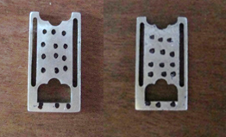

Figure 6. Sample # 3, showing both sides. Measurement points are shown with an ink dot.

Table 8. Hardness values of Sample # 3, Side A.

Sample # 2 | Hardness Values (HRB) |  |  |  | Average
 | Column # 1 | Column # 2 | Column # 3
Side A | 32 | 29.5 | 24 | 34.47
 | 37 | 30 | 45
 | 39 | 33 | 29
 | 36.5 | 39 | 32
 | 40 | 39 | 32
 | Standard Deviation |  |  | 5.42

Table 9. Hardness values of Sample # 3, Side B.

Sample # 2 | Hardness Values (HRB) |  |  |  | Average
 | Column # 1 | Column # 2 | Column # 3
Side A | 28 | 23 | 28 | 30.73
 | 34 | 28 | 30
 | 28 | 30.5 | 31
 | 28 | 34 | 36
 | 32 | 34 | 36.5
 | Standard Deviation |  |  | 3.34

Table 10. Average hardness values of Sample # 3, Side A and Side B.

 | Sample # 1, Average Hardness Calculation
Sample # 2 | Avg. Side A | 34.47 | Std. Dev, Side A | 5.42
 | Avg. Side B | 30.73 | Std. Dev, Side B | 3.34
 | Net Average | 32.60 | Net Std. Dev | 4.38

Discussion

It is clear from the data obtained that there is a wide variation in the hardness values obtained in all three samples. This variation is between the two faces of the sample, as well as within each side. For better visualization, we demonstrated the hardness values of three samples graphically in Figures # 7 to 9.

Values as high as 152% and as low as 47% of the average was observed in one case on “Side A” of Sample # 2. This variation is reflected in the higher values of the standard deviation obtained. When looking at the distribution of the values, data from Samples # 1 and # 3 show that points closer to the center of the piece tend to have more consistent values. The data is shown in the tables to reflect the pattern on each piece. The reader can match the values to the appropriate locations. Note that the surface finishes of some of the samples have been altered in subsequent research, but the hardness measurements were all done prior to any alteration to surface finish.

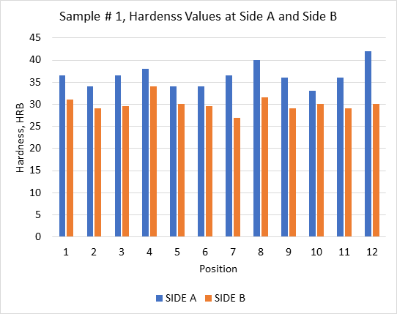

Figure 7. Graphical presentation of hardness values of Sample # 1.

It is important to note that for all samples, data suggest that one side is softer than the other. For all three samples, almost all locations on one side have a higher value compared to their mirror image on the other side. This leads us to believe that there might be a change in the hardness as the piece is built, the samples considered where relatively thin, and it would be interesting if thicker samples were also analyzed. Sample # 2 shows a much more of a variation in these values, but still shows a difference in the averages of both sides.

On thinner parts, extreme values where observed. In case of Samples # 1 and # 3, higher values were observed on the thinner part of the piece, while lower ones were observed towards the center. Samples # 1 and # 3 have identical geometries, but different compositions. The difference between the standard deviations of the data could be due to the heat dissipation of the different alloys used in those samples. Their rectangular shape is more uniform and less detailed than Sample # 2, which has very thin parts and a triangular shape. The highest standard deviation was observed for Sample # 2, on both sides. Sample # 3 had the second highest, also on both sides and Sample # 1 had the lowest. It is interesting to note that Sample # 1 is the only one that showed a certain symmetry in the values. Both end columns (far left and far right) have close values, an average difference of 0.91 HRB for the top three rows. The last row shows changes of 4 HRB on one side, but this row represent the thinner part of the sample.

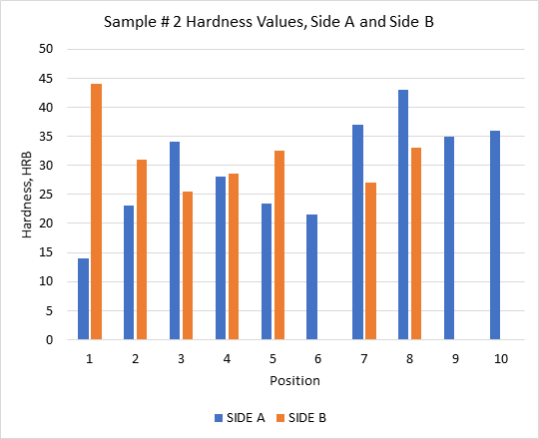

Figure 8. Graphical presentation of hardness values of Sample # 2.

The authors believe that the change is due to the cooling rate of the specimen, hence the difference between the two sides, as well as different locations. This assumes that other parameters such as material deposition rate is constants. During the printing process, the piece itself can act as a heat sink, and as a result its shape and size will play a key role. The thermal properties of the metals used will also influence the cooling rate and have an influence on hardness. Additional samples should be tested, ideally of different thicknesses in order to determine any particular trends in the hardness. Additionally, monitoring or recording the temperature distribution of a piece being printed might reveal a relationship between cooling rates and hardness values.

The samples tested were relatively small in size, and as many measurements as possible were performed. For further investigations and to obtain better statistics, additional samples and measurements must be made, preferably with larger samples of different thicknesses and geometries. The difficulty in obtaining larger one lies in the fact that the samples are very expensive to produce, and difficult to obtain.

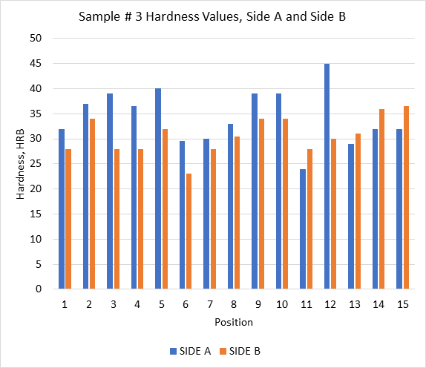

Figure 9. Graphical presentation of hardness values of Sample # 3.

Conclusion

In this research, we investigated the hardness of three different jewelry samples. Hardness was found to be different at different locations. Even for the same location, hardness was found to be different at different sides. Based on the data observed for all three samples, one side of the sample was found to be relatively softer (or harder) compared to the other side. In some sample, the thinner parts showed a slightly higher hardness. Plus, the center part of the samples offered more uniform hardness compared to other regions. Most of the engineering materials are not a pure chemical substance but an alloy. Hence, it is not unexpected to have slightly different hardness at different locations. The authors believe that the variation of hardness is due partly to the cooling rate of the samples which depends, among other factors, on the size, shape and printing parameters.

References
Sachs, E., Wylonis, E., Allen, S., Cima, M. & Guo, H. (2000). Production of Injection Molding Tooling With Conformal Cooling Channels Using the Three Dimensional Printing Process. Polymer Engineering & Science. 40. 10.1002/pen.11251.
KLA Instruments™. "Mapping the Hardness of 3D-Printed Aluminum". AZoM. 16 July 2022. <https://www.azom.com/article.aspx?ArticleID=21575>.
Xometry - https://www.xometry.com/
POM Group, Inc., Precision Additive Manufacturing of Medical Devices, White Paper (Auburn Hills, MI: The POM Group, Inc.). http://www.nist.gov/tip/wp/pswp/upload/129_precision_additive_manufacturing_of_medical_device.pdf.
Javaid, M. and Haleem A. (2019) Current Status and Applications of Additive Manufacturing in Dentistry: a literature-based review. J Oral Biol Craniofac Res 9:179–185. https://doi.org/10.1016/j.jobcr.2019.04.004
A.R. Thryft, Unmanned Aerial Vehicles Fly Via Additive Manufacturing. www.designnews.com/author.asp?section_id=1386&doc_id=235660. Accessed 4 Jan 2012.
A.R. Thryft, 3D Printing Flies High. www.designnews.com/author.asp?section_id=1392&doc_id=251526.
J.L. LaGoy (2011), MS&T - Material Science and Technology 2011 Conference, Internal Bodycote Trip Report (Westerville, OH: MS&T).
Nosheen, F., Abid, H., Shashi, B. and Mohd. J. (2021) Current Advances in Mechanical Engineering, Chapter: “Prospects of Jewelry Designing and Production by Additive Manufacturing, “p. 869-879”.
Cooper, F. (2016) Sintering and Additive Manufacturing: “Additive Manufacturing and the New Paradigm for the Jewelry Manufacturer”, Progress in Additive Manufacturing, 29–43. https://doi.org/10.1007/s40964-015-0003-2
Yap, Y.L. and Yeong, W.Y. (2014) Additive Manufacture of Fashion and Jewelry Products: A Mini Review. Virtual Phys Prototyping 9:195–201. https://doi.org/10.1080/17452759.2014.938993
Autonomous Manufacturing (AMFG), 3D Printing Precious Metals – a New Approach? August 16, 2018. https://amfg.ai/2018/08/16/3d-printing-precious-metals-a-new-approach/

