Optimization of Batch Manufacturing Process
of three-cell and five-cell Battery Power Pack Products

Jeremy B. Meehleib
Texas A&M University
jeremy_meehleib@yahoo.com

Stephen Thompson
Texas A&M University
swthompson@tamu.edu

Behbood Zoghi
Texas A&M University
zoghi@tamu.edu

Abstract

Charger Industries designs and manufactures battery power packs for the oil and gas wireline industry. Two of their products are of a customer's design and have tighter tolerance requirements than other products in their product line. Additional costs are associated with the procedures needed to meet these more stringent requirements. One process requires the use of a jig when applying heat-shrink material to the battery power pack and is the source of high rebuild percentages. It is this process that is the focus of this paper.

This study involved process review, design review, and quantitative tests. A series of 56 test builds of the heat-shrink application process were performed. Each test-build varied key elements of the process to allow insight into that elements' impact on repeatability in achieving target lengths and reduction in rebuilds.

This study identified four key recommendations: 1) Use of a nozzle for the heat gun at maximum temperature for improved heat transfer. 2) Continued use of jig is recommended for achieving target manufacturing lengths. The post-heat-shrink application time-in-jig should be limited to 10 minutes. 3) Change the target length measurement by +0.010 inch for the initial tolerance specification window to account for overnight shrinkage. 4) Implement the use of oven for controlled application of heat to heat-shrink material prior to assembly installation.

Implementation of the recommendations will provide an estimated 71% operational cost savings to the heat-shrink portion of the manufacturing process. An additional 5% in savings is achieved when accounting for a reduction in rebuilds. Other businesses could learn from this study and conduct a similar investigation into their current process and harvest considerable financial benefits depending on their scales.

Introduction

Company

Charger Industries is an industry-leading battery power pack manufacturer for the MWD (Measurement While Drilling) tools sector of the oil and gas industry. These products provide the power for the electronics used in the high pressure and high-temperature (150 – 200 degrees C) environments for the tools needed during the well-drilling process downhole.

Problem Introduction and Scope

Of the power pack products manufactured at the Houston location, one pair of products (a three-cell and a five-cell power pack assembly) is of a customer's design. These designs have tighter tolerance specifications than other products made by Charger Industries and require additional manufacturing steps to meet specifications.

These products require a jig during the manufacture to compress the power pack to the specified design length. Then, the power pack is encased by heat-shrink material for protection; to maintain the compressed length achieved by the jig and re-establish axial alignment due to the bowing that occurs during compression. Figure 1 illustrates this process.

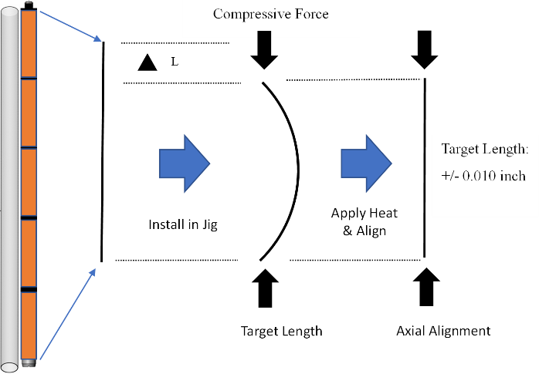

Figure 1 - Illustration of the compression of the battery pack to achieve the target length and axial alignment maintained by heat-shrink material.

Efficient assembly using this process is very technician specific due to the various techniques used by each technician when applying heat to the heat-shrink material. These technique variations may include, but are not limited to, the following:
- Distance of heat gun from heat-shrink material.
- Duration of heat application.
- Location and sequence of heat application along power pack
  - Top-to-Bottom of power pack
  - Center-to-Top / Center-to-Bottom of the power pack
Inconsistent build quality is a result. Breakdown and rebuilds are common. Charger Industries is asking for the current manufacturing process to be investigated. The goal of this study is to identify and implement tools and procedures that can increase fit repeatability and foolproof the manufacturing process, and positively impact product economics is economical.

Study Structure

This study will be broken down into three components: A review of the manufacturing process during the heat-shrink application process; a design evaluation of the three-cell and five-cell power pack; and conclude with recommendations.

Manufacturing Process

The manufacturing process review will capture the current state of the manufacturing process and document key areas of opportunity based on project metrics ranging from consistency and time to meet target length tolerance specifications; to determining the instances and time to rebuild battery power packs. Initial indications are that the jig apparatus and application of the heat-shrink material will be a key focus in this part of the investigation. This area of investigation is in control of Charger Industries and recommendations generated from these findings will show the most improvement in the process and economic impact.

Power Pack Design Review

The power pack design review will focus on the component items of the power pack itself. The specification tolerance requirements and thought process for the component's specifications will attempt to be confirmed. The Customer primarily controls this area of investigation.

Recommendation and Implementation

The paper will conclude with recommendations from the investigations. Improvements to product output quality metrics and documentation of rebuild instances will be recorded and evaluated for the economic impact on Charger Industries.

Literature Review

Process Control for Optimization

In addressing the manufacturing improvements of the advanced technologies of the MWD power packs in this project, this paper will propose improvements for processes that may not have complete documentation. Bengston (2010), in his article "Process measurement is critical." (1),” acknowledges that "many manufacturing processes have evolved or matured in the dark, and are based on anecdotal information, unrecorded assumptions and tribal knowledge." (1(Bengston, 2010, p. 12)

Process management improvements of this paper will document and capture best practices (i.e., tribal knowledge) related to the manufacturing of these three and five-cell power packs. By simply being aware of the potential hidden process opportunities, the manufacturing steps can be better captured to document, record, and pass along those learnings to the future manufacturing teams.

Establishing a fixed process for manufacture, Standard Work for the 3-cell and 5-cell power pack assemblies will be established for the study. Sundar et al. (2014) describe Standard Work as “the safest and most effective method to carry out a job in the shortest repeatable time as a result of utilization of resources.” Establishing Standard Work results in Standard Operating Procedures (SOP) that documents processes and sequences of work.

As a component of Lean Manufacturing, these small steps in organization of the manufacturing processes lead to baselines where performance can be measured and adjustments for improvement can be made.

Tolerance Considerations

The use of the jig in this project is necessary due to a tolerance requirement of the design. Hu and Xiong (2005) establish that as tolerance standards increase for a given product, manufacturing costs also increase. This paper will be evaluating the product design and look for those decisions that determined the tolerance requirements requiring the added processes. Design insights in combination with the manufacturing considerations, may allow for less strict tolerance requirements if the reasons for those requirements are explored further.

Heat-shrink Material – An Understanding

Kraus and Ryan (1988) describes the general manufacturing process of heat-shrink material as follows: "In manufacturing heat-shrinkable products, plastic is formed into tubing… before it is irradiated. The material is then heated enough to melt its crystal structure, stretched, and allowed to cool in this new form. The crystals reappear to hold the product in its expanded shape. When the end user heats the tubing …, the crystals melt again, allowing the cross links to pull the polymer back to its original unexpanded shape. As it cools, the crystals return to preserve the recovered form" (3) (Kraus & Ryan, 1988, p. 31)

Fluorinated Ethylene Propylene (FEP) is the heat-shrink material used to protect and maintain the length of the three and five-cell battery power packs in this project. Kili (2014) described FEP is a "random perfluonated copolymer of tetrafluoroethylene (TFE) and hexafluoropropylene (HFP) monomers." (Kili, 2014, p. 4)

As our study evaluates the process of final application of the FEP heat-shrink material, particular attention will be focused on improving the consistency in achieving the recovered state of the material.

Methodology

Scope

This project’s primary focus is on process investigations that most impact the length tolerance specification of the power pack assemblies. All quantitative physical testing investigations of this study focus on the five-cell power pack to reduce the number of iterations of testing. Deductions for this portion of the study are extended to the three-cell power pack by extrapolation. Qualitative studies are applicable to both three-cell and five-cell power packs.

The investigation is broken down into three sections:
- Areas controlled by the Contractor - Charger Industries
- Areas controlled by the Customer
- Heat-shrink Material Application Review

Areas controlled by the Contractor – Charger Industries

Areas controlled by Charger Industries include the physical process of assembly of the power pack products. The area of the process impacting the overall length of the final assembly is the use of the power pack jig and the application of the heat-shrink material.

Procedure

The test procedure of the heat-shrink application entails various structured applications of the heat-shrink material to the same four "dummy" five-cell power packs. The structured heat application scenarios entail four primary categories with two options each and one singular investigation. Twenty testing scenarios are the result. Only 16 conditions can be evaluated because the use of the nozzle with the heat gun requires the use of the jig and precludes any "pre-heat" application scenarios.

Data Analysis

Testing Matrix Review

Statistics of the data collection are as follows:
- Total five-cell Power Pack Builds: 56
- Unique Test Configurations: 18
- Recorded Data Points: 631

The testing included the documentation of the heat-shrink application process of the original technician for historical reference. This data set is included in the data analysis discussion.
Additionally, the dummy cells provided for the testing came in two configurations. One set was empty and hollow but fully enclosed, and the other set was filled with sand. These two configurations allowed for a review of the play of heat retention of the cells. For this study, five-cell power packs were used for all the "dummy “cell configurations.

General Data

The primary focus of this study was to capture the impact of various techniques of applying heat-shrink material to the power pack product. Collected data is compiled in Appendix A – Collected Data.

If the data is reviewed in a whisker plot, it is easily observed that the two types of dummy cells (hollow vs sand-filled) had a different performance. Figure 2 captures the lengths of the different configurations right after heat-shrink application and the length change happening overnight the next day.

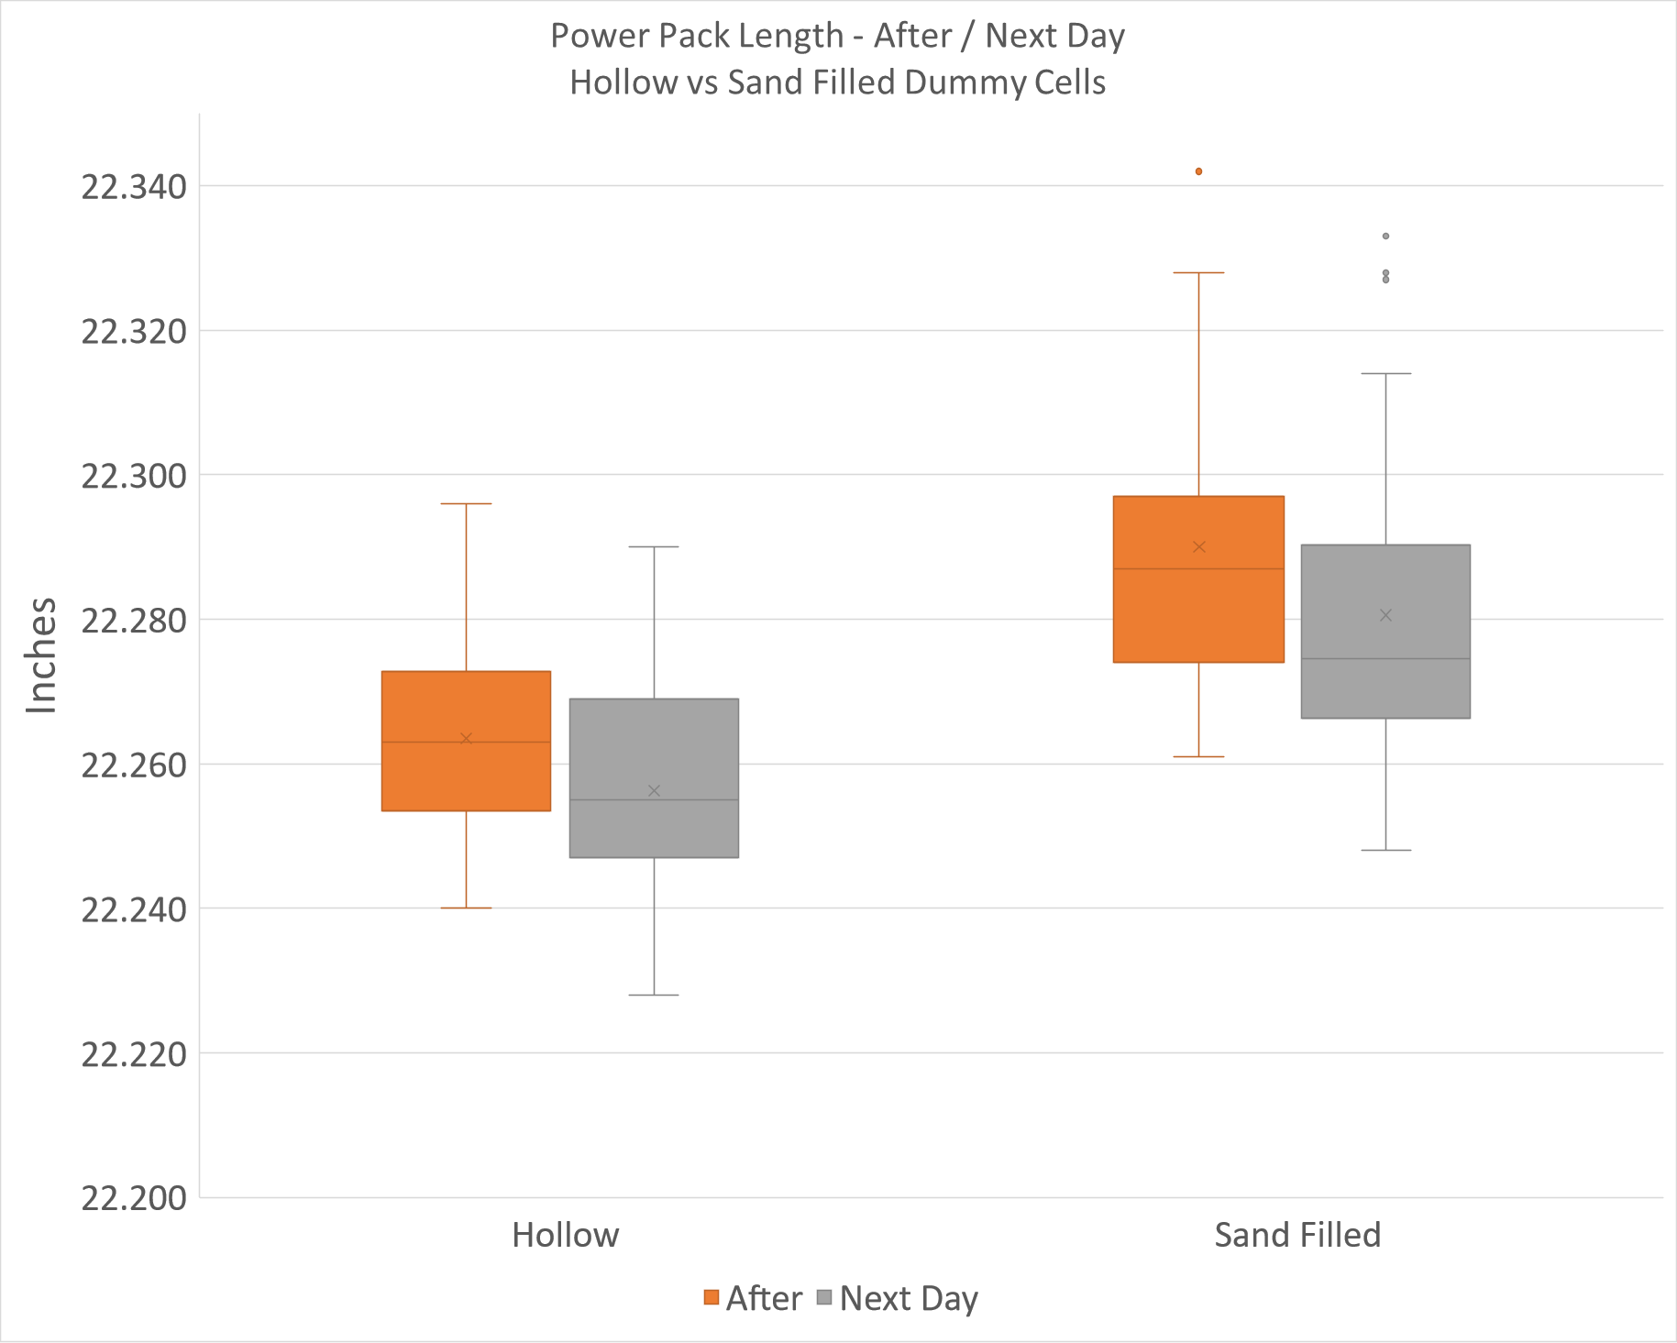

Figure 2 – Length of test power packs with hollow and sand-filled dummy cells.

The material in the cells that are filled with sand is determined to be absorbing an impactful portion of the heat being transferred during this process. This process results in the hollow dummy power packs having more overall length change than the sand-filled dummy power packs and allowing more recovery of the heat-shrink material at the time of heat application.
Because the actual battery cells of production power packs are filled with lithium and are not hollow, it was concluded that the performance properties of interest would be most reflected in data from the dummy power packs made with the sand-filled cells. For this reason, the remainder of the analysis will be in the review of data from the dummy power packs made from the sand-filled cells.

Sand Filled Dummy Power Pack Data Analysis – Length Analysis

The application of the heat-shrink tubing results in a reduction in the overall length of the assembly. The historical data set is the length change achieved by the technician that had historically performed this process. Please note that this technician’s process was unbounded by testing constraints to capture the process and document overall efficiency as historically performed. The achievement of reaching the target length for the product requirements required substantial time compared to the planned testing procedure of this investigation and will be discussed later in the paper. Figures 3 and 4 are whisker plots comparing the heat gun temperature (High and Low), and the use of the jig while heating (In Jig, No Jig).

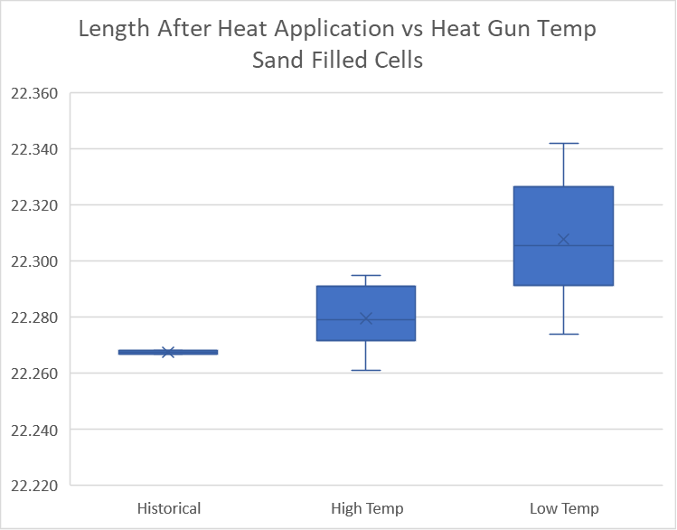

Figure 3 – Length of test power packs – Heat Gun Temperature

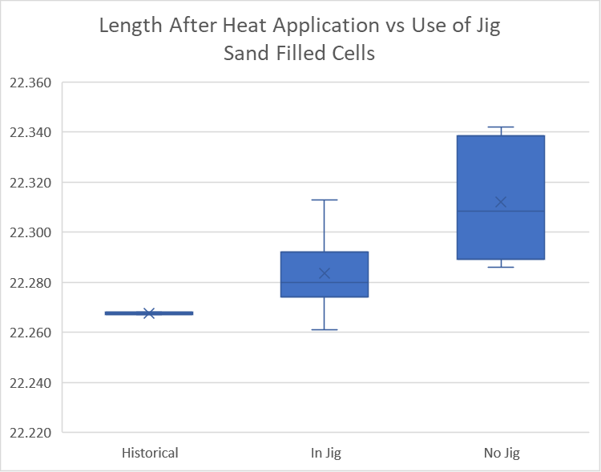

Figure 4 – Length of test power packs – Use of jig during heating

Figure 5 (Heat Gun Temp) and Figure 6 (Use of Jig During Heating) each show data sets that are quite significant in the difference in length change. The higher temperature setting of the heat gun had a larger impact on the length change of the power pack, as did the use of the jig. Each resulted in better achieving the targeted results for the power pack.

The heat gun temperature and use of the jig also showed differences in the impact on the overnight length change of the power pack assembly. The average overnight change was -0.012 inch for the high-temperature setting of the heat gun versus -0.008 inch for the low-temperature setting. The average overnight change was -0.012 inch for the use of the jig during heating versus -0.009 inch for the not using the jig during heating. The difference is approximately 25% different in either case.

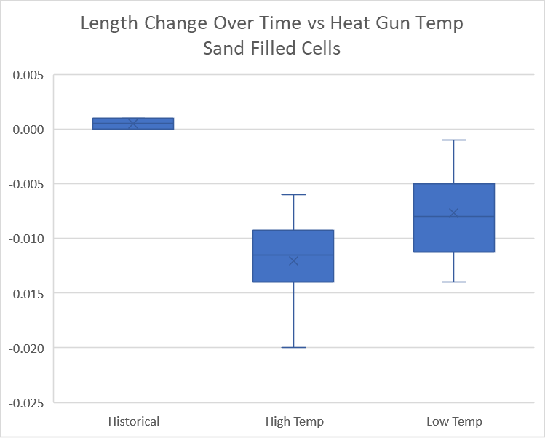

Figure 5 – Length change overnight of test power packs – heat gun temperature

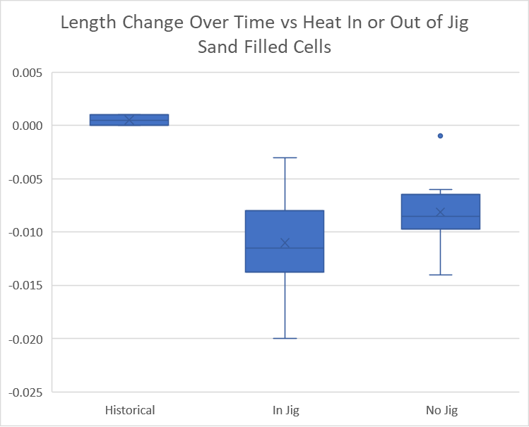

Figure 6 – Length change overnight of test power packs – use of jig

The average change in length overnight approximates 50% of the tolerance window for the entire assembly. This information will be valuable in establishing pre-QC target lengths and may significantly impact rebuild percentages of the assemblies should this shrinkage be accommodated in the manufacturing processes.

The next figure concerns the investigation of the use of an oven to put the heat-shrink material through a controlled heat cycle prior to application on the power pack. Two controlled conditions were tested, one with the heat-shrink an oven at 55 degrees C for 25 minutes and the other at the same temperature for 1 hour.

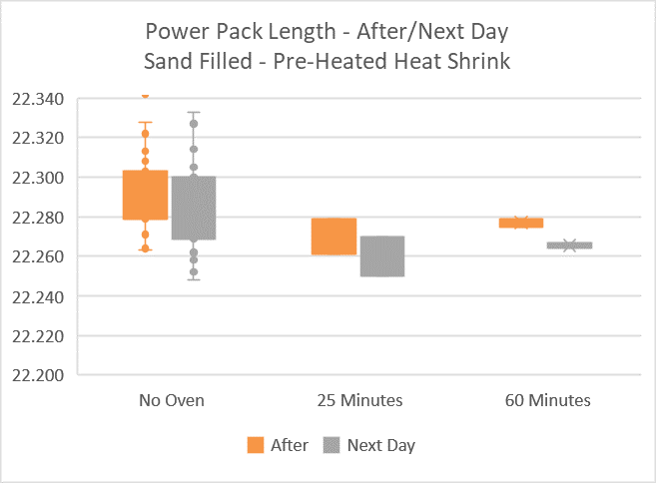

Figure 7 – Length change After / Next Day– controlled heat

Figure 7 shows that the controlled heating in the oven contributed to a much tighter spread of lengths achieved both right after heat application with the heat gun and over time with the measured length of the next day. The 60-minute controlled heat cycle in the oven of the heat-shrink material prior to installation on the power pack shows the possibility of increased process repeatability in achieving target lengths that are not indicated in any other test configuration.

Sand Filled Dummy Power Pack Data Analysis – Time Analysis

The total time recorded for each application is from the time it is placed into the jig initially until the next assembly is placed in the jig. This would simulate a continuous cycle under production. Power packs assembled by the historical process achieved the assembly lengths within tolerances but came at the expense of time, taking an average of 55 minutes to achieve.
For the testing of the matrix scenarios, the heat was applied for the time necessary by observation for sufficient application and then left the power pack in the jig for 10 minutes, before removal and measurement. This approach allows for processing a unit every 15 minutes using one jig.

Process Recommendations

The following conclusions and recommendations can be made:
- Direction of heat application to the heat shrink material showed no impact to the repeatability of achieving target length or reducing overnight change in length to the battery packs. Conclusion: Not influential in output.
- Use of the nozzle is open to interpretation. It is thought to add a level of control in heat application than without the nozzle and may assist in equalizing performance from one technician to another. However, for a trained technician, no influence was captured in the data set. Conclusion: Recommend use of heat gun nozzle to normalize performance among technicians.
- Use of the jig while heating the heat shrink demonstrated a direct correlation to achieving target length. The overnight length change was documented to consistently achieve an additional length change of approximately -0.010 inch. Conclusion: Recommend use of jig.
- Use of high heat setting of the heat gun while heating the heat shrink had a better correlation to achieving target length. The overnight length change was documented to consistently achieve an additional length change of approximately -0.010 inch. Conclusion: Recommend use of high heat setting of heat gun.
- The use of an oven for a controlled heat application cycle to the heat-shrink prior to assembly of the battery pack demonstrated significant influence on achieving repeatable target length. The overnight length changes also showed consistency of -0.010 inch. Conclusion: Recommend implementation of a pre-heating cycle of the heat shrink material in a heat-controlled oven at 55 degrees C, for one hr.

The target length of the assembly to pass final quality control is 22.260 inch +/- 0.010 inch. The preceding testing documented a consistent change in length overnight of approximately -0.010 inch. To accommodate this overnight change, the target length for the assembly should be between 22.260 to 22.280 inch after the initial heat cycle.

Jig Recommendations – Functional Opportunities

Any efforts to improve the current jig apparatus should focus on:
- Improvement in the speed of securing the power pack assembly into the jig. The initial setup used wing nuts with integral threaded shafts to attach a compression plate to a series of columns to establish the target length of the battery pack under compression. Improvements during the testing were implemented by securing the threaded shafts to the columns instead of the wing nuts and were successful in speeding up the process (Figure 8). A camlock type securing application should be investigated.

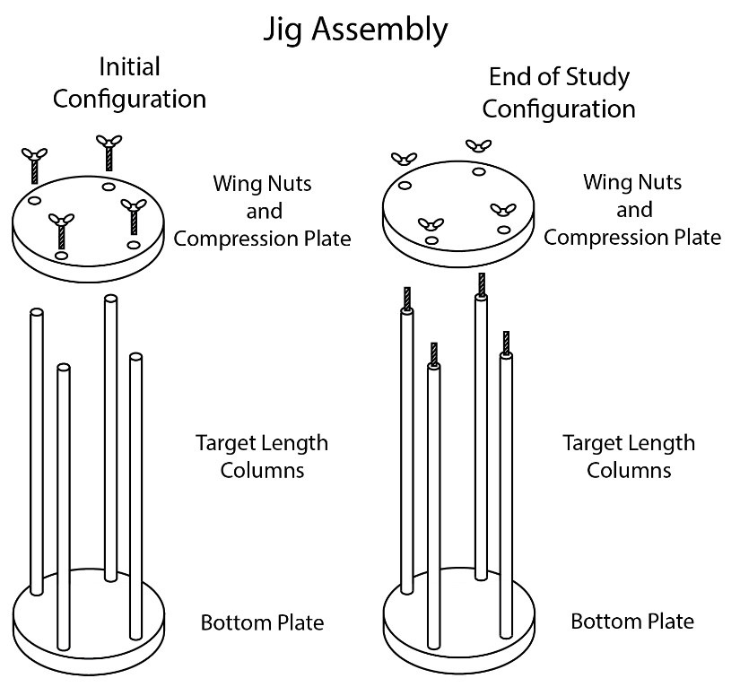
Figure 8 – Wing nut assembly configuration. Initial and End of Study

- The current design allowed for this application when accommodating the use of a nozzle on the heat gun. Although more space may allow for more freedom of movement and better heat distribution.
- Consideration for allowing more than one power pack in the jig. This should be determined by the sequence of full tightening of the jig on the power pack. The testing had a two-step approach. Light fastening during initial heating and full tightening during the 10-minute static condition. A two-step approach in the process may make the jig too complex.
- Favoring multiple simple jigs over a complex single jig that manages many power packs at once.

Areas controlled by the Customer

Areas controlled by the Customer include the actual design of the power pack products. The project reviewed the power pack components for design and purpose and evaluation of the tolerance requirements justification for the application

Data Analysis

In both the three-cell and five-cell power pack designs there are five primary components that make up the overall length of the assembly that needs to be within +/- 0.010 inch tolerance specification. Table 1 lists these items, the lengths, tolerances, and the count for each power pack assembly.

Table 1 – Powerpack components Contributing to target length
Part Name | Length | Tolerance | 3-Cell Power Pack | 5-Cell Power Pack
 | Inch | +/- | Part Count | Part Count
Top End | 0.995 | 0.005 | 1 | 1
O-Ring, Silicon | 0.139 | 0.004 | 4 | 6
Washer, Plastic | 0.062 | 0.007 | 4 | 6
Power Cell | 3.850 | 0.050 | 3 | 5
Bottom End | 0.998 | 0.0025 | 1 | 1

In doing a review of the length target, it must be noted that the native length of the power pack is longer than the target length after the heat-shrink is applied. Analysis of the above table shows that the five-cell power pack length before application of the heat-shrink is 22.449 inch. The length target for the assembly after heat-shrink application is 22.260 inch +/- 0.010 inch. The overall change in length that must be achieved is approximately 0.189 inch. This compression is entirely accommodated by the properties of the silicon O-rings.

All other components are fixed in function and/or material structure. The Top End for instance is stainless steel. This has fixed-length properties.

Although consultation with the Customer would have been advantageous, the assembly testing previously reviewed provided confidence that consistent target lengths can be achieved through manufacturing adjustments, as noted in the previous section, and no design changes of the power pack are necessary to reach the project objective.

Heat-shrink Material Application Review

The purpose of the heat-shrink material application review is to better understand the use of heat-shrink material and confirm the best practices in our application.

Data Analysis

As the test matrix was systematically completed, rules of thumb presented themselves. Many of them were anecdotal at the beginning of the project but were confirmed within the data.
One understanding was that the power packs change in length after they are set aside for QC. This was officially documented in the testing. As much as 0.010-inch shrinkage in the total length of the power pack was routinely observed. The technician should accommodate this phenomenon.

More significantly, the total thermal energy applied is important to the recovery process of the heat shrink. If applied heat is varied and inconsistent across the entire length of the heat-shrink material, a wide variety of responses will be observed. This was evident in Figure 7, where the handheld application had a wide spread of achieved lengths, while the use of an oven in a controlled cycle of thermal exposure promoted tighter responses in overall achieved target length. In the latter case, perhaps 60-75% of the thermal energy came from the time in the oven, and the last 40-25% was achieved through the application of the heat gun. This contrasts with the 100% use of the heat gun. The heat cycle in the oven reduced the overall total thermal heat transfer variability of the process.

Return on Investment

This paper will evaluate the monetary impact of implementation by breaking it down into two parts. The first will be to characterize the historical rebuild percentages and establish an average annual order and rebuild volumes. The second part will establish the potential cost savings of implementation of the recommendations presented in this paper given the historical average annual order volumes and an estimate of rebuild costs.

Historical Build Analysis
This product family of three-cell and five-cell power packs has been in production since August of 2018. Initial product runs were of the three-cell model followed by the five-cell model in August of 2019. Table 2 shows the total historical rebuild percentages for each product and the rebuilds of the product family as a whole.

Table 2 – Historic and average annual build and rebuild estimate
 | Historical Build and Rebuild Percentages
 | August 2018 – July 2021
 | 3-Cell Power Pack | 5-Cell Power Pack | Total Power Packs | Annual Avg
Total Units Ordered | 772 | 400 | 1172 | 185
Total Units Rebuilt | 151 | 63 | 214 | 34
Percent Rebuild | 20% | 16% | 18% | 18%

Total Cost Savings Potential

The test matrix documented opportunities set forth in the paper's recommendations. These recommendations impact two areas of interest in the economic evaluation.

Reduction / Elimination of Power Pack Rebuilds

By adjusting the target length of initial heat-shrink application by -0.010 inch documented in the test matrix, the 18% rebuild percentage could be drastically improved. This shrinkage was not considered previously and has been a recent cause of build rejections due to shrinking outside of the tolerance specifications.

Cost Analysis and Savings Potential

Combining the rebuild reduction and process improvement estimates, Table 3 presents the annual potential cost savings.

Table 3 – Processing cost evaluation
Heat Shrink Process Cost Evaluation - Average Annual Build
 | Historical | Process Improvements Only | 2nd Jig Addition
Cost of Heat Shrink | $5.60 | $5.60 | $5.60 | $/ft
Length of Heat Shrink Per Power Pack | 2 | 2 | 2 | ft
Heat Shrink Material Cost Per Power Pack | $11.20 | $11.20 | $11.20 | Material Cost Per Unit
Avg Historical Process Time | 0.875 | 0.250 | 0.167 | hr/unit
Facility Manufacturing Cost Per Hour | $75.00 | $75.00 | $75.00 | $/hr
Heat Shrink Facility Manufacturing Cost | $65.63 | $18.75 | $12.53 | $/unit
Manufacturing Cost Improvement |  | 71% | 81%
Average Annual Builds | 185 | 185 | 185
Average Annual Build Costs | $12,141 | $3,469 | $2,317
Rebuilds (18% Historical) | 34 | 0 | 0
Rebuild Costs | $2,612 | $0.00 | $0.00
Total Annual Heat Shrink Processing Cost | $14,753 | $3,469 | $2,317 | $/Year
Projected Annual Cost Reduction Savings |  | $11,284 | $12,436 | $/Year
Annual Cost Savings for Heat Shrink Process |  | 76% | 84%

By implementing only the procedural changes, the cost per unit for heat-shrink application improves by 71% over the historical process requiring 50+ minutes on average. With the addition of a second jig unit, the manufacturing cost per unit improves to 81%. When evaluated on an annual basis and assuming proper implementation of the -0.010 inch additional change in length overnight, the cost savings would be $11,284 annually should a second jig is not be implemented. Cost savings potential of $12,436 is possible if a second jig is available. These are 76% and 84% reductions in heat-shrink annual processing costs, respectively.

A note regarding the preparation of a battery power pack for rebuild following failure to meet length specifications. Length standards are confirmed before proceeding to final production. Failure requires replacement of the heat shrink material. Removal of the heat shrink material is takes less than five minutes. The process to reattach the heat shrink material is performed as described in this paper. For this reason, the improvements to the heat shrink application process was the focus of the economic analysis.

Recommendations and Conclusion

This project began with an objective to evaluate the use of a jig during the production of three-cell and five-cell power packs to meet heightened tolerance specifications relative to other products. It was believed that through the improvement of the jig, the process could be streamlined, and rebuild percentages could be reduced for this product set.

Initial evaluations of the process established an outline of investigation, resulting in a test matrix that focused on the application of heat-shrink material onto the power pack assemblies. The execution of the test matrix was heavily focused on the use and application of the jig apparatus in question.

The following recommendations are proposed for immediate effect in the next build cycle:
- Use of a nozzle for the heat gun at maximum temperature for improved heat transfer.
- Continued use of a jig, either in current form or with improved ease-of-use modifications as outlined earlier in this paper (Figure 8). Maintain restrained condition in the jig for 10 minutes after heat gun heat application.
- Change the target length measurement window by +0.010 inch (22.260" to 22.280") for the initial tolerance specification window when measuring for the length of the power pack just after heat-shrink application. This will account for the shrinking of power pack assembly overnight and eliminate rebuilds because of missing the final tolerance specifications due to insufficient length.
- Implement the use of an oven for controlled application of heat to heat-shrink material prior to assembly installation. A heat cycle of 1 hour at 55 degrees C was sufficient to improve the achievement of target length objectives during testing.

These procedural changes use resources already available in the manufacturing facility and return a 76% annual financial return over the process currently in place. As noted above, investment in a second jig may only be necessary if the average annual build requirements significantly improve over the volumes evaluated in this paper.

As for general knowledge of heat-shrink material, every effort should be made to ensure that the total thermal energy applied to the material is consistent across its entire length. Improvement on this front in this application was through the use of a nozzle on the heat gun, using the highest temperature setting of the heat gun, and the use of an oven for a prescribed period of time and temperature to accomplish a portion of the recovery process.

References

Bengston, D. (2010). Process measurement is critical. Manufacturing Engineering, 144(3), 12.
Hu, J. & Xiong, G. (2005). Concurrent design of a geometric parameter and tolerance for assembly and cost. International Journal of Production Research, 43(2), 267-293, DOI: 10.1080/00207540412331282051
Kili, T. (2014). The Synthesis and Characterisation of Fluorinated Ethylene Propylene (FEP) Copolymers. (Doctoral Dissertation) the University of Pretoria.
Kraus, R. & Ryan, D (1988). Advances in heat-shrink technology. IEEE Electrical Insulation Magazine, 4(3), 31-34, May-June 1988, doi: 10.1109/57.832.
Sundar, R., Balaji, A. N., & Kumar, R. S. (2014). A review on lean manufacturing implementation techniques. Procedia Engineering, 97, 1875-1885, DOI: 10.1016/j.proeng.2014.12.341

Appendix A – Collected Data
Test Scenario | Date | Dummy Cell : Hollow - H Sand - S | Scenarios to Test |  |  |  |  |  | Technician
 |  |  | Heating Protocols |  |  | Alignment of Power Pack | Historic | Pre-Heated Heat Shrink in Oven
 |  |  | Direction | Spacing | Temperature of Gun
 |  |  | Top to Bottom / Center Out | No Nozzle / Nozzle | High / Low | In Jig / No Jig
0 | 12/6/2021 | DP#1 - H | Historical | Historical | Historical | Historical | Historical | No Oven | A
0 | 12/6/2021 | DP#2 - S | Historical | Historical | Historical | Historical | Historical | No Oven | A
0 | 12/6/2021 | DP#3 - H | Historical | Historical | Historical | Historical | Historical | No Oven | A
0 | 12/6/2021 | DP#4 - S | Historical | Historical | Historical | Historical | Historical | No Oven | A
1 | 12/7/2021 | DP#1 - H | Top to Bottom | No Nozzle | High Temp | In Jig | Matrix | No Oven | B
1 | 12/7/2021 | DP#2 - S | Top to Bottom | No Nozzle | High Temp | In Jig | Matrix | No Oven | B
1 | 12/7/2021 | DP#3 - H | Top to Bottom | No Nozzle | High Temp | In Jig | Matrix | No Oven | B
1 | 12/7/2021 | DP#4 - S | Top to Bottom | No Nozzle | High Temp | In Jig | Matrix | No Oven | B
2 | 12/13/2021 | DP#1 - H | Top to Bottom | No Nozzle | High Temp | No Jig | Matrix | No Oven | B
2 | 12/13/2021 | DP#2 - S | Top to Bottom | No Nozzle | High Temp | No Jig | Matrix | No Oven | B
2 | 12/13/2021 | DP#3 - H | Top to Bottom | No Nozzle | High Temp | No Jig | Matrix | No Oven | B
2 | 12/13/2021 | DP#4 - S | Top to Bottom | No Nozzle | High Temp | No Jig | Matrix | No Oven | B
3 | 12/9/2021 | DP#1 - H | Center Out | No Nozzle | High Temp | In Jig | Matrix | No Oven | B
3 | 12/9/2021 | DP#2 - S | Center Out | No Nozzle | High Temp | In Jig | Matrix | No Oven | B
3 | 12/9/2021 | DP#3 - H | Center Out | No Nozzle | High Temp | In Jig | Matrix | No Oven | B
3 | 12/9/2021 | DP#4 - S | Center Out | No Nozzle | High Temp | In Jig | Matrix | No Oven | B
4 | 12/14/2021 | DP#1 - H | Center Out | No Nozzle | High Temp | No Jig | Matrix | No Oven | B
4 | 12/14/2021 | DP#2 - S | Center Out | No Nozzle | High Temp | No Jig | Matrix | No Oven | B
4 | 12/14/2021 | DP#3 - H | Center Out | No Nozzle | High Temp | No Jig | Matrix | No Oven | B
4 | 12/14/2021 | DP#4 - S | Center Out | No Nozzle | High Temp | No Jig | Matrix | No Oven | B
5 | 12/20/2021 | DP#1 - H | Top to Bottom | Nozzle | High Temp | In Jig | Matrix | No Oven | B
5 | 12/20/2021 | DP#2 - S | Top to Bottom | Nozzle | High Temp | In Jig | Matrix | No Oven | B
5 | 12/20/2021 | DP#3 - H | Top to Bottom | Nozzle | High Temp | In Jig | Matrix | No Oven | B
5 | 12/20/2021 | DP#4 - S | Top to Bottom | Nozzle | High Temp | In Jig | Matrix | No Oven | B
7 | 12/21/2021 | DP#1 - H | Center Out | Nozzle | High Temp | In Jig | Matrix | No Oven | B
7 | 12/21/2021 | DP#2 - S | Center Out | Nozzle | High Temp | In Jig | Matrix | No Oven | B
7 | 12/21/2021 | DP#3 - H | Center Out | Nozzle | High Temp | In Jig | Matrix | No Oven | B
7 | 12/21/2021 | DP#4 - S | Center Out | Nozzle | High Temp | In Jig | Matrix | No Oven | B
9 | 1/5/2022 | DP#1 - H | Top to Bottom | Nozzle | Low Temp | In Jig | Matrix | No Oven | A
9 | 1/5/2022 | DP#2 - S | Top to Bottom | Nozzle | Low Temp | In Jig | Matrix | No Oven | A
9 | 1/5/2022 | DP#3 - H | Top to Bottom | Nozzle | Low Temp | In Jig | Matrix | No Oven | A
9 | 1/5/2022 | DP#4 - S | Top to Bottom | Nozzle | Low Temp | In Jig | Matrix | No Oven | A
11 | 1/6/2022 | DP#1 - H | Center Out | Nozzle | Low Temp | In Jig | Matrix | No Oven | A
11 | 1/6/2022 | DP#2 - S | Center Out | Nozzle | Low Temp | In Jig | Matrix | No Oven | A
11 | 1/6/2022 | DP#3 - H | Center Out | Nozzle | Low Temp | In Jig | Matrix | No Oven | A
11 | 1/6/2022 | DP#4 - S | Center Out | Nozzle | Low Temp | In Jig | Matrix | No Oven | A
13 | 12/8/2021 | DP#1 - H | Top to Bottom | No Nozzle | Low Temp | In Jig | Matrix | No Oven | B
13 | 12/8/2021 | DP#2 - S | Top to Bottom | No Nozzle | Low Temp | In Jig | Matrix | No Oven | B
13 | 12/8/2021 | DP#3 - H | Top to Bottom | No Nozzle | Low Temp | In Jig | Matrix | No Oven | B
13 | 12/8/2021 | DP#4 - S | Top to Bottom | No Nozzle | Low Temp | In Jig | Matrix | No Oven | B
14 | 12/15/2021 | DP#1 - H | Top to Bottom | No Nozzle | Low Temp | No Jig | Matrix | No Oven | B
14 | 12/15/2021 | DP#2 - S | Top to Bottom | No Nozzle | Low Temp | No Jig | Matrix | No Oven | B
14 | 12/15/2021 | DP#3 - H | Top to Bottom | No Nozzle | Low Temp | No Jig | Matrix | No Oven | B
14 | 12/15/2021 | DP#4 - S | Top to Bottom | No Nozzle | Low Temp | No Jig | Matrix | No Oven | B
15 | 12/10/2021 | DP#1 - H | Center Out | No Nozzle | Low Temp | In Jig | Matrix | No Oven | B
15 | 12/10/2021 | DP#2 - S | Center Out | No Nozzle | Low Temp | In Jig | Matrix | No Oven | B
15 | 12/10/2021 | DP#3 - H | Center Out | No Nozzle | Low Temp | In Jig | Matrix | No Oven | B
15 | 12/10/2021 | DP#4 - S | Center Out | No Nozzle | Low Temp | In Jig | Matrix | No Oven | B
16 | 12/16/2021 | DP#1 - H | Center Out | No Nozzle | Low Temp | No Jig | Matrix | No Oven | B
16 | 12/16/2021 | DP#2 - S | Center Out | No Nozzle | Low Temp | No Jig | Matrix | No Oven | B
16 | 12/16/2021 | DP#3 - H | Center Out | No Nozzle | Low Temp | No Jig | Matrix | No Oven | B
16 | 12/16/2021 | DP#4 - S | Center Out | No Nozzle | Low Temp | No Jig | Matrix | No Oven | B
17 | 1/12/2022 | DP#4 - S | Top to Bottom | Nozzle | High Temp | In Jig | Matrix | 55 Deg C / 25 Min | B
17 | 1/12/2022 | DP#4 - S | Top to Bottom | Nozzle | High Temp | In Jig | Matrix | 55 Deg C / 25 Min | B
18 | 1/13/2022 | DP#4 - S | Top to Bottom | Nozzle | High Temp | In Jig | Matrix | 55 Deg C / 60 Min | B
18 | 1/13/2022 | DP#4 - S | Top to Bottom | Nozzle | High Temp | In Jig | Matrix | 55 Deg C / 60 Min | B

Test Scenario | Date | Dummy Cell : Hollow - H Sand - S | Power Pack Length - Target 22.260" +/- 0.010" |  |  |  |  | Drift Success |  | Max Temp | Times
 |  |  | Before | After | After Pass (Y/N) | Next Day | Next Day Pass (Y/N) | After Pass (Y/N) | Next Day Pass (Y/N) |  | Individual Pack Time | Total Pack Time - 4
 |  |  | Inches | Inches | (Y/N) | Inches | (Y/N) | (Y/N) | (Y/N) | Deg C | Min: Sec | Hr:Min:Sec
0 | 12/6/2021 | DP#1 - H | 22.404 | 22.270 | Y | 22.271 | Y | Y | Y | 90-95 | 0:38:17 | 3:18:00
0 | 12/6/2021 | DP#2 - S | 22.429 | 22.268 | Y | 22.269 | Y | Y | Y | 75-80/108 | 0:50:00
0 | 12/6/2021 | DP#3 - H | 22.400 | 22.256 | Y | 22.255 | Y | Y | Y | n/a | 0:47:00
0 | 12/6/2021 | DP#4 - S | 22.431 | 22.267 | Y | 22.267 | Y | Y | Y | 107 | 1:15:00
1 | 12/7/2021 | DP#1 - H | 22.397 | 22.249 | Y | 22.244 | X | Y | Y | 130-135 | 0:22:48 | 1:18:58
1 | 12/7/2021 | DP#2 - S | 22.412 | 22.292 | N | 22.272 | X | Y | Y | 110-115 | 0:17:06
1 | 12/7/2021 | DP#3 - H | 22.381 | 22.24 | N | 22.231 | X | Y | Y | 115-120 | 0:16:35
1 | 12/7/2021 | DP#4 - S | 22.408 | 22.263 | Y | 22.252 | Y | Y | Y | 110-115 | 0:20:11
2 | 12/13/2021 | DP#1 - H | 22.367 | 22.275 | N | 22.269 | Y | Y | Y | 100-125 | 0:15:06 | 1:00:20
2 | 12/13/2021 | DP#2 - S | 22.402 | 22.293 | N | 22.287 | N | Y | Y | 95-120 | 0:15:20
2 | 12/13/2021 | DP#3 - H | 22.363 | 22.265 | Y | 22.255 | Y | Y | Y | 100-125 | 0:13:00
2 | 12/13/2021 | DP#4 - S | 22.399 | 22.295 | N | 22.287 | N | Y | Y | 95-120 | 0:13:38
3 | 12/9/2021 | DP#1 - H | 22.377 | 22.262 | Y | 22.251 | Y | Y | Y | 110-120 | 0:17:02 | 1:06:43
3 | 12/9/2021 | DP#2 - S | 22.406 | 22.271 | Y | 22.258 | Y | Y | Y | 100-120 | 0:15:59
3 | 12/9/2021 | DP#3 - H | 22.372 | 22.242 | N | 22.228 | N | Y | Y | 110-125 | 0:15:00
3 | 12/9/2021 | DP#4 - S | 22.404 | 22.264 | Y | 22.248 | Y | Y | Y | 105-120 | 0:18:23
4 | 12/14/2021 | DP#1 - H | 22.366 | 22.268 | Y | 22.258 | Y | Y | Y | 110 | 0:15:40 | 0:58:45
4 | 12/14/2021 | DP#2 - S | 22.396 | 22.288 | N | 22.278 | Y | Y | Y | 100 | 0:14:35
4 | 12/14/2021 | DP#3 - H | 22.359 | 22.254 | Y | 22.248 | Y | Y | Y | 110 | 0:13:58
4 | 12/14/2021 | DP#4 - S | 22.407 | 22.286 | N | 22.277 | Y | Y | Y | 100 | 0:12:45
5 | 12/20/2021 | DP#1 - H | 22.397 | 22.241 | N | 22.229 | N | Y | Y | 120 | 0:14:50 | 0:55:16
5 | 12/20/2021 | DP#2 - S | 22.401 | 22.279 | N | 22.262 | Y | Y | Y | 120 | 0:13:40
5 | 12/20/2021 | DP#3 - H | 22.367 | 22.251 | Y | 22.238 | N | Y | Y | 110 | 0:12:55
5 | 12/20/2021 | DP#4 - S | 22.403 | 22.281 | N | 22.269 | Y | Y | Y | 105 | 0:13:36
7 | 12/21/2021 | DP#1 - H | 22.361 | 22.272 | Y | 22.255 | Y | Y | Y | 115-120 | 0:15:00 | 0:58:17
7 | 12/21/2021 | DP#2 - S | 22.382 | 22.294 | N | 22.280 | N | Y | Y | 100-110 | 0:17:58
7 | 12/21/2021 | DP#3 - H | 22.351 | 22.252 | Y | 22.234 | N | Y | Y | 110-120 | 0:13:02
7 | 12/21/2021 | DP#4 - S | 22.388 | 22.274 | N | 22.260 | Y | Y | Y | 95-115 | 0:14:00
9 | 1/5/2022 | DP#1 - H | 22.350 | 22.279 | N | 22.277 | N | Y | Y | 100 | 0:13:48 | 1:03:50
9 | 1/5/2022 | DP#2 - S | 22.383 | 22.313 | N | 22.305 | N | Y | Y | 105 | 0:15:24
9 | 1/5/2022 | DP#3 - H | 22.358 | 22.261 | Y | 22.255 | Y | Y | Y | 110 | 0:13:25
9 | 1/5/2022 | DP#4 - S | 22.383 | 22.291 | N | 22.285 | N | Y | Y | 90-118 | 0:13:30
11 | 1/6/2022 | DP#1 - H | 22.361 | 22.260 | Y | 22.263 | Y | Y | Y | 105-110 | 0:16:31 | 1:03:10
11 | 1/6/2022 | DP#2 - S | 22.385 | 22.308 | N | 22.303 | N | Y | Y | 110-115 | 0:15:29
11 | 1/6/2022 | DP#3 - H | 22.349 | 22.264 | Y | 22.256 | Y | Y | Y | 110-120 | 0:14:06
11 | 1/6/2022 | DP#4 - S | 22.383 | 22.303 | N | 22.300 | N | Y | Y | 110-120 | 0:15:09
13 | 12/8/2021 | DP#1 - H | 22.378 | 22.271 | Y | 22.269 | Y | Y | Y | 95-100 | 0:17:40 | 1:17:11
13 | 12/8/2021 | DP#2 - S | 22.410 | 22.292 | N | 22.284 | N | Y | Y | 85-95 | 0:20:03
13 | 12/8/2021 | DP#3 - H | 22.374 | 22.256 | Y | 22.253 | Y | Y | Y | 95-110 | 0:19:15
13 | 12/8/2021 | DP#4 - S | 22.403 | 22.292 | N | 22.280 | N | Y | Y | 80-90 | 0:20:13
14 | 12/15/2021 | DP#1 - H | 22.379 | 22.265 | Y | 22.261 | Y | Y | Y | 105 | N/A | 0:42:18+ N/A
14 | 12/15/2021 | DP#2 - S | 22.396 | 22.322 | N | 22.314 | N | Y | Y | 105 | 0:15:13
14 | 12/15/2021 | DP#3 - H | 22.361 | 22.289 | N | 22.279 | N | Y | Y | 105 | 0:10:15
14 | 12/15/2021 | DP#4 - S | 22.396 | 22.342 | N | 22.328 | N | Y | Y | 105-110 | N/A
15 | 12/10/2021 | DP#1 - H | 22.398 | 22.277 | N | 22.269 | Y | Y | n/a | 85-100 | 0:19:37 | 1:16:42
15 | 12/10/2021 | DP#2 - S | 22.428 | 22.274 | N | 22.269 | Y | Y | Y | 75-95 | 0:19:42
15 | 12/10/2021 | DP#3 - H | 22.402 | 22.258 | Y | 22.248 | Y | Y | Y | 90-105 | 0:17:24
15 | 12/10/2021 | DP#4 - S | 22.446 | 22.285 | N | 22.272 | Y | Y | Y | 80-95 | 0:19:20
16 | 12/16/2021 | DP#1 - H | 22.374 | 22.296 | N | 22.290 | N | Y | Y | N/A | 0:15:34 | 1:02:46
16 | 12/16/2021 | DP#2 - S | 22.404 | 22.342 | N | 22.333 | N | Y | Y | N/A | 0:17:10
16 | 12/16/2021 | DP#3 - H | 22.367 | 22.279 | N | 22.277 | N | Y | Y | N/A | 0:15:10
16 | 12/16/2021 | DP#4 - S | 22.405 | 22.328 | N | 22.327 | N | Y | Y | N/A | 0:13:46
17 | 1/12/2022 | DP#4 - S | 22.39 | 22.279 | N | 22.270 | Y | Y | Y | 80-90 | 0:13:22 | 0:27:35
17 | 1/12/2022 | DP#4 - S | 22.383 | 22.261 | Y | 22.250 | Y | Y | Y | 80-95 | 0:13:23
18 | 1/13/2022 | DP#4 - S | 22.399 | 22.275 | N | 22.264 | Y | Y | Y | 90-110 | 0:13:57 | 0:29:37
18 | 1/13/2022 | DP#4 - S | 23.394 | 22.279 | N | 22.267 | Y | Y | Y | 90-110 | 0:14:45

Author Biography

MR. JEREMY MEEHLEIB is currently the Senior Technical Writer at Beusa Energy, LLC. He obtained his Bachelor of Science degree in Mechanical Engineering from University of Texas at Austin, and Master of Engineering Technical Management degree from Texas A&M University. Jeremy has over 20 years of experience in the oil and gas service industry. His background includes product/engineering management and operational positions serving the Rockies, West and South Texas, and the Gulf of Mexico. He has specialties in pressure pumping services and offshore completion tools. Jeremy can be reached at jeremy_meehleib@yahoo.com.
DR. STEPHEN THOMPSON holds a Ph.D. in chemistry from the University of Dundee, Scotland. Thompson has 30 years’ industry experience, with a focus on technology, processes, operational methods and quality associated with electronics, procurement, and distribution. He is a veteran industry professional with expertise in semiconductor processes, equipment fabrication, operations, supplier management, and quality. Thompson has a proven record of driving world-class performance for global operations, quality and products through immediate improvement actions, defect prevention, model-based decision making and organizational commitment to performance management systems. He is an excellent team builder, analyst and problem solver, and an expert in implementing solutions in large, complex and time-critical organizations.
Thompson’s corporate career includes senior management experience in Europe, Asia, and North America. Thompson has lived in the United States, Denmark, Switzerland, and the United Kingdom, and traveled extensively throughout Europe and Asia. He can be reached at swthompson@tamu.edu.

DR. BEHBOOD ZOGHI is the Victor H. Thompson chair professor of Electronics System Engineering Technology at Texas A&M. He directs the RFID/Sensor Lab and the new online professional Master of Engineering in Technical Management program. A member of the Texas A&M University faculty for 30 years, he has distinguished himself as a teacher, writer, and researcher, and has been honored for his teaching excellence by the College and the Texas A&M University Association of Former Students. Ben’s academic and professional degrees are from Texas A&M (PhD), The Ohio State University (MSEE), and Seattle University (BSEE). Dr. Zoghi may be reached at zoghi@tamu.edu.

