**On the Surface Finish of 3-D Printed Jewelry: An Undergraduate Research Project.**

Hani Saad PhD.

Email: [hsaad@ewu.edu](mailto:hsaad@ewu.edu)

Professor of Mechanical Engineering

Heechang Bae PhD.

Assistant Professor of Mechanical Engineering

Email: [hbae1@ewu.edu](mailto:hbae1@ewu.edu)

Roman Semivrazhnov

EWU Mechanical Engineering student.

Email: [rsemivrazhnov@eagles.ewu.edu](mailto:rsemivrazhnov@eagles.ewu.edu)

David Teterin

EWU Mechanical Engineering student.

Email: [dteterin@eagles.ewu.edu](mailto:dteterin@eagles.ewu.edu)

**Abstract**:

This paper analyzes surface finish of 3-D printed precious metals samples. The research was carried out by undergraduate mechanical engineering students in their senior year. Different samples of 3-D printed jewelry pieces were analyzed to determine the quality of their surface finish. The exact composition is unknown as these were provided by a company that wishes to keep it secret. However, these samples were created using DMLS direct metal laser sintering with atomized powder metal. The main objective is to ameliorate the surface finish through a series of surface treatments. The students were not told what processes to consider, but they were provided access to shops and machines. They were responsible for designing all the necessary set ups and jigs as well as running the experiments. In addition, limited resources and access to equipment due to COVID restrictions forced them to improvise and made the project even more challenging. Polishing was done in three ways, ‘hand’ sanding, sand blasting and tumbling. To ensure accurate results, ‘hand’ sanding was automated by creating a mechanical jig capable of applying a constant pressure and identical conditions for each sample. The results obtained are analyzed and compared to the values obtained before polishing. The results show the greatest increase in surface finish quality is achieved by sanding, followed by sand blasting and finally tumbling. In some instances, such as in tumbling, the surface finish did not show improvement but rather quite a bit of deterioration. In other instances, it was difficult reaching some areas such as in ‘hand’ sanding. The major part of the effort was in deciding what methods to use, how to properly implement them and how to draw the proper conclusions from the data obtained given all the constraints present.

**Introduction.**

Additive Manufacturing (AM) is a process where material is added to form the object rather than removing material or using some form of a mold. Subtractive Manufacturing (SM) requires material to be removed to form the desired part utilizing processes such as cutting, milling, grinding, drilling, etc. Requiring a multitude of machines and the expertise to use each one individually further limits the capabilities for rapid prototyping with SM. Historically, AM had been primarily used to fill the role of rapid prototyping, but it is expanding and increasingly used to create end user products (Caulfield et al., 2007). The use of AM has allowed an increase in custom or specialized products, while reducing waste and manufacturing time (Gibson et al., 2015; Wang et al., 2017; Qin et al., 2019; Laureijs et al., 2017; Korium, 2021). The product obtained will have mechanical and physical properties that depend on many factors, including printing parameters such as layer thickness and build orientation (Muammel et al., 2021)

Among many different AM processes, Direct Metal Laser Sintering (DMLS) is widely used to build metal products from a CAD file by selectively fusing metal powder into thin layers (Xometry, 2022). In DMLS, layer-by-layer printing allows multiple parts to be combined during the printing process (Korium et al., 2021).

Working with precious metals can be challenging for more than one reason. The most obvious reason is cost. This makes manufacturing very expensive and parts difficult to obtain. In addition, technical challenging issues result partly from the high thermal conductivities of metals such as gold and silver. Platinum is another metal that is used as well. It is very difficult to cast, but some companies, such as Cooksongold , were able to produce a density of 99.9% using AM compared to 99.2% for a cast platinum, and they currently have a wide range of platinum filaments available. (Cooksongold)

Current DMLS capabilities have limitations due to the use of the sintering process (Cooper, 2015). Sintering is a thermal process of converting loose fine particles into a solid mass by applying heat and/or pressure without fully melting the particles to the point of liquefaction. The sintering process deals with densification of a powder by bonding individual powder particles via solid-state diffusion (Shackelford, 2007). This process involves the atoms in materials diffusing across the particle boundaries and fusing together into one piece. Sintering occurs naturally in mineral deposits and is used as a manufacturing process for materials including ceramics, metals and plastics (Popovich, 2016; Agarwala, 2016). The surface finish is a property of DMSL that is limited by the sintering process. The sintering process does not form a continuous and smooth surface finish. Instead, it consists of ridges and voids of material. Such surface texture is undesirable for jewelry properties where a smooth mirror surface is usually desired. This significantly impact the quality and the surface finish of the product. For those reasons, it will be beneficial for the jewelry market if the DMLS technology and post surface treatments are exploited efficiently.

This research explores the effects of surface treatments on the surface quality and roughness of 3D printed jewelry pieces using DMLS technology. Five samples of DMLS 3-D printed jewelry samples were obtained, although their specific compositions and printing parameters were not provided. We were able to secure them through a fellow researcher, working on the feasibility of using additive manufacturing for creating jewelry pieces. This was part of his masters’ degree at ESCP (Ecole Superieure de Commerce de Paris), London. The exact sample compositions, and printing parameters were considered trade secrets and were not divulged. We do know that the parts were created using DMLS (direct metal laser sintering) by Cooksongold. The students were then asked to investigate the effect of the three following processes on the surface finish: sanding, sandblasting and tumbling. They had to make the decisions on which processes are possible and likely to yield results. They also had to design and build any jigs they might need in the process. This research project was performed during COVID lockdown when support and resources for students and faculty were at a minimum. This includes shop access, machine maintenance, parts ordering etc. As a result, students had to improvise and adjust to these constraints. Additional methods including waterjet and laser treatment were considered but had to be dismissed due to a lack of support and maintenance.

**Experimental Procedure.**

Surface finish measurements were performed using a calibrated Mitutoyo Surface Roughness Tester SJ – 410 and surface profiles were recorded with a cutoff length of 0.8mm. The set up and the samples are shown in Figures 1 and 2, respectively. Measurements were performed on a number of locations on the samples and in different directions as shown in Figure 3. The Arithmetic Average Height(Ra) and Total Height of Roughness Profile(Rt) measurements were used as the basis for comparison. If the surface is imagined as having peaks and valleys, the Ra value is the average mean of the absolute values of the peaks and valleys of the surface, while the Rt value represent the difference between the deepest valley and highest peak. Three different processes were applied to all samples to improve surface finish quality.

The first process used was sanding at 1500 grit. Surface Epoxy was used to mount the samples to a 0.875 lbs rod during sanding. Sanding was done in a figure 8 pattern and was run 150 times (figure 3). Care was taken to ensure that the samples were flat against the sandpaper. After sanding, Dykem was used to check the flatness of the samples. Figures 4 and 5 show the sanding apparatus and the results of using Dykem.

The second process was sandblasting using 70 grit black aluminum oxide as the blasting media. Each sample was sandblasted for 30 seconds and used a back-and-forth motion to ensure a uniform process. The choice of the time was a rough estimate. Due to the limited number of samples available, no additional testing at different times was possible. Thirty seconds was long enough time for sandblasting to treat the surfaces, and short enough not to remove excess material. The sandblasting setup is shown in Figure 6.

The final process was tumbling. The same black aluminum oxide used for sandblasting was also used as the abrasive material for tumbling and the parts were tumbled for 48 hours. The setup is shown in Figure 7.

Samples were sanded on one side entirely, as it is very difficult to perform the sanding on part of the area, and not all. But for tumbling and sand blasting, it was possible to protect half the area while the other half was treated. This was done using heavy duty tape as shown in figure 6. It was important to apply one process only per area so its effect could be compared effectively to the untreated one. Due to the sample sizes, it was not possible to consider additional processes, or to modify some parameters on the current ones.



Figure 1 – Profilometer Setup. Mitutoyo Surface Roughness Tester SJ – 410

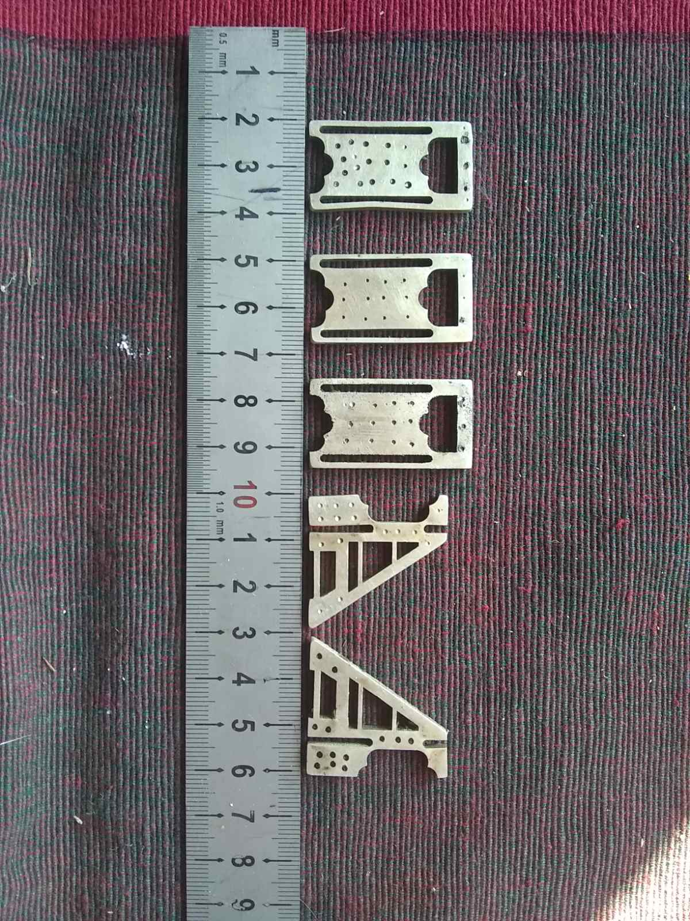

Figure 2. Samples 1 through 5 (left to right).

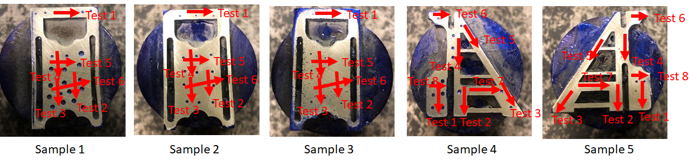

Figure 3. Surface Roughness Test Directions. Arrows represent the direction along which the different measurements were performed.



Figure 4. Sanding Process. Mounting the sample to a 0.875 lbs rod and sanding in a figure 8 pattern.

|  |  |  |  |  |
| --- | --- | --- | --- | --- |
|  |  |  |  |  |
|  |  |  |  |  |
| **Sample 1** | **Sample 2** | **Sample 3** | **Sample 4** | **Sample 5** |

Figure 5. Sanded Parts Flatness Check Using Dykem

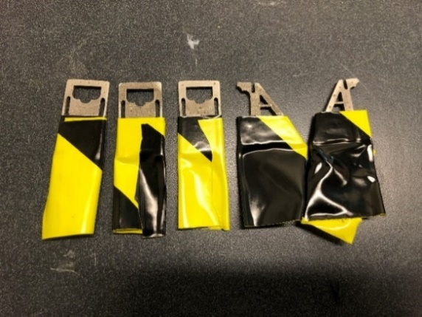

Figure 6. Sandblasting Setup and Sample Preparation.

 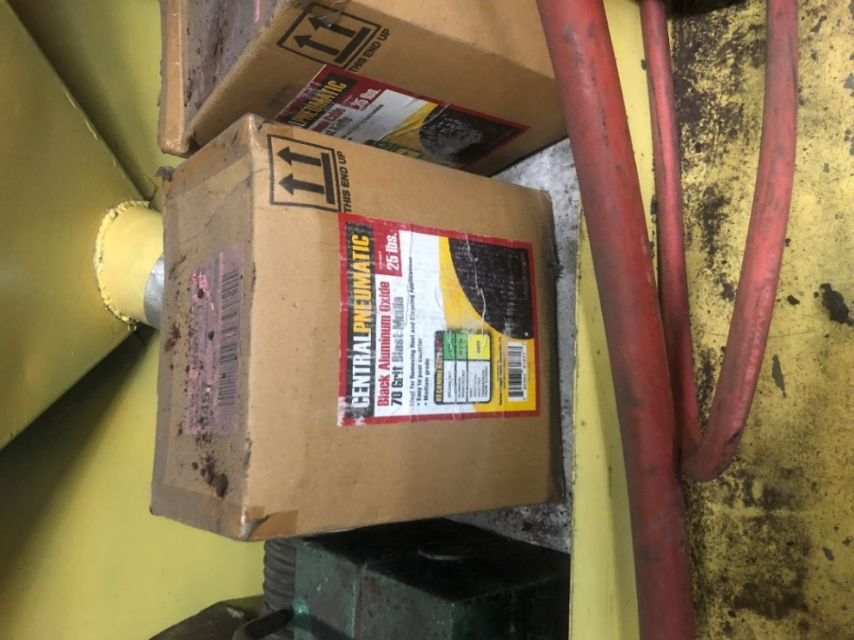

Figure 7. Tumbling Setup and Media Used.

# **Experimental Data**

Table 1 – Average Surface Roughness Values for Sanding

|  |  |  |  |  |  |  |
| --- | --- | --- | --- | --- | --- | --- |
| Average Surface Roughness Values for Sanding | | | | | | |
|  | **Untreated** | | **Sanding** | | **Percent Change** | |
| **Sample** | Ra (μm) | Rt (μm) | Ra (μm) | Rt (μm) | Ra (μm) | Rt (μm) |
| Sample 1 | 0.343 | 2.720 | 0.219 | 3.107 | -36.2% | 14.2% |
| Sample 2 | 0.450 | 4.370 | 0.151 | 1.729 | -66.4% | -60.4% |
| Sample 3 | 6.727 | 43.690 | 0.186 | 2.803 | -97.2% | -93.6% |
| Sample 4 | 0.340 | 2.687 | 0.146 | 1.595 | -57.1% | -40.6% |
| Sample 5 | 10.145 | 67.112 | 0.153 | 1.998 | -98.5% | -97.0% |

Table 2 – Average Surface Roughness Values for Sandblasting

|  |  |  |  |  |  |  |
| --- | --- | --- | --- | --- | --- | --- |
| Average Surface Roughness Values for Sandblasting | | | | | | |
|  | **Untreated** | | **Sandblasting** | | **Percent difference** | |
| **Sample** | Ra (μm) | Rt (μm) | Ra (μm) | Rt (μm) | Ra (μm) | Rt (μm) |
| Sample 1 | 0.343 | 2.720 | 1.646 | 12.965 | 379.9% | 376.7% |
| Sample 2 | 0.450 | 4.370 | 1.596 | 14.021 | 254.7% | 220.8% |
| Sample 3 | 6.727 | 43.690 | 2.138 | 15.799 | -68.2% | -63.8% |
| Sample 4 | 0.340 | 2.687 | 1.419 | 11.348 | 317.4% | 322.3% |
| Sample 5 | 10.145 | 67.112 | 3.793 | 30.979 | -62.6% | -53.8% |

Table 3 – Average Surface Roughness Values for Tumbling

|  |  |  |  |  |  |  |
| --- | --- | --- | --- | --- | --- | --- |
| Average Surface Roughness Values for Tumbling | | | | | | |
|  | **Untreated** | | **Tumbling** | | **Percent difference** | |
| **Sample** | Ra (μm) | Rt (μm) | Ra (μm) | Rt (μm) | Ra (μm) | Rt (μm) |
| Sample 1 | 0.343 | 2.720 | 0.408 | 4.032 | 19.0% | 48.2% |
| Sample 2 | 0.450 | 4.370 | 0.540 | 5.587 | 20.0% | 27.8% |
| Sample 3 | 6.727 | 43.690 | 6.354 | 38.348 | -5.5% | -12.2% |
| Sample 4 | 0.340 | 2.687 | 0.703 | 7.809 | 106.8% | 190.6% |
| Sample 5 | 10.145 | 67.112 | 8.182 | 53.151 | -19.3% | -20.8% |

Table 4 – Standard Deviation Values of the Surface Roughness Results

|  |  |  |  |  |  |  |  |  |
| --- | --- | --- | --- | --- | --- | --- | --- | --- |
| Standard Deviation Values | | | | | | | | |
|  | **Untreated** | | **Sanding** | | **Sandblasting** | | **Tumbling** | |
| **Sample** | Ra (μm) | Rt (μm) | Ra (μm) | Rt (μm) | Ra (μm) | Rt (μm) | Ra (μm) | Rt (μm) |
| Sample 1 | 0.054 | 1.751 | 0.096 | 1.677 | 0.145 | 1.983 | 0.086 | 1.325 |
| Sample 2 | 0.202 | 1.141 | 0.032 | 0.391 | 0.195 | 2.733 | 0.114 | 2.351 |
| Sample 3 | 1.086 | 8.340 | 0.097 | 1.808 | 0.545 | 4.946 | 0.979 | 8.212 |
| Sample 4 | 0.039 | 0.464 | 0.040 | 0.410 | 0.128 | 3.574 | 0.470 | 4.270 |
| Sample 5 | 2.191 | 8.666 | 0.021 | 0.955 | 0.834 | 7.595 | 1.573 | 14.688 |
| **Avg.** | **0.714** | **4.072** | **0.057** | **1.048** | **0.369** | **4.166** | **0.644** | **6.169** |

Figure 8. Sample 1 Surface Roughness Data

Figure 9. Sample 2 Surface Roughness Data

Figure 10. Sample 3 Surface Roughness Data

Figure 11. Sample 4 Surface Roughness Data

Figure 12. Sample 5 Surface Roughness Data

Figure 13. Sample 1. Average Ra and Standard Deviation

Figure 14. Sample 2. Average Ra and Standard Deviation.

Figure 15. Sample 3. Average Ra and Standard Deviation.

Figure 16. Sample 4. Average Ra and Standard Deviation.

Figure 17. Sample 5. Average Ra and Standard Deviation.

**Discussion**

Table 1 shows the average surface roughness values for sanding. For all of the samples, the surface roughness decreased substantially. The roughest samples were sample 5 and sample 3 which saw a 97% and 98% decrease in the Ra values, respectively. The Rt value for sample 5 saw a 97% decrease and sample 3 saw a 94% decrease in Rt value. The Rt value for Sample 1, however, experienced a 14% increase. On the third run of the surface measurement, abnormally high values were recorded for Ra and Rt. A visual inspection of the part showed a scratch in the area that was tested. This scratch was most likely made when handling the part in the lab. If this data run is not incorporated in the calculations, the Rt value decreased by 8%.

|  |  |  |  |  |
| --- | --- | --- | --- | --- |
|  |  |  |  |  |
|  |  |  |  |  |
| **Sample 1** | **Sample 2** | **Sample 3** | **Sample 4** | **Sample 5** |

Figure 18 – Samples After Sanding (note that Dykem was used to check for flatness)

The second process performed was sandblasting. Table 2 shows the surface roughness values measured. For the parts that were relatively smooth (Samples 1 , 2 and 4) the surface roughness increased substantially. The Ra value of Sample 1 increased by 380%, Sample 2 by 255%, and sample 4 by 317%. For these three parts, sandblasting with the media selected is certainly not a viable option for increasing the smoothness. However, for the rough surface of samples 5 and 3, it is a possibility. Both of these had a decrease in the Ra and Rt values. After sandblasting, sample 3 had a decrease of 68% for the Ra value and a decrease of 64% for the Rt value. Sample 5 experienced similar results. This is due to the fact that these samples had a lot of sharp edges on the surface that were smoothed out after being sandblasted. After sandblasting, sample 5 showed clear and severe pitting as seen in Figure 19.

|  |  |  |  |  |  |  |  |  |
| --- | --- | --- | --- | --- | --- | --- | --- | --- |
|  | |  | |  | |  |  | |
| **Sample 1** | **Sample 2** | | **Sample 3** | | **Sample 4** | | | **Sample 5** |

Figure 19. Samples After Sandblasting

The last process performed was tumbling the samples with media for 2 days. The results of the surface finish can be seen in Table 3. This process provided similar results to sandblasting. Sample 1 , 2 and 4 all ended up with a rougher surface. Sample 1 and 2 both saw 20% increase in the Ra values and a 48.2% percent and 27.8% increase in the Rt values. Sample 4 saw the highest change of all samples with a 106.8% increase in the Ra value and a 191% increase in the Rt value. As with sandblasting, the rougher finish of sample 5 and sample 3 was smoothed out. The Ra value of sample 3 decreased by 5% and the Rt value decreased by 12%. Sample 5 saw a 19% decrease in the Ra value and a 21% decrease in the Rt value.

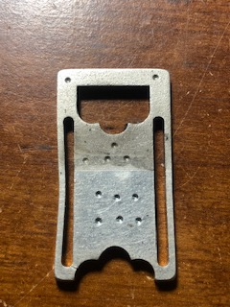 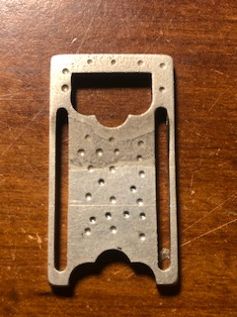 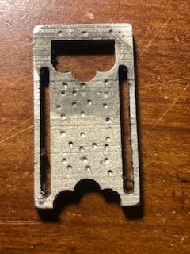 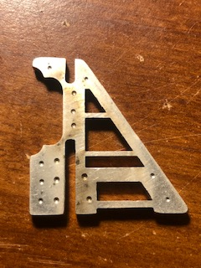 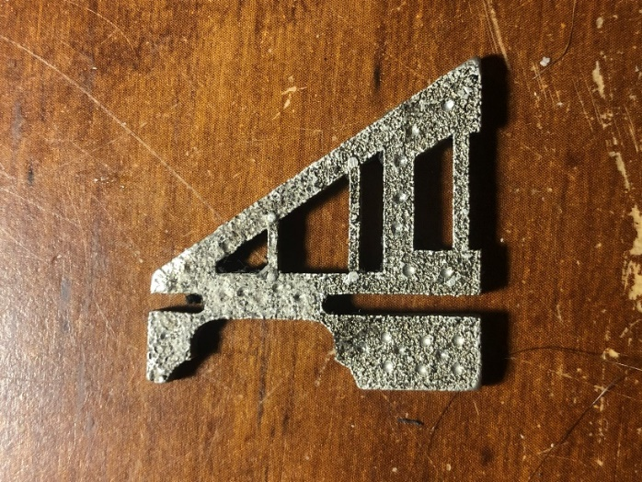

Sample 1 Sample 2 Sample 3 Sample 4 Sample 5

Figure 20. Samples After Tumbling

Figures 18 - 20 show the surfaces of the samples for the processes performed. Table 4 and Figures 13 - 17 show the values of the standard deviations of the Ra and Rt values measured for each sample. For the Ra values, it is clear from this data, that sanding gives the most uniform surface finish in all cases, including the untreated sample. For sand blasting and tumbling, all measurements except for sample 3, yield lower standard deviations. For the Rt values, the same is observed, except that for Sample 5, the difference is even more noticeable, the standard deviation goes from a value of 0.95 for sanding to 7.95 for sandblasting to 14.69 for tumbling. Sample 5 in particular had the roughest untreated surface as shown in Table 1.

In order to create more uniform 3-D printed jewelry pieces that will keep their strength and their surface characteristics, more analysis should be conducted to try to relate the composition of the sample, the printing parameters, heat dissipation rate to surface finish and physical properties in general. The challenge is not only in obtaining these relationships but also to procure larger samples. These are usually difficult to procure and expensive to create.

**Conclusion**:

The surface finish of 5 samples of 3-D printed jewelry pieces were analyzed by mechanical engineering students in their senior year. Sanding, sandblasting and tumbling were performed on all samples and the resulting surface finish measured. Ra and Rt values were used as a reference. Sanding at 1500 grit showed the best results. In this case, the surfaces saw an improvement, with a decrease in the Rt and Ra values in the 90%. Sandblasting showed mixed results with three of the five samples showing a drastic increase in the Ra and Rt values, up to 380%, while the other two showed about 60% decrease in the Ra and Rt. Tumbling yielded similar results as sandblasting, Ra and Rt values increased for three samples, up to 106% and 191 %, respectively. Increase in these values was observed in the remaining 3 samples, of up to 19% and 21% for Ra and Rt on one sample, respectively.

**References**

1. Caulfield, B, McHugh P. and Lohfelds., “Dependence of mechanical properties of polyamide components on build parameters in the SLS process”, Journal of Materials Processing Technology, Vol. 182, No. 1/3, pp. 477-488, 2007
2. Gibson, I., Rosen, D., and Stucker, B., Additive Manufacturing Technologies, 2nd ed. New York, NY, USA: Springer-Verlag, 2015.
3. Groza, J. R., Shackelford, J.F., “Materials Processing Handbook”, 2007 ISBN 9780429122330 taylorfrancis.com
4. Korium, M.S., Roozbahani, H., Alizadeh, M., Perepelkina, S. and Handroos, H., 2021. Direct Metal Laser Sintering of Precious Metals for Jewelry Applications: Process Parameter Selection and Microstructure Analysis. IEEE Access, 9, pp.126530-126540.
5. Laureijs, R. E, Roca, J. B., Narra, S. P., Montgomery, C., Beuth, J. L., and Fuchs, E. R. H., ``Metal additive manufacturing: Cost competitive beyond low volumes,'' J. Manuf. Sci. Eng., vol. 139, no. 8, Aug. 2017, Art. no. 081010, doi: 10.1115/1.4035420.
6. Muammel M. Hanon, József Dobos, László Zsidai,The influence of 3D printing process parameters on the mechanical performance of PLA polymer and its correlation with hardness, Procedia Manufacturing, Volume 54, 2021, Pages 244-249, ISSN 2351-9789.
7. Qin, Y., Qi, Q., Scott, P. J., and Jiang, X., ``Status, comparison, and future of the representations of additive manufacturing data,'' Comput.-Aided Des., vol. 111, pp. 44-64, Jun. 2019, doi: 10.1016/j.cad.2019.02.004.
8. Xometry - <https://www.xometry.com/> .
9. Wang, X., Jiang, M., Zhou, Z., Gou, J. and Hui, D., ``3D printing of polymer matrix composites: A review and prospective,'' Compos. B, Eng., vol. 110, pp. 442-458, Feb. 2017, doi: 10.1016/j.compositesb.2016.11.034.

**Bibliographies**:

**HANI SAAD, PhD**. Dr. Saad earned his BS and MS degrees in mechanical engineering from Marquette University, WI in 1997 and 1999, respectively. He received his PhD from Washington State University also in mechanical engineering in 2005. He is currently a professor at Eastern Washington University in Cheney, WA.

**HEECHANG BAE, PhD**. Dr. Bae is Assistant Professor in Mechanical Engineering and Technology department at Eastern Washington University. His research focus on producing numerical models and experimental optimization to improve the strength and durability of aerospace materials. His research interests include engineered materials, durability of materials, damage tolerance, FEA and additive manufacturing. Dr. Bae received M.S. and Ph.D. degrees in Mechanical Engineering from University of Washington.

**ROMAN SEMIVRAZHNOV**. Mr. Semivrazhnov earned his BS in Mechanical Engineering from Eastern Washington University in the fall of 2021.

**DAVID TETERIN.** Mr. Teterin earned his BS in Mechanical Engineering from Eastern Washington University in the fall of 2021.