Reduction of Lab Sample Cycle Process Time for Waste Reduction and Cost Saving

Christopher Huebel
cjhuebel@gmail.com
Texas A&M University

Stephen Thompson
swthompson@tamu.edu
Texas A&M University

Behbood Zoghi
zoghi@tamu.edu
Texas A&M University

Abstract

This project aims at reducing the sample cycle time using controlled variables and resources while reducing lab waste and costs and increasing accurate data results. Quantitative research methods were used to find patterns, relationships and make predictions with the goal of a reduced sample cycle process. Through experimental research, correlation between sample cycle time reduction and quasi-experimental sampling was explored in a controlled laboratory setting. This study focused on the different variables within the sampling process and the effect of a controlled change to better understand the impact on the sampling process. Due to the nature of the current sample cycle process in the N.G. organization, the target variables included the laboratories' sample bottle size, temperature, cycle time, testing schedule, etc., due to its controlled environment and ease of access.

Data analyses showed that reducing the sample bottle size from 500ml to 250ml could result in 31% cost savings on lab consumables and 49% lab waste disposal, while safely reducing the sample cycle time. Therefore, it is recommended that the sample size be reduced by half, and sample prepping should be done before receiving the samples on a consistent schedule. These recommendations allow for decreasing costs while improving the accuracy and timeliness of results.

Accurate sample results are fundamental in the production process. The data provided from this project will provide insights for many organizations with improvements towards process enhancement while presumably cutting costs and waste reduction.

Introduction

Sample analysis has been an integral part of any production facility since its inception in the late 1880s. It provides valuable insight into the current operations and processes of the refinery. Yet, the importance of this sample data is stifled by its informal and leisurely cycle time. My organization, N.G., shares this problem, as do many other oil and gas industry refineries. With a quality product such as the methanol produced by N.G., sample analysis and the timely delivery of these results are more critical than ever. Off spec. product (product that does not meet the quality specifications) could result in profit losses for the organization and shareholders as well as a significant increase in downtime. Thus, affecting the global methanol market.
Being the largest methanol production facility in the United States, N.G.'s pure, refined methanol is a key market driver (N.G., 2020). In our organization, one of the critical areas of production is quality control and analysis. Our laboratory at N.G. is tasked with running tests on plant processes such as plant water quality, environmental testing, and crude and final product certification. and final product purity before being shipped to consumers. Sample analysis of plant utilities is one of the most critical aspects in any industry that relies on consistent and accurate data to make crucial decisions. These decisions can impact both the present and future of an organization. In the present case, these utility samples including demineralized water, raw water from a local source, process water, and cooling water, are needed to make instantaneous changes to produce an on-spec Methanol product. These decisions can also impact the future by giving an accurate rate of corrosion in the methanol synthesis process. Corrosion wreaks havoc on process piping located throughout the plant. Corrosion causes the pipe wall thickness to be reduced which could result in ruptured pipe, environmental deviations, and safety impacts to personnel. These samples are needed to keep a close watch on one of the more profound issues in the downstream oil and gas industry, corrosion. Specifically, in production refineries, precise data is vital in quickly changing processes that could improve the quality and quantity of their products. Sample degradation over time can cause inaccurate results that can lead to analysis that is not representative of the process conditions. These samples are significant as they provide operations with the data needed to change the production processes. The basis of all accurate lab data starts with a representative sample. The acquired data allows the lab to provide a “snapshot” of the current process to ensure both operations and engineering make the proper decisions.

This project's scope is to reduce the sample cycle time by experimenting on controlled laboratory variables such as the laboratories' sample bottle size, temperature, testing schedule, etc., while reducing lab waste and costs and increasing accurate data results using quantitative and statistical analysis. With constant changes in the energy industry, organizations have continuously looked for new areas to improve their process. The fluctuating oil and gas market has also driven organizations to try and reduce costs while staying viable in the industry.

Review of Literature

Reduction of cycle times concerning the sampling, testing, and delivery of analysis of petrochemical processes are areas of interest to many refineries. The analysis from these samples plays a vital role in actions taken by operations and engineering to provide the highest quality process. With a focus on improving petrochemical refinery processes such as decreased downtime, better quality products, and increased batch production, this section aims to review articles and journals by understanding existing research and debates relevant to this area of study.
In nature, petroleum, hydrocarbons, and lipids are complex and structurally diverse compounds with different chemical and physical properties. The hydrocarbons that occur are regarded as one of the factors that shape the natural habitats of microorganisms. Analytical tools such as the gas chromatography (GC) and mass spectrometer (Walters, 2015) are used in laboratory experiments to characterize these mixtures of organic compounds in environmental samples. The use of analytical techniques and methods allows for a comprehensive range of sample metrics. Wilkes (2016) notes that methods and approaches toward the useful characterization of diverse interactions are advantageous in noting interactions between microbial communities and complex hydrocarbons. What Wilkes (2016) does not mention in the journal is the detailed analysis of petroleum-derived hydrocarbons. This is vital because many of our hydrocarbons are naturally occurring (Clark, 2018) but are also a considerable driving force for modern civilization when processed. This detailed analysis can be accomplished by Walters (2015) GC analytical methods that provide a fingerprinting and detailed study on a massive scale using spectrometers.

Walters (2015) proposed the analysis method is essential in the data derived from these environmental and petroleum samples. While most of the samples that come through the lab are focused on the processes and productivity of the refinery, environmental samples play an equally important role in all refineries. Again, by using Walters (2015) analytical methods, the sample cycle time can be reduced for environmental samples that require the data of a particular component in the sample. This is important to sample cycle time reduction.

Regardless of the specific type of work a laboratory performs, efficiency is always crucial for increasing productivity and improving repeatable results in analysis. ("5 Tips," 2018) concludes that with a few simple changes, the reader can increase lab efficiency without sacrificing accuracy and, more importantly, safety in your lab. (“5 Tips,” 2018) states that any lab can safely and efficiently improve productivity and repeatability by leveraging the benefits of automation, perfecting lab processes, streamlining workstations, correcting inefficiencies, and investing in quality equipment. While (“5 Tips,” 2018) makes many valid points in the article, there are still several critical elements in the addition of efficiency and productivity in the lab that should have been mentioned. It may have been beneficial to add preparation as an essential element of improvement to efficiency and productivity. Sample and instrument preparation is a crucial element that should be performed in every lab. This can be illustrated by having the instruments ready for testing as soon as the sample arrives. This suggests the need for a strict sample schedule to aid in preparation of instruments and sample preparation. This preparation can aid in the reduction of sample cycle time in all laboratories rather than just those dedicated to petrochemicals.

Paar (n.d.) highlights two of the conventional methods for sample preparation of petroleum products. The first method listed in this article is through dilution of oil samples by use of an organic solvent. The author states that while this traditional method is fast, it is not applicable to samples containing larger particles, leading to clogs and measurement interferences. The second conventional method mentioned is through dry ashing, which burns off the organic matrix of the sample and is then dissolved with acids into an aqueous solution. As Paar (n.d.) states, while allowing for processing of larger sample quantities, this method has a much longer turnaround time than the latter mentioned method. Paar (n.d.) states that a possible solution to these outdated methods is microwave-assisted closed-vessel digestion, which increases the technicians' safety and increases efficiency in sample preparation, reduced risk of contaminations, and a lower number of reagents is required. However, while Paar (n.d.) focuses on the positive aspects of the microwave-assisted digestion, it does not mention the key element of price and special availability in a lab. This article would have been more beneficial if it mentioned the instrument's price and the comparison of time and typical sample size. For samples with smaller quantities, this would cut down on both digestion time and reduction of solvents needed in both of the conventional methods listed. This article would have been more beneficial if the author made comparisons on the price of the instrument to the time saved and the reduction of reagents and solvents needed for the first two methods listed. Proper sample size is a crucial element in reducing sample cycle time. While this article focuses on different technologies to achieve faster and safer analysis, the sample size is the key takeaway. The proper sample size can reduce waste, and aid in sample preparation, especially when the temperature of the incoming sample is a major factor. This allows the sample to be cooled quicker and to be analyzed more rapidly.

The article written by LabVantage Solutions (2018) argues that laboratory information management systems (LIMS) systems are key to helping labs function in a timely manner. LIMS systems are widely employed in a variety of laboratories in an effort to support global operations. LabVantage Solutions (2018) states that some of the key elements a LIMS system should provide are global accessibility, managed compliance, reduced data transcription errors, increased efficiency, reduced costs, and easy access.
While many laboratories around the world use a LIMS system, it’s worth noting that ease of access to information in real-time is a main component of any system. The easy access to data from both laboratory technicians, operations, and engineers combined make these systems highly beneficial in reducing sample cycle time.

Klooster (2012) focuses on the advantages of benchmarking and the benchmarking process in laboratories. The author notes that often times, analytical labs in all industries are under continuous pressure to increase efficiency and decrease costs year after year. The article defines benchmarking as the continuous process of measuring and comparing a labs operation with those of an applicable reference associate group. Klooster (2012) exclaims that benchmarking in an analytical setting offers opportunities for improvement through objectively evaluating risk used to measure a team’s own performance. Benchmarking is also a useful tool in visualizing the strong and weak areas in a team in a constructive way. One key aspect of this article is the focus on both tangible and intangible benefits of benchmarks. Klooster (2012) notes that benchmarking covers all aspects of the laboratory, not just one key area. These focus areas can set key performance indicators (KPIs) and are a key reporting tool for stakeholders. Efficiency is a key aspect of reducing sample cycle time in any laboratory. Benchmarking allows a laboratory to lower the cost of operation, optimize manpower and sample size, and utilize space. One notable aspect Klooster (2012) notes are the intangible benefits such as reduced risk of noncompliance, reduction of IT complexity, and simplification of management structure. These benefits are often shared by the stakeholders and administration, leading to an efficiency within the organization as a whole. Another key part of this article is the alternative outcomes to benchmark testing. While KPIs are a valuable metric, a lab that introduces benchmarking may find a reduction of costs with an increase in safety by outsourcing testing to a third party. Many times, organizations look internally at areas to reduce costs. Klooster (2012) notes that outsourcing to a third party may also be used to perform a benchmark study to evaluate the performance of the lab to point out that there may be no gains by outsourcing.

In the article from Lab Diagnostics (2021), by pairing the two strategies of lab management and stewardship, a laboratory can become the center of excellence that supports an organizations goals and mission. These integral solutions can increase revenue through performing reference testing at marketing prices, leveraging supply and equipment pricing to provide reduced costs, and driving efficiencies with quality assurance and increased productivity. The article believes that a lab may also decrease unnecessary tests and make more informed and proactive data-driven decisions across the organization. One key element this article does not mention however, is the method of the twin strategies of lab management and lab stewardship. While this article mentions many of the benefits of the approaches, it does not relay how a laboratory should incorporate these strategies and the development of each individual process. This is worth noting because many of the benefits listed in the article are predicated on how the strategies are implemented within an organization. With a focus on lab efficiency and sample cycle time reduction, many factors point towards the efficiency in the process, as this article does, however; not fully explaining the process and its integration could lead to a failed implementation and less valuable solutions in this capstones area of focus.

Methodology

Research Design

The research design associated with this project explores the correlation between sample cycle time reduction and quasi-experimental sampling in a controlled laboratory setting; collected data were used to find patterns, relationships and make predictions with the goal of a reduced sample cycle process. With experimental research, the data analyzed will be used to determine the cause-and-effect relationship between variables. For this particular project, the study will focus on the different variables sample testing schedule, analytical testing, and the laboratory employees testing durations within the sampling process and the effect of a controlled change to better understand the impact on the sampling process. Due to the nature of the current sample cycle process in the N.G. organization, the target variable for this research will be take place in the laboratory due to its controlled environment and ease of access. The metrics associated with this research method are listed as sample time arrival, sample temperature, and sample size. These areas will provide adequate data for statistical analysis in the form of quantitative research. During the study, each metric will be observed to determine its natural state. Once observed, each metric will be introduced to a controlled change, and its effects will be recorded and analyzed to determine if the change reduces the sample cycle time. Figure 1 below illustrates the quantitative methodology that will be used for this project.

Figure 1. Research methodology.

Participants

The participants needed for this research are the eight lab technicians and the author of the study. These participants were chosen due to the nature of their positions within the N.G. organization and the variations they offer between shifts, and the style of work they perform. Between the eight lab technicians, there are two technicians on each shift that work a modified Dupont schedule. The schedule can be found below in Figure 2. Each shift works through a 12-hour period, ensuring that coverage inside the laboratory is maintained at all times. During the 12-hour shift, the two technicians get a set of samples at six am/pm and one am/pm, depending on the shift they are working. There are four shifts (A-D), each comprised of different methods and techniques applied by the individual technicians. The observations and experiments will be applied to each shift during their monthly weeklong day shift schedule. This is done to ensure that the research author will be available to participate in observations and experiments. Each shift projects different approaches towards data analysis when the samples enter the laboratory for testing. For example, Shift A will wait approximately 30 minutes before beginning analysis on the samples to ensure that samples have been decreased in temperature to room temperature, around 70° F. Whereas Shift B may start some testing immediately on analysis that is not affected by the temperature of the sample but must still wait for the samples to reach room temperature to begin other analysis. The variations between each shift team ensure that the research project will benefit from a wide range of data that encompasses all participants.

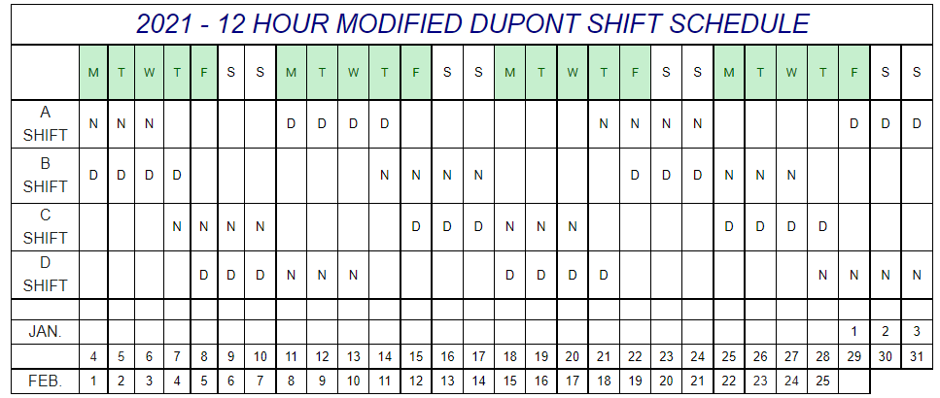
Figure 2. Twelve-hour modified Dupont Shift schedule.

Instruments

The instruments used in this research project will be used to collect, measure, and analyze data related to the research project (Teachers College, Columbia University, n.d.). The instruments primarily consist of both observations and experiments. The observation instruments are made up of 4 different forms of research. The first is structured observations, where the observation is conducted at a specific time and place where the participants are observed in a standardized procedure (Teachers College, Columbia University, n.d.). The second observation instrument is observing the participants in their natural state. The participants in this instrument are laboratory employees and are observed during their dedicated shift when samples arrive at the lab for analysis. These data will show the instinctive behaviors such as immediate or delayed sample analysis of participants in the laboratory setting observed by the researcher from a personal view. The third observation instrument is through participation; in this study, the researcher plays an active role in the group being observed to gain a deeper insight into the actions taken by each team. The fourth key instrument used to collect data for this research project is experimentation. According to Professional Writing Bay (n.d.), these experiments are conducted within a laboratory setting to test potential outcomes on the research project purpose. These experiments are designed to consider different approaches to achieve the final result. For this project, independent variables will be manipulated and applied to one or more dependent variables (Table I) to measure the cause-and-effect (Formplus Blog, 2020).

Table I. Variables within this study.
Independent Variables | Dependent Variables
Sample Bottle Size (250ml/500ml) | Temperature of sample
Initiated response to arriving samples | Sample schedule

Experimental design is typically composed of three different types, pre-experimental, quasi-experimental, and true experimental research. Due to the structure of this research, beginning with approximate questions such as “does the sample container size have an effect on cooling effects and times on samples” and focusing on the observed data and composing analytical data to reach conclusions, a key quantitative data set will be based on quasi-experimental research. This instrument was mainly chosen to work with a selected group of participants rather than at random. This concept is also key due to the ability to control the experiment's setting. The three primary variables in experimental research design are the variables involved, the environment, and the multivariable according to Formplus Blog (2020).

According to Formplus Blog (2020), the measurements and scales in this research will define the different ways the variables are defined and grouped into different categories. For this project, measurement scales (interval scales and Behavior Observational Scales) will be used to record the observations collected through the research being conducted. This research will also use scaling to assign numbers and semantics to objects and variables. Because this project focuses on reducing cycle time in the sampling process, the study will rely heavily on the interval scale. The interval scale is a scale that labels, orders, and applies a specific interval of time between its variables. An example can be seen below in Figure 3. For this research, an interval scale will be used to test the temperature of each sample in both the 250ml and 500ml containers to record the time it takes for each container to reach the appropriate analytical testing temperature according to the testing procedures. Another essential observational scale is the Behavior Observation Scale (BOS). The BOS measures behaviors against levels of performance and measures the frequency in which they occur (US Legal.com, n.d.). This scale will be used in conjunction with the observations instruments to render statistical data from the observations.

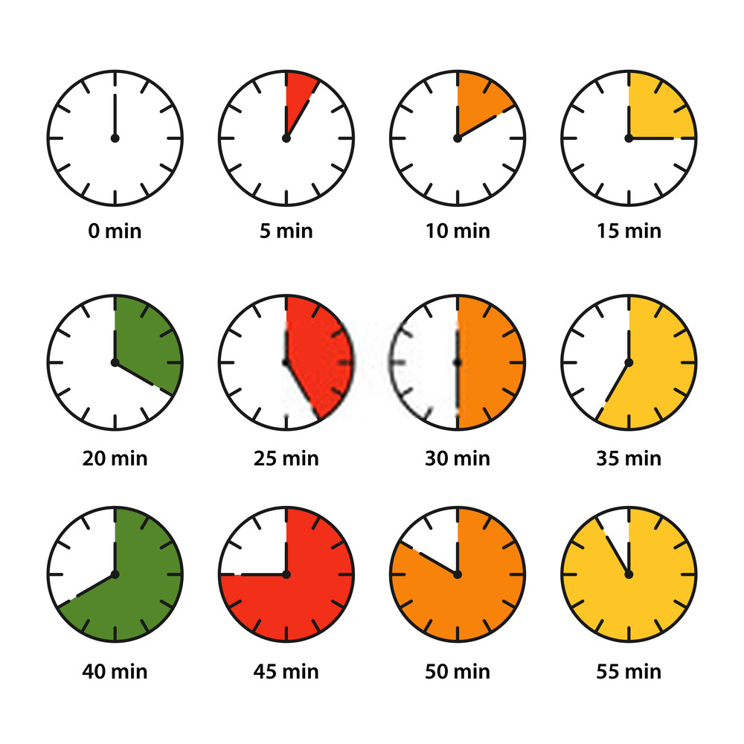
Figure 3. Interval scale example.

Procedures

The first variable in this experimental research involves the sample size. Each sample is typically supplied in a one-quart bottle. During this experiment, each sample will be reduced to 250 milliliters (ml). This is done to test the appropriateness of each sample based on the tests being run on the sample during routine analysis. Another factor that will be observed is the cooling rate for both the quart and the 250 ml bottle. By cooling both sample variables simultaneously, the goal of this experiment is to provide faster cooling via a smaller and more adequate sample size. The second variable is the length of time taken for the team on shift to begin testing the sample. The participants will be observed in their natural state for the first two days of their four-day shift. During that time, observations will be conducted on the time it takes for the team to begin testing on the samples when they enter the lab. During the last two days of the shift, participants will begin work immediately after the samples enter the lab. During this time, testing that does not require temperature reduction will be started while the samples are cooling. After samples are cooled to room temperature, they will be run according to the Hach Iron (Fe) method. Once data is entered into the laboratory information management systems (LIMS) system, the experiment will cease.

Data Analysis Plan

Data analysis can be defined as the process of organizing and analyzing the data collected by the research. Data analysis is used for applying statistical techniques to illustrate and assess data. A data analysis plan is also a valuable tool in planning the study and visualizing the project's goals and outcomes. According to an article written by (Banks et al., 2013), there are four main components of a data analysis plan: background, aims, methods, and planned tables and figures. The background for the conducted research aims to reduce the sample cycle time in an industrial process. While this project's primary focus is on sample cycle time reduction, it also aims to achieve: one, with a reduced sample size that is adequate only for the testing needed, the lab may reduce the sample cycle time by bringing the sample temperature down quicker and reducing lab waste with smaller sample size; and two, with a reduced sample size, lab costs will be reduced from purchasing smaller sample containers for a lower price compared to quart-size bottles. With reduced lab waste, the lab waste will be disposed of less frequently, leading to a reduction in costs. The BOS scale is used to organize the quantitative data (Figure 4). Quantitative data collected will be put into Excel to establish relationships and variable outcomes, also known as descriptive statistics. Descriptive statistics for this project summarize data into tendencies, variations and deviations, standards, and relationships (please contact author for data request).

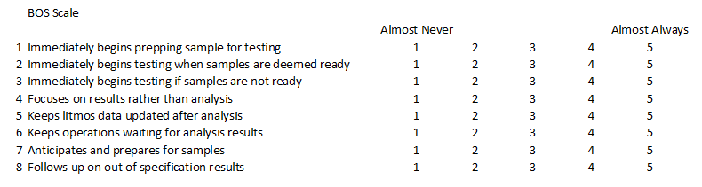
Figure 4. Behavior Observation Scale (BOS) used for quantitative data.

For the first stage in the data collection for this project, structured observations were studied and transformed into quantitative data using the BOS scale. The participants were observed first in their natural state and then introduced to a controlled change. Their responses were recorded on the BOS scale and resulted in the chart represented by Figure 5. Using the BOS scale, a set of questions tailored to the research project were used to transform the observations in the laboratory to valuable quantitative data. This is significant in relation to having a statistical value represent behavioral observations. A percentage is calculated based on the Figure 5 below, for example, 4 out of 5 on the BOS scale represented all shifts, which equal to 80%. The resulting analysis of the observation showed that on average, across all of the shifts, 80% of the time, each shift immediately began prepping the sample when it arrived at the laboratory. Meaning the sample was placed in the cooling bath, and the sample cells were cleaned and ready for use. 70% of the shifts began testing immediately when the samples were deemed ready. Samples are considered prepared when they reach room temperature, as stated previously. Another 70% immediately updated LIMS with sample results after the participants completed the analysis. After completing the testing on all of the full sets of samples, results are entered and updated into the LIMS system. Only 55% of the shifts anticipated and prepared for sample arrival. This would include prepping the bath at the proper temperature, having cleaned instruments and glassware, and an available instrument to run the tests on. Finally, 90% of the shifts followed up with Operations on out-of-specification results. A set of guidelines and specifications are issued for each test, designed to represent the optimal range of the analyzed components in the plant’s process. These results represented time-saving methods and averaged 73% across all shifts. On the other end of the spectrum, the participants averaged 50% in time disruption methods. 35% of the time, the participants would immediately begin testing even if the samples were not ready. This could lead to inaccurate analysis and the spread of misinformation. A staggering 65% of the shifts focused on results rather than analysis. Indicating that while the samples may have been out of specification range, it caused no concern to the lab. Instead, the shift would inform the operations supervisor of the abnormal result and pay no more attention. 50% of the time, the participants would keep operations waiting for analysis results. Indicating that after the samples were analyzed, the shift would take a small break or partake in other actions. However, this last analytic may be considered somewhat misleading. Suppose Operations or Engineering brought abnormal or off-schedule samples to the lab during or soon after the regularly scheduled samples, it could skew the results in a different experiment run by someone else. In that case, these samples generally take priority and are considered a rush. Thus, delaying the input of the sample analysis.

Figure 5. Observational data recorded in BOS, Green = Time Saving Methods, Red = Time Disruption Methods

It is important to note that while many return on investments (ROIs) are associated with profits and expenses, this project’s return focuses on cost savings and improved accuracy rather than a cost-associated percentage or ratio. The laboratory in N.G. is considered a cost center rather than a profit center. An article written by Accounting Tools in 2021 states that “a cost center is a reporting unit of business that is responsible for costs incurred” (Bragg, 2021). In contrast, a profit center is defined as “a reporting unit of business that is responsible for profits generated” (Bragg, 2021). Because the laboratory only incurs costs associated with testing the final product of Methanol and quality control, the N.G. laboratory is considered a cost center. This is important to note as the project closely relates to cost savings rather than generating profit and income needed to calculate a traditional ROI.

For this project, the financial cost comes from purchasing the sample bottles needed for the experiment. This cost was precisely $430.14, which includes a case (250 bottles) of 250ml bottles shown in Figure 6.
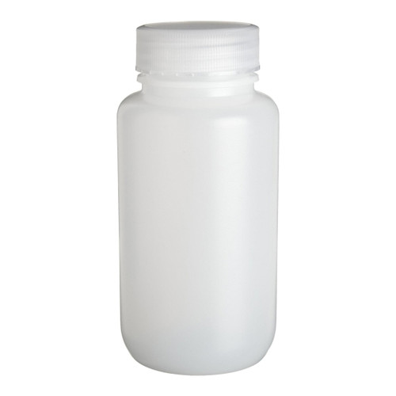
Figure 6. 500ml (left) vs. 250 ml (right) sample bottles.

The laboratory uses approximately 13 bottles (including reuse) every week. This means an order for sample bottles would have to be made roughly every 19 days. This equates to an average of 19 orders a year, costing a total of $8,172.66 yearly. This can be compared to the cost of ordering 500 ml sample bottles in a case of 125 at $312.83 a case. At the same rate applied to the 250 ml sample bottles, an order placed every 19 days would equal $625.66 (each order would contain two cases) and would average a yearly cost of $11,887.54. Ultimately this results in a cost savings of 31% compared with the use of 500 ml bottles. These calculations were done in Excel Spreadsheet and can be seen below in Table II.

Table II. Cost savings of sample bottle consumable.
Number of bottles in a case (250ml) | 250
Cost of case of 250 sample bottles | $430.14
Sample bottles used weekly | 13
Order to be made every: | 19.2 days
 | 19 orders a year
Cost of orders a year (250ml) | $8,172.66
Number of bottles in a case (500ml) | 125(x2)
Cost of case of 250 sample bottles | $625.66
Sample bottles used weekly | 13
Order to be made every: | 19.0 days
 | 19 orders a year
Cost of orders a year (500ml) | $11,887.54

This same cost savings method can be applied to reducing lab waste disposal costs. Laboratory waste is disposed of in a 5-gallon waste bucket and is disposed of at a rate of $99 a bucket. When using 500 ml sample bottles, a 5-gallon bucket is filled approximately every 18 hours, totaling roughly 41 buckets a month. At the current rate of $99, this equates to $4,059 a month in waste disposal costs. With the reduction of a sample size to 250 ml, a 5-gallon bucket is filled approximately every 36 hours, equating to 20 buckets a month. Ultimately, cutting the cost of lab waste disposal each month, using 250 ml bottles, to $1980. This reduces the waste in the laboratory by half and, in return, cuts down on the cost of disposal by roughly 51%. These calculations can be seen below in Table III. The cost savings associated with this project reduce operating expenses that may be of value in a different aspect of the facility funding.
Table III. Cost savings of waste disposal.
Waste disposal - 500ml bottle
Waste disposal of 5-gallon drum | $99
Buckets filled in a month | 41
Amount of time taken to fill up drum | 18 hours
Cost of waste disposal in a month (500ml) | $4,059.00
Waste disposal - 250ml bottle
Waste disposal of 5-gallon drum | $99
Buckets filled in a month | 20
Amount of time taken to fill up drum | 36 hours
Cost of waste disposal in a month (250ml) | $1,980.00

With any investment, there are always some forms of inherent risks. For investments, “increased potential returns on investment usually go hand-in-hand with increased risk” (Corporate Finance Institute, 2022). While many would consider the financial expense the only cost related to the ROI, one can assume that the risk of the project and the risk reduction can be added to the ROI. In an article written by the Center for Internet Security, “implementing new solutions and controls will likely require a monetary expense. This is where you’ll benefit from the ability to determine the cost of a potential risk versus the cost of the control” (Center for Internet Security, 2019). The reduction of risk can be calculated using the following formula: Reduction in risk = annualized rate of occurrence x expected monetary loss for a single event x reduction in the probability of risk occurrence with the implemented control. (Center for Internet Security, 2019). The risk reduction can cause a rise in costs associated with the ROI. While this project has inherently low risks as the project’s costs are low, one of the main risks factors is limited resources. Because the project relies on third-party suppliers to supply sample bottles, there is a risk of not having these resources when needed. This risk can be resolved by purchasing an extra case of sample bottles every time an order is placed. This would help reduce the risk of limited resources but would incur the additional cost of another case of sample bottles ($430.14).

The returns on the investment can be realized through cost savings, increased efficiency, and improved accuracy. Increased efficiency in the laboratory can be achieved by reducing lab waste, improving processes, and the project’s main goal, which is to reduce sample cycle time. Finally, it should be noted that there is also an increase in safety with an increase in efficiency. This increase in safety makes the benefits outweigh the costs in any return-on-investment scenario. Improved accuracy is accomplished by capitalizing on the previous results of the observations and experiments noted in the methodology research.

Recommendations and Conclusion

Based on the quantitative data collected and analyzed, it can be concluded that reducing the sample bottle size can ensure cost savings on consumables and lab waste disposal while safely reducing the sample cycle time. By cutting costs associated with the resources needed for the project and the reduced lab wastes, the reader can safely assume that a reduction of sample time is genuinely possible and creates a favorable monetary result. By reducing the size of the sample bottle from 500 ml to 250 ml, a reduction of cost by 31% is observed in concurrence with the decrease in lab waste which results in a reduced disposal cost of 49%. Therefore, it is recommended that the sample size be reduced by half to 250ml and prepping for the samples should be done before receiving the samples on a consistent schedule. These recommendations allow for decreasing costs while improving the accuracy and timeliness of results.

There can be no doubt that through the research and data collected, the preceding recommendations will allow for a positive impact on the project's primary goal of reducing sample cycle time while reducing costs.

References

Banks, E., Paige, E., & Mather, T. (2013). Developing a quantitative data analysis plan for observational studies. Retrieved from https://rsph. anu. edu. au/files/Data_Analysis_Plan_Guide_20131125_0. pdf.
Bragg, S. (2021). The difference between cost center and profit center — Accounting Tools. [Online]. Retrieved from https://www.accountingtools.com/articles/2020/11/23/the-difference-between-cost-center-and-profit-center#:~:text=The%20main%20difference%20between%20the,to%20have%20a%20complex%20structure. [Accessed: 26- Feb- 2022].
Business Queensland. (2016, June 22). Benefits and limitations of SWOT analysis. [Online]. Retrieved from https://www.business.qld.gov.au/starting-business/planning/market-customer-research/swot-analysis/benefits-limitations. [Accessed: 17-Nov-2021].
Center for Internet Security. (2019, September 18). The one equation you need to calculate risk-reduction ROI. Retrieved from https://www.cisecurity.org/insights/blog/the-one-equation-you-need-to-calculate-risk-reduction-roi. [Accessed: 22-June-2021].
Corporate Finance Institute (2022, February 8). Risk and return, a highly correlated relationship. [Online]. Retrieved from https://corporatefinanceinstitute.com/resources/knowledge/trading-investing/risk-and-return/. [Accessed: 26- Feb- 2022].
Fernando, J. (2022, May 23). Return on investment (ROI). [Online]. Retrieved from https://www.investopedia.com/terms/r/returnoninvestment.asp. [Accessed: 22 June- 2022].
Formplus Blog (2020, January 23). Experimental Research Designs: Types, Examples & Methods. [Online]. Retrieved from https://www.formpl.us/blog/experimental-research. [Accessed: 15-Nov-2021].
Formplus Blog (2020, October 20). 7 types of data measurement scales in research. [Online]. Retrieved from https://www.formpl.us/blog/measurement-scale-type. [Accessed: 16-Nov-2021].
Harris, A. D., McGregor, J. C., Perencevich, E. N., Furuno, J. P., Zhu, J., Peterson, D. E., & Finkelstein, J. (2006). The use and interpretation of quasi-experimental studies in medical informatics. Journal of the American Medical Informatics Association, 13(1), 16-23.
Klooster (2012). Benchmarking of Analytical Laboratories, the advantages of benchmarking and the benchmarking process. [Online]. Retrieved from https://www.intertek.com/outsourcing/laboratory/benchmarking/white-paper/. [Accessed: 22-June-2022].
Labnet International. (2018, October 15). 5 tips to improve efficiency in your lab. [Online]. Retrieved from https://www.labnetinternational.com/blog/2018/10/5-tips-improve-efficiency-your-lab. [Accessed: 25-Oct-2021].
Quest Diagnostics. (2021). Lab optimization. [Online]. Retrieved from: https://www.questdiagnostics.com/business-solutions/hospitals-health-systems/lab-optimization. [Accessed: 05-Nov-2021].
LabVantage Solutions (2018, April 14). Oil & gas industry: extracting efficiency from your LIMS. [Online]. Retrieved from https://www.labvantage.com/oil-gas-industry-extracting-efficiency-from-your-lims/. [Accessed: 25-Oct-2021].
N.G. (2020, December 14). [Online]. Retrieved from https://www.natgasoline.com/. [Accessed: 11-Oct-2021].
Paar, A. (n.d.). Sample preparation of petroleum products. [Online]. Retrieved from https://wiki.anton-paar.com/en/sample-preparation-of-petroleum-products/. [Accessed: 25-Oct-2021].
Professional Writing Bay (n.d.). Examples of Research Instruments. [Online]. Retrieved from https://www.professionalwritingbay.com/examples-of-research-instruments.html. [Accessed: 15-Nov-2021].
Symonds, M (2014). SWOT analysis in Project Management PDF [Online]. Retrieved from https://images.template.net/wp-content/uploads/2016/01/18110551/swot-analysis-in-project-management-pdf.pdf. [Accessed: 18-Nov-2021].
Teachers College, Columbia University (n.d.) Research Instrument Examples. [Online]. Retrieved from https://www.tc.columbia.edu/media/administration/institutional-review-board-/guide-amp-resources---documents/Published_Study-Material-Examples.pdf [Accessed: 22-June-2022].
Twproject (2021, May 14). SWOT analysis of a project, how to do it and why. [Online]. Retrieved from https://twproject.com/blog/swot-analysis-project/. [Accessed: 19-Nov-2021].
US Legal.com (n.d.). Behavior Observation Scale Law and Legal Definition. [Online]. Retrieved from https://definitions.uslegal.com/b/behavior-observation-scale/#:~:text=A%20behavior%20observation%20scale%20%28BOS%29%20is%20an%20appraisal,in%20school%20and%20work%20environments%2C%20and%20other%20uses. [Accessed: 17-Nov-2021].
Walters, C.C. (2015). Protocols for GC-based methods for generic and environmental hydrocarbon analysis. McGenity, T., Timmis, K., Nogales, B. (eds) Hydrocarbon and Lipid Microbiology Protocols. Springer Protocols Handbooks. Springer, Berlin, Heidelberg. https://doi.org/10.1007/8623_2015_190
Wilkes, H. (2016). Introduction to petroleum, hydrocarbon, and lipid analysis. McGenity, T., Timmis, K., Nogales, B. (eds) Hydrocarbon and Lipid Microbiology Protocols. Springer Protocols Handbooks. Springer, Berlin, Heidelberg. https://doi.org/10.1007/8623_2016_217

Author Biography

MR. CHRISTOPHER HUEBEL is currently the Senior Laboratory Technician / Utilities Specialist at Natgasoline LLC. He obtained his Bachelor of Science degree in Industrial Technology from Lamar University and Master of Science degree in Engineering Technical Management from Texas A&M University. He can be reached at cjhuebel@gmail.com.
DR. STEPEHN THOMPSON holds a Ph.D. in chemistry from the University of Dundee, Scotland. Thompson has 30 years’ industry experience, with a focus on technology, processes, operational methods and quality associated with electronics, procurement, and distribution. He is a veteran industry professional with expertise in semiconductor processes, equipment fabrication, operations, supplier management, and quality. Thompson has a proven record of driving world-class performance for global operations, quality and products through immediate improvement actions, defect prevention, model-based decision making and organizational commitment to performance management systems. He is an excellent team builder, analyst and problem solver, and an expert in implementing solutions in large, complex, and time-critical organizations.
Thompson’s corporate career includes senior management experience in Europe, Asia, and North America. Thompson has lived in the United States, Denmark, Switzerland, and the United Kingdom, and traveled extensively throughout Europe and Asia. He can be reached at swthompson@tamu.edu

DR. BEHBOOD ZOGHI is the Victor H. Thompson chair professor of Electronics System Engineering Technology at Texas A&M. He directs the RFID/Sensor Lab and the new online professional Master of Engineering in Technical Management program. A member of the Texas A&M University faculty for 30 years, he has distinguished himself as a teacher, writer, and researcher, and has been honored for his teaching excellence by the College and the Texas A&M University Association of Former Students. Ben’s academic and professional degrees are from Texas A&M (PhD), The Ohio State University (MSEE), and Seattle University (BSEE). Dr. Zoghi may be reached at zoghi@tamu.edu.

