047-x-22

Developing a Performance Assessment Framework for Petrochemical Maintenance Work

Jiyong Choi
Department of Manufacturing and Construction Management
Central Connecticut State University
jaychoi@ccsu.edu

Namhun Lee
Department of Manufacturing and Construction Management
Central Connecticut State University
leen@ccsu.edu

Myungjin Chae
Department of Manufacturing and Construction Management
Central Connecticut State University
chae@ccsu.edu

Jaeho Cho
Department of Architectural Engineering
Dankook University
11991030@dankook.ac.kr

Abstract

Maintenance is a crucial activity in the process industry in order to maintain consistent production capacity. To achieve successful maintenance outcomes, asset owners and managers need to know the relationship between the outputs of the maintenance process by evaluating their contributions to the business goal. Benchmarking is defined as the systematic process of measuring one’s performance against recognized leaders for the purpose of determining which practices lead to superior performance. Although rigorous efforts have been made into benchmarking capital projects over the last decades, few have focused on benchmarking maintenance work performance especially for petrochemical facilities. Some researchers introduced performance indicators tailored for the process facility maintenance, they failed to develop a platform for collecting performance data and generating benchmarking outcomes. To bridge the gap in knowledge and practice, this research aims at developing a performance assessment framework building on the existing benchmarking programs along with knowledge in maintenance performance assessment. The framework has been developed through an interactive process that relies on input from both industry subject matter experts (SMEs) and researchers at Construction Industry Institute (CII). The framework adopted both leading and lagging indicators that can be used as predictors of levels of maintenance performance (i.e., leading indicators) and measures linked to the outcomes of maintenance activities (i.e., lagging indicators). It is expected that the proposed framework is effective for the evaluation of maintenance performance, thereby assisting asset owners and managers of petrochemical facilities in improving strategies for successful maintenance.

Introduction

Maintenance is defined as “the combination of all technical, administrative and managerial actions carried out during the life of an item intended to retain it in, or restore it to, a state in which it can perform its required function.” (Moubray, 1997). Maintenance plays an important role to the production process that transforms raw material into final products, with the purpose of keeping the process running and maximizing the availability of production (Shan et al., 2020). Maintenance tasks in the petrochemical industry have one unique characteristic, which is they are more vulnerable to risks and are more likely to be on the critical path of the production schedule (Guiras et al., 2018). It is, thus, vital to reduce the durations of the maintenance tasks carried out in petrochemical facilities, minimizing the disruption, and making sure that production resumes as quickly as possible. It is generally accepted that maintenance is a key function in sustaining long-term profitability for organizations and it is viewed as a value-adding activity (Parida et al., 2015).

Maintenance management supports the effective production process by eliminating and reducing the frequency and the severity of equipment failures. In order to increase the economic benefits of plants by improving availability, flexibility, and operability of equipment in a cost-effective way, sound maintenance management strategy and up-to-date maintenance technology, and reliable maintenance service systems are all important. Searching for the best-in-the-class practices is an important part for improving the maintenance management practice, and benchmarking can be a quick and efficient way to achieve this result. Therefore, it is necessary for asset owners and managers to assess and benchmark maintenance performance of their plants.

Benchmarking is a systematic, data-driven process of continuous improvements that involves gauging performance to identify, achieve, and sustain best practice (Choi et al., 2020). It requires assessing project data through performance metrics and comparing the measures with similar data compiled by other organizations. To this end, the results enable an organization to establish improvement targets by explicitly identifying the gaps with their peers and assist in promoting changes for better project outcomes (Choi et al., 2018). Nowadays, in a very competitive global environment, benchmarking is recognized as a common practice to manage capital projects, and various benefits contributing to the improvement of the Architecture, Engineering, and Construction (AEC) industry have been identified. Although rigorous efforts have been made into benchmarking capital projects over the last decades, few have focused on benchmarking maintenance performance for petrochemical facilities (Choi et al., 2016). Some researchers introduced performance indicators tailored for the process facility maintenance, they failed to develop a platform for collecting performance data and generating benchmarking outcomes.

Construction Industry Institute (CII) started its Benchmarking program in 1994. Since then, it has benchmarked more than 1,100 heavy industrial projects (a category that encompasses both refining and chemical manufacturing projects). More recently, CII developed the 10-10 framework as a way to enable project benchmarking to occur during project execution by using a combination of leading and lagging indicators. Such a program gives project team members actionable information that may allow them to correct deficiencies and improve project performance. In 2014, CII launched the program with the goal of evaluating projects using 10 leading indicators and 10 lagging indicators (Yun et al., 2016). The 10 project management inputs include planning, organizing, leading, controlling, design efficiency, human resources, quality, sustainability, supply chain, and safety that help project managers identify the project status and establish corrective action plans. Built upon industry experts' input and an extensive review of existing metrics, 10 lagging indicators consists of phase-wise and phase-specific metrics that were created under the categories of cost, schedule, efficiency, staffing, procurement, and safety performance (Kang et al., 2014).

The 10-10 program was designed to benchmark several phases of a project, with each phase feeding its results into subsequent phases. For leading indicators, the 10-10 Program relied on input from the project team to perform its assessment of several factors that affect project performance. However, the program was originally developed for new construction projects, so it requires modification before it could be applied to maintenance work. Since most of CII’s previous benchmarking work was on capital projects and new construction, the research team turned to academic research and industry subject matter experts (SMEs) in search of knowledge about how to benchmark maintenance and shutdown/turnaround projects. The goal of this research is to identify which indicators needed to be addressed in order to adapt the existing 10-10 indicators for use in the maintenance context. This paper describes the framework that the research team developed to benchmark maintenance work focusing on petrochemical projects.

Research Method

The objective of this research is to develop a benchmarking framework tailored to maintenance work for petrochemical projects. Figure 1 illustrates an overview of the research approach to achieve the research goal and each step is discussed in this section.

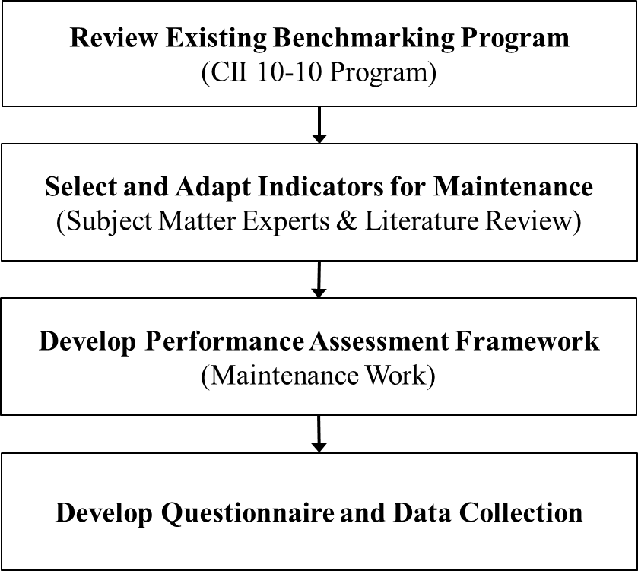

Figure 1. Overview of research approach.

The first step used the existing approaches from CII’s benchmarking programs (i.e., 10-10 program) as its starting point for the maintenance benchmarking. Although the existing approaches for 10-10 provided
the starting point for the benchmarking for maintenance work, it was required some changes to account for the different nature of maintenance work. For instance, the leading indicator scores need to be based on how members of the maintenance team answer questions that address specific issues in maintenance work.

The next step in this study required the research team to identify leading indicators for the maintenance and develop the questions that will be used to calculate these selected indicators. The team’s broad literature review helped it to identify common and critical indicators for maintenance benchmarking. This review was supplemented by input from subject matter experts (SMEs) engaged by CII. The team expanded the original set of 10 leading indicators by adding two: Maintenance Strategy and Information Systems. Next, the team removed two of the original 10-10 indicators: Design Efficiency and Sustainability. Finally, the team reviewed the questions used to generate the remaining indicators (i.e., Planning, Organizing, Supply Chain, Leading, Controlling, Safety/HSE, and Human Resources), and the team included or removed questions until the framework was prepared to properly address the issues related to maintenance work. The team also made major changes to the original lagging indicators it borrowed from the 10-10 program. The team added several maintenance efficiency indicators (described in greater detail in the next chapter) and tailored the final list of lagging indicators to addresses the efficiency of work planning and execution, training efforts, uptime, cost effectiveness, and safety.

Once the research team had finished selecting their indicators and questions, based on the literature review and the SMEs’ input, the team developed the questionnaires through an interactive process that relied on input from both SMEs engaged by CII and professionals in petrochemical projects. The research team used a first version of the performance assessment questionnaire to get feedback from participating companies and the participating companies. Then the team reviewed these submissions and contacted the individual survey coordinators (i.e., each company’s main point of contact who submitted the survey). A conference call with each survey coordinator discussed the goal of maintenance work benchmarking and explained its questionnaires. During the call, the survey coordinators offered feedback on their submitted data and the questionnaires. The research team used this feedback to improve the questionnaires that would next be used in the online system.

Benchmarking Framework for Maintenance Work

Figure 4 illustrates the benchmarking framework for maintenance work for petrochemical facilities and highlights how it took inputs from the project team and produced leading and lagging indicators. To calculate the leading indicators (listed in Table 1), multiple project management team members were asked to respond to a survey, and the aggregation of their data produced leading indicators. For the lagging indicators, one team member (called the survey coordinator) provided output project data, which were used to generate lagging indicators.

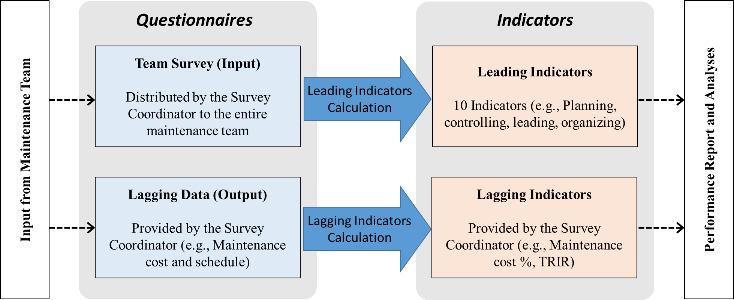

Figure 2. Maintenance work benchmarking framework

In the questionnaire, data were entered into three sections: general information, leading indicators, and lagging indicators. The general section (i.e., general project information section) was always required, because its data were used to find similar projects based on the comparison criteria. However, each project could provide data for any combination of the two other sections (i.e., leading and lagging sections). For instance, one contractor could decide to provide only lagging data for a project, while another contractor might only provide data for leading indicators. The following sections explain the leading and lagging sections in detail.

Leading Indicators for Maintenance Work Benchmarking

The team expanded the original set of 10 leading indicators by adding two: Maintenance Strategy and Information Management. Finally, the team reviewed the questions used to generate the remaining indicators (i.e., Planning and Organizing), and the team included or removed questions until the questionnaire was prepared to properly address the issues related to maintenance work. Table 1 describes the definitions of selected leading indicators for maintenance work.

The leading indicator section of the questionnaire contains an individual survey that was provided to each member of the project management team. The questions were qualitative in nature (i.e., yes/no or Likert questions, where users agreed or disagreed with statements), and users could skip any questions that did not apply to their scope of work. On average, a user required 20 minutes to respond to this individual survey. Once individual responses had been received for all members of a team, the combined data from these surveys could be used to evaluate the 10 leading indicators for the project. This evaluation depended on the correspondence between the individual questions on the survey and the 10 leading indicators. (Only a small set of questions was associated with each indicator.) For instance, the score for the Planning indicator is calculated by averaging the team members’ individual responses to the questions associated with Planning. The final score of each leading indicator was a value between 0% and 100%, with higher scores being better, so a score of 100% would have indicated that the maximum score had been achieved for every question related to that indicator.

Table 1. Selected leading indicators.

Leading Indicator | Definition
Planning | The work a manager performs to predetermine a course of action. The function of planning includes the following activities: Forecasting, Objective Setting, Program Development, Scheduling, Budgeting, and Policies and Procedures Development.
Leading | The work a manager performs to cause people to take effective action. The activities involved in the function of leading include decision-making, communications, motivation, selection of people, and development of people.
Organizing | The work a manager performs to arrange and relate the work to be done so people can perform it most effectively. The function of organizing includes the following activities: development of organization structure, delegation of responsibility and authority, and establishment of relationships.
Controlling | The work a manager performs to assess and regulate work in progress and completed. Management controls are achieved through the following activities: establishment of performance standards, measurement of performance, evaluation of performance, and correction of performance.
Human Resources | An examination to determine whether the project is staffed correctly, with a minimum amount of staff turnover and appropriate training, and measures if people are capable of achieving project goals.
Quality | A measurement that shows whether the project team is strictly conforming to project requirements. Analyzes if programs are pursued to assure the delivery of material goods as intended.
Safety/EHS | A measurement that shows the performance of the practices the project team followed to eliminate any possibility of personal injury or property damage on the project.
Supply Chain | An examination of the strategies the project team used to promote enhanced working relationships among all project stakeholders including those in the project supply chain.
Information Management | The set of all activities concerned with the acquisition, processing, and distribution of information related to maintenance activities.
Maintenance Strategy | The maintenance strategies are optimized so that the productivity of the plant is  maintained using cost-effective maintenance techniques.

Lagging Indicators

In the maintenance context, performance benchmarking usually assesses maintenance work with the goal of maximizing uptime, often by gauging the efficiency level of maintenance work in a given plant. Numerous indicators have been developed for assessing maintenance performance. For instance, the Society for Maintenance and Reliability Professionals (SMRP) has defined a number of harmonized indicators for maintenance (Kumar et al. 2013). Based on that, the research team made major changes to the original lagging indicators it borrowed from the 10-10 program. The team added several maintenance efficiency indicators (described in greater detail in the next chapter) and tailored the final list of lagging indicators to addresses the efficiency of work planning and execution, training efforts, uptime, cost effectiveness, and safety. The final list of selected lagging indicators is described in Table 2.

Table 2. Excerpt of selected lagging indicators.

Indicators | Formula Description | Interpretation
Materials  Service Level  (Owner only) | (Count of Material and Equipment Received on Time ÷ Count of Material  and Equipment Requested) × 100 | Percent of the time material is available when requested. This metric is relevant for planned maintenance efficiency and craft work productivity. It should support the identification of an optimal inventory level.
Overtime  Percentage | (Total Overtime Maintenance Work  Hours ÷ Total Maintenance Work Hours) × 100 | This metric is the number of overtime maintenance labor hours used to maintain the plant or unit, divided by the total maintenance work hours to maintain the plant or unit, expressed as a percentage. This is a measure of planning effectiveness, assessing if the normal work force is appropriately staffed and/or  performing effectively.
Planned and  Scheduled  Maintenance  Percentage | (Total Planned and Scheduled Maintenance Work Hours ÷ Total Maintenance Work Hours) × 100 | The metric consists of the amount of planned and scheduled work hours worked in the plant/unit being reported in this survey over the total amount of work  hours worked in the plant/unit. The metric is a measure of maintenance efficiency.
Percentage  of Preventive  Maintenance  Work | (PM Work Hours ÷ Total Maintenance Work Hours) × 100 | This metric consists of the amount of Preventive Maintenance (PM) work divided by the total amount of  maintenance hours spent during the survey period. A low percentage of PM work is often indicative of pressure to give priority to “urgent and emergency” work.
TRIR | (Total Number of Recordable Incidents ×  200,000) ÷ Total Maintenance  Work Hours | The total recordable incident rate (TRIR) is the number of recordable injuries occurring annually among 100 full-time workers (i.e., 2,000 hours per worker per  year).

The lagging indicators are designed to be based on the quantitative data the survey coordinator entered in the respective questionnaire sections. The sample questionnaire for lagging indicators section, as an instance, is presented in Figure 3.

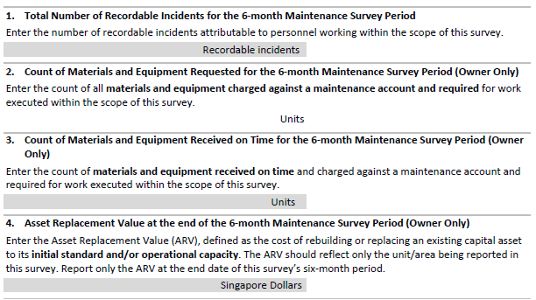

Figure 3. Lagging indicators section of the questionnaire (example)

Data Collection

CII received submissions for the benchmarking questionnaire for two years. A total of 21 surveys were collected from 19 owners and 2 contractors. During the submission period, survey coordinators were encouraged to attend training and work closely with the research team, so that their data would be entered in accordance with data requirements. For each submission, the General Information section of the questionnaire collects a description of the project or work being reported. Most data fields in the general information section are optional but, as a rule, most surveys contain all General Information fields. The leading Indicators survey is also virtually always provided. The sections collecting lagging indicators data are commonly sparse, as the data required in these fields are harder to collect.

Conclusion

This paper provides a snapshot of the work related to maintenance in petrochemical facilities. The results presented here aim to draw a baseline that will be useful to measure future maintenance work improvements. The path forward includes developing an online platform for collecting and storing the data required to establish a baseline for measuring and tracking improvements of maintenance work by using leading and lagging indicators presented in this paper. The future research also includes the expansion of the current benchmarking framework to record the implementation of specific maintenance practices including Activity Analysis (AA), Best Productivity Practice Implementation Index (BPPII), and
Work Face Planning (WFP). This way, contractors could report their results in a confidential way and compare themselves to other contractors regarding the implementation of specific practices. In summary, owners and contractors should commit to benchmark their work towards better maintenance outcomes, and the proposed framework serve as a stepping stone to support these efforts.

References

Choi, J., Leite, F., & de Oliveira, D. P. (2018). BIM-based benchmarking system for healthcare projects: Feasibility study and functional requirements. Automation in Construction, 96(September), 262–279. https://doi.org/10.1016/j.autcon.2018.09.015
Choi, J., Leite, F., & Oliveira, D. P. De. (2020). BIM-based benchmarking for healthcare construction projects. Automation in Construction, 119(November 2020), 103347. https://doi.org/10.1016/j.autcon.2020.103347
Choi, J., Yun, S., & Oliveira, D. P. De. (2016). Developing a cost normalization framework for phase-based performance assessment of construction projects. Canadian Journal of Civil Engineering, 43(12), 1075–1086. https://doi.org/10.1139/cjce-2016-0223
Guiras, Z., Turki, S., Rezg, N., & Dolgui, A. (2018). Optimal maintenance plan for two-level assembly system and risk study of machine failure. International Journal of Production Research, 57(8), 2446–2463. https://doi.org/10.1080/00207543.2018.1521017
Kang, Y., Dai, J., Mulva, S., & Choi, J. (2014). The 10-10 Performance Assessment Campaign: New Theories Regarding the Benchmarking of Capital Project Performance. Construction Research Congress 2014, 2008, 140–149. https://doi.org/10.1061/9780784413517.176
Moubray, J. (1997). Reliability-centered Maintenance. Industrial Press Inc.
Parida, A., Kumar, U., Galar, D., & Stenström, C. (2015). Performance measurement and management for maintenance: A literature review. In Journal of Quality in Maintenance Engineering (Vol. 21, Issue 1). https://doi.org/10.1108/JQME-10-2013-0067
Shan, M., Hwang, B. G., Caldas, C. H., Yin, Z., & Oliveira, D. P. (2020). Towards cleaner and more productive maintenance in petrochemical facilities: Mechanization and an assessment method. Journal of Cleaner Production, 259, 120864. https://doi.org/10.1016/j.jclepro.2020.120864
Yun, S., Choi, J., de Oliveira, D. P., & Mulva, S. P. (2016). Development of performance metrics for phase-based capital project benchmarking. International Journal of Project Management, 34(3). https://doi.org/10.1016/j.ijproman.2015.12.004

Biographies

JIYONG CHOI is an assistant professor of construction management at Central Connecticut State University. He earned his BE from the University of Seoul in 2007, MS in Civil Engineering in 2012 from the University of California at Berkeley, and PhD in Civil Engineering in 2019 from the University of Texas at Austin. Dr. Choi’s research interests include capital project benchmarking, project data analytics, and automated performance assessment.

NAMHUN LEE is a professor of construction management at Central Connecticut State University. He earned his BE in Architectural Engineering from Kyunghee University in South Korea in 1998, MS in Construction Management from the University of Washington in 2003, and PhD in Built Environment in 2009 from the University of Washington.

MYUNGJIN CHAE is an associate professor of construction management at Central Connecticut State University. He earned his BS in Civil Engineering from Yonsei University in South Korea in 1996, MS in Civil Engineering from Purdue University in 1998, and PhD in Construction Engineering and Management from Purdue University in 2001.

JAEHO CHO is a visiting scholar at Central Connecticut State University’s construction management program. He is a research professor at Dankook University in South Korea and earned PhD in Architectural Engineering at Dankook University. His research interests include collaborative design, lean construction, BIM 4D scheduling and 5D cost management.

