Gas Lift Closed-Loop Optimization Using IIoT Edge Technology

Denise Sherrod, Texas A&M University; Behbood Zoghi, Texas A&M University,

Abstract
Gas lift optimization is the process of determining the optimal injection rate for each well within a network supported by a central compression facility. This process is usually an open-loop process utilizing nodal analysis software. This paper presents an advanced method which performs the optimization process automatically, utilizing new IIoT (Industrial Internet of Things) technology with edge devices. The IIoT technology provides the ability to implement a closed-loop system by collecting data from multiple sources, running an advanced algorithm to determine the optimal injection rates, writing the setpoints to the well controllers, and analyzing the results using real-time data. A project was conducted on a central compression facility with six compressors supporting a network of 12 active gas lift wells. The wells were monitored for 94 days before and after the implementation of the new solution. Both quantitative and qualitative research methods were used to determine the overall effectiveness of the closed-loop IIoT gas lift optimization solution. Data collected showed that the algorithm was proven to be accurate, the closed-loop optimization resulted in improved gas lift optimization, increased production, as well as a 66% improvement in response time to upset conditions (more will be discussed in the paper). Based on these conclusions, the recommendations were to implement a secure IIoT architecture, expand IIoT solutions, and to develop and implement a full IIoT support lifecycle.
Introduction

When a well is initially drilled, the reservoir pressure is adequate to move the well's products (oil, water, and gas) to the surface, enabling the well to flow naturally. As production continues, the natural reservoir pressure decreases; consequently, various artificial lift methods are employed to maintain production. The gas lift method, which is often the first method applied, works by injecting compressed gas into the wellbore. The gas decreases the hydrostatic pressure of the column of oil, enabling the lower reservoir pressure to produce the fluids. There are a series of valves that open and close based upon the tubing pressure and casing pressure through which the gas is injected, as shown in Figure 1 (Epiclift.com).

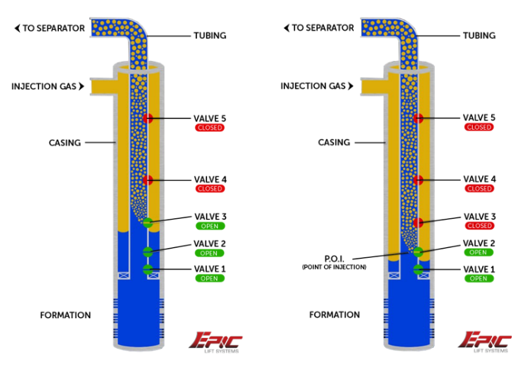

Figure 1. Gas lift injection well (illustration from epiclift.com Step 5).

Each gas lift well, or often a group of wells, is controlled by a PLC (programmable logic controller), which contains setpoints to control the gas injection rates by adjusting an automated choke on the injection valve.

Gas Lift Optimization

A production engineer run various well models to determine the appropriate injection rate for each well. More gas doesn’t necessarily mean increased production, as shown in Figure 2.

Production Rate
Gas Lift Injection Rate
Optimum Injection Rate
Optimum Injection Rate with Constraints
Unstable Injection Rate

Figure 2. Optimum gas lift injection rate.

"The quantity of the injected gas [into each well] at any point in time is considered as a critical variable; whereas a high injection rate does not necessarily increase total production and a low injected rate may result in a decrease in production rate" (Miresmaeili, Zoveidavianpoor, Jalilavi, Gerami, & Rajabi, 2013). The optimal injection rate changes due to the well's natural decline in production and conditions within the reservoir. Surface compression facilities are used to produce the compressed gas, with each facility being connected to multiple wells, thereby creating a network of wells. The compressors' capacity and availability determine the total amount of gas that can be distributed to the wells in the network. Determining the optimal amount of gas to allocate to each well within a given network is accomplished through network modeling. A production engineer first determines the optimal rate for each well then puts that information into the network model. The network model determines the optimal rate for all wells within the network based on the total amount of gas that can be allocated, as shown in Figure 3 (Cahill, 2016).

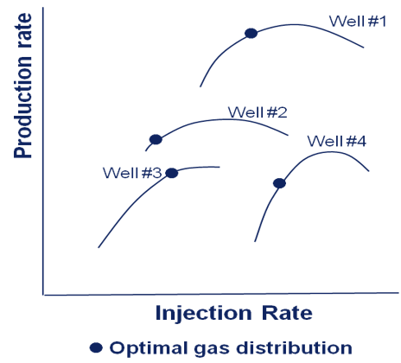

Figure 3. Optimal gas lift injection rates for wells in a network (Illustration from Emersonautomationexpert.com).

This process, called integrated process model (IPM), is typically performed whenever a new well test is available. The output of the process provides updated injection rates, which are entered remotely as recalibrated setpoints into each well's controller (PLC).

Various methods of gas lift optimization are presented in the publication by Rashid, Bailey, & Couët (2012). They range from a simple single-well nodal analysis to a very complex full scale integrated modeling approach. The limitations of each method are discussed, as well as the data requirements for each process. The integrated model technique is recommended because it can account for the numerous constraints encountered in an actual production environment. This recommendation validates the decision to use the IPM optimization method in this project.

Internet of Things (IIoT) Technology

Industrial control systems in the oil and gas industry typically consist of PLCs and HMIs (Human Machine Interface). The PLCs are located throughout the field and are programmed using basic logic to control various types of equipment, such as valves and pumps. The HMIs collect the data from the PLCs and provide visualizations and alarm notifications to help the operators manage their wells and equipment. The PLCs and HMIs are usually deployed in an industrial control network, which requires a closed architecture, allowing minimal outside access. Direct connection to other business networks and the internet is strictly prohibited. IIoT is a newer technology that utilizes edge devices in place of PLCs. The edge devices are small, low-cost computers capable of computing complex calculations. They can be programmed to perform the same type of control functions as the PLCs but with the added ability to run advanced analytics. Because the edge devices communicate to the cloud, they present security concerns as an inherent function of their design. A new security architecture is required to ensure the IIoT technology met the security requirements of the industrial control network.

Literature Review

Gas Lift Optimization Research

Numerous studies have been published on the topic of gas lift optimization. Some publications concentrate on the gas lift process itself, with the focus being on a single well optimization. Other studies attempt to find the most efficient way to optimize the full integrated network while applying gas lift capacity constraints

The various methods of gas lift optimization are presented in the publication by Rashid et.al (2021). They range from a simple single-well nodal analysis to a very complex full scale integrated modeling approach. The limitations of each method are discussed, as well as the data requirements for each process. The integrated model technique is recommended because it can account for the numerous constraints encountered in an actual production environment. This recommendation validates the decision to use the IPM optimization method in this project.

A simple gas lift algorithm was tested by Fandi (2015) to determine its accuracy compared to the Equal Slope allocation method, which was established by Kanu, Mach, & Brown (1981) as a reliable allocation method. The advantage of the simple algorithm is that it requires only a few data elements and can be calculated quickly. In contrast, the Equal Slope allocation method requires much more data and involves a lengthy procedure. A simulation using six wells was conducted using both methods. The results showed both approaches produced similar results. This study's finding is significant because the algorithm tested is comparable to the one used in this project. In addition, the algorithm used in the project includes several additional data elements, so it should prove equally, if not more, effective.

A study of a nonlinear predictive model process control (NPMC) method of gas lift optimization was published in the “Journal of Process Control” (Diehl, Almeida, Anzai, Gerevini, Neto, Von Meien, & Campos, M., et al., 2018). The study utilized simulators for both the reservoir and the surface network and focused on analyzing a single well. The results of the study showed an increase in production using a predictive model solution due to the ability to stabilize the well. “The gains verified in this work reached around 45%, which corroborates with the order of magnitude expected in some research papers” (Diehl, Almeida, & Anzai, et al., 2018). The algorithm used in this project is not as sophisticated as a NPMC, but it incorporates the same concept through real-time optimization and therefore, should produce similar results.

IoT

IoT technology has been used for years in other industries but is relatively new to the oil and gas industry. Although some papers have been published that describe IoT technology within this industry (Irons-Mclean & Greengrass, 2016), it is not yet recognized as a trusted alternative to legacy automation systems. A systematic review of IoT in the oil and gas industry was published in the JIoT (Wanasinghe, Gosine, James, Mann, De Silva, & Warrian, 2020). providing an evaluation of the application, impact, challenges, and opportunities of this technology within the industry. The assessment gathered data from 66 articles dealing with IoT in the oil and gas industry to develop its final report. The report shows that this technology's primary application within the oil and gas industry is for automation and control, personnel tracking, collaboration and digital twin, and supply chain fleet management. The impact this technology provides is “a paradigm shift in the entire industrial and social status quo” (Wanasinghe et al., 2020). The challenges include cybersecurity issues, the lack of intrinsically safe devices, and interoperability with other systems. This project has overcome these challenges by implementing an approved security architecture, eliminating the need for intrinsically safe device by placing the Edge device away the wells, and developing a specific user interface for the application. The opportunities offer a means to potentially reduce capital and operations expenditures while advancing technology in health, environment, and safety. The report quotes Mahdavi (2017) in saying, “with the right IoT infrastructure, we can achieve integrated management of the reservoir, well, and surface facilities, enabling end-to-end optimization with a much more economic value proposition compared to the status quo.”

The benefits of using an Edge device to implement a closed-loop solution are discussed in a case study that included the analysis of 41 process variables associated with 11 manipulated variables through a feedback loop (Luo, Zhao, & Yin, 2018). In this study, the proposed Edge architecture was applied to the TE benchmark process, which is described in Bathelt, Ricker, & Jelali (2015). The study concluded that an IoT architecture functions well in a large-scale industrial process used for monitoring and controlling. It shows that this architecture eliminates online processing and reduces communication data usage. This study validates the use of Edge technology versus cloud computing.

Project Overview

Project Objectives

Determining the optimal injection rate for a gas lift well is critical to maximizing the well’s production. It is particularly important when upset conditions occur, such as the loss of a compressor. When a compressor failure occurs, the total amount of available gas that can be distributed to the wells decreases. If the well setpoints are not updated, the wells closest to the facility will consume all the gas, causing the father wells to stop producing. This scenario can cause significant production losses, especially if the wells farthest from the compression facility are higher producing wells. Consequently, when upset conditions occur, models are run to determine the appropriate injection rate for each well, accounting for the decrease in available gas, and priority is given to the better wells. In an open-loop process, this is a manual process that, subsequently, causes a delay in network optimization. Operating when the network is not fully optimized results in lower production volumes and decreased revenue. This project explored the capabilities of utilizing new IIoT technology with edge devices to demonstrate the benefits of a closed-loop gas lift optimization system. The solution tested the ability to run an algorithm on an edge device which calculated the optimal injection rate for each well. A closed-loop system was created by developing the ability for the edge device to automatically download recalibrated setpoints to the well controllers.

The finding from Kanu et al. (1981) is significant because the algorithm tested is comparable to the one used in this project. In addition, the algorithm used in the project includes several additional data elements, so it should prove equally, if not more, effective. Real-time data from the wells, compression facility, and production network were provided as inputs to the algorithm.

The overall project objectives were:

- Implement an advanced algorithm that will automatically determine the optimum allocation of lift gas for a network of wells.
- Automatically send the optimum gas lift setpoints to the well controllers.
- Demonstrate the benefits of a closed-loop optimization engine.
- Prove the capabilities of IIoT technology.
- Establish a secure IIoT architecture within an industrial control network.

Scope

The project was conducted on a central compression facility with six compressors supporting a network of 12 active gas lift wells. The wells were monitored for 94 days before and after the implementation of the new solution.

Risk Management Process

The site selected for this project offered a reduced risk compared to other sites in area because excess compression was available at this site. Producing more gas than is needed decreases the impact of a compressor outage. The injection setpoints will not vary widely under normal operations with excess lift gas, therefore, error deviations were less impactful.

Value Proposal

The benefits of this project include reduced workforce requirements, increased production volumes, and the opportunity to test the applicability of IIoT technology within an oil and gas industrial control network. Currently, engineers use various commercial applications to perform gas lift network optimization, which requires intensive resources to maintain configurations and run the well models. The closed-loop solution automatically calculates the optimal setpoints and downloads the setpoints to the well controllers without human intervention. This programmed approach reduced the workforce requirements needed to perform gas lift optimization. In addition, this advanced control resulted in faster field optimization and increased production by efficiently utilizing the existing gas injection capacity and quickly adjusting to disturbances. Implementing this solution on an edge device also proved the viability of IIoT technology which expands the ability to perform real-time advanced process control.

Limited research has been done on true closed-loop gas lift optimization although it is recommended over open-loop control (Jing, Errouissi, Al-Durra, & Boiko, 2015). One study, conducted by Ni, Ren, & Mao (2012), demonstrated the results of a closed-loop solution using a sequenced based automation controller. A dynamical simulator was used to illustrate the general gas lift principles, and a transient multiphase pipe flow simulator was used to represent the network model. “Around 20-40% of production loss is observed due to gas-lift instability for typical well settings in our simulations” (Ni et al., 2012), The study showed the closed-loop solution increased production due the ability to stabilize the wells.

Methodology

Research Design

Both quantitative and qualitative research methods were used to determine the overall effectiveness of the closed-loop IIoT gas lift optimization solution.

Qualitative Research

Case study qualitative research methods were used to examine the changes in manpower requirements between the current manual process and the new closed-loop solution. Participants included the production engineers that supported the field in which the solution was deployed. The participants were asked to document the amount of time they spent performing the network optimization prior to implementing the new closed-loop solution. They were asked to document the same data after the implementation.

Quantitative Research

Descriptive quantitative research methods were conducted using real-time data from the wells and compression facility. Quantitative data were used to achieve the following objectives:

- Validate the accuracy of the algorithm’s computations.
- Measure the overall effect of a closed-loop gas lift optimization solution.
- Test the security of the IIoT architecture.

Instruments

A generic edge device was used to automatically calculate the optimal injection rate for each well. Various containers were deployed on the edge device to perform the needed functions. The containers were developed in an Azure IoT hub in the cloud and downloaded to the edge device. A Modbus container acquired the real-time data from PLCs. A Python container ran the algorithm. A SQL container stored the inputs and outputs.

A data historian was used to capture all the research data during the project's implementation phase. User interfaces were developed to visualize and analyze the data.

Procedure

The IIoT edge device communicated directly to the PLCs to obtain real-time data through a fiber-optic network. Well test data, used to calculate the well models, were sent from the business network to an Azure database in the cloud and then to the edge device through a cellular connection. The edge device calculated and downloaded new injection rates for each well every 15 minutes. Each time the algorithm ran, the inputs and outputs were logged in a SQL database in the edge device for onsite analysis and were collected by a data historian over an Ethernet IP-Radio communication network directly from the PLCs.

Data Analysis Plan

Data obtained before the implementation of the closed-loop system were compared to the same data after the implementation. The data sets used in the analysis included the following:

- Before Closed-Loop Gas Lift Optimization – Data from October 3, 2020, to January 4, 2021.
- After Closed-Loop Gas Lift Optimization – Data from January 5, 2021, to April 8, 2021.

The closed-loop system was implemented on Jan 4, 2021; therefore, the production data from Jan 5, 2021, represented the system in full operation.

Project Results

Algorithm Accuracy

During the test phase of the project, it was important to validate the new algorithm's accuracy. To confirm the injection rate setpoints generated by the algorithm were valid, the program was run in test mode for numerous weeks. During this test mode, the algorithm ran every hour using real-time data obtained from the PLCs and well models. The algorithm ran exactly as it would in production except the injection rate setpoints were written to a SQL database rather than to the well PLCs. The production engineers continued to generate the well and network models manually, producing the recalibrated setpoints. The production engineers compared the manually generated setpoints to those generated by the new algorithm. Initially, slight variations were observed, which caused adjustments to be made to improve the algorithm's accuracy. Once the accuracy was validated to the production engineers' confidence level, the new closed-loop optimization solution was put in production.

Upset Condition Events

One of the primary objectives of the closed-loop solution was to automatically detect and respond to compressor down events. This objective aimed to detect the compressor outage, calculate new optimized injection rates for each well based on the reduced gas capacity, and automatically download the recalibrated setpoints to each well. An upset condition was defined as a rate or pressure PV (Present Value) of zero for any of the compressors in the central compression facility. The condition must be detected in two concurrent runs of the algorithm to be considered valid. This restraint was implemented to eliminate bad data. A user interface was developed to help the production engineers verify compressor events and validate that recalibrated setpoints were being downloaded to the wells. Numerous compressor down events occurred during the project and recalibrated setpoints were downloaded to the wells during this same time frame. This result validated the algorithm’s ability to detect and respond to compressor down events.

Gas Allocation Optimization

To achieve improved optimization in a gas lift system, the proper utilization of the available gas is crucial. In Figure 7, the amount of available gas for injection is represented by the purple line. The total gas being injected is represented by the green line.

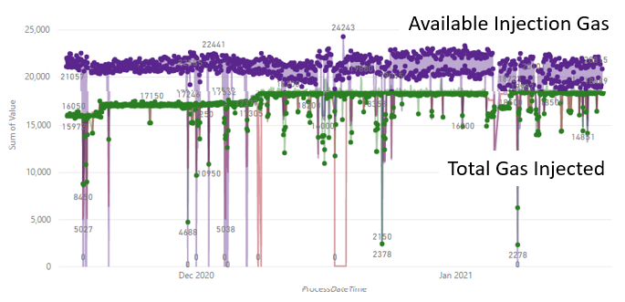

Figure 4. Gas lift utilization graph.

Before the closed-loop system was implemented, the available gas was ~21,540 mcf and the total gas being injected was ~16,150 mcf, resulting in a 79% utilization rate. After the closed-loop system was in production, the total available gas was ~20,133 mcf and the total gas being injected was ~18,494, resulting in a 92% utilization rate. This project confirms that automatically adjusting the injection rate setpoints through a closed-loop system improves the overall gas utilization.

Response Time to Upset Conditions

Another metric used to determine the closed-loop system's success was the response time to upset conditions such as compressor outages. During an outage, the amount of available gas is constrained, thereby decreasing production until the recalibrated setpoints are downloaded to the well PLCs. For the purpose of this analysis, response time was defined as the difference between the time the compressor down event was captured in the data historian and the time all of the recalibrated setpoints were downloaded. The response time for the manual process, before the closed-loop system was implemented, was 59 minutes. The response time with the automated solution was 20 minutes. This result proved the closed-loop optimization resulted in a 66% improvement in response time.

Reduction in Man Hours

The closed-loop system was designed to provide a much less manpower-intensive solution than the previous manual processes. To calculate the time difference, customer interviews were conducted. The production engineers were asked to provide time estimates of their process before and after the new solution was implemented. The manual process consisted of four steps, shown in Figure 5.

Figure 5. Manual gas lift optimization process.

The closed-loop solution performed all the steps automatically, so the only time spent was for data validation. The overall time savings, for the 12 wells included in the project, equaled 34 hours per month.

Change in Production Volumes

An increase in overall production determined the ultimate success of the closed-loop system. The original estimate was an increase of .5% to 1%. The data used to analyze this information was the sum of the well tests (oil measurement) for the wells included in this project. The data were analyzed in two time periods, before the closed-loop system was implemented and after it was implemented, shown in Figures 6 (a) and 6 (b).

Figure 6(a). Comparison of production volumes (before).

Figure 6(b). Comparison of production volumes (after).

The difference in the trend before the system was implemented was calculated by subtracting the ending oil volume, 5217 BOPD (barrel of oil per day) from the beginning oil volume, 6610 BOPD. The result was a -1392 BOPD difference, which equals a 21% decrease for this period. The same method was used for the trend after the system was implemented, subtracting the ending oil volume of 4085 BOPD from the beginning oil volume of 5113 BOPD. The result was a -1027 BOPD difference, which equals a 20% decrease for this period. Subtracting the ending decrease from the beginning decrease shows a result of a 1% increase. This information is provided in a single graph for easier comparison in Figure 7.

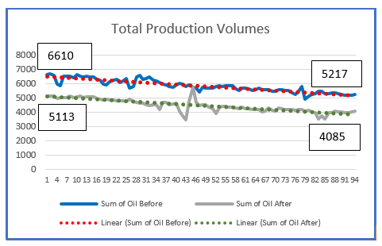

Figure 7. Total production comparison.

In order to determine the actual impact of the gas lift optimization solution, the expected production trend for the wells must be examined. The wells included in this project are horizontal shale wells which have a high rate of decline. Figure 8 shows the production trend plotted for all twelve wells (in green) against the expected decline curve for wells in this reservoir (in black). The system used to capture this data only contained production information for 365 days, but the wells in this study were between 450 and 550 days old, as indicated by the oval area in Figure 8.

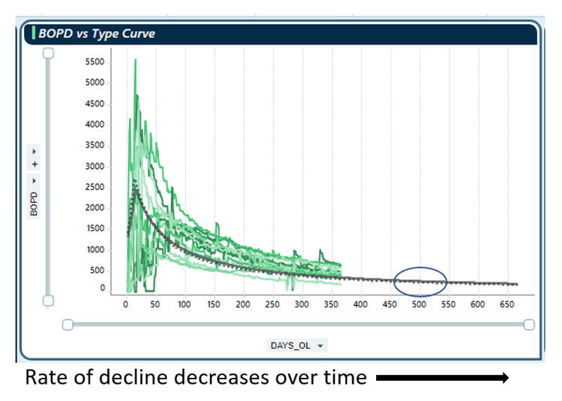

Figure 8. Rate of decline.

As the information shows, the rate of decline decreases throughout the life of the well. Based on analysis of this data, the expected decline should have been .5% higher during the period after the solution was implemented, compared to the same period before. The results of the study showed a 1% change, therefore, .5% can be contributed to the implementation of the closed-loop solution.

IIoT Security Risks

The primary concern for implementing an IIoT solution within a process control network was the system's security. The process control network's security architecture requires separation from the business network and complete isolation from the internet. Introducing a device that communicates directly to the cloud broke this security model.

Initially, an IIoT architecture was developed using an IoT private cloud which communicated to the business network, the industrial control network, and the edge device, as shown in Figure 9. The use of a private cloud provided increased security over a public cloud; however, it did not meet the security requirements to completely separate the three networks. In order to achieve complete separation, an IoT DMZ was implemented, as shown in Figure 10.

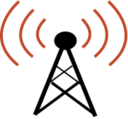
IoT Hub
Blob
Edge Device
Business Network
Industrial Control Network
Megaport ExpressRoute
Verizon ExpressRoute

Figure 9. IIoT initial architecture.

Firewall
Edge Device
Business Network
Industrial Control Network
Megaport ExpressRoute
Verizon ExpressRoute
Blob
Vnet to Vnet Peer
IoT Private Cloud
IoT DMZ
IoT Hub

Figure 10. IIoT final architecture.

To test the security of this architecture, penetration tests to the IIoT device were performed. The penetration testing was performed with an open-source application called Ubuntu. The following functions were run with this application:

- Execute vulnerabilities assessment tasks.
- Identify online devices in a network.
- Collect information of targeted devices
- Expose the attacks against targeted devices.

The results of the tests confirmed that there were no vulnerabilities or exposures to the IIoT edge device.

Conclusion and Recommendations

This project achieved all the stated objectives. It offered a unique opportunity to concurrently test several value propositions during normal production operations with minimal risks. The IIoT technology provided a platform to test the new gas lift algorithm within a closed-loop system, thus supplying a continuous process for automatic injection rate calculations and updates. The data showed the algorithm resulted in improved gas lift optimization and increased production, which is significant beyond this project for several reasons:

- This project was conducted using 12 wells that were toward the bottom of their decline curve. The results of this project could be amplified by implementation on newly drilled wells with high production volumes and in fields with larger gas lift networks.
- Many field operation processes in the oil and gas industry are still manual. Optimization can be achieved by expanding IIoT closed-loop solutions to these processes.
- The IIoT platform delivers technology that can be used to implement other solutions quickly.

Recommendations

Implement a Secure IIoT Architecture

The most critical component in implementing IIoT technology is the full implementation of a secure IIoT architecture. The environment should be approved by the corporate cybersecurity team. The final architecture needs to include to following components:

- Device certification –provides a method for certification of newly installed devices
- Azure Active Directory for Identity Access Management – provides a means to ensure only authenticated users have access
- Production Azure environment with backup and DR solutions- provides a secure and reliable cloud architecture to support IIoT devices deployed in the field
- Cybersecurity testing and audits – ensures the IIoT does not introduce new security threats
- Implement an edge device management solution – provides capabilities to monitor the health of deployed edge devices
- Network segmentation – extends the corporate security architecture to the cloud environment.

Expand IIoT Solutions

Another recommendation includes the continued development of IIoT solutions. This project has proven that IIoT technology is a viable solution for industrial control in the oil and gas industry. Gas lift optimization is only one application. This technology can be applied to numerous other solutions. One solution that could have a big impact on operations is the deployment at central production facilities. An IIoT device could be programmed to control the amount of fluid in and out of the facility, which would optimize operations. Wells could be slowed down to manage facility constraints which would eliminate large-scale shutdowns. Another option for an IIoT implementation is the replacement of well controllers. Many artificial lift methods require expensive propriety controllers, which could be replaced with lower-cost edge devices.

Implement a Full IIoT Support Model

The final recommendation is to develop and implement a full IIoT support lifecycle. IIoT technology presents unique challenges because it requires very tight integration between Operation Technology (OT) and Information Technology (IT). Many other factors must be considered, such as cybersecurity, network architecture, data management, field technician support, etc. Processes need to be defined, and roles and responsibilities need to be assigned before the deployment of the edge devices can be fully supported. The following support functions need to be considered:

- Procurement
- Device commissioning
- Device Monitoring and Maintenance
- User Interface (UI) Development
- New Technology

References

Bathelt, A., Ricker, N. L., & Jelali, M. (2015). Revision of the Tennessee Eastman process model. IFAC-PapersOnLine, 48(8), 309-314. doi: 10.1016/j.ifacol.2015.08.199.
Cahill, J. (2016, February 18). Maximizing Production through Optimized Gas Lifting. Retrieved from https://www.emersonautomationexperts.com/2016/industry/oil-gas/maximizing-production-optimized-gas-lifting/
Diehl, F. C., Almeida, C. S., Anzai, T. K., Gerevini, G., Neto, S. S., Von Meien, O. F., ... & Trierweiler, J. O. (2018). Oil production increase in unstable gas lift systems through nonlinear model predictive control. Journal of Process Control, 69, 58-69. doi: 10.1016/j.jprocont.2018.07.009.
Epiclift.com. (n.d.). How It Works. Retrieved from https://epiclift.com/how-it-works/
Fandi, R. A. (2015, September). A simple-effective analytical model for multi-well gas lift allocation optimization 2015IFEDC. In 2015 International Field Exploration and Development Conference (IFEDC 2015), 1-7. IET. doi: 10.1049/cp.2015.0579.
Irons-Mclean, R., & Greengrass, J. (2016, September). The Internet of Things IoT and security: A practical strategy to secure an OT and IT integrated process control domain. In SPE Intelligent Energy International Conference and Exhibition. OnePetro. Retrieved from: https://www.onepetro.org/conference-paper/SPE-181002-MS. DOI: 10.2118/181002-MS
Jing, S., Errouissi, R., Al-Durra, A., & Boiko, I. (2015, September). A data-driven subspace predictive controller design for artificial gas-lift process. In 2015 IEEE Conference on Control Applications (CCA), 1179-1184. IEEE. doi: 10.1109/CCA.2015.7320772.
Kanu, E. P., Mach, J., & Brown, K. E. (1981). Economic approach to oil production and gas allocation in continuous gas lift (includes associated papers 10858 and 10865). Journal of Petroleum Technology, 33(10), 1887-1892.
Luo, H., Zhao, H., & Yin, S. (2018). Data-driven design of fog-computing-aided process monitoring system for large-scale industrial processes. IEEE Transactions on Industrial Informatics, 14(10), 4631-4641. doi: 10.1109/tii.2018.2843124.
Mahdavi, M. (2017). Guest editorial: Ushering in a new era of oilfield innovation with the Internet of Things. Journal of Petroleum Technology, 69(07), 14-15. doi: 10.2118/0717-0014-JPT.
Miresmaeili, S. O. H., Zoveidavianpoor, M., Jalilavi, M., Gerami, S., & Rajabi, A. (2019). An improved optimization method in gas allocation for continuous flow gas-lift system. Journal of Petroleum Science and Engineering, 172, 819-830. doi: 10.1016/j.petrol.2018.08.076.
Ni, J., Ren, Z., & Mao, F. (2012, October). Improved feedback control system of unstable gas-lift wells. In 2012 5th International Conference on BioMedical Engineering and Informatics (pp. 1240-1244). IEEE. doi: 10.1109/BMEI.2012.6512943.
Rashid, K., Bailey, W., & Couët, B. (2012). A survey of methods for gas-lift optimization. Modelling and Simulation in Engineering, 2012. doi: https://doi.org/10.1155/2012/516807.
Wanasinghe, T. R., Gosine, R. G., James, L. A., Mann, G. K., De Silva, O., & Warrian, P. J. (2020). The internet of things in the oil and gas industry: a systematic review. IEEE Internet of Things Journal, 7(9), 8654-8673. doi: 10.1109/JIOT.2020.2995617.

Biographies

MS. DENISE SHERROD is currently the Chief of Automation at Occidental Petroleum Corporation in Texas. She graduated from The University of Texas Permian Basin with a bachelor’s degree, in Business Administration and Management, and from Texas A&M University with a master’s degree in Engineering Technical Management. Ms. Sherrod may be reached at Denise_Sherrod@oxy.com.

DR. BEN ZOGHI is the Victor H. Thompson chair professor of Electronics System Engineering Technology at Texas A&M. He directs the RFID/Sensor Lab and the new online professional Master of Engineering in Technical Management program. A member of the Texas A&M University faculty for 30 years, he has distinguished himself as a teacher, writer, and researcher, and has been honored for his teaching excellence by the College and the Texas A&M University Association of Former Students. Ben’s academic and professional degrees are from Texas A&M (PhD), The Ohio State University (MSEE), and Seattle University (BSEE). Dr. Zoghi may be reached at zoghi@tamu.edu.

