# 040-x-22

Simulation of Robotic Gaits Using a Single Degree of Freedom Leg

Andrew J. Wasson
Kettering University
wass1286@kettering.edu

Diane L. Peters
Kettering University
dpeters@kettering.edu

Yaomin Dong
Kettering University
ydong@kettering.edu

Abstract

This paper presents the analysis of three different gaits, a diagonal gait, side gait, and front-back gait, for a quadrupedal robot. The specific robotic leg used in this work, first proposed in (Peters & Chen, 2014) and further developed in (Jin, 2015), is actuated with a double cam system. The cams all turn at constant speed throughout the duration of the simulation. This analysis is carried out using the dynamic simulation capabilities of the Dassault Systemes SolidWorks® CAE software. Two out of the three gaits were found to have issues balancing left to right while the third had issues with balancing front to back. The first gait’s balancing issues were judged to be issues that could be corrected, leading to the conclusion that it is a feasible gait for this robot. Those corrections will be explored in future work, as will the performance of a robot using this specific leg in a hexapod configuration.

Introduction

Mobile robots can take many different forms and use different types of locomotion. In some cases, wheels or tracks are used. However, legs are also a possible method for robots to move themselves through the world. The advantage of using legged locomotion is that wheels require some sort of prepared surface to function best, and may not function at all in some types of terrain (Raibert, 1986). With the use of legs, a robot can step over some obstacles and traverse different types of terrain.

Many robotic legs use multiple degrees of freedom and complicated control systems to move and interact with their surroundings, which has the advantage of giving them some degree of flexibility, beyond simply adjusting the timing between the legs (Joze, Habibi, & Asadi, 2007; Herrero & Martinez, 2007). However, there are legs that are far simpler in design and have correspondingly simple control systems, such as the hexapod locomotion systems described in (Buehler, Koditschek, & Saranli, 2002; García-López, Gorrestieta-Hurtado, Vargas-Soto, Ramos-Arreguin, Sotomayor-Olmedo, & Morales, 2002), as well as quadruped systems that are meant for running (Talebi, Poulakakis, Papdopoulos, & Buehler, 2001).

Just as there are many different types of robotic legs, there are a variety of different gaits, or ways in which the different legs can move with respect to one another. Some of these gaits are focused on the motion specifically of bipedal robots (Kurz, Judkins, Arellano, & Scott-Pandorf, 2008; Collins & Ruina, 2005; Ha, Han, & Hahn, 2007). These robots pose special challenges, as a bipedal robot is not stable in the absence of some form of control (Song & Waldron, 1989). As humans are bipedal creatures, much of this work is based on a study of human gait patterns, with the goal of implementing aspects of human walking in a robot.

There is also a significant body of work dealing with the gaits that can be used with quadruped robots, e.g., (Tsujita, Tsuchiya, & Onat, 2001; Lewis & Bekey, 2002; Inagaki, Yuasa, Suzuki, & Arai, 2006), with the work in (Inagaki, Yuasa, Suzuki, & Arai, 2006) also applicable to robots with a greater number of legs. In many of these cases, a trotting gait is used (Spröwitz, Tuleu, Vespignani, Ajallooeian, Badri & Ijspeert, 2013; Zhang, Gao, Han, Chen, & Han, 2014; Zhang, Rong, Hui, Li, & Li, 2016; Fukuoka & Kimura, 2009). Such a gait is relatively fast, compared to walking, but can be more challenging to maintain stability. Other gaits considered are walking (Fukuoka & Kimura, 2009; Nagakubo & Hirose, 1994) and running (Nagakubo & Hirose, 1994; Poulakakis, Smith, & Buehler, 2005). In addition, some work focuses specifically on the terrain that a quadruped robot can traverse, e.g. (Raibert, Blankespoor, Nelson, & Playter, 2008). In this paper, we focus on the performance of a specific robot with three different walking gaits: a diagonal gait, a side gait, and a front-back gait. These three gaits are described in the following section. Next, the robot itself is described, and the configuration of the CAD model is presented. In the following section, results are given, followed by a discussion and conclusion. Recommendations of the future work is also discussed.

Robotic Gaits

In this work, three walking gaits are used, described as the diagonal gait, side gait, and front-back gait. Each is briefly described, and a diagram is given to illustrate which legs are being used simultaneously. As they are walking gaits, there is always at least one leg, and in this case two legs, in contact with the ground at all times.
Diagonal Gait Configuration
right front leg
left front leg
right back leg
left back leg
Side Gait Configuration
right front leg
left front leg
right back leg
left back leg
Front-Back Gait Configuration
right front leg
left front leg
right back leg
left back leg

Figure 1. Gait Configurations

In the diagonal gait configuration, shown at the top of Figure 1, the legs diagonally across from each other move at the same time. Legs in contact with the ground are represented by a black box, while a leg not contacting the ground is represented by white. The right front leg, therefore, is contacting the ground at the same time as the left back leg; when these legs are lifted, the left front leg and right back leg contact the ground.

In the side gait configuration, the front and back legs on one side of the robot move at the same time. The right front and back legs contact the ground at the same time, and the left front and back legs contact the ground while the right legs are lifted. In the front-back gait configuration, the two front legs move together, and the two rear legs move together. This configuration is shown at the bottom of Figure 1.

Description of System

The robot is in a quadruped configuration with the cams mounted to the main body and one of the pieces of the leg attached to the main body to allow it to pivot. The main body of the robot is a hollow rectangular mass. The platform the robot walks on is a flat rectangular surface. This configuration is shown in Figure 2.
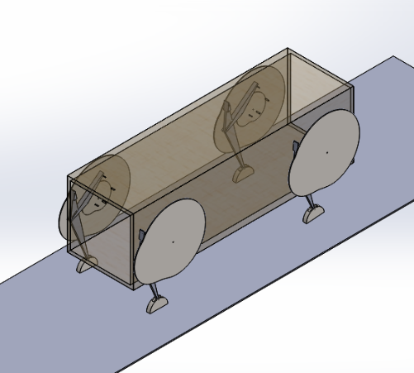
Figure 2. Robot Configuration

The robot was modeled and simulated in Solidworks (Solidworks, 2020) using the motion analysis tool. The legs are constrained to the cams which are connected to the main body. Each gait was simulated for 50 seconds and at 4 different rotation rates for the cams. The simulation was started and then after five seconds rotation was given to one set of legs depending on the gait and then five seconds later rotation would be provided to the other set of legs. The legs were controlled only in how fast the cams were rotating and when they started rotating. After the initial start, rotation was never reduced or taken away from any pair of legs.

The Cartesian coordinate system was set up so that the positive X direction would be to the right and the positive Y direction would be up. The positive Z direction, considered forward, is perpendicular to the XY-plane pointing out of the page.
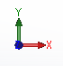
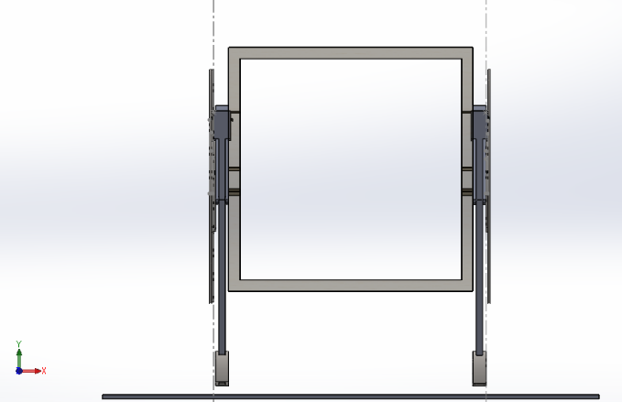
Figure 3. Coordinate System and Front of Robot

The position, velocity, and acceleration of the center of gravity (CoG) of the main body was tracked and graphed in both the X and Y plane. The Z plane was tracked but was not graphed because it only shows whether the robot moved forward or backwards which is not relevant to how well the robot is able to support and balance itself.

As can be seen in Figure 3, the robot sits about 2 inches above the platform. This was done to prevent clipping issues at the start of the simulation. Due to this, the first five seconds of the simulation there are no control inputs to give the robot an opportunity to land on the platform, settle, and stop vibrating before locomotion begins. Therefore, if any data points during the time period 0-5 seconds were abnormally large and reduced the readability of the graphs those data points would be set to zero to increase the resolution of the actual data. This phenomenon was mainly seen in the velocity and acceleration graphs.

Results

A variety of data was collected from the simulation, all specifically for the center of gravity (CG), and then shown graphically. The graphs will display position, velocity, and acceleration for the center of gravity of the main body vs time at RPM rates.
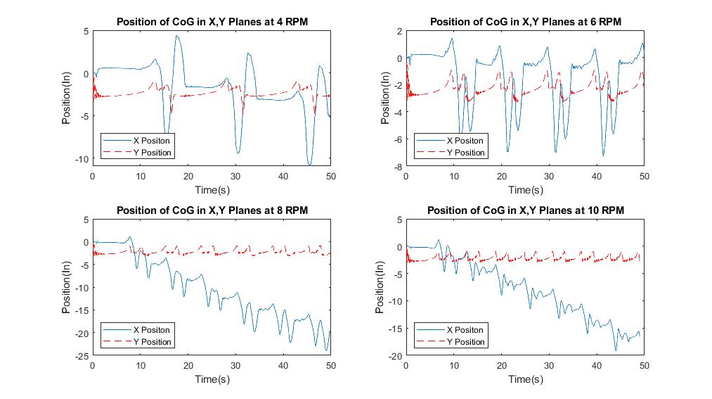
Figure 4. Position of CG for Diagonal Gait

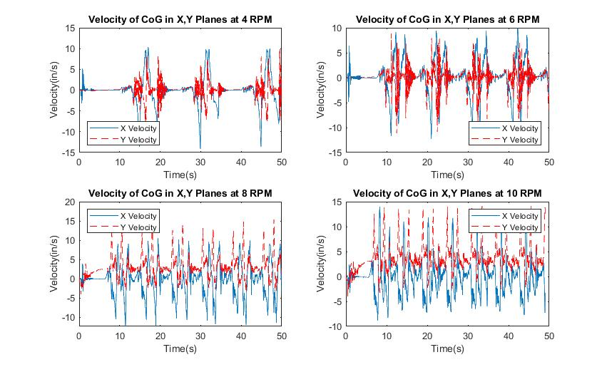
Figure 5. Velocity of CG for Diagonal Gait
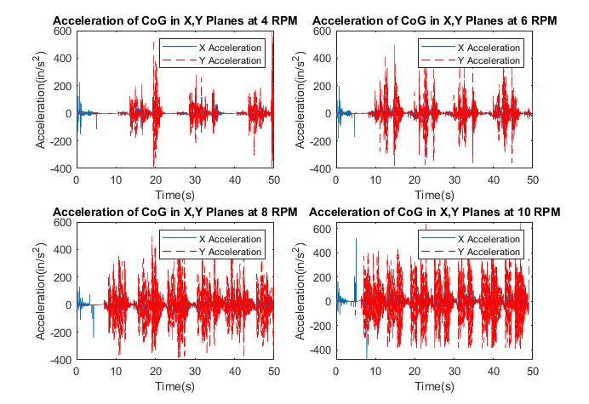
Figure 6. Acceleration of CG for Diagonal Gait

As shown in Figure 4, the change in position of the center of gravity in the X plane, in order, for the different RPMs was 11.86in, 7.85in, 6.88in, and 5.47in. As RPM increased there was diminishing returns on how much the change in position, or what could be consider the side to side sway, of the robot, decreased. There also appears to be a RPM “breakpoint” between 8 RPM and 6 RPM where the drift of the robot starts earlier and is more pronounced.

The velocity graphs in Figure 5 have a pattern present in the 4 and 6 RPM graphs of there being a repeating cone shape for the Y plane where it may be vibrating when standing still and the velocity is dissipating. This pattern does not exist in the 10 and 8 RPM graphs. Another difference between the set of graphs is that the highest velocity in the 4 and 6 RPM graphs is recorded in the X direction, but the max velocities for 8 and 10 and in the Y direction. The acceleration graphs all seem to have similar peak accelerations around 500 in/s², or 1.29Gs in the Y direction with the X direction having no relatively significant acceleration outside of the first 5 seconds. All 4 graphs also seem to only have this high of acceleration once during their motion. This may be due to a Solidworks issue, or the simulation wasn’t carried out long enough to see a pattern of these spikes.

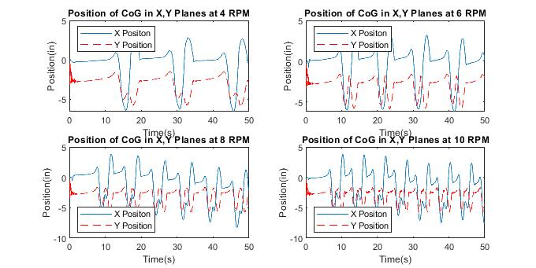
Figure 7. Position of CG for Side Gait

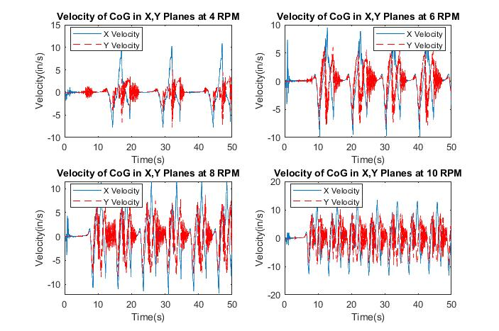
Figure 8. Velocity of CG for Side Gait
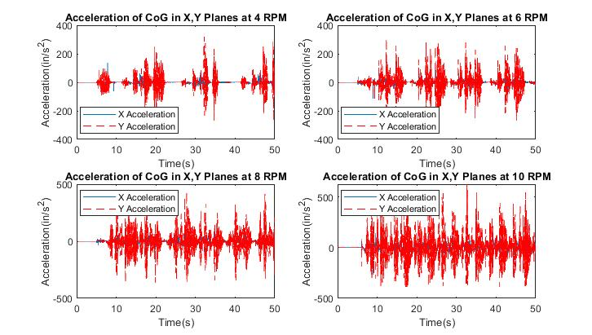
Figure 9. Acceleration of CG for Side Gait

One of the most notable features about the side gait is its consistency across different speeds. The shape of the graphs between different RPMs are very much alike with only the period lengths decreasing and max values increasing for velocity and acceleration. Another difference is that in the 8 and 10 RPM position graphs in Figure 7 there is a small spike inside of each valley. The average motion in the X direction (sway) is around 9 in for all 4 graphs. This shows that for this gait, increasing the speed of the cams only increases the speed at which the robot walks forward.

The velocity and acceleration follow the same pattern as the position and have very similar graphs between the different RPMs. The velocity graph does show an increase of max velocities in the X direction between the graphs from 10.21 in/s for the 4 RPM graph to 13.25 in/s for the 10 RPM graph. The acceleration graphs show a max acceleration of 317.5 in/s² (.82Gs) for 4 RPM up to 624.7 in/ s² (1.6Gs) for 10 RPM in in the Y direction with there being relatively insignificant acceleration in the X direction.

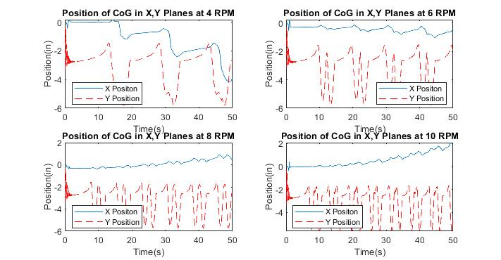
Figure 10. Position of CG for Front-Back Gait

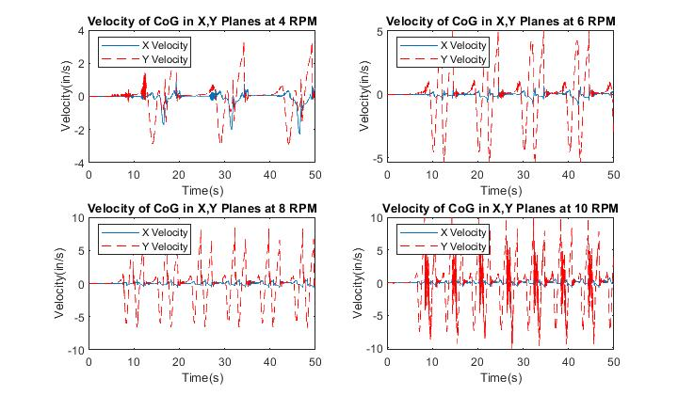
Figure 11. Velocity of CG for Front-Back Gait
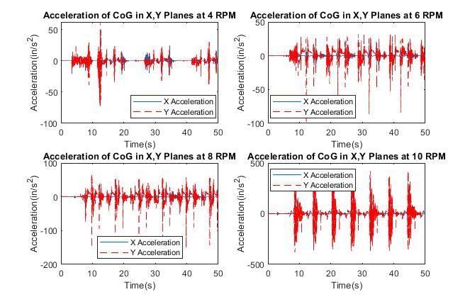
Figure 12. Acceleration of CG for Front-Back Gait

The graphs for the Front-Back gait show the same kinds of consistency as the side gait graphs, but in this case, it is in the Y direction instead of the X. The position graphs in Figure 10 do have a piece of interesting data in that for most of the RPMs the robot tends to stay straight or drift very slightly to the right. Except for the 4 RPM graph where the robot drifts very much to the left. Other than that, all the position graphs have a similar distance of motion for the center of gravity in the Y direction with the average being around 4in for all the graphs. The velocity and acceleration in the X direction is extremely small in this case with the largest X direction velocity being 2 in/s in the 4 RPM graph, and the largest X direction acceleration being around 35 in/s² in the 10 RPM graph. The velocity graphs follow a pattern of decreasing periods with an increasing max value as RPM increases, going from 3.32 in/s at 4 RPM to 10 in/s at 10 RPM. The acceleration graphs display similar patterns with large spikes and then a period of dissipation. The major difference is that in the 4 RPM graph there is a large spike in acceleration that is much greater than the others and is not repeated.

Discussion

In the diagonal gait, most of the motion in the robot was in the X plane from left to right. This means that the robot was not well balanced when it was on two legs. The cause seems to be the small loop at the end of the trajectory of the foot (Peters & Chen, 2014) causing the robot to shove itself forward before picking up its feet causing it to be off balance as the feet lift. The drifting to the left seems to be caused by the timing of the rotation of the cams. When the first pair of legs rise to walk this is right after the robot shoves itself forward, as the second pair of legs move to rise, they also do this slight shoving motion but the first pair of feet are just above the platform so they don’t get shoved forward by this motion; they simply hit the ground which leaves the first pair of feet slight to the left but not pitched forward providing a more stable base to balance on while the second pair of feet are in the air. Since the robot is balanced better while the second pair of feet are in the air it also means they travel in more of a straight line instead of causing the robot to lean slightly right and “correct” the trajectory of the robot. The motion in the Y plane is mostly from the actuation of the legs and the dip that the robot takes from being off balance. This type of motion is acceptable and will be improved further when the robot’s balance is improved.

When looking at the velocities, the velocity in the X plane is still much higher than desired but it is to be expected with the balance issues currently with the diagonal gait. The velocity in the Y plane also acts mostly as expected, meaning that as the rpm and therefore the speed at which the leg actuates increases the velocity of the center of gravity since it is moving up and down faster as the robot walks, but there is very little to no difference between the velocities at 8 RPM and the velocities at 10 RPM. The accelerations act as expected and desired since the acceleration in the Y plane is much greater than the X plane. So much so that it is difficult to see the X acceleration line on the graph. Most of the g force that the robot will experience will be in the plane where it is most supported.

With the side gait, the position graph acts as expected with the X plane having the most amount of motion. Since one side tries to lift completely off the ground the robot tips completely that way before correcting itself since there’s no real way for it to balance. This gait’s motion could also be described as “swaying”. The velocity graph also shows the X velocity to be greater than the Y but the acceleration in the Y plane is still greater than the X.

The front-back gait, while being the most stable in the X plane, has much more motion in the Y plane than both the diagonal and side gait. It acts similar to the side gait in the fact that the exaggerated motion is because the robot has no way to balance when either the front or back feet are rising so it falls onto them until the legs move back into more of a straight position and the robot corrects itself. The front-back gait has an interesting acceleration chart since it’s the only one who has a similar 4 RPM and 6 RPM acceleration but as the robot operates with 8 or 10 RPM the acceleration increases greatly. This is more in line with the idea that as the rpm increase so will the acceleration of the center of gravity.

Conclusion

This work shows that a robot using single degree of freedom legs can walk and stand by itself with a simple control system. However, currently the design is not very efficient because of the balance issues. More complex simulations will be needed to optimize the placement and timing of the legs to make the robot walk effectively.

The diagonal gait is the most promising configuration out of the three gaits that were simulated. While it still has some balance issues that need to be corrected, the other gaits under-perform too much to consider future work with them. The side gait sways too much from left to right and this can cause issues when trying to travel on terrain that is not perfectly straight. The front-back gait has the same issues that it sways back and forth too much for it to be useful with a single degree of freedom system. A robot using single degree of freedom legs cannot shift its weight on its own due to the restrictions of the design itself and the relatively simple control system to allow it to balance the weighs out and use the side or front-back gait. The diagonal gait could be corrected by moving the mounting position of the cams of the legs to the main body so that they are balanced around this shoved forward position that the trajectory of the foot imposes on the robot. Future work could be done with more sophisticated control systems that control the rotation of the cams more precisely. Allowing the robot to mimic the motion of a quadrupedal animally. Another avenue for progress is to change the system from quadrupedal to a hexapod. This would always allow the robot to keep three points of contact with the ground and greatly improve the balance of the robot.

References

Buehler, M., Koditschek, D. E, & Saranli, U. (November 2012) Single actuator per leg robotic hexapod, U.S. Patent 6,481,513.
Collins, S. H., & Ruina, A. (2005). A bipedal walking robot with efficient and human-like gait. In Proceedings of the 2005 IEEE International Conference on Robotics and Automation (pp. 1983-1988). IEEE.
Fukuoka, Y., & Kimura, H. (2009). Dynamic locomotion of a biomorphic quadruped ‘Tekken’robot using various gaits: walk, trot, free-gait and bound. Applied Bionics and Biomechanics, 6(1), 63-71.
García-López, M.C., Gorrostieta-Hurtado, E., Vargas-Soto, E., Ramos-Arreguín, J. M., Sotomayor-Olmedo, A., & Moya Morales, J. C. (2012). Kinematic analysis for trajectory generation in one leg of a hexapod robot, Procedia Technology, Vol. 3, Pages 342-350
Ha, S., Han, Y., & Hahn, H. (2007). Adaptive gait pattern generation of biped robot based on human’s gait pattern analysis. International Journal of Mechanical Systems Science and Engineering, 1(2), 80-85.
Herrero, D., & Martinez, H. (2007). Embedded behavioral control of four-legged robots, Robotic Soccer, Pedro Lima, IntechOpen, DOI: 10.5772/5132.
Inagaki, S., Yuasa, H., Suzuki, T., & Arai, T. (2006). Wave CPG model for autonomous decentralized multi-legged robot: Gait generation and walking speed control. Robotics and Autonomous Systems, 54(2), 118-126.
Jin, B. (2015). Modeling of a cam-actuated robotic leg. Undergraduate Thesis: Kettering University, Flint, MI
Joze, H. R. V., Habibi, J., & Asadi, N. (2007). Impossibles: A fully autonomous four-legged robot soccer team, Robotic Soccer, Pedro Lima, IntechOpen, DOI: 10.5772/5146.
Kurz, M. J., Judkins, T. N., Arellano, C., & Scott-Pandorf, M. (2008). A passive dynamic walking robot that has a deterministic nonlinear gait. Journal of Biomechanics, 41(6), 1310-1316.
Lewis, M. A., & Bekey, G. A. (2002). Gait adaptation in a quadruped robot. Autonomous Robots, 12(3), 301-312.
Nagakubo, A., & Hirose, S. (1994). Walking and running of the quadruped wall-climbing robot. In Proceedings of the 1994 IEEE International Conference on Robotics and Automation (pp. 1005-1012). IEEE.
Peters, D. L. & Chen, S. (2014). Design of a cam-actuated robotic leg. In Proceedings of the International Mechanical Engineering Congress & Exhibition, Montreal, Canada. (Paper-#IMECE2014-39803).
Poulakakis, I., Smith, J. A., & Buehler, M. (2005). Modeling and experiments of untethered quadrupedal running with a bounding gait: The Scout II robot. The International Journal of Robotics Research, 24(4), 239-256.
Raibert, M. H. (1986). Legged Robots That Balance, The MIT Press, Cambridge, Massachusetts
Raibert, M., Blankespoor, K., Nelson, G., & Playter, R. (2008). Bigdog, the rough-terrain quadruped robot. IFAC Proceedings, Vol. 41(2), 10822-10825.
Solidworks help website,
http://help.solidworks.com/2019/English/SolidWorks/sldworks/r_welcome_sw_online_help.htm, accessed on 03/15/20
Song, S. M., & Waldron, K. J. (1989). Machines that walk: the adaptive suspension vehicle. MIT press.
Spröwitz, A., Tuleu, A., Vespignani, M., Ajallooeian, M., Badri, E., & Ijspeert, A. J. (2013). Towards dynamic trot gait locomotion: Design, control, and experiments with Cheetah-cub, a compliant quadruped robot. The International Journal of Robotics Research, 32(8), 932-950.
Talebi, S., Poulakakis, I., Papadopoulos, E., & Buehler, M. (2001) Quadruped robot running with a bounding gait. In: Rus D., Singh S. (eds) Experimental Robotics VII. Lecture Notes in Control and Information Sciences, Vol. 271. Springer, Berlin, Heidelberg
Tsujita, K., Tsuchiya, K., & Onat, A. (2001). Adaptive gait pattern control of a quadruped locomotion robot. In Proceedings 2001 IEEE/RSJ International Conference on Intelligent Robots and Systems. Expanding the Societal Role of Robotics in the Next Millennium (Cat. No. 01CH37180) (Vol. 4, pp. 2318-2325). IEEE.
Zhang, J., Gao, F., Han, X., Chen, X., & Han, X. (2014). Trot gait design and CPG method for a quadruped robot. Journal of Bionic Engineering, 11(1), 18-25.
Zhang, G., Rong, X., Hui, C., Li, Y., & Li, B. (2016). Torso motion control and toe trajectory generation of a trotting quadruped robot based on virtual model control. Advanced Robotics, 30(4), 284-297.

Biographies

ANDREW J. WASSON earned his BS in mechanical engineering from Kettering University in 2020. Mr. Wasson may be reached at wass1286@kettering.edu.

DIANE L. PETERS is an associate professor of mechanical engineering at Kettering University. She earned her BS in mechanical engineering from the University of Notre Dame in 1993, MS in mechanical engineering in 2000 from the University of Illinois – Chicago, and PhD in mechanical engineering in 2010 from the University of Michigan. Dr. Peters’ research interests include control co-design, control systems, and autonomous vehicles. Dr. Peters may be reached at dpeters@kettering.edu.

YAOMIN DONG is currently a Professor of Mechanical Engineering at Kettering University. He received his Ph.D. in Mechanical Engineering at the University of Kentucky in 1998. Dr. Dong has extensive R&D experience in automotive industry and holds multiple patents. Dr. Dong’s areas of expertise include metalforming processes, design with composite materials, computer graphics, computer-aided engineering and finite element analysis. Dr. Dong may be reached at ydong@kettering.edu.

