033-x-22

Development of Experiential Learning Experiences for K-12 Students Focusing on Smart Cities

Murat Kuzlu
Old Dominion University, Norfolk, VA
mkuzlu@odu.edu

Vukica Jovanovic
Old Dominion University, Norfolk, VA
v2jovano@odu.edu

Nathan Puryear
Virginia Commonwealth University
puryearna@vcu.edu

Patrick J. Martin
Virginia Commonwealth University
martinp@vcu.edu

Sherif Abdelwahed
Virginia Commonwealth University
sabdelwahed@vcu.edu

Özgür Güler
eKare, Fairfax, VA
ozgur.guler.phd@gmail.com
Abstract

The main objective of this paper is to describe a project focused on the development of experiential learning experiences for undergraduate and graduate students focusing on smart cities. The future workforce needs students with various data analytics skills, service reliability, and sustainability. The team of researchers from Old Dominion University and Virginia Commonwealth University is developing a virtual smart city lab environment at both universities and collaborating on multiple research projects. The main purpose of this virtual labs is to provide a testbed that can be used for students who are interested in careers related to cyber-physical systems (CPS). These emergent technologies often develop faster than changes in the curriculum at various universities and K-12 school systems. New technologies related to connectivity, data collection, visualization, analysis, resource management, and control require a future workforce that is well-equipped with cybersecurity skills. The future workforce that will work on the design, development, maintenance, and utilization of smart cities requires the application of multiple research areas, such as embedded and cloud computing, wireless communications, and artificial intelligence (AI), to realize safe, intelligent public services, such as utilities, transportation, healthcare while ensuring privacy and security. This paper will present an overview of different outreach curriculum modules that are used for high school student engagement and outreach for a future pathway to the smart city workforce. It is a part of the bigger project related to the experimental learning for smart city application.

Introduction

Experiential learning is defined as learning from experience or learning by doing (Lewis, 1994) or creating knowledge from someone’s expertise (Hajshirmohammadi, 2017). The four critical steps associated with experiential learning are Action, Reflection, Abstraction, and Application, and all of these can be repeated in a cycle (Luckmann, 1996). Different approaches encourage students to develop more complex thinking for making engineering students capable of achieving good decisions in their future jobs, especially in real-world engineering problems that are often ambiguous (Pavelich, 1996). If enrolled in an electrical and computer engineering program, students can have experiential learning experiences while taking upper-division courses through course projects, internships, and capstone projects (Hajshirmohammadi, 2017).

However, although these experiences are very beneficial, there is always additional challenges that are happening is related to the ongoing changes in technology, especially engineering technology (Harsh, 2015). Recent developments in the application of wireless communication technologies in all areas of our lives have led to the fast-paced development of various new paradigms such as the Internet of Things (IoT), next-generation networks (5G and beyond), cloud-edge computing, and the new area of interconnectivity at the hardware and software level among various smart devices, that can be found in various daily aspects of human life, such as buildings, roads, vehicles, infrastructure, healthcare, and other components of what make up an urban living.

In literature, some recent studies have focused on IoT-based open platform solutions (Soe, 2002; Ahlgren, 2016) for smart cities. The objective of the proposed OpenCyberCity platform is to extend the open platform ideas and provide an environment to engage students in experiential learning that adds meaningful activities that can span from professional to personal. In this way, students can engage and experience problems that are related to their daily lives. These experiences will be of great value to many teachers since bringing real-world experience into the classroom might be a challenging problem for academics who mainly focus on developing new technologies and things that do not yet exist, which might be often found in many engineering universities. These instructors often had no industry experience and were not necessarily working in a real industrial environment. At the same time, many other instructors have professional engineering experience and may offer such experiences to their students. Some studies focused on the application of smart technologies in the smart trash applications for environmental education (Rahmayanti, 2020) and also emphasized the importance of introduction of such skills in K-12 curriculum (Pellegrino, 2021, Williamson, 2015).

Workforce Gap for Cybersecurity Workforce

Due to the rapid changes in new communication technologies, there has been a significant gap in the current workforce. The current needs for new hires in all different levels of expertise for areas such as data analytics, service reliability, and sustainability. These emergent fields are now overlapping and spanning multiple technical, scientific, and engineering domains. This gap is widening due to the pace at which technology is developing since educational changes take a longer time to be implemented and developed. Another aspect of different curriculum changes across these domains is related to the aspects of safe, secure, and timely developments related to the cybersecurity aspects of any job that deals with cyber-physical systems. Some of the topics that need to be delivered to the various audiences and through the various modes are connectivity, data collection, visualization, analysis, resource management, and control. In this way, the cyber workforce of the future will have enough workforce that would be able to design, develop, maintain, and use cyber-physical systems such as various systems in smart cities. The knowledge that needs to have various skills developed are in the areas of embedded and cloud computing, wireless communications, and artificial intelligence (AI) to realize safe, intelligent public services, such as utilities, transportation, and healthcare while ensuring privacy and security.

These experiential learning activities that are presented in this paper are supplemental to the educational modules that were developed as part of the different project U.S. Department of Education, Office of Career, Technical, and Adult Education, Division of Academic and Technical Education, Innovation and Modernization Program, award # V051F190072 in which educational modules for the Cybersecurity Fundamentals (2020) course 6302 under Commonwealth of Virginia Cybersecurity Pathway was developed (Jovanovic, 2020, Jovanovic, 2021, Jovanovic, 2022).

OpenCyberCity Case Study - Experiential Learning Experience

OpenCyberCity (formally known as OpenCity), an open architecture testbed for smart cities, is hosted at Virginia Commonwealth University (Figure 1). It is a physical mockup of the representative infrastructure representing residential, traffic, and communal areas that are used by the residents of one model city. This smart city testbed was developed to provide experiential learning experiences for both education, and the research topics focused on smart city development. In this way, experiences that would be developed around the application of the technologies that are used in smart can be used by students to gain experience and then the necessary knowledge to join the workforce of the future.

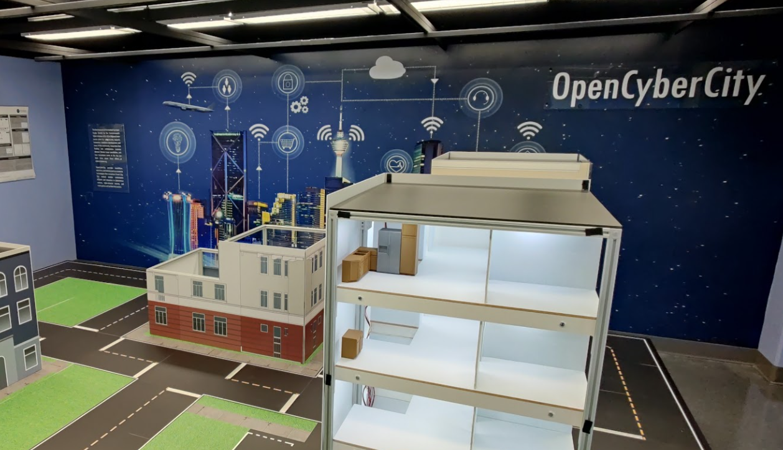

Figure 1. The mockup smart building of the OpenCyberCity testbed at Virginia Commonwealth University.

OpenCyberCity testbed will provide experiential learning experiences related to the technologies that support smart homes and buildings, urban mobility, smart grid, and water management. Figure 1 shows one example of a smart building that is used in the urban setting - the kitchen in a high-rise building. Various elements will be added to the system that supports the water distribution system in such a kitchen, which will represent a smaller-scale version of the plumbing and sewage distribution systems. In this way, students can learn about possible problems that may occur in the residential environment, possible solutions, and automation that can be embedded and implemented in such a system, all to make human lives safer, more comfortable, and energy efficient. Various sensors can be placed in the plumbing and sewage systems, such as the ones related to water flow and pressure control, leakage detection, sewage testing, and for example, detection of hazardous or biohazardous substances that can be present in the sewage water outlet from this kitchen. All of these sensors can be connected to the cloud and virtual testbed, and all of them can be used to stream real-time data that can be used to understand better and predict necessary actions that can be used for deep learning, artificial intelligence, and data science analyses that can help us predict future energy use and management, on need maintenance operations planning, and prevention of unwanted situation in such residential settings. Such use of embedded systems (sensors and microcontrollers, devices connected to the internet) through the use of the Internet of Things (IoT) will provide a real-time information stream for city managers and public service providers to better understand the strain placed on the city's infrastructure and resources (Zohrabi, 2021). The data collection process is one of the most challenging tasks, and a robust and efficient data collection architecture is needed. To meet these requirements, OpenCyberCity is built on an end-to-end data collection architecture consisting of five main components: s, (1) IoT Networks, (2) Server-side MQTT Interfacing, (3) Kafka Server-side Streaming, (4) Cassandra NoSQL Database, and (5) Django Web Server (Kuzlu, 2022).

This mockup system representing the residential building will include various microcontrollers such as Rasberry Pi4 Model B, and Raspberry Pi Zero W. It will include various motors such as Micro servo stepper motors and various smaller-scale sensors that represent sensors that can be found in a typical smart home such as a temperature sensor (DHT22), gas detection sensor (MQ-2) gas sensor, light sensor, passive infrared (PIR) sensor, infrared motion detection sensor (IR LED), camera (Rasberry Pi Camera), electric heating pad, water level sensor, and various other electronic components such as cooling fan, LED RGB strip. The main functions that will provide hands-on experiential learning experiences for the students will provide real-life usages case studies such as Building Control and Management, Sensor and Actuator Control and Management, Door and Window Movement, Temperature and humidity monitoring, flammable gas and smoke sensor detection, building illumination, security features such as motion sensor detection and related features (human presence detention, security, and monitoring), Heating and Air Conditioning (HVAC) features such as temperature and humidity monitoring, individual temperature control), and also leakage prevention such as tank water level and leaks (Zograbi, 2021). All microcontrollers, sensors, and other parts used in OpenCyberCity are given in Table 1.

Table 1: OpenCyberCity's building component list (Zohrabi, 2021)

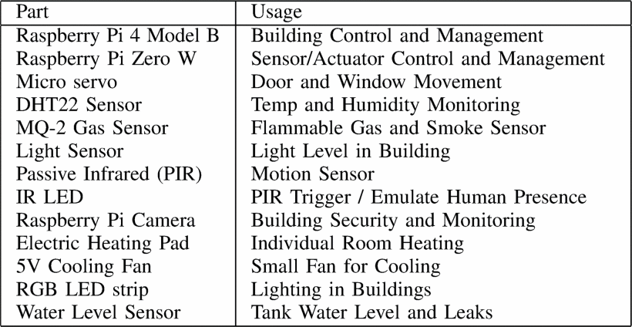

One such activity is focused on gathering temperature and humidity data, as shown in Figure 3 and Figure 4. Resistor 10k is placed between Pin 1 and Pin 2 of the DHT22, one wire connects Pin 1 of the DHT22 to physical Pin 1 (3v3) on the Pi. Another wire Pin 2 connects the DHT22 to the physical Pin 7 (GPIO4) on the Pi. One more wire connects Pin 4 of the DHT22 to the physical pin 6 (GND) on the Pi. The temperature and humidity sensor has four pins: Pin 1 is VCC (Power Supply); Pin 2 is DATA (The data signal); Pin 3 is NULL (Do not connect); and Pin 4 is GND (Ground) (Emmet, 2022).

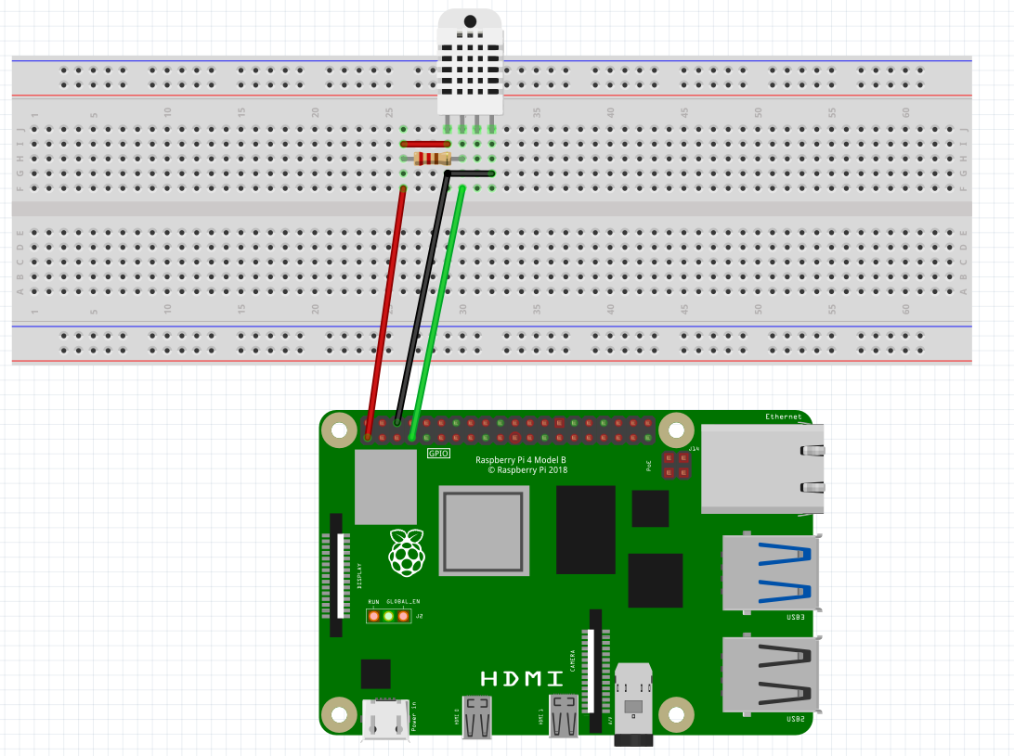

Figure 3. Humidity and temperature sensor hands-on activity physical layout.

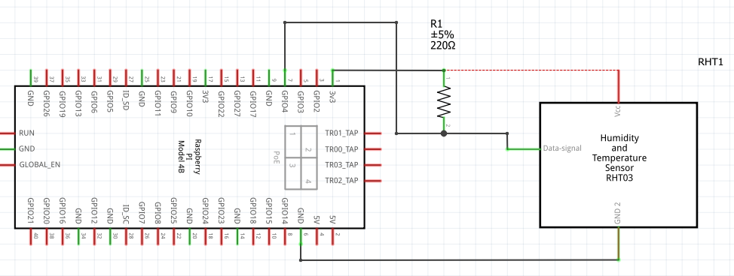

Figure 4. Humidity and temperature sensor hands-on activity schematic.

Such humidity and temperature sensors can be connected to the internet, and data about the current temperature and humidity can further be streamed to the cloud. In this way, residents of the smart city can detect different water leaks (under the dishwasher, under the fridge, under the sink) or detect worrisome humidity levels in the crawl space or the basement, HVAC condensation leaks that might go undetected, or any other rooms that might have increased humidity levels or presence of some leak that might endanger the structure, cause mold and make unnecessary expenses to the residents. This is especially important in large residential buildings that can have many rooms that are not frequently visited by the tenants or the residents. One such flow diagram of home automation included home appliances such as lights, door locks and air conditioning (Sahran, 2018). Conceptual model of one such system is given in Figure 5. Important thing to consider is added cybersecurity feature to such system since home automation system has to be secure from unauthorized access.
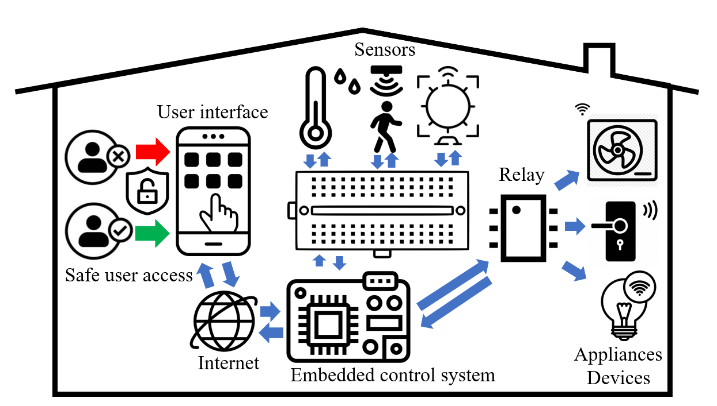

Figure 5. An example of Internet-based automation system structure.

Education and Career Pathway for Smart City Infrastructure

Cybersecurity Pathways in Old Dominion University include various courses related to the topics of cyberinfrastructure. These courses include Informational Technology (IT) Fundamentals, Cybersecurity Fundamentals, and Cybersecurity Operations, which are part of the Business and Informational Technology pathway. These are part of the Career and Technical Education programs. Another course, Advanced Placement (AP) Computer Science, is offered to high achieving students that are qualified to take such courses under the science cluster and is not offered in each school. Another course that covers such topics related to smart city applications is Engineering Studies. All of these courses could integrate such activity with the above-mentioned sensor. The cost of the open-source electrical prototyping platforms is less prohibitive than before, and such activities can be easily integrated into the curriculum. OpenCyberCity platform will significantly contribute to future workforce development in data science and cybersecurity by providing experiential learning opportunities to students and creating an ecosystem for students and researchers to function in interdisciplinary research projects and support their professional development, as well as supporting to sustain the growth of the future workforce. These experiential learning modules will be shared with the cybersecurity teachers who are teaching courses such as Information Technology Fundamentals and Cybersecurity Fundamentals in Commonwealth of Virginia. Home automation hands on activities can be integrated within the high school CTE course Cybersecurity Fundamentals: CF-Tasks 50-58 – How Does Internet Work Examining Computer Networks as a Foundational Element of Cybersecurity. Students are learning about the concept of the Internet as a network of connected systems (Jovanovic, 2022, Virginia Department of Education, 2019).

Conclusion

The team of researchers from Old Dominion University (ODU) and Virginia Commonwealth University (VCU) has been developing a virtual smart city lab environment that will complement this OpenCyberCity testbed located at VCU. The main purpose of this virtual lab is to provide a testbed that can be used for students and researchers who are interested in careers related to cyber-physical systems (CPS). One of the main ideas that will be achieved during this project is to provide data streams of all these subsystems that can be used as test case studies for undergraduate and graduate students who want to be engaged in experiential learning and experiential research on the smart city technologies. The platform has already started collecting data from IoT devices in the mockup smart building of the OpenCyberCity testbed. It is expected that the platform will be fully virtual to provide an experiment modeling and orchestration environment that allows students and researchers to explore the algorithms and technologies related to smart cities in the future. The future workforce will have to be fluent in the data acquisition of all these smart technologies but also in learning how to make smarter decisions through deep learning, artificial intelligence, and data science methods so that people can make sense of the harvested data and make more secure, safer, and more energy-efficient residential life for the community. To meet the future workforce demand, new educational resources are required to bridge the theory and practice gap in CPS education and workforce development for students and professionals to exercise their skills.

Acknowledgment

The project team wishes to acknowledge funding received by the Commonwealth Cybersecurity Initiative (CCI), award # CCI: Developing a Smart City Virtual Lab to Support CPS Experiential Learning. The project team wishes to acknowledge funding received by the U.S. Department of Education, Office of Career, Technical, and Adult Education, Division of Academic and Technical Education, Innovation and Modernization Program, award # V051F190072.

References

Ahlgren, B., Hidell, M. and Ngai, E.C.H., 2016. Internet of things for smart cities: Interoperability and open data. IEEE Internet Computing, 20(6), pp.52-56.
Emmet (2022). Raspberry Pi Humidity Sensor using the DHT22, Pi My Life Up, Retrieved on March 15, 2022, from https://pimylifeup.com/raspberry-pi-humidity-sensor-dht22/
Hajshirmohammadi, A. (2017). Incorporating experiential learning in engineering courses. IEEE Communications Magazine, 55(11), 166-169.
Harsh, M., Caron, B., Dysart-Gale, D., Gopakumar, G., & Schmitt, K. (2015). Implementing experiential education on engineering and society. Proceedings of the Canadian Engineering Education Association (CEEA).
Jamison, C. S. E., Fuher, J., Wang, A., & Huang-Saad, A. (2022). Experiential learning implementation in undergraduate engineering education: a systematic search and review. European Journal of Engineering Education, 1-24.
Jovanovic, V. M., Kuzlu, M., Popescu, O., Badawi, A. R., Marshall, D. K., Sarp, S., Tsouganatou, S., Katsioloudis, P. J., Vahala, L., Wu, H. M. (2020, June), An Initial Look into the Computer Science and Cybersecurity Pathways Project for Career and Technical Education Curricula Paper presented at 2020 ASEE Virtual Annual Conference Content Access, Virtual Online. 10.18260/1-2—34128
Jovanović, V., Kuzlu, M., Popescu, O., Katsioloudis, P., Vahala, L., Wu, M., & Addison, M. (2022). Digital Educational Modules Development for The Career and Technical Cybersecurity Pathways During the COVID-19 Pandemic. Technology Interface International Journal, 22(2).
Jovanovic, V., Popescu, O., Kuzlu, M., & Katsioloudis, P. (2021). let's collaborate! the importance of cybersecurity pathways and their accessibility. Technology and Engineering Teacher, 81(2), 30-33.
Kuzlu, M., Kalkavan, H., Gueler, O., Zohrabi, N., Martin, P.J. and Abdelwahed, S., (2022, April). An End-to-End Data Collection Architecture for IoT Devices in Smart Cities. In 2022 IEEE Power & Energy Society Innovative Smart Grid Technologies Conference (ISGT).
Lewis (1994). Experiential learning: Past and present. New directions for adult and continuing education, 1994(62), 5-16.
Luckmann, C. (1996). Defining experiential education. Journal of experiential education, 19(1), 6-7.
Pavelich, M. J., & Moore, W. S. (1996). Measuring the effect of experiential education using the Perry model. Journal of Engineering Education, 85(4), 287-292.
Pellegrino, M. A., Roumelioti, E., Gennari, R., & D’Angelo, M. (2021, October). Smart City Design as a 21st Century Skill. In International Conference in Methodologies and intelligent Systems for Techhnology Enhanced Learning (pp. 271-280). Springer, Cham.
Rahmayanti, H., Ichsan, I. Z., Oktaviani, V., Syani, Y., Hadi, W., & Marhento, G. (2020). Environmental attitude for smart city technology: Need assessment to develop smart trash in environmental education. International Journal of Advanced Science and Technology, 29(3), 8374-8383.
Sachan, M. (2018). INTERNEt Of THINGs: Raspberry Pi Home Automation System based on IoT, medicum.com. Retrieved on March 12, 2022, from https://medium.com/@mahimasachan/internet-of-things-raspberry-pi-home-automation-system-based-on-iot-d94cac70a7c1.
Soe, R.M., Ruohomäki, T. and Patzig, H., 2022. Urban Open Platform for Borderless Smart Cities. Applied Sciences, 12(2), p.700.
Spournias, A., Faliagka, E., P. Antonopoulos, C., & S. Voros, N. (2020, November). Knowledge diffusion through experiential education, focusing on robotic technologies, virtual reality, and the internet of things. In 24th Pan-Hellenic Conference on Informatics (pp. 363-366). Lewis, L. H., & Williams, C. J. (1994).
Virginia Department of Education. (2019b). Cybersecurity Fundamentals. Virginia Department of Education, Richmond, Virginia. Retrieved on July 10, 2022 from http://www.cteresource.org/curriculum/business-andinformation-technology/Cybersecurity%20Fundamentals%206302.pdf
Williamson, B. (2015). Educating the smart city: Schooling smart citizens through computational urbanism. Big Data & Society, 2(2), 2053951715617783.
Zohrabi, N., Martin, P. J., Kuzlu, M., Linkous, L., Eini, R., Morrissett, A., ... & Abdelwahed, S. (2021, September). OpenCity: An Open Architecture Testbed for Smart Cities. In 2021 IEEE International Smart Cities Conference (ISC2) (pp. 1-7). IEEE.

Biographies

MURAT KUZLU, assistant professor of engineering technology, joined Old Dominion University, Norfolk, VA’s Electrical Engineering Technology program in 2018. He received his B.Sc., M.Sc., and Ph.D. degrees in Electronics and Telecommunications Engineering from Kocaeli University, Turkey, in 2001, 2004, and 2010, respectively. From 2005 to 2006, he worked as a Global Network Product Support Engineer at Nortel Networks, Turkey. In 2006, he joined the Energy Institute of TUBITAK-MAM (Scientific and Technological Research Council of Turkey – The Marmara Research Center), where he worked as a senior researcher. Before joining ODU, he worked as a Research Assistant Professor at Virginia Tech’s Advanced Research Institute. His research interests include smart cities, smart grids, cyber-physical systems, artificial intelligence, and next-generation networks. Dr. Kuzlu may be reached at mkuzlu@odu.edu.

VUKICA M. JOVANOVIĆ, Chair, Batten Endowed Professor, and associate professor of engineering technology at Old Dominion University, Norfolk, VA. She holds a Ph.D. from Purdue University in Mechanical Engineering Technology, focuses on Digital Manufacturing. Her research focuses on engineering pathways, career and technical education, digital thread, cyber-physical systems, mechatronics, digital manufacturing, broadening participation, and engineering education. She worked as a Visiting Researcher at Commonwealth Center for Advanced Manufacturing in Disputanta, VA on projects focusing on the digital thread and cybersecurity of manufacturing systems. She has funded research in broadening participation efforts of underrepresented students in STEM funded by the U.S. Department of Education, focusing on computer science and cybersecurity pathways, and from the Office of Naval Research, focusing on mechatronic pathways. She leads the team that delivers the summer program to nine graders that focus on broadening the participation of underrepresented students in STEM (ODU BLAST), funded by the Virginia Space Grant Consortium. Dr. Jovanovic may be reached at v2jovano@odu.edu.

NATHAN PURYEAR is a Ph.D. student at Virginia Commonwealth University and received his B.S. in Computer Engineering from Virginia Commonwealth University in 2019. He worked as a Computer Engineer and Systems Engineering Graduate Research Assistant at the Commonwealth Center for Advanced Manufacturing (CCAM), Disputanta, VA. Mr. Puryear can be reached at puryearna@vcu.edu

SHERIF ABDELWAHED, a full professor at Virginia Commonwealth University, Richmond, VA. Sherif Abdelwahed received a Ph.D. degree from the Department of Electrical and Computer Engineering, University of Toronto, in 2002. He is a professor of Electrical and Computer Engineering (ECE), at Virginia Commonwealth University (VCU). Before joining VCU in August 2017, he served as the associate director of the Distributed Analytics and Security Institute, Mississippi State University (MSU). He is also an associate professor with the ECE Department, MSU. He received the StatePride Faculty award for 2010 and 2011, the Bagley College of Engineering Hearin Faculty Excellence award in 2010, and recently the 2016 Faculty Research Award from the Bagley College of Engineering, MSU. Dr. Abdelwahed can be reached at sabdelwahed@vcu.edu.

PATRICK J. MARTIN is an assistant professor at Virginia Commonwealth University, Richmond, VA. Dr. Martin received a Ph.D. in Electrical and Computer Engineering from Georgia Institute of Technology, an M.S. in Electrical Engineering from the University of Maryland College Park, and a B.S. in Physics and Applied Mathematics from Hampden-Sydney College. Dr. Martin's research applies control theory and artificial intelligence to enable the safe deployment of distributed autonomous systems. Prior to joining VCU’s Electrical and Computer Engineering Department, he worked at MITRE Corporation, BAE Systems. He was also an assistant professor at York College of Pennsylvania. Dr. Martin is an IEEE Senior Member and is affiliated with the Control Systems Society and Robotics and Automation Society. Dr. Martin can be reached at martinp@vcu.edu.

ÖZGÜR GÜLER, eKare, Fairfax, VA. Özgür Güler received a B.S. degree in computer science and an M.S. degree in computer science with a focus on image-guided surgery from the University of Innsbruck, Innsbruck, Austria, and a Ph.D. degree from the Medical University of Innsbruck, Austria, with a focus on image-guided diagnosis and therapy. He is currently an Imaging Scientist and AI Researcher specializing in 3-D chronic wound imaging and computer vision. Prior to joining eKare Inc., he was a Researcher with the Sheikh Zayed Institute (SZI) for Pediatric Surgical Innovation Center, Washington, DC, where he developed the segmentation and classification algorithms that laid the groundwork for the eKare inSight system.EOD. Dr. Güler can be reached at ozgur.guler.phd@gmail.com

