Digital Twin Integration for Smart City Framework Development

Wesley Conwell
Department of Electrical and Computer Engineering
University of Alabama at Birmingham
wlconwel@uab.edu

Leon Jololian
Department of Electrical and Computer Engineering
University of Alabama at Birmingham
leon@uab.edu

Abstract

The development of smart cities requires a framework for managing the complexities of operating growing cities. Unfortunately, current smart city framework implementation techniques do not take full advantage of a city’s potentially useful generated information, leading to wasted opportunities. In this paper, we propose an integrated architecture that aims at monitoring the use and consumption of city resources to manage these resources efficiently and proactively and effectively meet the demands of citizens in a smart city. The components of the architecture comprise an Internet-of-Things (IoT) framework for data collection, big data analytics for mining the data, a machine learning engine for discovering patterns and trends in the data, and a digital twin framework for the simulation of alternative solutions in the configuration of resource management.

Introduction

Whether driven by population shifts because of the global COVID-19 pandemic, war in Ukraine, or other factors, population flows continue growing in city-regions worldwide. Cities are the main poles of human and economic activity. They hold the potential to create synergies, allowing great developmental opportunities to their inhabitants. However, they also generate a wide range of problems that can be difficult to tackle as they grow in size and complexity. The world’s cities are growing in both size and number. In 2016, there were 512 cities with at least 1 million inhabitants globally. By 2030, a projected 662 cities will have at least 1 million residents (United Nations, 2016). The share of the population living in cities is projected to increase across the globe. In North America, more than half of the population lived in cities with 500,000 inhabitants or more in 2016, and one in five people lived in a city of 5 million inhabitants or more. Current smart city frameworks show promise in the quest to structure systems effectively to manage growing cities' complexities. However, current smart city framework implementation techniques squander the system’s potentially useful generated information, leading to wasted resources. In this paper, we propose a digital twin architecture for a smart city to more productively use existing data and establish a problem-solving architecture to optimally manage the complexities assessed in the sub-domains of a smart city, such as smart energy, smart health, and smart transportation. This paper contributes to the growing area of smart city research by exploring resource consumption in smart cities. In distinguishing between current and future frameworks for managing smart cities, the proposed work seeks to highlight the advantages of a digital twin implementation structure by pointing to various levels of frameworks for implementation.

Smart City (basic concept.

Cities are a human invention, born from the human need for security, the convenience of living together, easier management of resources, better quality of life, and smaller mobility distances. With smart cities, people can reinforce their role and their proximity inside the city space (Zubizarreta et al., 2016). Despite considerable research in the field, debates remain concerning the definition of a smart city. Albino’s research relates a smart city as a fuzzy concept used in ways that are not always consistent (Albino et al., 2015). There is neither a single template of framing a smart city nor a one-size-fits-all definition of it. First used in the 1990s, the term smart city focused on the significance of new Information and Communications Technology (ICT) regarding modern infrastructures within cities. Smart city researcher Michael Batty considered that “the concept of the smart city emerged during the last decade of the 20th century as a fusion of ideas about how information and communications technologies might improve the functioning of cities, enhancing their efficiency, improving their competitiveness, and providing new ways in which problems of poverty, social deprivation, and poor environment might be addressed” (Batty et al., 2012, p. 483). More than ever, more people are electing to live in cities, which poses unprecedented challenges for city stakeholders in addressing city inhabitants' quality of life. Frameworks for sustainable city development are needed to address the many challenges cities worldwide face today. Smart City initiatives have emerged as an alternative means to tackle sustainable city development challenges. Due to the nature of smart city objectives being highly local and even regional, different cities require different “smart” solutions.
Some studies suggest that the smart moniker is used to rationalize institutionalizing technology as a means of municipal power, shifting the discourse away from politics and citizen-centric policy to a technologically driven focus controlled by consultants and private industry (Osborne & Rose, 1999; Vanolo, 2014). Regardless, with no shared definition to date, cities are self-defining as smart without a consensus. Although many definitions abound, a smart city ultimately represents a complex system of systems that leverages innovative ICT for the benefit of a community, integrated with complex subsystems to fulfill its operational objectives.

Challenges for managing smart cities.

There are many challenges and opportunities for managing smart cities. Andres Monzon’s brilliant research on urban challenges in the Meditteranean provides excellent insight. Although his research focused on the Meditteranean region, the insights represent a global perspective. Monzon’s research categorized the challenges in six key areas–governance, economy, mobility environment, people and living. Those key areas are subdivided into several categories of specific global challenges, such as shrinking cities, unemployment, urban sprawl, affordable housing, problems of urban youth, and climate change effects (Monzon, 2015). Monzon’s visual summary in Figure 1 encapsulates the challenges for broader evaluation.

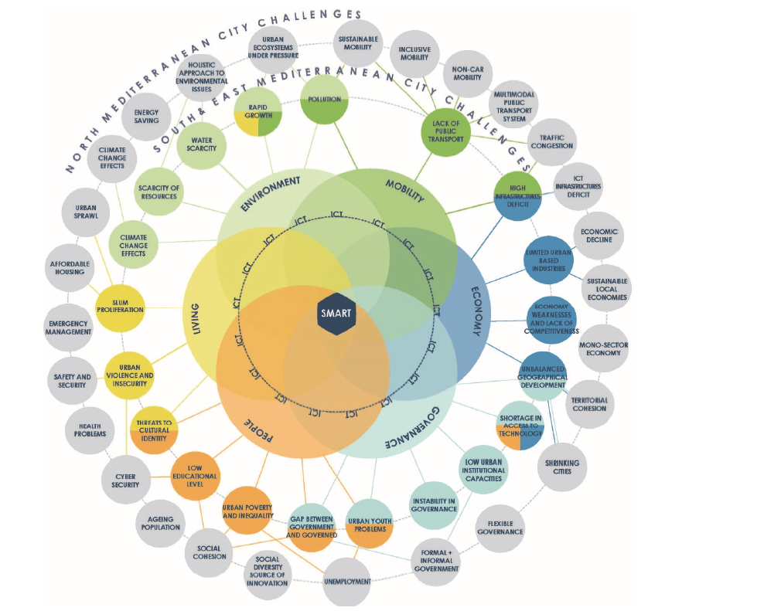

Figure 1: Relations between Smart City Dimensions, South & East Mediterranean Challenges and general City Challenges.

Growing populations in urban areas demand more resources and better services to meet the challenges ahead. As many challenges exist in managing smart cities, opportunities for improvement are borne out of smart city implementation to solve problems.

Prior solutions to the management of smart cities.

In the smart cities' space, several researchers developed unique solutions concerning the management of smart cities. First, Strohbach (Martin Strohbach, Holger Ziekow, Vangelis Gazis, 2015) established that an increasing amount of valuable data sources, advances in the Internet of Things, and Big Data technologies offer new potential to deliver valuable analytical services to citizens and urban decision-makers. However, there remains a gap in combining the current state of the art in an integrated framework that would help reduce development costs and enable new kinds of services. Strohbach’s work demonstrated how such an integrated Big Data analytical framework for Internet of Things and Smart City applications would work.

Second, China is a fast growing innovator of smart city solutions and ideas. Chen’s 2016 (Chen et al., 2016) work noted that to build sustainable, livable, and safe cities, the Chinese government began experimenting with its first Smart City project in 90 cities in late 2012. The project aimed to transform digital cities into smart cities, and as of 2016, more than 290 cities were involved. China emphasizes smart cities' data from the data life cycle perspective (data collection, data analysis, and data-driven smart services). Chen’s research highlighted three unique challenges in China’s smart city efforts and presented three promising future directions to characterize a potential road map for smart city development: 1) Overwhelming amounts of data not being open for broader analysis, 2) structural deficiency in operating through centralized, “top-down” approaches, and 3) reactive responses to significant events.

Last, Mohammadi’s 2017 study addresses (Mohammadi & Taylor, 2017) rapid urbanization challenges, in which cities are determined to implement advanced socio-technological changes and transform into smarter cities. However, the success of such transformation greatly relies on a thorough understanding of the city’s states of spatiotemporal flux. Understanding such fluctuations in context and interdependencies among various entities across time and space is crucial if cities are to maintain their smart growth. In connection to this research, Mohammadi introduced a Smart City Digital Twin paradigm that can enable increased visibility into cities’ human-infrastructure technology interactions, in which spatiotemporal fluctuations of the city are integrated into an analytics.

The concept of a Digital Twin as a monitoring and analytical tool for tracking systems or operations of enterprises.
This research's focus is the development of an architecture that can monitor a smart city with a digital twin as its backbone. The primary research questions is “How can a city implement smart concepts in its operations and management using a digital twin?” The digital twin concept is increasingly popular with researchers and professionals seeking to visualize, model, and work with complex urban systems. This is achieved by coupling physical systems with comprehensive digital representations that can automatically update to match their physical counterparts' state (Dawkins, 2018). In the early 2000s, Michael Grieves developed the current framing of the digital twin concept putting forward the embodiment of physical world items in a digital representation. In this instance, software clones physical objects and embodies Marc Andreesen’s famous 2011 Wall Street Journal quote in which he stated that we are rapidly advancing to a society in which “software is eating the world” (Andreesen, 2011). The digital twin concept follows the continuum advanced by the 4th industrial revolution bringing forth the age of cyber physical systems (CPS); Illustrated in Figure 2 shown below.
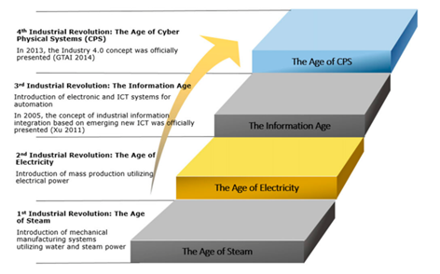
Figure 2: The evolution from Industry 1.0 to Industry 4.0.

CPS is the core foundation of Industry 4.0 in which physical and software components are deeply intertwined, each operating on different spatial and temporal scales and interacting with each other in a myriad of ways that change with context (Xu et al., 2020).

Within the construct of the digital twin in smart cities, there is no widely accepted standard architecture. Michael Grieves’ expertise in product design initially rooted the digital twin concept in production engineering. In recent years, the idea broadened in its application to characterize a variety of digital simulation models that run alongside real-time processes that pertain to social and economic systems and physical systems (Batty, 2018). One area from which to draw lessons for more general application is the smart health space. ISO/IEEE 11073 (X73) Personal Health Device standards emerged in 2008 to facilitate communication between personal health devices [such as computer systems and smartphones] and health care managers. The standards are aimed at promoting health data exchange while providing plug-and-play real-time interoperability. The minimum requirement for personal health devices and managers to be X73 compliant is to adhere to the X73 communication model. As such, the X73 standards ensure that a health device and a compliant manager can complete the data transfer successfully. The overall requirements include: 1) Data collection using sensory devices, 2) Standardization of data communication, 3) Data analytics to detect patterns, and 4) Real twin and health caregiver feedback using hard and soft actuation.

Expanding the digital twin push for some measure of standards, industry titans joined the conversation. Microsoft developed Azure Digital Twins leveraging its Azure cloud computing service. Azure Digital Twins is created as a platform as a service (PaaS) offering that enables the creation of digital models of entire environments. These environments could be buildings, factories, farms, energy networks, railways, stadiums, and entire cities. Also, IBM developed a digital twin exchange for easy access to digital twin data for equipment, facilities, and IoT; it uses real-time data to enable understanding, learning, and reasoning; applications range from the Duke Energy renewables wind turbine fleet to Europe’s largest shipping port–Port of Rotterdam.

A Smart City Architectural Framework —

Cities’ services and infrastructures are being stretched to their limits in scalability, environment, and security as they adapt to support this population growth. Thus, visionaries and planners seek a sustainable, post-carbon economy to improve energy efficiency and minimize carbon-emission levels. Along with cities’ growth, innovative solutions are crucial for improving productivity (increasing operational efficiencies) and reducing management costs. The development of a broad-based, solution-focused architecture helps manage the complexity.

In smart cities, an increasing amount of valuable data sources, advances in the Internet of Things and Big Data technologies, and a wide range of machine learning algorithms offer new potential to deliver analytical services to citizens and urban decision-makers. However, there is still a gap in combining the current state of the art in an integrated framework that would help reduce development costs and enable new services. From the research of Mohammadi [5] and Dawkins [6], we discern the establishment of models relaying the shift to a digital twin – smart city paradigm. Mohammadi’s research constituted a pragmatic perspective in developing a model to capture data from an actual city (Atlanta, GA) and account for spatiotemporal fluctuations at the intersection of reality and virtuality. Dawkins’ paper investigated this paradigm shift through the lens of seeking a solution in visualizing, modeling, and working with complex urban systems across the Atlantic at London’s Queen Elizabeth Park.
Building from the efforts of Mohammadi and Dawkins, Figure 3 demonstrates the digital twin-smart city architecture proposed in this research.

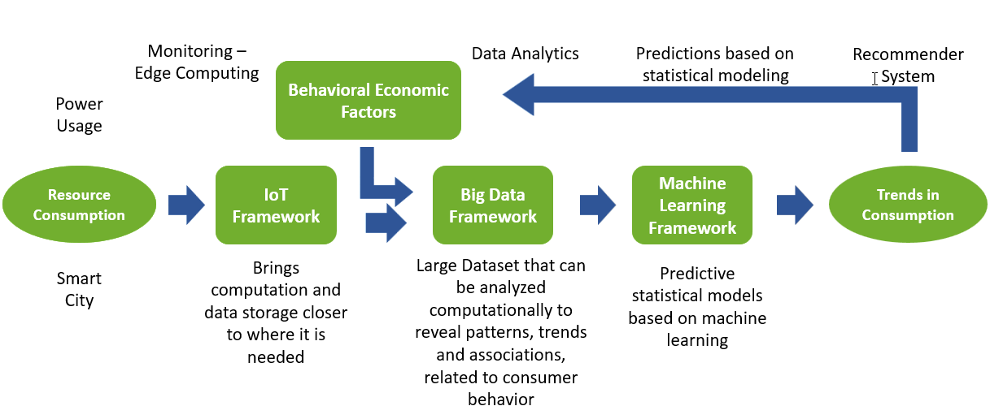
Figure 3 - Research architecture

In terms of an overview of the framework, the starting point is a representative smart city digitized via the Microsoft Azure platform [(Microsoft, 2021)], then optimized as encompassed in the architecture noted in Figure 1. First is the monitoring tier for sensing resources associated with resource usage. We start with the Internet of Things which relates the sensors necessary to feed the data required to inform the development of the digital twin. This section of the framework applies to this concept of edge computing, where the meters in the smart energy subsystem of the smart city tie to the more extensive system. The sensors are dispersed in the field, where computation may occur at a distant location or near the device. Second, a middle layer analyzes data to detect anomalies or patterns in real time. Storage is encompassed in this aspect as a component in the Big Data framework. Also, this is where data can reveal patterns and trends heretofore unseen in previously constructed operational frameworks. The third layer of the proposed framework involves machine learning to discover classification of the type of usage for relevant resources, predictive models, and other aspects of discovery feeding into the recommender subnetwork, where trends and consumption are assessed. The architecture connects to an interdisciplinary component associated with behavioral economic factors from the recommender system. Those factors additionally serve as input to the Big Data framework. The behavioral economic factors are important because they inject the conceptual measure of uncertainty and irrationality into the framework as related to human decision-making. In the sections that follow, the proposed research lays out details concerning the critical technologies of the architecture.

To broaden the accessibility of smart cities of all sizes regardless of the complexity of the challenges, this research proposes a structure of smart city implementation with allowance of cities of any size based on five levels of engagement. The varying levels of implementation are noted in Figure 4.
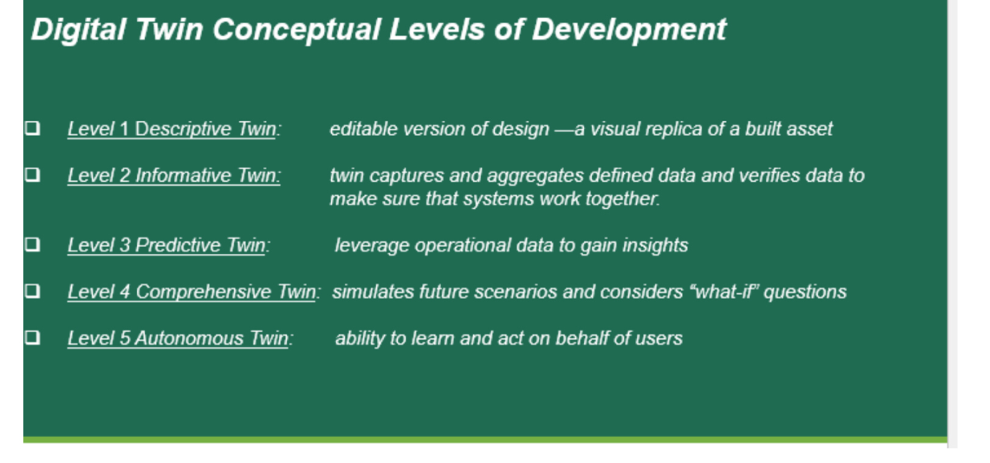
Figure 4: Conceptual Levels of Development

Level 1 is the Descriptive Twin level. It is a live, editable version of design — a visual replica of a built asset. Users specify what kind of information they want included and what data they want to extract. I t conveys the most basic level, essentially converting analog data to digital format, and acts as the base for all the other upper levels.

Level 2 denotes the Informative Twin level. This level has an added layer of operational and sensory data. The twin captures and aggregates deﬁned data, then veriﬁes it to make sure that systems work together.

Level 3 is the Predictive Twin level. This twin can use operational data to gain insights. At this level, we get insights from the data and are answering the questions about why certain things or situations are occurring. Data analysis become a common part at this stage.

Level 4 is the Comprehensive Twin level. This twin simulates future scenarios and considers “what-if” questions. At this level, systems can start answering what will happen in the future and decide accordingly; also, all generative methods, design simulations, and artificial intelligence algorithms come at this level.

Level 5 is the Autonomous Twin level. This twin can learn and act on behalf of users; the machine recommends the ideal solution and taking action. This represents the ultimate sophistication for the proposed architecture.

These five levels of development allow for implementation to be as simple or as complex as resources are available for a city.

Conclusion

Researchers have not firmly settled upon the very definition of a smart city. However, for this study, it is defined as the integrated framework of services operational and human-technology interactions that allow for citizenry's efficient and beneficial needs in a densely populated urban setting. Notably, the literature has more consensus in defining the digital twin as the computer-generated representation of an actual process or entity; it is suitable for our proposed research application for implementation in a smart city framework.
In constituting the digital twin in the smart city framework, this proposal focuses on the smart energy domain employing three quintessential technologies of the Industrial 4.0 era: 1) IoT as analogous “eyes and ears” within the context of necessary sensors in the smart city framework, represented by AMI inputs in the smart energy domain, 2) Big Data in the smart energy relation to the massive datasets previously not available in the analog-based energy grid, and 3) machine learning capabilities to leverage tools, algorithms, and data analytics yielding insights for the digital twin implementation in the smart city framework. Integrating these components leads to the research aim of developing an architecture that can monitor a smart city with a digital twin as the backbone of the implementation. The digital twin concept is becoming increasingly popular with researchers and professionals in many industries to visualize, model, and work with complex urban systems. This research's contribution is to develop an architecture that can monitor a smart city with a digital twin as the backbone of the implementation.
Future work of this research effort will be to further develop and test this model using a digital twin case study of the smart energy sub-domain.

References

Albino, V., Berardi, U., & Dangelico, R. M. (2015). Smart cities: Definitions, dimensions, performance, and initiatives. Journal of Urban Technology, 22(1), 3–21. https://doi.org/10.1080/10630732.2014.942092
Batty, M. (2018). Digital twins. Environment and Planning B: Urban Analytics and City Science, 45(5), 817–820. https://doi.org/10.1177/2399808318796416
Batty, M., Axhausen, K. W., Giannotti, F., Pozdnoukhov, A., Bazzani, A., Wachowicz, M., Ouzounis, G., & Portugali, Y. (2012). THE EUROPEAN PHYSICAL JOURNAL Smart cities of the future. Eur. Phys. J. Special Topics The European Physical Journal Special Topics, 214, 481–518. https://doi.org/10.1140/epjst/e2012-01703-3
Chen, C., Wang, S., & Guo, B. (2016). The Road to the Chinese Smart City. IT Pro - IEEE Computer Society, January/February, 14–17.
Dawkins, O. (2018). Living with a Digital Twin: Operational management and engagement using IoT and Mixed Realities at UCL’s Here East Campus on the Queen Elizabeth Olympic Park. Giscience and Remote Sensing.
Martin Strohbach, Holger Ziekow, Vangelis Gazis, and N. A. (2015). Towards a Big Data Analytics Framework for IoT and Smart City Applications. Modeling and Processing for Next-Generation Big-Data Technologies, 4(JANUARY 2014), 283–317. https://doi.org/10.1007/978-3-319-09177-8
Microsoft. (2021). Azure digital twins documentationAzure digital twins documentation. (n.d.). Developer tools, technical documentation, and coding examples | Microsoft Docs. https://docs.microsoft.com/en-us/azure/digital-twins/
Mohammadi, N., & Taylor, J. E. (2017). Smart city digital twins. 2017 IEEE Symposium Series on Computational Intelligence, SSCI 2017 - Proceedings, 2018-Janua, 1–5. https://doi.org/10.1109/SSCI.2017.8285439
Monzon, A. (2015). Smart Cities Concept and Challenges: Bases for the Assessment of Smart City Projects. In Communications in Computer and Information Science (Vol. 579, pp. 17–31). SCITEPRESS.
Xu, L., Xu, E., & Li, L. (2020). Industry 4 . 0 : state of the art and future trends. 56(8), 2941–2962.
Zubizarreta, I., Seravalli, A., & Arrizabalaga, S. (2016). Smart city concept: What it is and what it should be. Journal of Urban Planning and Development, 142(1), 1–8. https://doi.org/10.1061/(ASCE)UP.1943-5444.0000282

Biographies

WESLEY CONWELL is a PhD candidate of interdisciplinary engineering at the University of Alabama at Birmingham. He earned his BS in electrical engineering from the University of Alabama, MBA from the University of Alabama at Birmingham, and MS in electrical engineering from the University of Alabama at Birmingham. Mr. Conwell’s research interests include smart cities, data analytics, big data, Internet of Things and machine learning. Mr. Conwell may be reached at wlconwel@uab.edu

LEON JOLOLIAN is Interim Chair, Professor, Undergraduate & Graduate Program Director at the University of Alabama at Birmingham. He earned his BS in electrical engineering from Manhattan College, MS in electrical engineering from Georgia Institute of Technology, MS in computer science from Polytechnic University, and PhD in computer science from New Jersey Institute of Technology. Dr. Jololian’s research interests component-based software architecture, mobile and cloud computing, internet of things, and machine learning. Dr. Jololian may be reached at leon@uab.edu

