**026-x-22**

**Nickel Nanoparticle Coating onto Carbon Fiber using Electroless Deposition Method**

A.H.M.E. Rahman

School of Science, Engineering and Technology, Pennsylvania State University – Harrisburg, Middletown, PA 17057

[aer15@psu.edu](mailto:aer15@psu.edu)

Jonathan Ehring

Department of Mechanical Engineering and Mechanics, Drexel University, Philadelphia, PA 19104

[jce63@drexel.edu](mailto:jce63@drexel.edu)

**Abstract**

Hybrid aluminum matrix composites (HAMCs) are a promising advanced composite material consisting of two or more reinforcements homogeneously distributed within an aluminum matrix. A ceramic such as aluminum oxide is typically chosen in combination with a high tensile material, such as carbon fiber, which carries much of the stress applied to the composite. HAMCs are researched for their applications in automotive and aerospace industries, whose strength to weight ratios and excellent thermal properties increase overall fuel efficiency. In recent attempts, the carbon fibers did not bond well with the aluminum matrix, due to the large difference in the coefficient of thermal expansion between the fibers and aluminum. However, coating the fiber surface with nickel nanoparticles has been suggested by current authors to effectively bond the fibers with the surrounding matrix. The carbon fibers were coated with nickel nanoparticles using an electroless bath of sodium hypophosphite monohydrate (reducing agent), sodium acetate trihydrate (complexing agent) and nickel sulphate hexahydrate (source of Ni+2 ions) with varied levels of reagent and fiber concentrations while maintaining a constant temperature of 90℃ for one hour. Scanning electron microscopy (SEM) were used to determine the distribution and size of the nickel particles. SEM images and EDS area analysis confirmed the Ni coatings on the surface of carbon fibers (c-fiber). SEM also confirmed the homogeneous distribution of Ni coatings as Ni particles in most cases. The behavior of these modified c-fibers in the c-fiber reinforced aluminum matrix composites is yet to be determined.

**Introduction**

Advancements in composite materials have dramatically influenced industries such as aerospace, defense and automotive, whose economics substantially favor lighter and stronger materials. In 1996, the Boeing 777 fuselage consisted of twelve per cent composite material. Today, the Boeing 787 fuselage contains over fifty percent composite material and has gained a fuel efficiency of over twenty per cent compared to the 777. The trend to adopt composite materials is only set to rise in the coming decades and spread to other industries as the cost of manufacturing is reduced.

Increased pressure from government regulations and consumer interests alike have shaped the transportation industry into a much leaner and fuel-efficient enterprise, which has supported decades of research into metal matrix composites (MMCs), and more recently hybrid aluminum matrix composites (HAMCs). Consisting of two or more reinforcements, HAMCs aim to combine various mechanical properties, such as high tensile strength, thermal conductivity, and wear resistance. However, the major challenge of fabricating a suitable HAMC is attributed to the reactions, dimensional stability and wettability at the interfaces between reinforcements and matrix. Liu et. al showed the wettability of woven carbon fiber to Al matrix has been improved by electroplated coating of copper (Yang et. al. 2014). Nickel is a popular choice for coating fiber reinforcements for its self-lubrication and has been reported to improve wettability and prevent reactions at the fiber-matrix interface (E. Hajjari et. al. 2004).

Many researchers have focused on coating carbon fiber (c-fiber) with nickel using electroless deposition and a two-step catalyzation process and have attained homogenous coatings up to 1.2 µm (Fan et. al. 2007). An alternative approach is to study the effects of coating the fibers with nickel nanoparticles which are easily attracted to the defects on the CF surface and do not require a catalyzation process. Nanoparticle reinforcement is becoming increasingly popular subject for its increased strength and low interfacial reactions. Finite elemental analysis of nanoparticle coated carbon fiber reinforcement in an epoxy matrix has revealed increased interfacial wetting, however, few in situ studies have been accomplished and less have focused on metal matrix composites. The goal of this paper is to determine reagent and fiber concentrations necessary for nickel nanoparticles to homogeneously coat the fibers while limiting the size of the particles to the nanoscale.

**Experimental Procedure**

Table 1: Reagents and substrate for electroless deposition bath.

|  |  |  |
| --- | --- | --- |
| Material | Vendor | Specifications |
| Complexing Agent | Sigma Aldrich | Sodium acetate trihydrate, >99%  (C2H3O2Na·H2O) |
| Reducing Agent | Sigma Aldrich | Sodium hypophosphite monohydrate, >99%  (NaH2PO2·H2O) |
| Ni+2 ion Source | Alfa Aesar | Nickel (II) sulfate hexahydrate, 98% crystalline  (NiSO4·6H2O) |
| Carbon Fibers | Fibre Glast | 1/4” chopped carbon fibers |

Table 2: The concentration of reagents and carbon fiber. All samples were maintained at a pH of 6 for one hour.

|  |  |  |  |  |
| --- | --- | --- | --- | --- |
| Sample | NaH2PO2·H2O  (g/L) | C2H3O2Na·H2O  (g/L) | NiSO4·6H2O  (g/L) | Fiber  (g) wt.%) |
| A | 11 | 20.5 | 26.25 | 0.5 (5%) |
| B | 16.5 | 30.5 | 39.5 | 0.8 (5%) |
| C | 11 | 20.5 | 26.25 | 0.2 (1.9%) |
| D | 16.5 | 30.5 | 39.5 | 0.5 (3%) |
| E | 11 | 20.5 | 26.25 | 0.8 (8%) |

An electroless bath containing sodium hypophosphite monohydrate (NaPO2·H2O), sodium acetate trihydrate (C2H3O2Na·H2O) and nickel sulphate hexahydrate (NiSO4·6H2O) was used to deposit Ni on c-fiber. The reagents and c-fibers were purchased from different vendors shown in Table 1. The reagents were combined in a 600 ml beaker containing 200 ml of water. Distilled water was added until the solution level reached 400 ml (Figure 1). The beaker was placed on a hot plate and stirred continuously using a magnetic stirrer. Once the temperature reached 90°C, chopped carbon fibers were introduced into the bath. At this time, a pH strip was used to test the pH level and maintained at 6 using acetic acid. A watch glass was placed over the top of the beaker to prevent evaporation and a magnetic stirrer continued for one hour. The fibers were then drained from the bath using a filter and washed in hydrochloric acid and distilled water 3 times. The fibers sat under a fume hood for a period of 24 hours to dry completely. This procedure was repeated at different levels of bath concentration, fiber concentration, time and temperature, as shown in Table 2. The fibers were then characterized using Scanning Electron Microscopy (SEM), Energy Dispersive Spectroscopy (EDS), and Thermogravimetric Analysis (TGA).

a) during deposition

(b) after the deposition

Figure 1: The electroless coating of nickel nanoparticles onto the carbon fibers

**Results and Discussions**

The electroless coating of nickel is an autocatalytic process whereby a redox reaction continuously deposits metal ions onto the target surface and is typically governed by:

${Ni}^{+2}+H_{2}{PO}_{2}^{-}+ H_{2}O → {Ni}^{0}+H_{2}{PO}_{3}^{-}+ {2H}^{+}$ (1)

$H_{2}PO_{2}^{-}+H_{2}O→ H_{2}{PO}_{3}^{-}+ H_{2}$ (2)

${Ni}^{+2}+2H_{2}{PO}_{2}^{-}+{2H}_{2}O →{Ni}^{0}+2H_{2}{PO}_{3}^{-}+ {2H}^{+}+H$ (3)

These equations fail to consider the deposition of phosphorous and the overall complexity of the reaction phenomenon, which has been shown to increase non-linearly with an increase in reagent concentrations (Mallory & Hajdu, 1990). However, an increase in hypophosphite concentration does increase the rate of deposition, which coincides with the results seen in figures 1 and 3, whose reducing agent increased by 1.5x and whose deposition of nickel increased significantly.

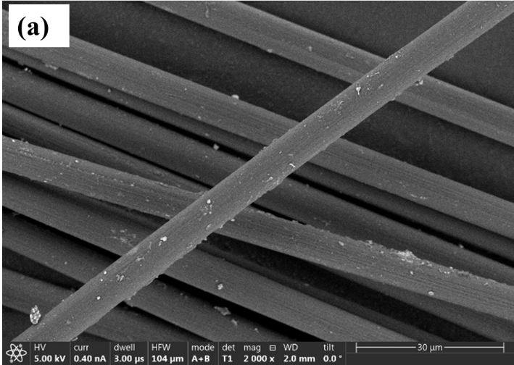

SEM image of sample A.

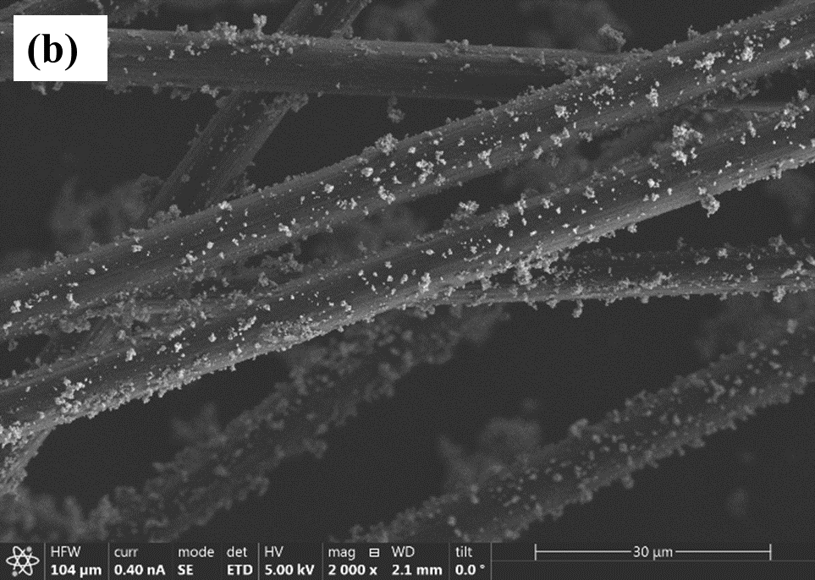

SEM image of sample B.

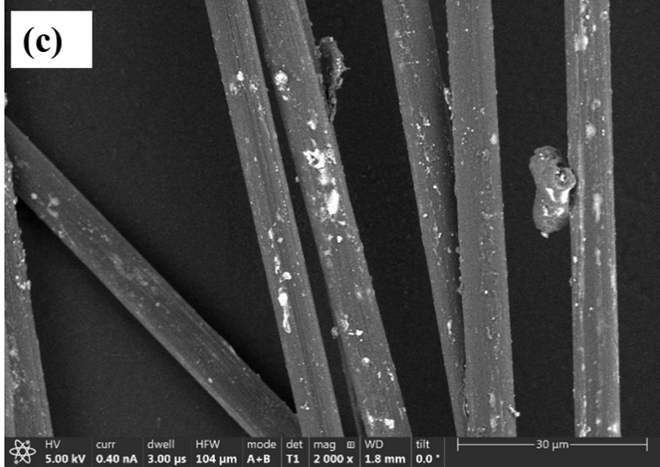

SEM image of sample C.

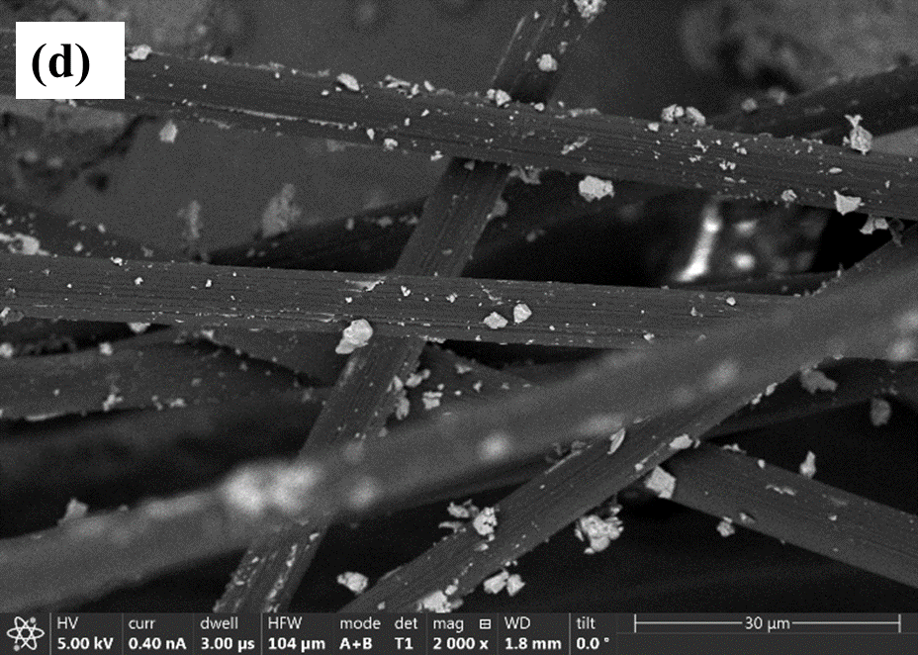

SEM image of sample D.

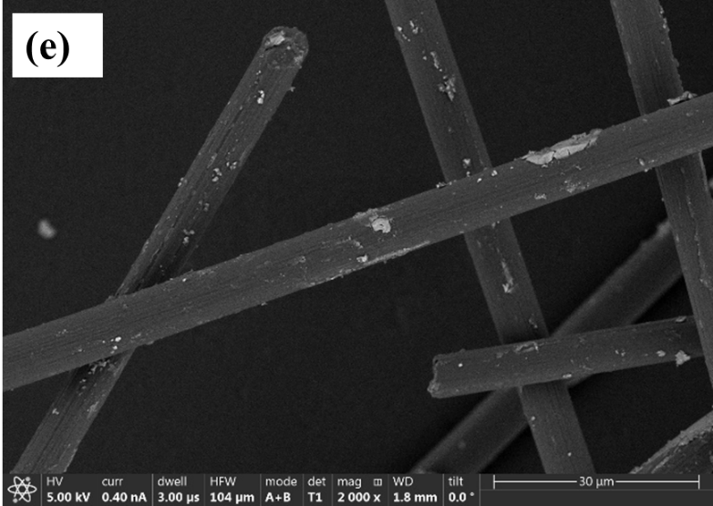

SEM image of sample E.

Figure 2. SEM images of Ni coated carbon fiber for different bath compositions (electroless bath compositions are in Table 2).

Figure 2 shows SEM images (a-e) of Ni coated fibers. The distribution of particles is homogeneous, and the size of the particles largely remained in the submicron level. By decreasing the fiber concentration from 5wt.% to 3wt.% with respect to the weight of nickel sulfate, the particles formed large aggregates of 10-15μm (Figure 2c) and seemed the coating was not homogeneous. The increase in deposition rate, indicative by the emission of H2 (Devarakonda, 2016), increased the nickel coating while also increasing the particle size. Samples B and D, whose reagent concentrations remained constant but c-fiber wt.% decreased from 5wt.% to 3wt.%, showed similar increases in particle size as seen in samples A and C. Figure 3 shows area EDS analysis (in a rectangular area Figure 3a) Sample B. The EDS analysis indicated a significant number of nickel counts (Figure 3b) when analyzing a 59.2 µm x 7.12 µm area. Nickel coating was approximately 13.5 wt. ± 1% nickel.

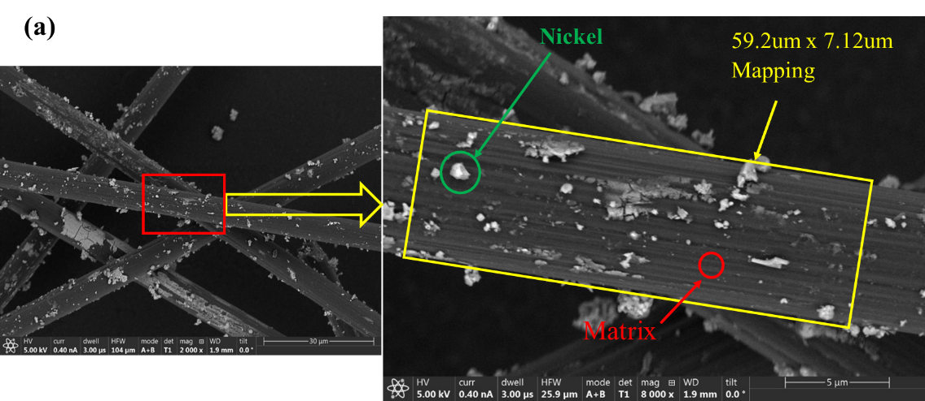

SEM and magnified images taken from the red boxed area of sample B.

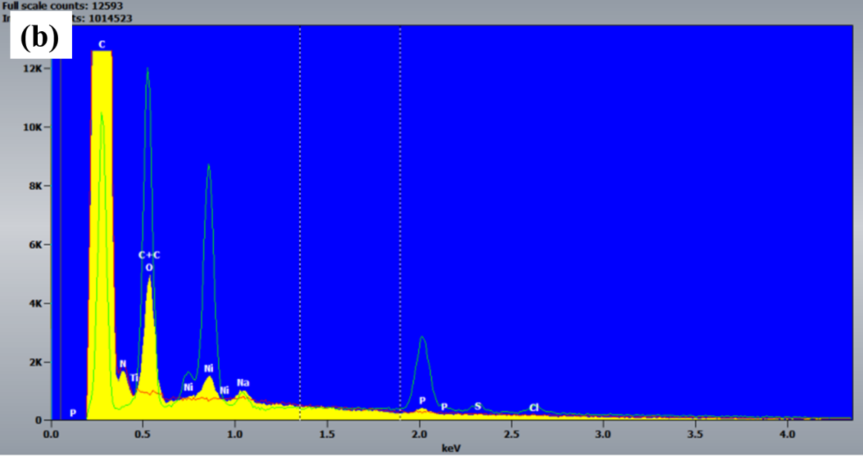

Spot EDS of coated particle shown in green circle in previous image on the fiber.

Figure 3. A spot EDS analysis of sample B.

The nickel nanoparticle size and distribution are mostly dependent on the concentrations of reducing agent and concentration of c-fiber with respect to nickel sulfate, where 5 wt.% c-fiber yielded the best results and 1.9-3wt.% resulted in large aggregates in the range of 10-15 um. By limiting the nickel coating to the nanoscale, it is expected that the interfacial reactions will be minimized, and increased wetting is expected at the c-fiber-Al interface. Even though the SEM images did not show a blanket cover of Ni coating on the fiber, however, it was understood that there was a very thin layer of coating obtained which was not visible using SEM. A Transmission Electron Microscopy (TEM) study is needed to confirm the exact nature of coating. Moreover, it is yet to be determined how Ni coatings behave with c-fiber and Al matrix once a composite is sintered and characterized.

**Conclusions**

Carbon fibers were coated with Ni using electroless deposition method to modify the fiber surface. Nickel nanoparticles were homogenously distributed onto the carbon fiber surface using concentrations of 11g/L sodium hypophosphite monohydrate, 20.5 g/L sodium acetate trihydrate, 26.25 g/L nickel sulphate hexahydrate with 5 wt.% carbon fiber with respect to the nickel sulphate. By decreasing the carbon fiber concentration to 3 wt.%, the nickel nanoparticles agglomerated and form large aggregates in the 10-15 µm range, whereas increasing the reagent concentrations resulted in a homogeneous coating of nickel deposition and large particles in the range of 2-5 µm. There should be a balance between the concentration of reagents and c-fiber such as in Sample A. It provided homogeneous and nano Ni particles coating on the fiber as can be seen in SEM image.

**Acknowledgments**

This work was supported in part by the Multi-campus Research Experience for Undergraduate (MC-REU) at the University of Pennsylvania.

**References**

[1] Yang, Q., Liu, J., Li, S., Wang, F., Wu, T., (2014). “Fabrication and mechanical properties of Cu-coated woven carbon fibers reinforced aluminum alloy composite. *Materials and Design,* 57, 442–448.

[2] Hajjari, E., Divandari, M., Mirhabibi, A.R., (2004, Jan). The Study of Electroless Coating of Nickel on Carbon Fibers. *Iranian Journal of Materials Science and Engineering*, Vol. 1, No. 1, 43-48.

[3] Fan, Y., Yang, H., Zhu, H., Liu, X., Li, M., Qu, Y., Yang, N., and Zou, G., (2009). Metallization of Carbon Fibers with Nickel by Electroless Plating Technique. *Metallurgical and Materials Transactions A*, vol. 38, no. 9, 2148–2152.

[4] Mallory, G.O., and Hajdu. J.B., (1990), *Electroless Plating: Fundamentals and Applications*. American Electroplaters and Surface Finishers Society.

[5] Devarakonda, S.K., Suman, K.N.S., Palavalasa, R., (2016), A Study on Electroless Deposition of Nickel on Nano Alumina Powder Under Different Sensitization Conditions. *International Journal of Advanced Science and Technology*, vol. 97, 59–68.

**Biographies**

**A.H.M.E. RAHMAN** is an assistant professor of Mechanical Engineering at Pennsylvania State University – Harrisburg. He earned her BS from University of Engineering and Technology of Bangladesh in 2004, and PhD in Mechanical Engineering in 2013 from the University of North Dakota. Dr. Rahman research interests include light alloy technology, metal matrix composites, hybrid bio-composite, and diffusion bonding of specialty alloy. Dr. Rahman may be reached at [aer15@psu.edu.edu](mailto:aer15@psu.edu.edu)

**JONATHAN EHRING** is a PhD student in the department of mechanical engineering in Drexel University. He earned his BS in mechanical engineering from the Pennsylvania State University – Harrisburg. His research interests include advanced materials characterization, electrochemical energy storage, flowable slurry electrodes, vanadium redox flow batteries, supercapacitors, and flowable capacitive deionization. Mr. Ehring may be reached at [jce63@drexel.edu](mailto:jce63@drexel.edu).