Residential Electricity Consumption during the COVID-19 Pandemic: A Case Study

Manuel Mar
Purdue University
mmar@purdue.edu

Eric Dietz
Purdue University
jedietz@purdue.edu

Abstract

The pandemic scenario caused by COVID-19 is an event that reminds the energy sector to study people's electricity consumption when staying most of their working hours at home. Residential electricity consumption can be studied to observe how energy loads and appliance usage have changed during the stay-at-home order weeks. This study analyzes household energy units such as appliances and lighting systems. The data collection process was done through online surveys and publicly available data. Previous studies have successfully characterized residential electricity using surveys with stochastic models. The characterized electricity consumption data allows researchers to generate predictive models, make regressions and understand the data. Therefore, the data collection will not be as costly as installing measuring instruments or smart meters. Behavioral characteristics of each participant will be presented; additionally, the output of the analysis will be the estimated electricity consumption "kWh." Then results will show electricity consumption through time and examine how people evolved their load during, before, and after the pandemic. This research can help understand the change in electricity consumption of people who worked at home during the pandemic and generate energy indicators and costs such as home office electricity cost kWh/year. In addition to utilities and energy managers can benefit from clearly understanding domestic consumers during emergency scenarios such as pandemics.

Introduction

The COVID-19 Pandemic affected all society sectors, such as manufacturing, information technology, and healthcare. Private and public institutions had to move their efforts to mitigate the pandemic effects, which generated a shift in their consumption habits. The energy sector was negatively affected; for instance, oil prices went down to historically low prices, reaching minus zero costs, which meant producers paid the traders to buy oil (Desjardins, 2020). The electricity and fuel load profile changed within the biggest consumers: commercial, industrial, and residential. Globally, the electricity demand decreased between 2.5% - 4.5% in Q1 2020, not only because of COVID-19 but because the weather conditions were milder than in 2019 (International Energy Agency, 2020). This reduction happened because most people stopped going out, and activities such as office work, education, or shopping continued online. Additionally, the energy demand per country in 2020 is associated with the governments' containment measures. Limited restrictions produced a shift of 10% in Korea's and Japan's energy consumption; partial mandatory stay-at-home-order accounted for a 17% reduction in Europe, and total Lockdown averaged 25 to 30% in some cases (International Energy Agency, 2020)

In most U.S. states, people had to stay at home between 6-8 weeks as part of the "stay at home order"; they could only go out for essential activities such as groceries or medical emergencies (U.S. News, 2020). This containment measure called "lockdown" or "stay-at-home-order" occurred between late March and early May. As a result of the containment measures and efforts to restrict people's mobility, the U.S Energy Information Administration estimated the residential electricity usage per customer increased by 6% in April 2020 compared to the previous five Aprils. On the other hand, the commercial and industrial sectors decreased by 10% and 9%, respectively (EIA, 2020).

Although previous studies about electricity consumer patterns (Chicco, 2012), (Tsekouras et al., 2007),(Pan et al., 2017), researchers have not studied in depth these patterns under diverse containment scenarios or work-from-home policies. During pandemic scenarios, most employees are requested to work from home for several weeks, which shifts electricity consumption drastically in urban areas, especially in the U.S, where most Americans' occupations occur in offices and buildings (U.S. Bureau of Labor Statistics, 2014).
Most of the COVID-19 electricity impact analyses and studies have shown a general increase in residential demand (International Energy Agency, 2020; MISO, 2020). However, there is little information about the specific or granular demand, such as appliances, lightning usage delta, and demographic correlations. In other terms, there are plenty of macro analyses but few granular consumer analyses.

This study analyzes historical data on household electricity consumption during the first ten months of 2020. This research intends to describe how people changed electricity consumption in three different periods during 2020. People use diverse loads in a household, such as appliances, lighting systems, heating/cooling, and even generate their energy. Therefore, it is expected to observe various highs and lows during the weeks of the "stay-at-home-order" and Fall 2020.

A quarantine can produce a significant shift in the domestic electricity load; therefore, it is hypothesized that there is a strong correlation between the number of quarantine weeks and domestic electrical consumption. Another tentative assumption is that the electricity load will increase during this Lockdown in the residential sector since people do more home activities. The problem addressed by this study is providing an estimation of how the quarantine changed consumer behavior in residential clients. This work can help utilities with consumer profiling and in understanding people's electricity load behavior.

Methodology

The data analyzed for this research was collected from the Energy Information Administration (EIA) and surveys made in the Lafayette Metropolitan area in Indiana. Most of the survey respondents were workers and university students. They were asked about their appliance usage during 2020 and demographic data. After collecting and processing the data, a population summary was done with the behavior towards the usage of appliances at three different moments in 2020: Pre-Covid or everyday conditions, Stay-at-home order (Lockdown), and Fall 2020 when containment measures were relaxed. A comparison of three moments of the year is made to analyze trends and finally approximate with a load simulator how much more energy in kWh was used when restrictions for the pandemic started.

Stochastic Modeling for Characterization

Household electricity consumption has many variations since it is strongly tied to the number of people living in a dwelling and their lifestyle (Cagni et al., 2004). Consequently, measuring or disaggregating the electric load of any dwelling is a complicated task requiring the use of several power meters in households. Electric companies measure total power usage; however, this is not informative enough to understand people's specific demands.
A probabilistic analysis approach helps estimate the load power distributions at different dwellings without power meters. This analysis consists of asking survey questions to residential consumers and asking them about their primary power appliances usage. Once usage data is collected, a stochastic analysis can characterize the load data in kWh (Carpaneto & Chicco, 2008; Sandwell et al., 2016). This approach has been used previously in low-income countries where utilities need to quantify the aggregated demand from a given micro-population (Boait et al., 2015). For instance, the following statements are questions that can be asked in each survey.

- The family unit (number of people, sex, age, activity, and frequency of presence at home).
- The characteristics of the houses (size, number of rooms)
- Electrical appliances (type number electrical data and usage)

(Carpaneto & Chicco, 2008) demonstrated that gamma, normal, binomial, and log-normal are the most suitable distributions to fit the data with the actual load patterns. The survey used for this work is in the Appendix section and was made based on the studies mentioned above. The load simulator algorithm is shown in Figure 1, which needs as primary input the number of devices of each participant household and the utilization times per week; after that, a random process is executed to get the final system load per month of each participant, a method described by (Boait et al., 2015)

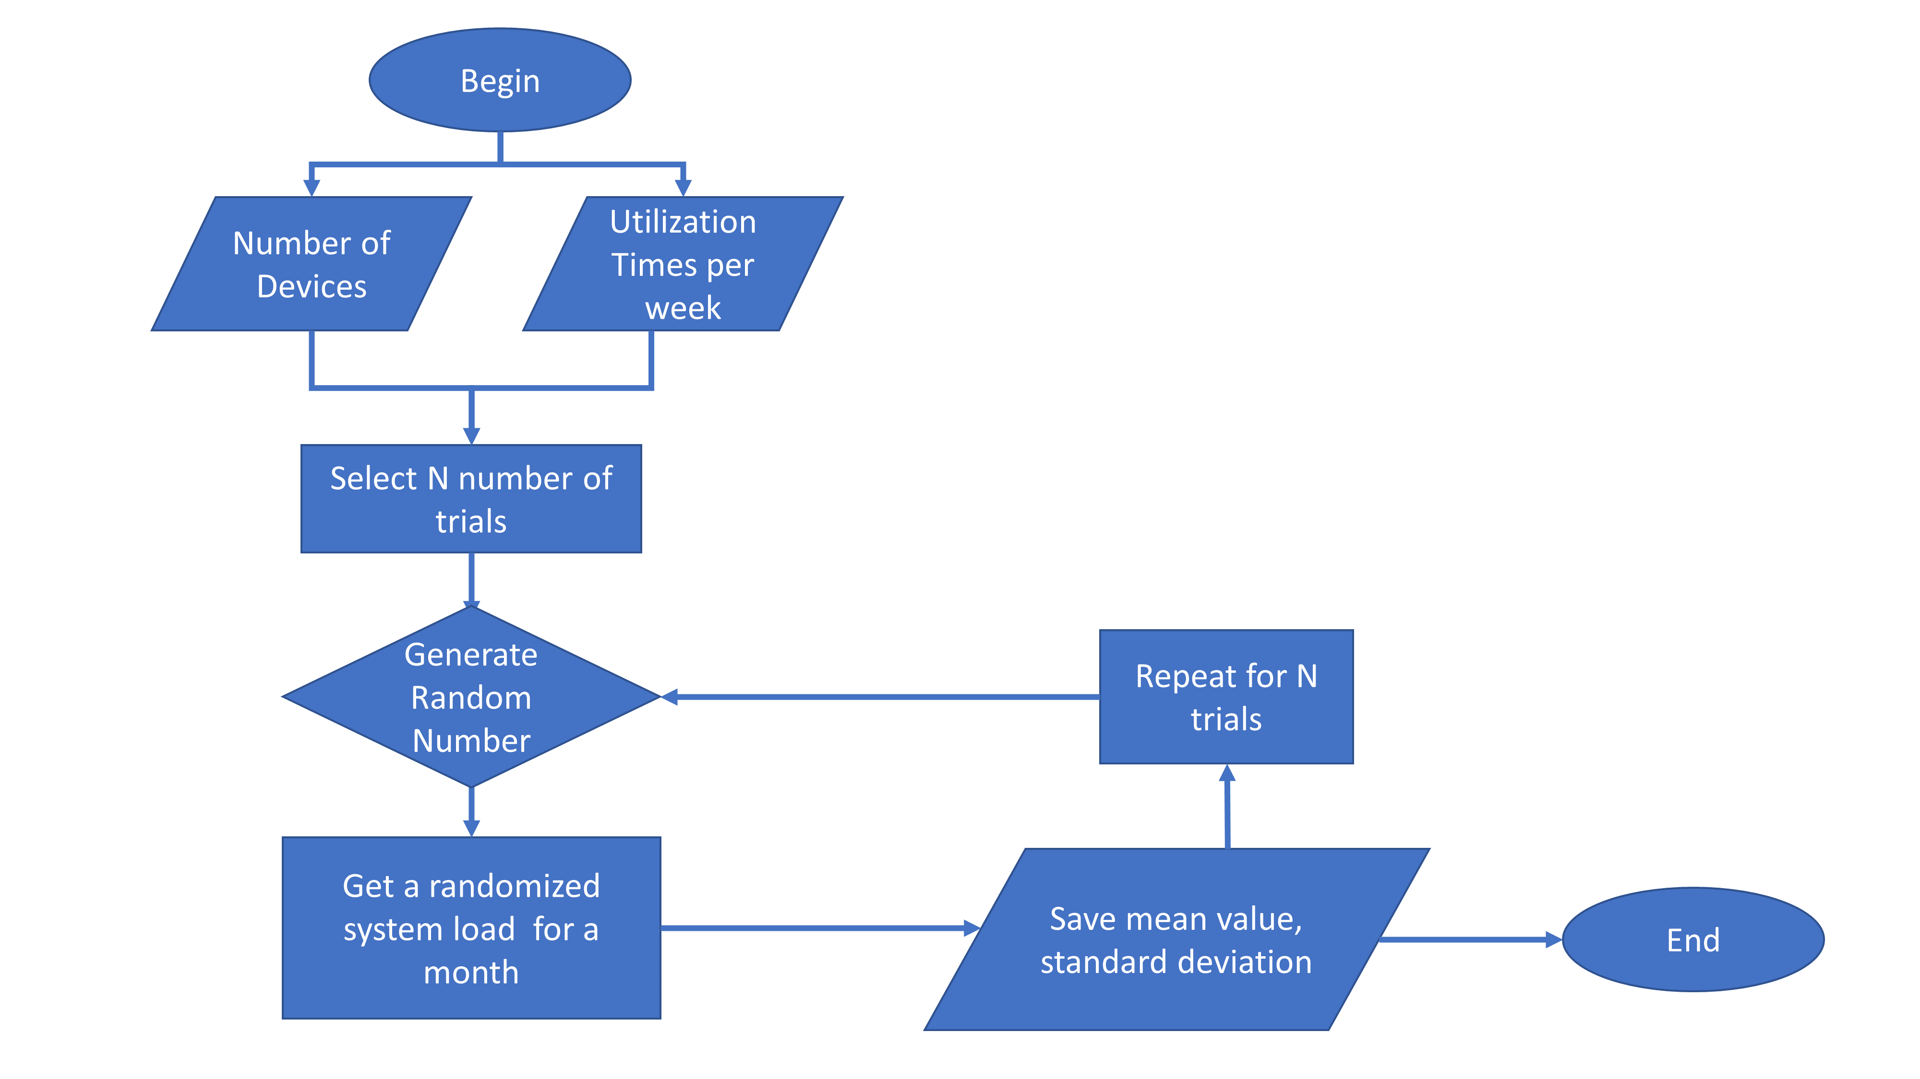
Figure 1. Load Simulator Algorithm

Population Summary

Participants' demographics are shown in Figure 1. Most participants live in apartments with at least one roommate, whereas 41 out of 59 live in apartments. Females were more responsive, having 54% of all answers, and the most common dwelling size is between 700-1000 sqft, an average apartment size.

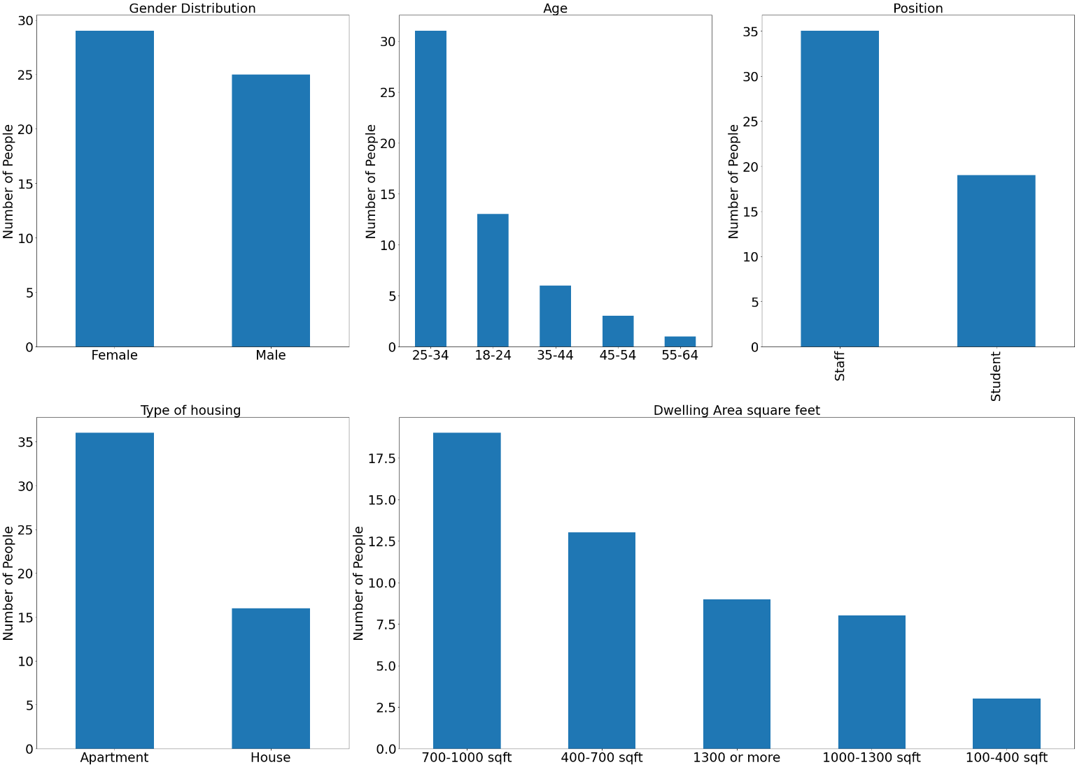
Figure 2. Surveyed Population Demographics and Summary

Daily Activities Change

Participants were asked about their consumption behavior before the stay-at-home order in late March 2020. In addition, they shared their daily on-campus activities at work from January to March and August to December. These activities were performed between Monday and Friday or the "working days."

As expected, most participants, who were university workers and students, had meetings, studied, did research, and others. Such activities need electric appliances; for example, during study sessions or research, people generally use computers or lab equipment such as laptops, microscopes, or oscilloscopes. Also, meetings or virtual sessions require projectors; eating at work probably needs a microwave or a kitchen with electric appliances. Figure 2 shows the change in daily activities before and after the lockdown; there is a reduction in activities performed at the workplace. For instance, activities such as teaching and eating were the most affected since they involved physical interaction, while research was the least affected since it did not require much contact. Usually, researchers require larger machines to work on-campus; therefore, research as activity shows more minor changes among all asked activities, as presented in Figure 2.

A pandemic scenario with lockdown reduced people's footprint in the workplace, where activities such as working with a computer were no longer performed. Taking classes became a remote task, with some exceptions. Figure 2 and Figure 3 show how activities performed at the workplace were moved from work to households, consequently moving electric usage to apartments and houses.

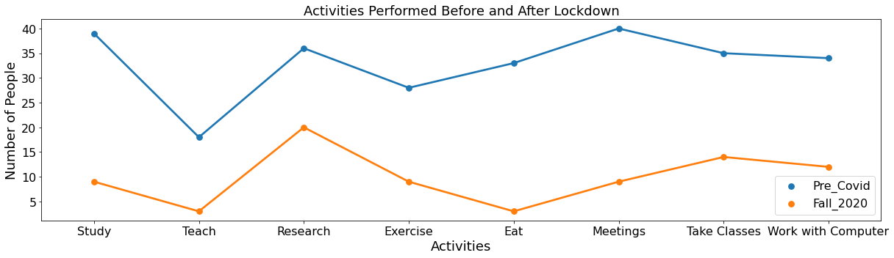
Figure 3. People's Activities in workplace Pre-Post Lockdown

Figure 3 shows time spent at the workplace through 2020; in this section, participants answered about the range of hours spent on campus. Before the stay-at-home order, at least 72% of participants spent between 5-15 hours on campus, Monday to Friday. On the other hand, Lockdown made people work from home, moving more than 45% of full-time workers to perform activities in their household units (Bick et al., 2021). Although some essential activities were still done on-site, such as building or server maintenance, 34% of U.S jobs could be performed remotely (Dingel & Neiman, 2020).

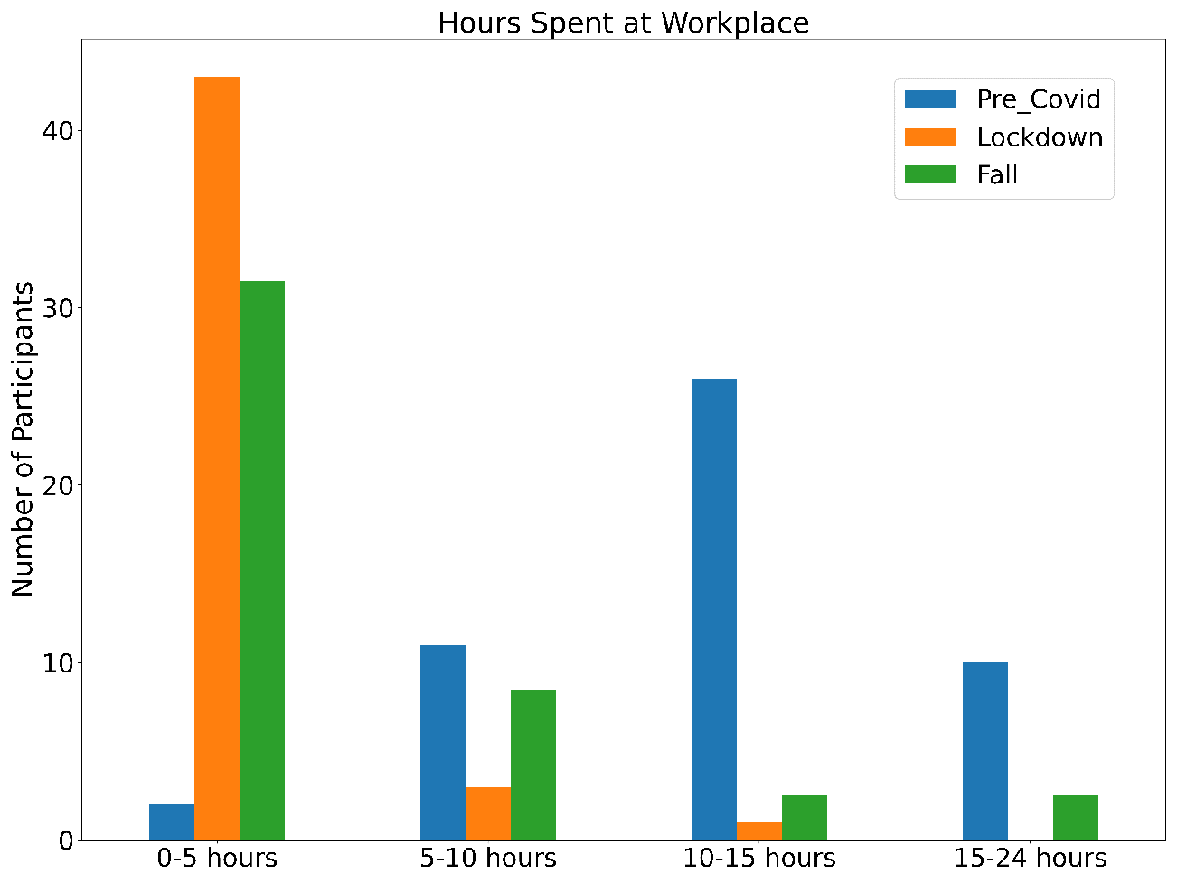
Figure 4. Time Spent at the Workplace

Appliance Usage

Figure 4 shows the appliance usage change through 2020. The PRE-COVID usage is in red dots, showing usage under normal conditions before the pandemic. Meanwhile, the other blue and green dots show the change in appliances usage percentage during stay-at-home orders and the fall of 2020. Since workers and students stayed out of the workplace after March 2020, home appliances are expected to increase; in Figure 4, these changes are shown for the most common appliances in a residential household.

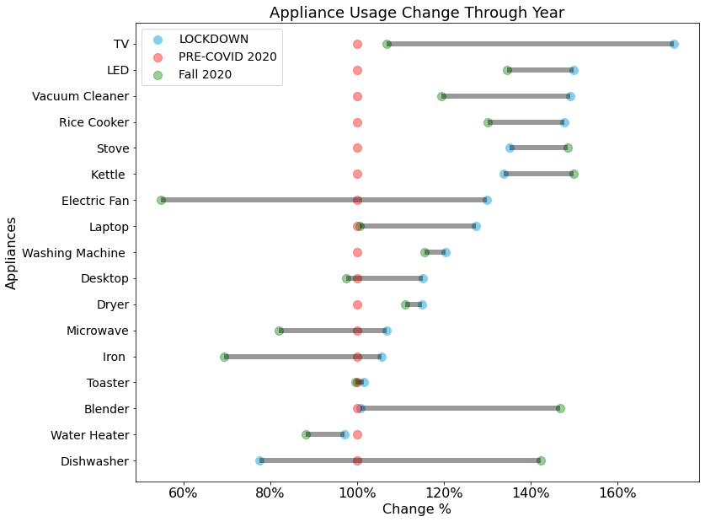
Figure 5. Appliance Usage Through 2020

T.V. and chore appliances, like the dishwasher or vacuum cleaner, were among the most significant changes after March 2020; the increase rate of these appliances was above 40%. Office appliances such as laptops and desktops also increased around 25% throughout the year. Appliance usage depends on the seasonality; devices such as fans are primarily used in summer and water heaters in winter. Even though Lockdown or stay-at-home orders end in late May, usage habits persisted during Fall 2020, where more than 50% of all appliances usage increased by at least 15% as shown in Figure 4.

Correlation Analysis Between Appliances
The following figures show heatmaps that highlight the appliance usage that is more and less correlated with each other; red blocks represent a Pearson value "r" of one, and the intense blue is close to minus one, which means appliance usage would not be correlated. Participants were not asked why they used certain appliances more; however, a correlation analysis could better identify meaningful relationships between variables and show devices' interdependencies. For instance, workers who use laptops to work will have a router or modem turned on; also, when using the dishwasher, people are very likely to use the stove or oven.

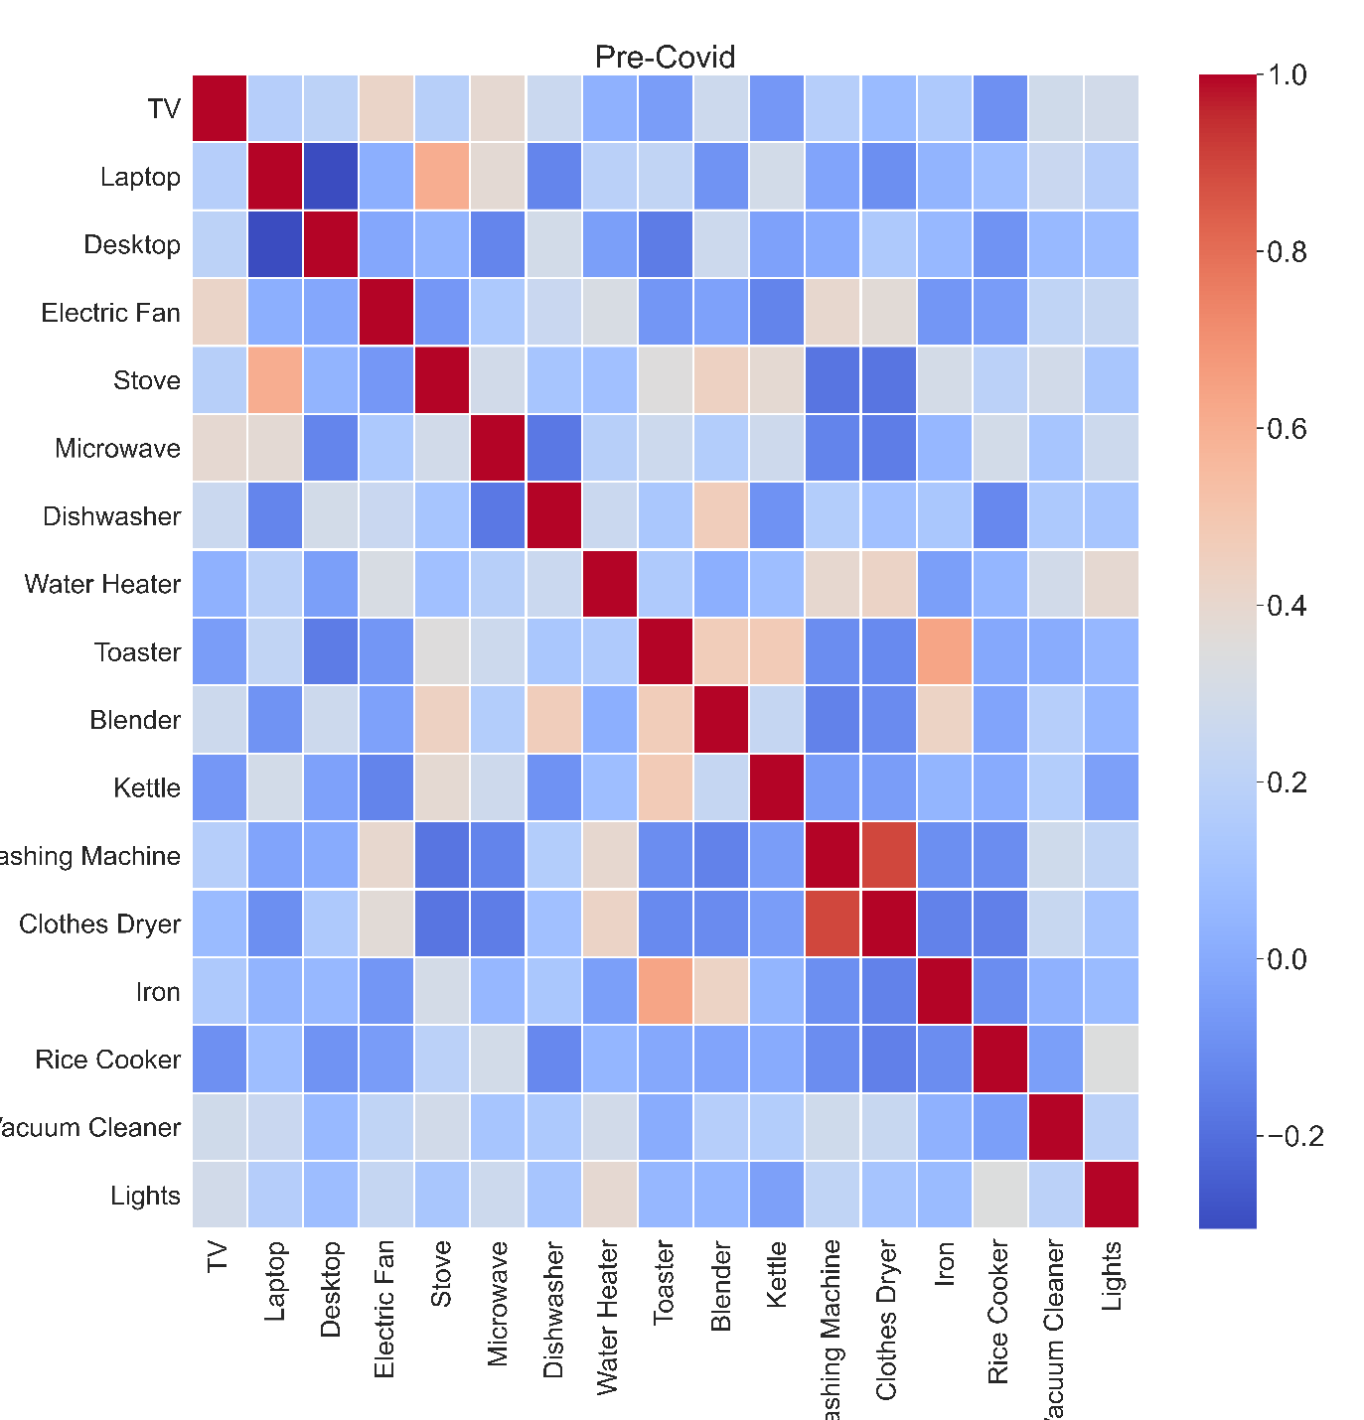
Figure 6. Appliance Correlation Matrix – PRE-COVID
In Figure 5, the clothes dryer and the washing machine (r=0.95), kettle and microwave (r=0.55), or laptop and lights (r=0.47). Nevertheless, there are opposing pairs, such as laptops and desktops (r=-0.34) or toasters with almost all the appliances. Similarly, Figure 6 shows the stay-at-home order heatmap. In this case, more pairs showed up. For instance, kettles were more associated with appliances such as blenders, iron, and microwave (r=0.55).
On the other hand, the vacuum cleaner correlates with other appliances such as iron, stove, washing machines, and clothes dryers. These changes could have increased because people spent more time at home and used more appliances as previously shown in Figure 3 and Figure 4.

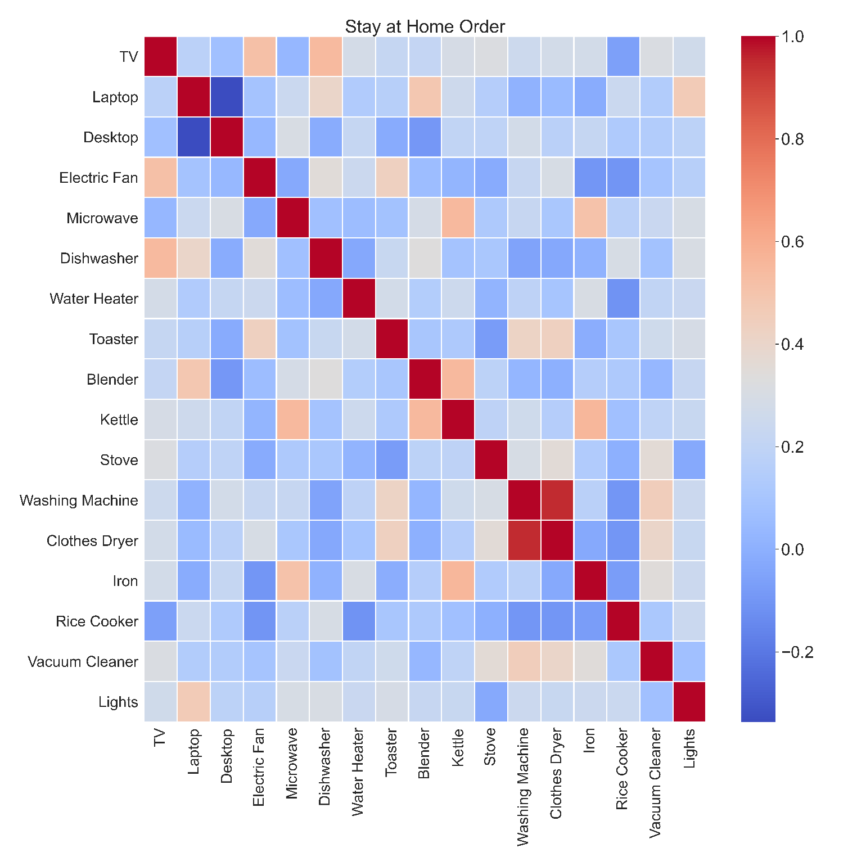
Figure 7. Appliance Correlation Matrix – Stay-at-Home-Order

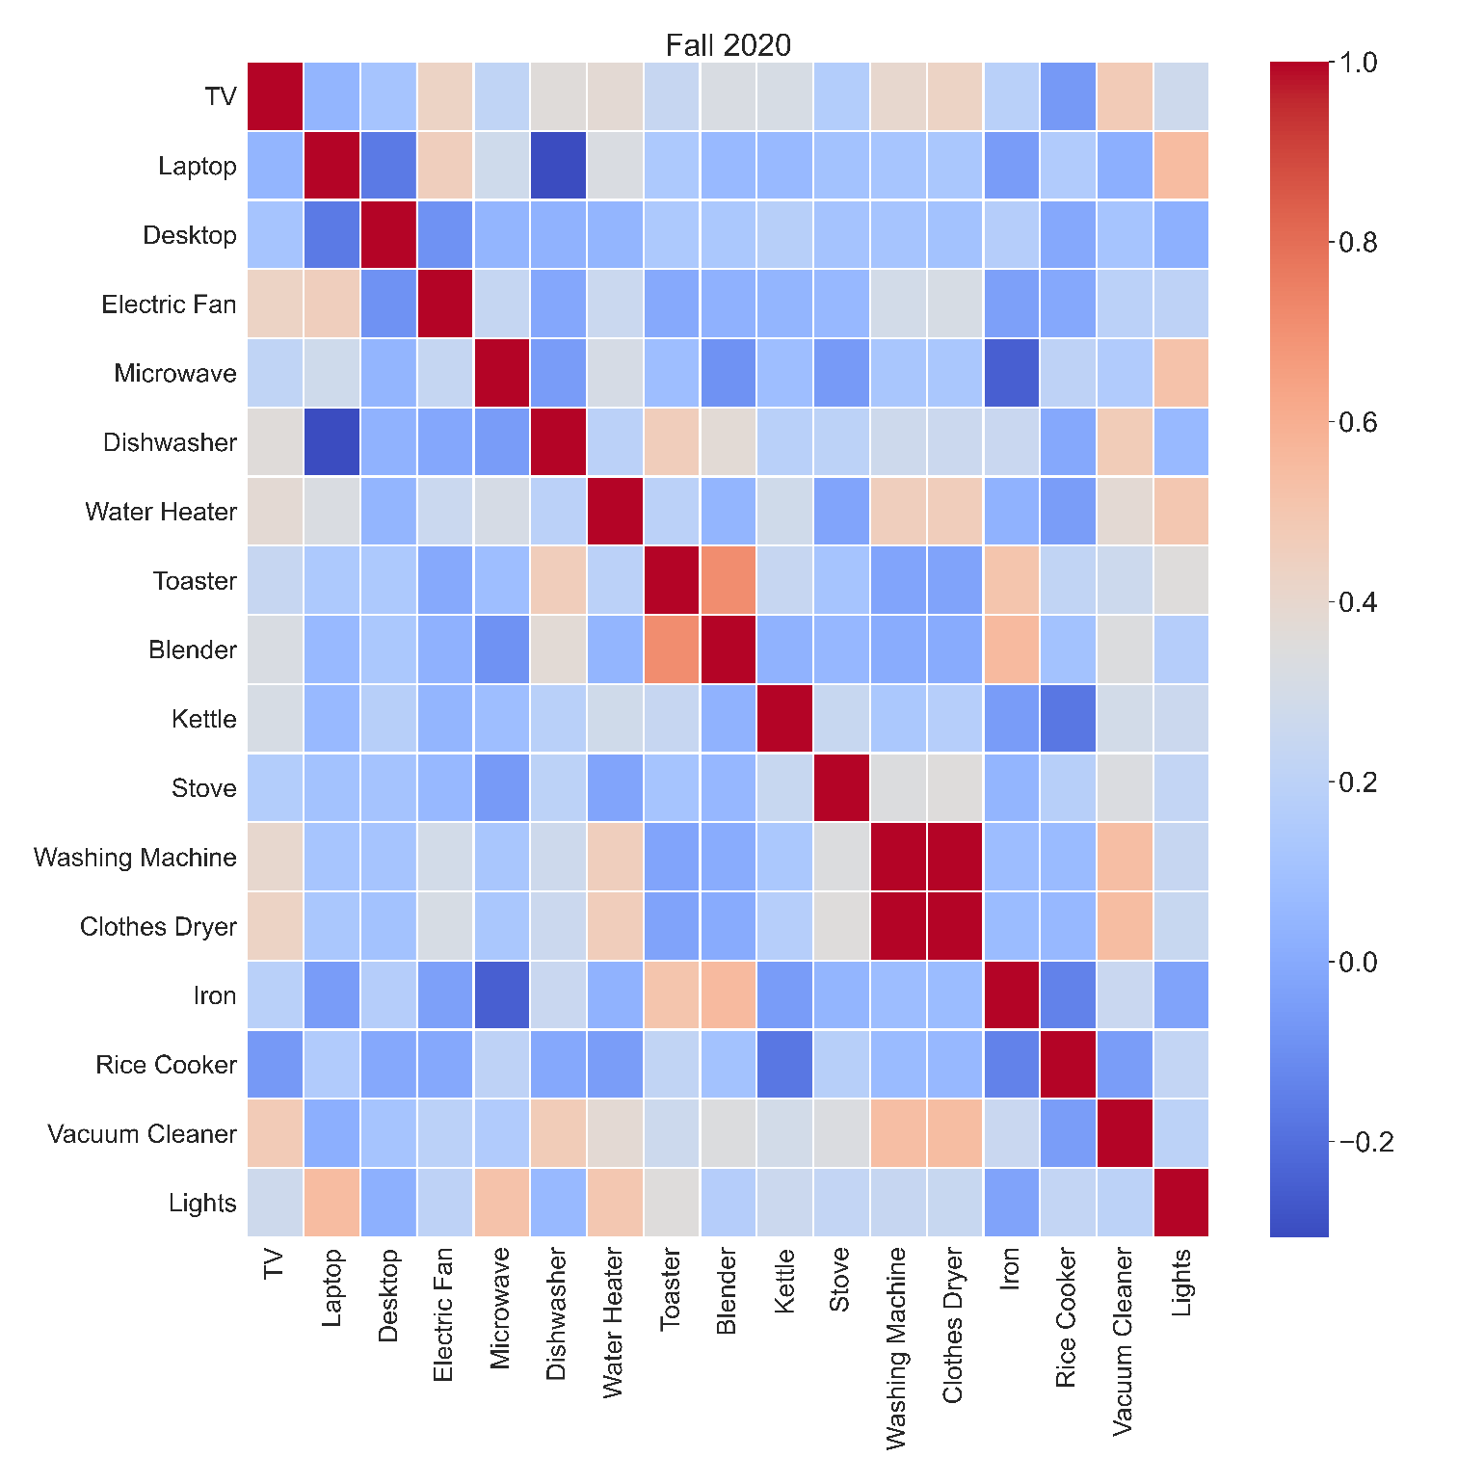
Figure 8. Appliance Correlation Matrix – Stay-at-Home-Order

Characterization of Surveyed Data into Daily Electricity Consumption

A stochastic load simulator (Sandwell et al., 2016) was used to estimate daily electricity consumption established each month of 2020, which is part of the participant's appliance usage results. Figure 8 shows a boxplot of the daily electricity consumption of participants at three different moments: Pre-Covid, stay-at-home order, and Fall 2020. As inferred, the stay-at-home order showed the biggest kWh daily consumption close to Fall 2020 results; meanwhile, Pre-Covid daily home consumption was 15-20% less, respectively, as shown in Figure 8.

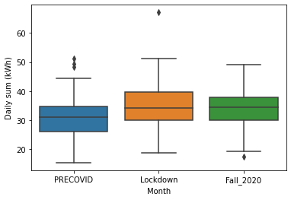
Figure 9. Daily kWh Consumption at different moments in 2020

Table 5 shows a statistical comparison between the self-made survey and the Energy Information Administration in 2015survey made to all residential consumers in the U.S. The EIA 2015 dataset validated the self-made survey results and developed a predictive model using the more extensive data set.

Yearly average residential electricity consumption before COVID is approximately 2000kWh less than the stay-at-home order and Fall 2020. Figure 8 shows that people used more appliances during the pandemic, which increased. On the other hand, the EIA 2015 shows more kWh year consumption for several reasons. One is because participants are from all parts of the USA, and the dwelling types vary more. In contrast with the self-made survey, the EIA survey interviewed many more houses, which increases the average kWh year consumption. In the self-made survey, almost 70% of the dwelling were apartments.

 | Survey
 | Pre-COVID | Stay-at-home order | Fall 2020 | EIA 2015  Survey
Annual Average Electricity Consumption (kWh) | 8,468 | 10,031 | 10,659 | 11,055
Standard Deviation | 4,620 | 4,892 | 5,661 | 7,039
Max | 23,821 | 21,496 | 23,564 | 63,217
Min | 3,049 | 3,209 | 2,528 | 1,058
Median | 7,200 | 8,870 | 8,446 | 9,559
Observations | 54 | 46 | 45 | 5,672
Table 1. Comparison of Survey Data with the EIA Survey of 2015

Conclusions and Future Work

Overall appliance usage increased between 20-30% during the stay-at-home order and 10-15% during Fall 2020. One of the main reasons for this is the rapid shift from working at the office to working from home. As a result, people started using laptops as part of their work; they passed from 7-8 hours to almost 10 hours daily. At the same time, laptop usage affected other appliances positively and negatively. For instance, vacuum cleaners and laptops are negatively correlated, meaning people who work more on their computers use cleaning appliances less frequently.

Even though office appliances have a relatively minimal consumption, they account for hundreds of dollars when adding consumption in a kWh/year period. Indeed, this study showed appliance usage increases during pandemics with the lockdown as a containment measure. For instance, pre-pandemic, a home-office worker could pay roughly 40USD; during the stay-at-home order, this amount goes to 55.71 USD, and in fall 2020, it goes down to 39 USD. These numbers are relatively low cost compared to the average salary of a worker in the USA. However, when multiplying this number, remote workers can add to hundreds of thousands of dollars. Finally, one can highlight that less usage of devices/appliances in the worksite means less maintenance and, consequently, fewer maintenance costs.

This study could model future domestic electricity consumption in pandemic scenarios; machine learning or deep learning techniques could be used to predict individual consumption per type of household or state. In addition, the EIA publishes energy demand surveys every four to five years; therefore, that data can be used to model residential consumption in every state, region, or climate zone within the United States.

Acknowledgments

We express our gratitude to the staff of the Polytechnic Institute of Purdue University for all their help during this study.

References

Bick, A., Blandin, A., & Mertens, K. (2021). Work from Home Before and After the COVID-19 Outbreak. Federal Reserve Bank of Dallas, Working Papers, 2020(2017). https://doi.org/10.24149/wp2017r2
Boait, P., Advani, V., & Gammon, R. (2015). Estimation of demand diversity and daily demand profile for off-grid electrification in developing countries. Energy for Sustainable Development, 29, 135–141. https://doi.org/10.1016/J.ESD.2015.10.009
Cagni, A., Carpaneto, E., Chicco, G., & Napoli, R. (2004). Characterisation of the aggregated load patterns for extra-urban residential customer groups. Proceedings of the Mediterranean Electrotechnical Conference - MELECON. https://doi.org/10.1109/melcon.2004.1348210
Carpaneto, E., & Chicco, G. (2008). Probabilistic characterisation of the aggregated residential load patterns. IET Generation, Transmission and Distribution. https://doi.org/10.1049/iet-gtd:20070280
Chicco, G. (2012). Overview and performance assessment of the clustering methods for electrical load pattern grouping. Energy, 42(1), 68–80. https://doi.org/10.1016/j.energy.2011.12.031
Desjardins, J. (2020). How Oil Prices Went Subzero: Explaining the COVID-19 Oil Crash. Visual Capitalist. https://www.visualcapitalist.com/subzero-oil-price-crash-covid-19/
Dingel, J. I., & Neiman, B. (2020). How many jobs can be done at home? Journal of Public Economics, 189(June). https://doi.org/10.1016/j.jpubeco.2020.104235
EIA. (2020). Total Electric Power Industry Summary Statistics, 2020 and 2019. https://www.eia.gov/electricity/monthly/epm_table_grapher.php?t=table_es1a
International Energy Agency. (2020). Global Energy Review 2020: The impacts of the Covid-19 crisis on global energy demand and CO2 emissions. In IEA. https://www.iea.org/reports/global-energy-review-2020
MISO. (2020). COVID-19 Impact to Load & Outage Coordination. https://cdn.misoenergy.org/COVID 19 Impacts to MISO Load and Outage_as of June20454548.pdf
Pan, S., Wang, X., Wei, Y., Zhang, X., Gal, C., Ren, G., Yan, D., Shi, Y., Wu, J., Xia, L., Xie, J., & Liu, J. (2017). Cluster analysis for occupant-behavior based electricity load patterns in buildings: A case study in Shanghai residences. Building Simulation, 10(1), 889–898. https://doi.org/10.1007/s12273-017-0377-9
Sandwell, P., Chambon, C., Saraogi, A., Chabenat, A., Mazur, M., Ekins-Daukes, N., & Nelson, J. (2016). Analysis of energy access and impact of modern energy sources in unelectrified villages in Uttar Pradesh. Energy for Sustainable Development, 35, 67–79. https://doi.org/10.1016/J.ESD.2016.09.002
Tsekouras, G. J., Hatziargyriou, N. D., & Dialynas, E. N. (2007). Two-stage pattern recognition of load curves for classification of electricity customers. IEEE Transactions on Power Systems, 22(3), 1120–1128. https://doi.org/10.1109/TPWRS.2007.901287
U.S. Bureau of Labor Statistics. (2014). Office and administrative support occupations make up nearly 16 percent of U.S. employment, May 2013. https://www.bls.gov/opub/ted/2014/ted_20140409.htm
US News. (2020). U.S. Coronavirus Lockdown to Last 10-12 Weeks, Top Trump Official Says. https://www.usnews.com/news/us/articles/2020-03-22/us-coronavirus-lockdown-to-last-10-12-weeks-top-trump-official-says

Appendix. Survey Questions

Q100
Demographics and General Information

Q64 Please provide your preferred email
________________________________________________________________

Q14 What is your gender?
Male (1)
Female (2)
Other (specify) (3) ________________________________________________

Q1 How old are you?
18-24 (5)
25-34 (6)
35-44 (7)
45-54 (8)
55-64 (9)
65 or over (10)

Q39 Select your Status at Purdue University
▼ Faculty (1) ... Other (9)

Display This Question:
If Select your Status at Purdue University = Other

Q108 Specify what is your position
________________________________________________________________

Q3 What type of housing do you live in?
House (1)
Apartment (2)
Other Specify (3) ________________________________________________

Q7 How large is your living space in square feet? You may find for this information in the webpage of your residence building.
100-400 sqft (1)
400-700 sqft (2)
700-1000 sqft (3)
1000-1300 sqft (4)
1300 or more (5)

Q8 How many other people do you live with ?
1 (1)
2 (2)
3 (3)
4 (4)
5 or more (5)

Q16 Do you have smart meters? A smart meter is an electronic device that records information such as consumption of electric energy, voltage levels, current, and power factor.
Yes (1)
No (2)

End of Block: Demographics

Start of Block: Appliances, HVAC, and Ligthning

Q76 Select the appliances you have at home
- TV (1)
- Microwave (2)
- Laptop (3)
- Desktop (4)
- Dishwasher (5)
- Water Heater (6)
- Stove (7)
- Washing Machine (8)
- Dryer (9)
- Refrigerator (10)
- Toaster (11)
- Iron (13)
- Blender (14)
- Electric Fan (15)
- Rice cooker (16)
- Vacuum Cleaner (17)
- Electric Kettle (18)
- Air Conditioner (19)
- Heating (20)

Q18 What type of lights do you have at home? Select all that apply
- Fuorescent (1)
- LED Bulbs (2)
- Mercury Lamp (3)
- Tube Fluorescent (4)
- Incandescent Lamp (6)
- Other (7) ________________________________________________

Q63 When you set up your workspace in your OFFICE, what electric objects do you use? Select all that apply
- Laptop (1)
- Desktop (CPU) (2)
- 1 Monitor (3)
- 2 Monitors (4)
- 3 Monitors (5)
- 3 or more monitors (13)
- TV (6)
- Lamp (7)
- Cellphone (9)
- Wireless Mouse (10)
- Wireless headphones (11)
- Wireless keyboard (12)
- Modem-Router (14)
- Speakers (15)
- Heater (16)
- Humidifier (17)
- Fan (18)
- Other (specify) (20) ________________________________________________
- N/A (22)

Q61 When you set up your workspace at HOME, what electric objects do you use? Select all that apply
- Laptop (1)
- Desktop (CPU) (2)
- 1 Monitor (3)
- 2 Monitors (4)
- 3 Monitors (5)
- 3 or more monitors (13)
- TV (6)
- Lamp (7)
- Spotlight (8)
- Cellphone (9)
- Wireless Mouse (10)
- Wireless headphones (11)
- Wireless keyboard (12)
- Modem-Router (14)
- Speakers (15)
- Heater (16)
- Humidifier (17)
- Fan (18)
- Other (specify) (20) ________________________________________________

Page Break

End of Block: Appliances, HVAC, and Ligthning

Start of Block: PRE COVID-19

Q101
PRE COVID-19 Routine
Answer this information related to your routine during the semester previous COVID-19 stay at home order (before mid-March).

Q4 On average, how many hours did you spend at home during a typical weekday (Monday through Friday)? [Pre COVID-19]
0-5 hours (1)
5-10 hours (2)
10-15 hours (3)
15-20 hours (4)
21-24 hours (5)

Q98 On average, how many hours did you spend at home during a typical day over the weekend (Saturday and Sunday)? [Pre COVID-19]
0-5 hours (1)
5-10 hours (2)
10-15 hours (3)
15-20 hours (4)
21-24 hours (5)

Q43 On average, how long did you spend on Campus during the academic year on a daily basis? [Pre COVID-19]
▼ 0 (28) ... 22-24 (10)

Q38 Which building did you spend most of your time in? [Pre COVID-19]
▼ KNOY (1) ... Other (18)

Q55 On average, how many hours did you spend in the building selected in the previous question on a daily basis? [Pre COVID-19]
0-3 (1)
3-6 (2)
6-9 (3)
9-12 (4)
12- or more (5)

Q46 Before COVID-19, what activities did you used to partake in on Campus? [Pre COVID-19]
- Study (1)
- Teach (2)
- Research (3)
- Exercise (4)
- Eat (5)
- Meetings (8)
- Take classes (9)
- Work with a computer (11)
- Socialize (15)
- Other (14) ________________________________________________

Q80 On average, how long (HOURS) did you use the following appliance/device on a given weekday (Monday through Friday)? [Pre COVID-19]
Display This Choice:
If Select the appliances you have at home = T.V.
Display This Choice:
If Select the appliances you have at home = Laptop
Display This Choice:
If Select the appliances you have at home = Desktop
Display This Choice:
If Select the appliances you have at home = Electric Fan
Display This Choice:
If Select the appliances you have at home = Stove
Display This Choice:  If Select the appliances you have at home = TV  TV (1) | ▼ 0 (1) ... 24 (64)
Display This Choice:  If Select the appliances you have at home = Laptop  Laptop (2) | ▼ 0 (1) ... 24 (64)
Display This Choice:  If Select the appliances you have at home = Desktop  Desktop (3) | ▼ 0 (1) ... 24 (64)
Display This Choice:  If Select the appliances you have at home = Electric Fan  Electric Fan (4) | ▼ 0 (1) ... 24 (64)
Display This Choice:  If Select the appliances you have at home = Stove  Stove (6) | ▼ 0 (1) ... 24 (64)

Q79 On average, how often (times) did you use the following appliance/device on a given weekday (Monday through Friday)? [Pre COVID-19]
Display This Choice:
If Select the appliances you have at home = Microwave
Display This Choice:
If Select the appliances you have at home = Dishwasher
Display This Choice:
If Select the appliances you have at home = Water Heater
Display This Choice:
If Select the appliances you have at home = toaster
Display This Choice:
If Select the appliances you have at home = Blender
Display This Choice:
If Select the appliances you have at home = Electric Kettle
Display This Choice:  If Select the appliances you have at home = Microwave  Microwave (2) | ▼ 0 (1) ... 20 (28)
Display This Choice:  If Select the appliances you have at home = Dishwasher  Dishwasher (4) | ▼ 0 (1) ... 20 (28)
Display This Choice:  If Select the appliances you have at home = Water Heater  Water Heater (10) | ▼ 0 (1) ... 20 (28)
Display This Choice:  If Select the appliances you have at home = Toaster  Toaster (17) | ▼ 0 (1) ... 20 (28)
Display This Choice:  If Select the appliances you have at home = Blender  Blender (18) | ▼ 0 (1) ... 20 (28)
Display This Choice:  If Select the appliances you have at home = Electric Kettle  Kettle (19) | ▼ 0 (1) ... 20 (28)

Q81 On average, how often (times) did you use the following appliance/device per WEEK? [Pre COVID-19]
Display This Choice:
If Select the appliances you have at home = Washing Machine
Display This Choice:
If Select the appliances you have at home = Dryer
Display This Choice:
If Select the appliances you have at home = Iron
Display This Choice:
If Select the appliances you have at home = Rice cooker
Display This Choice:
If Select the appliances you have at home = Vacuum Cleaner
Display This Choice:  If Select the appliances you have at home = Washing Machine  Washing Machine (7) | ▼ 0 (1) ... 8 (16)
Display This Choice:  If Select the appliances you have at home = Dryer  Clothes Dryer (8) | ▼ 0 (1) ... 8 (16)
Display This Choice:  If Select the appliances you have at home = Iron  Iron (16) | ▼ 0 (1) ... 8 (16)
Display This Choice:  If Select the appliances you have at home = Rice cooker  Rice Cooker (17) | ▼ 0 (1) ... 8 (16)
Display This Choice:  If Select the appliances you have at home = Vacuum Cleaner  Vacuum Cleaner (18) | ▼ 0 (1) ... 8 (16)

Q82 On average, how long (hours) did you keep your lights on per day on a given weekday (Monday through Friday)? [Pre COVID-19]
▼ 0 (1) ... 24 (39)

Page Break

End of Block: PRE COVID-19

Start of Block: LOCKDOWN

Q102
Stay at Home Order Section
Answer this section with information related to your routine during the stay at home order or Lockdown established in Indiana in mid March until May 1st.

Q5 On average, how long (hours) did you spend at home during the Lockdown on a given weekday (Monday through Friday)? [LOCKDOWN]
0-5 hours (1)
5-10 hours (2)
10-15 hours (3)
15-20 hours (4)
21-24 hours (5)

Q93 On average, how long (hours) did you spend on Campus on a daily basis? [LOCKDOWN]
▼ 0 (28) ... 22-24 (10)

Q83 On average, how long did you use the following appliance/device on a given weekday (Monday through Friday)? [LOCKDOWN]
Display This Choice:
If Select the appliances you have at home = T.V.
Display This Choice:
If Select the appliances you have at home = Laptop
Display This Choice:
If Select the appliances you have at home = Desktop
Display This Choice:
If Select the appliances you have at home = Electric Fan
Display This Choice:
If Select the appliances you have at home = Stove
Display This Choice:  If Select the appliances you have at home = TV  TV (1) | ▼ 0 (40) ... 24 (66)
Display This Choice:  If Select the appliances you have at home = Laptop  Laptop (2) | ▼ 0 (40) ... 24 (66)
Display This Choice:  If Select the appliances you have at home = Desktop  Desktop (3) | ▼ 0 (40) ... 24 (66)
Display This Choice:  If Select the appliances you have at home = Electric Fan  Electric Fan (4) | ▼ 0 (40) ... 24 (66)
Display This Choice:  If Select the appliances you have at home = Stove  Stove (6) | ▼ 0 (40) ... 24 (66)

Q84 On average, how often (times) did you use the following appliance/device on a given weekday (Monday through Friday)? [LOCKDOWN]
Display This Choice:
If Select the appliances you have at home = Microwave
Display This Choice:
If Select the appliances you have at home = Dishwasher
Display This Choice:
If Select the appliances you have at home = Water Heater
Display This Choice:
If Select the appliances you have at home = toaster
Display This Choice:
If Select the appliances you have at home = Blender
Display This Choice:
If Select the appliances you have at home = Electric Kettle
Display This Choice:  If Select the appliances you have at home = Microwave  Microwave (2) | ▼ 0 (1) ... 8 (15)
Display This Choice:  If Select the appliances you have at home = Dishwasher  Dishwasher (4) | ▼ 0 (1) ... 8 (15)
Display This Choice:  If Select the appliances you have at home = Water Heater  Water Heater (10) | ▼ 0 (1) ... 8 (15)
Display This Choice:  If Select the appliances you have at home = Toaster  Toaster (17) | ▼ 0 (1) ... 8 (15)
Display This Choice:  If Select the appliances you have at home = Blender  Blender (18) | ▼ 0 (1) ... 8 (15)
Display This Choice:  If Select the appliances you have at home = Electric Kettle  Kettle (19) | ▼ 0 (1) ... 8 (15)

Q85 On average, how often (times) did you use the following appliance/device per WEEK? [LOCKDOWN]
Display This Choice:
If Select the appliances you have at home = Washing Machine
Display This Choice:
If Select the appliances you have at home = Dryer
Display This Choice:
If Select the appliances you have at home = Iron
Display This Choice:
If Select the appliances you have at home = Rice cooker
Display This Choice:
If Select the appliances you have at home = Vacuum Cleaner
Display This Choice:  If Select the appliances you have at home = Washing Machine  Washing Machine (7) | ▼ 0 (1) ... 8 (15)
Display This Choice:  If Select the appliances you have at home = Dryer  Clothes Dryer (8) | ▼ 0 (1) ... 8 (15)
Display This Choice:  If Select the appliances you have at home = Iron  Iron (16) | ▼ 0 (1) ... 8 (15)
Display This Choice:  If Select the appliances you have at home = Rice cooker  Rice Cooker (17) | ▼ 0 (1) ... 8 (15)
Display This Choice:  If Select the appliances you have at home = Vacuum Cleaner  Vacuum Cleaner (18) | ▼ 0 (1) ... 8 (15)

Q86 On average, how long (hours) did you keep your lights on per day throughout the whole week? [LOCKDOWN]
0-2 (1)
2-4 (2)
4-6 (9)
6-8 (10)
8-10 (3)
10-12 (4)
12-14 (5)
14-16 (6)
16-18 (7)
18-24 (15)

Page Break

End of Block: LOCKDOWN

Start of Block: POST COVID-19

Q103
Fall 2020 Section
Answer this section with information related to your routine during the semester of Fall 2020 until now.

Q91 On average, how many hours do you current spend at home on a given weekday (Monday through Friday)? [FALL SEMESTER 2020]
0-5 hours (1)
5-10 hours (2)
10-15 hours (3)
15-20 hours (4)
21-24 hours (5)

Q92 On average, how long (hours) do you spend on Campus on a daily basis during a given weekday (Monday through Friday)? [FALL SEMESTER 2020]
▼ 0 (28) ... 22-24 (10)

Q94 What activities do you partake in on Campus currently?
- Study (1)
- Teach (2)
- Research (3)
- Exercise (4)
- Eat (5)
- Meetings (8)
- Take class (9)
- Play (10)
- Work with a computer (11)
- Move around campus (12)
- Other (14) ________________________________________________

Q87 On average, how long (hours) do you use the following appliance/device on a given weekday (Monday through Friday)? [FALL SEMESTER 2020]
Display This Choice:
If Select the appliances you have at home = T.V.
Display This Choice:
If Select the appliances you have at home = Laptop
Display This Choice:
If Select the appliances you have at home = Desktop
Display This Choice:
If Select the appliances you have at home = Electric Fan
 | 0 (1) | 1-2 (30) | 2-3 (34) | 3-4 (32) | 4 -5 (36) | 5-6 (38) | 6-7 (39) | 7 + (40) | (18)
Display This Choice:
If Select the appliances you have at home = TV
TV (1)
Display This Choice:
If Select the appliances you have at home = Laptop
Laptop (2)
Display This Choice:
If Select the appliances you have at home = Desktop
Desktop (3)
Display This Choice:
If Select the appliances you have at home = Electric Fan
Electric Fan (4)

Q88 On average, how often (times) do you use the following appliance/device on a given weekday (Monday through Friday)? [FALL SEMESTER 2020]
Display This Choice:
If Select the appliances you have at home = Microwave
Display This Choice:
If Select the appliances you have at home = Dishwasher
Display This Choice:
If Select the appliances you have at home = Water Heater
Display This Choice:
If Select the appliances you have at home = toaster
Display This Choice:
If Select the appliances you have at home = Blender
Display This Choice:
If Select the appliances you have at home = Electric Kettle
 | 0-1 (1) | 1-2 (7) | 2-3 (2) | 3-4 (3) | 4-5 (4) | 5-6 (5) | 7+ (6)
Display This Choice:
If Select the appliances you have at home = Microwave
Microwave (2)
Display This Choice:
If Select the appliances you have at home = Dishwasher
Dishwasher (4)
Display This Choice:
If Select the appliances you have at home = Water Heater
Water Heater (10)
Display This Choice:
If Select the appliances you have at home = toaster
Toaster (17)
Display This Choice:
If Select the appliances you have at home = Blender
Blender (18)
Display This Choice:
If Select the appliances you have at home = Electric Kettle
Kettle (19)

Q89 On average, how often (times) do you use the following appliance/device per WEEK? [FALL SEMESTER 2020]
Display This Choice:
If Select the appliances you have at home = Stove
Display This Choice:
If Select the appliances you have at home = Washing Machine
Display This Choice:
If Select the appliances you have at home = Dryer
Display This Choice:
If Select the appliances you have at home = Iron
Display This Choice:
If Select the appliances you have at home = Rice cooker
Display This Choice:
If Select the appliances you have at home = Vacuum Cleaner
 | 0-1 (1) | 0-2 (2) | 2-3 (3) | 3-4 (4) | 4-5 (5) | 5-6 (6) | 7+ (7)
Display This Choice:
If Select the appliances you have at home = Stove
Stove (6)
Display This Choice:
If Select the appliances you have at home = Washing Machine
Washing Machine (7)
Display This Choice:
If Select the appliances you have at home = Dryer
Clothes Dryer (8)
Display This Choice:
If Select the appliances you have at home = Iron
Iron (16)
Display This Choice:
If Select the appliances you have at home = Rice cooker
Rice Cooker (17)
Display This Choice:
If Select the appliances you have at home = Vacuum Cleaner
Vacuum Cleaner (18)

Q90 On average, how long (hours) do you keep your lights on per day? [FALL SEMESTER 2020]
0-2 (1)
2-4 (2)
4-6 (9)
6-8 (10)
8-10 (3)
10-12 (4)
12-14 (5)
14-16 (6)
16-18 (7)

Biographies

Manuel Mar is an MSc in Technology in Computer Information Technology 2021 from Purdue University and has a bachelor's degree in Energy Engineering from the University of Engineering and Technology in Peru. His research interests are energy technologies such as smart grids, predictive analytics, and demand planning. Also, he has worked with electric vehicle security and simulation and autonomous vehicles powertrain and planning. mmar@purdue.edu

J. Eric Dietz, PhD PE
An Indiana native, Eric graduated in 1984 from Rose-Hulman Institute of Technology after earning a Bachelor of Science in chemical engineering. He also earned a Master of Science from Rose-Hulman Institute of Technology in 1986 and a PhD in chemical engineering in 1994 from Purdue University. Dr. Dietz's research interests include measurement and optimization of emergency response, homeland security and defense, energy security, and engaging veterans in higher education. As a Director of the Purdue Military Research Institute, Dr. Dietz organizes faculty to involve current and former military in Purdue research with focus on defense and security projects to increase Purdue's involvement in national defense. As a Director of the Purdue Homeland Security Institute, Dr. Dietz organizes interdisciplinary homeland security research including increasing the impact of Purdue research on society and organizing interdisciplinary projects within the university. jedietz@purdue.edu

