017-M-22

Modeling and Control of Regenerative Braking in a Multi-mode Plug-in Hybrid Electric Vehicle

Aneesh Suri
Kettering University
suri0787@kettering.edu

Diane L. Peters
Kettering University
dpeters@kettering.edu

Abstract

In this paper, a systematic design methodology is used to design a regenerative braking system. The parallel brake systems are tested for delivering the optimum stopping distance and energy conserved while braking. The model of the vehicle is tested by utilizing this regenerative system in a model of flexible plug-in hybrid electric vehicle that is modeled for a multi-mode plug-in hybrid vehicle using MATLAB and Simulink. In addition to improving the overall efficiency of the vehicle, regenerative braking also extends the life of the brake pads, since the energy recapture process reduces the use of friction brakes. Implementing regenerative braking requires a control algorithm to determine the usage of both hydraulic brakes and regenerative brakes, optimizing energy conservation during braking while ensuring the safety and stability of the vehicle by considering the dynamics of braking. The model created in this project is tested for different city driving cycles. It integrates all components of a multi-mode hybrid electric vehicle and regenerative braking system to obtain maximum energy restoration out of each braking.

Introduction

The increase in demand to reduce vehicular exhaust and reduce fuel consumption from governing bodies has created a large interest in electric and hybrid vehicle technologies. Major auto manufacturers in the world have their research teams invested in making new energy-efficient vehicles. The advantage of a Hybrid Electric Vehicle (HEV) is that both the battery and the engine can run at optimum points, delivering maximum overall efficiency. The hybrid powertrain configurations can be classified into three types: parallel, series, and complex hybrid systems. A complex hybrid system provides the characteristic combination of both parallel hybrid and series. A highly coordinated energy management system is essential to have a flexible operational powertrain such that it can perform the blending of torque, power, and speed from multiple power sources (Raut, A., Phalke, S. & Peters, D., 2019). The control system of the hybrid vehicle presented here features multiple modes of operation with a wide range of possible combinations of fuel and battery usage. The modes are narrowed based on urban, suburban, and highway driving styles.

The operation of the gasoline engine in urban driving stop-and-go conditions is inefficient. However, the electric powertrain is more efficient in these conditions (Ehsani, M. et al., 2019). An additional advantage of an electric powertrain is that the energy consumed during braking can be recovered, stored, and used for propulsion. Variation of vehicle speeds in an urban cycle is highly dynamic, and thus, braking consumes a significant amount of energy (Gao, Y., Chen, L. & Ehsani, M., 1999). To recover the energy that is typically lost as heat, regenerative braking is utilized. A Regenerative Braking System (RBS) minimizes the energy loss and improves the fuel economy of the vehicle. The energy that can be recovered through RBS limited by the State of Charge (SOC) and by braking torque requirements; if batteries are already at or near full charge, then no further energy can be stored. In addition, RBS cannot provide the full amount of brake torque that is required at times, and therefore the RBS has to be merged, or blended, with friction braking systems so that torque requirements can be met. The key criteria for the brake blending are to provide a proper brake force distribution to minimize braking distance stably and to recover the maximum possible amount of energy.

Configuration of the Multi-Mode Plug-in HEV

A hybrid vehicle platform provides an opportunity to reduce emissions and improve fuel economy by reducing transient losses, idling loss, and recapturing energy lost in braking. Traditional engines at highways driving perform more efficiently than in driving in an urban setup. At lesser loads (stop-and-go) traditional engines involve higher levels of friction (Mechtenberg, A., 2009). By adding an electric motor to the traditional powertrain, the efficiency of lesser loads can be improved as well as braking energy lost to heat can be reduced by using the motor as a generator.

Many different hybrid configurations can utilize RBS systems; in this work, the hybrid powertrain considered is that first proposed in (Mechtenberg, 2009) and further developed in (Mechtenberg & Peters, 2012). The fundamental configuration of this front-wheel hybrid is shown in Fig. 1. The powertrain system has a split fuel tank with a bi-fuel engine that can accommodate two different fuels in two different sets of engine cylinders (i.e., gasoline and compressed natural gas). To allow a greater degree of freedom with charging and discharging, the powertrain is equipped with two motors. One motor works exclusively as a traction motor and the other works as both motor and generator. To facilitate both deep and shallow charging, two batteries are in the system. One is for the deep charging cycle while the vehicle is plugged in, and one for the shallow charging cycle (Raut, A., Phalke, S. & Peters, D., 2019).

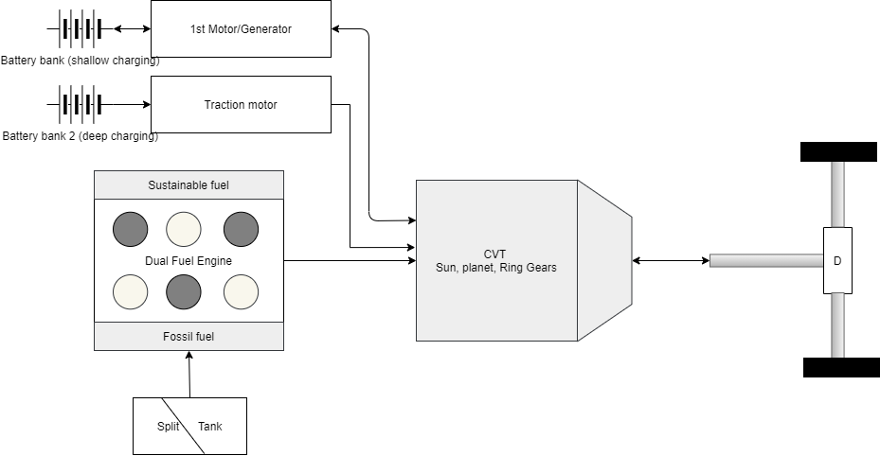

Figure 1. Schematic Overview of Hybrid vehicle drivetrain configuration (Raut, A., Phalke, S. & Peters, D., 2019) (Mechtenberg, A.R. & Peters, D.L., 2012).
Table 1. Parameters of target Hybrid Electric Vehicle (Raut, A., Phalke, S. & Peters, D., 2019)

Parameter | Value
Height | 2 m
Width | 2.5 m
Drag Coefficient | 0.45
Gross Vehicle Mass | 1900 kg
Height of Center of Gravity | 0.6 m
Wheel Radius | 0.35 m
Wheelbase | 2.75 m

Brake Force Calculation

Based on the mode of braking selected, the model will calculate the total braking force. The braking dynamics change based on the weight and load on the vehicle axle, and the forces required to stop the vehicle change. The force to be generated by a braking system is calculated based on the vehicle dynamics and the behavior of the vehicle during braking (Breuer, B.J. & Bill, K., 2008).

Figure 2. Forces acting on vehicle while braking on level ground

Using the free body diagram in Figure 2, the static forces on the vehicle are determined (Breuer, B.J. & Bill, K., 2008). Several intermediate values are defined, as follows:

$Ψ=\frac{F_{wgt,F}}{F_{weight}}=\frac{ı_{f}}{ı}$ (1)

$χ=\frac{h_{CoG}}{ı}$ (2)

Based on Newton’s Second Law, we know $F=ma$, where m is mass and a is acceleration. The deceleration $\frac{a}{g}$ of the vehicle is calculated from brake force proportions of front and rear, as detailed and explained in (Breuer, B.J. & Bill, K., 2008).

$\frac{a}{g}F_{weight}=F_{wgt,F}+F_{wgt,R}$ (3)
$\frac{a}{g}=\frac{F_{wgt,F}+F_{wgt,R}}{F_{weight}}$ (4)
In a braking maneuver, the dynamic axle load distribution is observed, by using the principle of torque equilibrium around the center of tire contact of both the axles. Since tire is the only point of contact between the road surface and the vehicle,

$FB=μ_{x,B}F_{weight}$ (5)

where FB is the total braking force and 𝜇_{𝑥,𝐵} is the coefficient of friction and in this equation, F_{weight} is considered as the normal force applied on the surface of the road.

$F_{B,f}=μ_{xBf}F_{wgt,F}$ (6)
$\frac{F_{B,f}}{F_{weight}}=μ_{xBf}\frac{F_{wgt,F}}{F_{weight}}=μ_{xBf}\left(1-Ψ+\frac{a}{g}χ\right)$ (7)

Similarly, on the rear axle when the forces are calculated,

$\frac{F_{B,r}}{F_{weight}}=μ_{xBr}\frac{F_{wgt,R}}{F_{weight}}=μ_{xBr}\left(Ψ-\frac{a}{g}χ\right)$ (8)

The relationship from Eq. (7) and (8) applies to the force transmission between tire and road as well. For a homogenous road, friction coefficients are 𝜇_{𝑥𝐵𝑓}= 𝜇_{𝑥𝐵𝑟} (Breuer, B.J. & Bill, K., 2008).

Brake Blending

The total braking force demanded to decelerate is produced by braking at the front axle and rear axle. The amount of force to be applied at the front axle brake force and rear axle brake force is decided by brake blending. As shown in Figure 3, with the rear braking force on the Y-axis and front braking force on the X-axis, the blending between the front and rear brakes is analyzed and this is called the brake blending curve. The braking forces distribution is bounded by ECE regulation addendum 12 H: regulation No. 13H (Uniform provisions concerning the approval of passenger cars concerning to braking), which indicates that the front axle braking force at all conditions is to be higher than the rear axle braking force to ensure vehicle stability (Regulation No. 13-H-01: Passenger Car Braking, 2019).
The minimum deceleration of the vehicle is supposed to be:

$z≥0.1+0.85\left(k-0.2\right)$ (9)

where z is the braking rate of the vehicle in g’s and 𝑘 is the theoretical coefficient of adhesion between tire and road (Regulation No. 13-H-01: Passenger Car Braking, 2019).

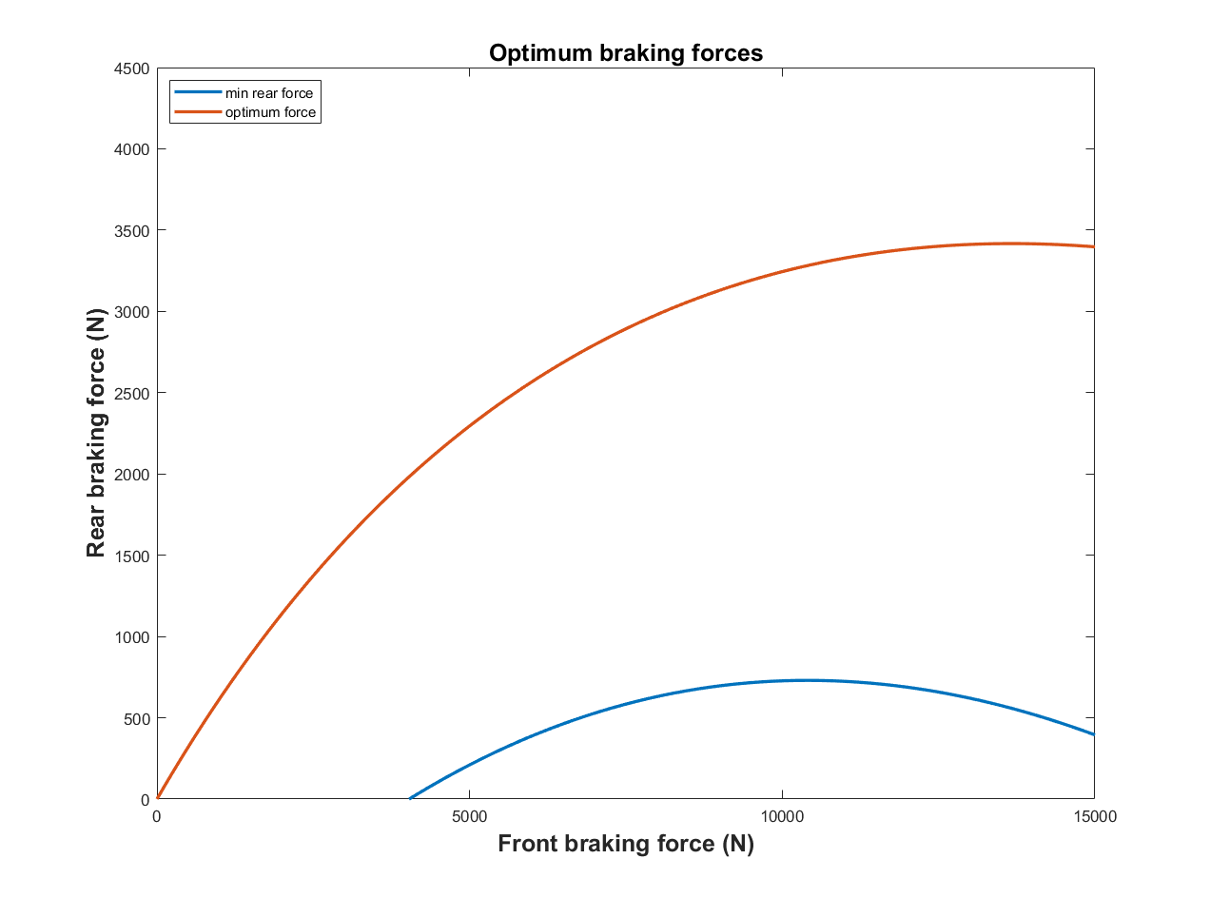
Figure 3. Optimum and minimum brake force distribution curve

Regenerative Braking Configuration

The motor-generator is operated to convert the kinetic or potential energy of vehicle mass into electric energy that can be stored and reused. The plug-in HEV considered in this paper is equipped with a series brake system. A series braking approach effectively recovers a significant amount of energy (王 永红, 2019). Series braking uses a segmented distribution of regenerative braking and traditional braking power. The algorithm uses regenerative braking power after the braking demand reaches a certain value and then uses hydraulic braking. The front axle braking force is shared by regenerative and hydraulic brakes whereas, the rear axle brake load is provided by hydraulic brakes. A schematic of the series braking scheme is described in Figure 4.

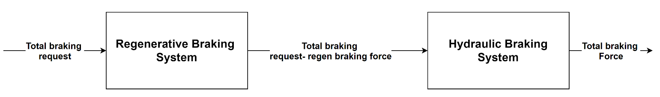
Figure 4. Schematic of series HEV

The braking forces on the front and rear axles are distributed adhering to the regulations stated in ECE Regulations 13H (Regulation No. 13-H-01: Passenger Car Braking, 2019). The designed control algorithm should deliver braking force such that the braking force on the front and rear axle are near to the optimum/ideal braking force. The optimum/ideal brake force distribution would ensure the stability of the car and stop at the shortest distance.

Modeling of Multi-Mode Plug-in Hybrid Electric Vehicle

The multi-mode plug-in HEV model is based on the model by Raut et al, described in (Raut, A., Phalke, S. & Peters, D., 2019). The vehicle model for this HEV is structured as a collection of subsystems, where each subsystem has a specified function in the overall vehicle. In Figure 5, the subsystems are shown; they are based on functionality such as driver, drive mode controller, engine, electrical systems, driveline, vehicle dynamics, and braking systems.

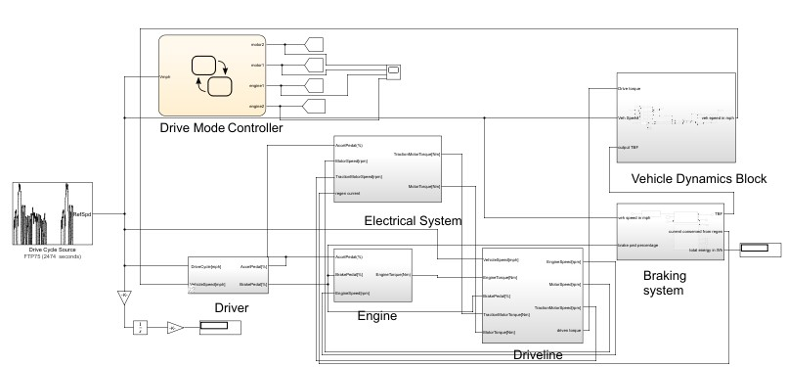
Figure 5. Overview of the multi-mode plug in Hybrid electric Vehicle Simulink model

Driver Model

In the driver model, the actual vehicle speed is compared to the target speed input from the drive cycle. The difference in speeds (error) is provided as input to a PI controller, which was tuned to minimize error and achieve the target speed. The output of the PI controller is connected to a transfer function such that if the error is positive then the vehicle accelerates, and if the error is negative the vehicle brakes. Based on calculated accelerator and brake pedal percentages, torque is demanded from the engine and motors and brake force required to retard the vehicle are calculated further.

Drive mode selector:

The drive mode selector is based on the hybrid vehicle described by Mechtenberg (Mechtenberg, A., 2009). A Stateflow controller is developed to select the driving modes of the vehicle based on the vehicle speed (Golbuff, S., 2006. At low speed/high torque maneuvers (between 0 to 25 kph), the traction motor is used to power the vehicle. A motor/generator system will provide power between the speeds of 25 kph to 50 kph. At vehicle speeds higher 50 kph and less than 100 kph, three cylinders of a V6 engine are powered by gasoline. The other three cylinders are powered by sustainable fuel source when vehicle speed in between100 kph and 130 kph. If the vehicle is above 130 kph, the engine uses gasoline and sustainable fuel source to power the vehicle.

Engine and Electric system (Batteries, Motors and Generator):

The simulation model of engine and electrical systems is developed using a quasi-static approach, based on the simulation targets and powertrain characteristic of the model (Millo, F., Rolando, L. & Andreata, M., 2011). The output to be delivered by each of the power systems is torque (i.e., engine torque when the engine is running and a motor torque when the motors are selected), which is determined by interpolation of steady-state performance maps from the inputs of accelerator, brake and engine/motor speed data.

Driveline

In a parallel hybrid, the torque from the engine must combine with the torque from the electric motors to meet the requirements for propulsion (Che, J. et al., 2009). The vehicle switches power sources between engine and motors based on the control system demand of drive mode selector. A planetary gear train is utilized to combine all the sources of power; the engine is connected to the ring gear and the motor/generator to the sun gear. The traction motor is connected to the differential via a simple gearbox arrangement. To have a seamless torque delivery in the transmission model, a clutch is modelled to engage and disengage the IC engine, motor/generator and traction motor independently from the respective gearboxes.

Braking System

The braking system subsystem functions as the brake control unit (BCU) of the model. The brake percentage input from the driver triggers the BCU. Total braking force requested by the driver to retard the vehicle is estimated from the percentage of the brake pedal pressed. From Newton’s Second Law, the braking rate is calculated based on Eq. (10).

$\frac{RBF}{Weight}=\frac{a}{g}$ (10)

where RBF is the requested brake force, a is the deceleration of the vehicle and g is the acceleration due to gravity. The brake rate calculated is provided to the brake mode selector as shown in Figure 6.
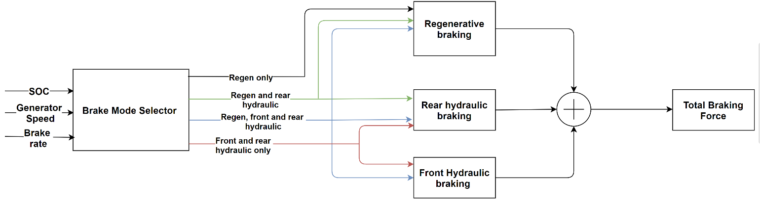
Figure 6. Schematic of the brake controller

Brake mode selector

The brake mode selector was designed based on the principles set forth in (Gao, Y., Chen, L. & Ehsani, M., 1999). A front wheel driven passenger car under normal driving procedures would decelerate within the range of 0.1-0.3g. This is the region in which maximum regenerative braking should occur. At lower G-forces the vehicle can come to a slow halt or just reduce the speed, whereas at high G-force values (above 0.6) the vehicle needs to stop at the shortest distance possible or retard in a short span. These requirements were incorporated into the algorithm.

As shown in Figure 7, at a small braking rate ($\frac{a}{g}≤0.1$) only regenerative braking on the front axle is activated, depicted by AB in Figure 7. To ensure the stability of the vehicle, in the case where the braking rate is in the range of $0.1<\frac{a}{g}<0.3$, the front axle would use regenerative braking force and rear axle hydraulic braking force is activated, which produces the brake force distribution curve between points B and C. When the requested braking rate is in the higher range of $0.3<\frac{a}{g}<0.6$, there is a higher priority on stopping the vehicle quickly. Due to the increase in brake force demand, the front hydraulic braking force works simultaneously with regenerative braking on the front axle, and rear hydraulic braking is active, producing the curve from point C to D. In cases where the braking rate is greater than 0.6 g’s, it is considered an emergency braking condition where stopping the vehicle in the shortest distance is the priority. To stop the vehicle at the shortest possible distance the brake force distribution should be equal to the optimum/ideal brake distribution. Hence, only hydraulic braking on the front and rear axles are given priority in this case. Thus, the points D and E lie on the optimum/ideal force distribution curve.

Apart from brake rate values, regenerative braking is also dependent on the state of charge (SOC) of the battery and on the generator speed, as shown in Figure 6. If the SOC of the battery is above 80% the vehicle would not be charged further through regenerative braking. If the generator speed is higher than the rated base speed the amount of torque the generator can produce is limited. The generator cannot generate enough current to put back into the shallow charge battery, due to the losses the current must overcome.
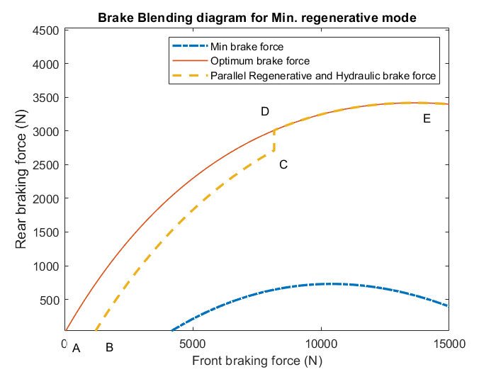
Figure 7. Brake Force distribution curve for min. regen mode

Total braking force

To deliver the total braking force requested by the driver model, the braking option is selected by the brake mode selector. The regenerative braking force to be delivered is dependent on the torque that can be produced by the generator at the given generator speed.

$F_{gen}=\frac{T_{gen}η_{gen}GearRatio}{WheelRadius}$ (11)

where 𝑇_{𝑔𝑒𝑛} is the generator torque for the specified generator speed, 𝜂_{𝑔𝑒𝑛} is the efficiency of the generator, and 𝐹_{𝑔𝑒𝑛} is the braking force.

As the generator can deliver the same torque at multiple motor speeds, to prevent cases of over braking 𝐹_{𝑔𝑒𝑛} is compared with the force required on the front axle for the requested brake rate. If 𝐹_{𝑔𝑒𝑛} is greater than or equal to the requested front axle braking force, then the output must be the value of the requested front axle braking force. Otherwise, the output must be F_{gen}. The front and rear hydraulic braking forces are then calculated by the following equations:

$F_{wgt,F}=F_{weight}\left(1-Ψ+\frac{a}{g}χ\right)$ (12)
$F_{wgt,R}=F_{weight}\left(Ψ-\frac{a}{g}χ\right)$ (13)

Based on the mode of braking selected, the braking forces generated per axle is calculated. And finally, the regenerative braking torque provided by generator and friction braking force generated by the hydraulic brakes will meet the total brake request of the vehicle.

Vehicle dynamics

A one-dimensional vehicle dynamics block is built in MATLB/Simulink to predict the tractive forces required by the vehicle. The model calculates the dynamic weight shifts during acceleration and braking. The entire brake control algorithm, including the various decisions noted above and the vehicle dynamics integration, is given in Fig. 8.

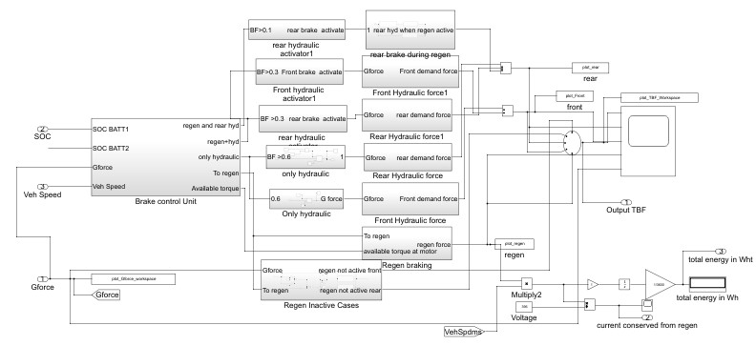
Figure 8. Top level view of the Brake control algorithm
Simulation and Results

Unit test to verify brake blending

The brake blending must have a seamless delivery of force. If the brake force delivered to the driver is either higher or lower than demand the consequences could be severe. To prevent the cases of over-braking and under-braking a brake system unit test is performed. This tests the performance of the brake blending algorithm by pressing the brakes from 0 to 100%. The force generated at various pedal percentages is shown in Figure 9.

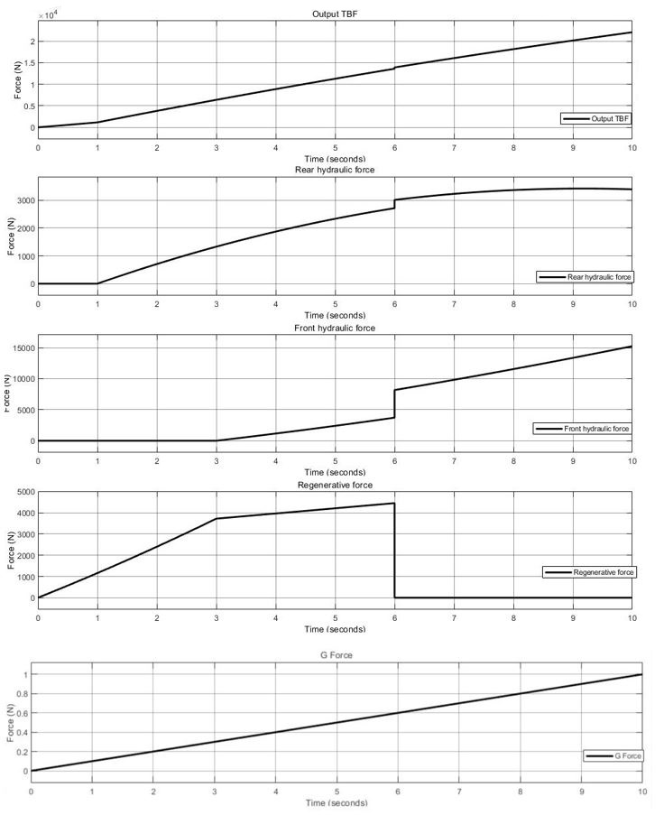
Figure 9. Force distribution during a brake blending test.

Testing cycle to predict the stopping distance

The prime function of a braking system is to stop the vehicle at a given distance. When the driver demands brake force to retard or stop the vehicle is to deliver the required force under ideal condition and stop the vehicle at the least possible distance. When parallel regenerative braking is in the system the vehicle’s braking system has an additional function to conserve energy; however, it is essential that this energy recapture and conservation does not compromise vehicle safety.

The ECE R13 regulation calls for a braking performance test where the vehicle is tested on a track for the emergency condition and the stopping distance taken by the vehicle is measured to check if it is within limits. The performance braking test conditions state that the distance covered by the vehicle from the moment when the driver begins to actuate the control of braking systems shall be determined until the vehicle stops. The brake systems performance is measured by determining the distance travelled by the vehicle to stop.

As per the regulation followed for testing, the stopping distance is the vehicle is accelerated to 160 kph (100 mph) and the brake is pressed to 100%. This test is conducted on a track with coefficient of friction equal to 0.9. The stopping distance for the vehicle is given by

$StoppingDistance \left(m\right)≤0.1V+0.0067V^{2}$ (14)

where V is the initial vehicle speed (i.e., 160 kph). Therefore, the stopping distance must be less than or equal to 171.52 m when the brakes are pressed to 100%.

Performance of Brake System

A test pattern similar to the brake performance test is simulated, where the vehicle is accelerated to 100 mph (160 kph) and then maintains the speed for 25 s; then, the brake pedal is triggered as shown in Figure 12. Instead of performing the test for only 100% braking the vehicle’s stopping distance is measured at all load cycles. It is assumed that the driver presses the brake and holds it at a constant brake percentage. The results of the simulated brake performance test are based on a few assumptions:
- The driver’s reaction time for braking remains same in all cases;
- There is no condition for wheel lock up;
- The environmental factors remain same.
Additionally, the test was conducted at various modes of regenerative braking namely, pure hydraulic, minimum regenerative braking, medium regenerative braking and high/maximum regenerative braking. A brake blending curve of each of the braking modes is shown in Figures 10 and 11.
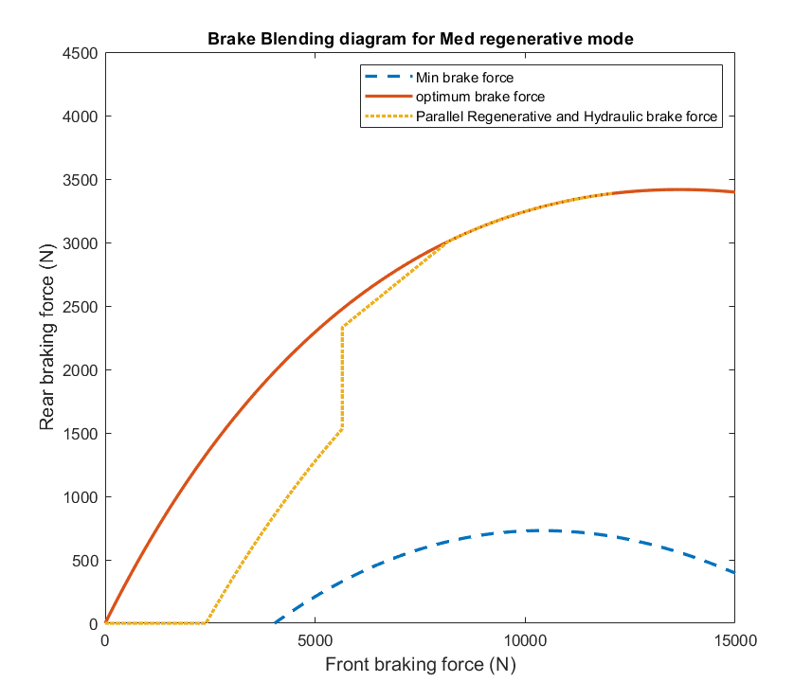
Figure 10. Brake blending curve for medium regenerative braking mode

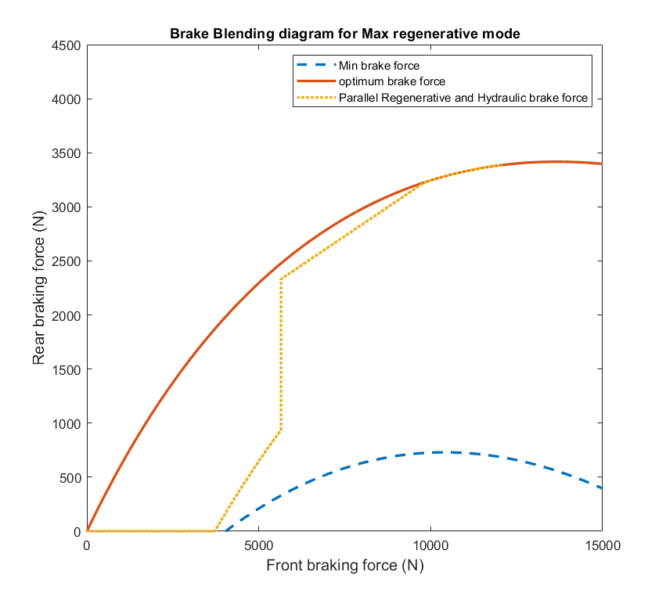
Figure 11. Brake blending curve for maximum regenerative braking

All the above-mentioned regenerative modes are above the minimum brake force required. To determine the optimum trade-off between braking distance and energy conservation, the brake performance test is run for various load cycles. Results were utilized to determine which mode of regenerative braking would aid in recuperating energy and as well as stop the vehicle in reasonably shorter distance. A test cycle with a single load was run with different modes and pedal rates, with results for one such test run shown in Figure 12, with the brake applied at 70 seconds.

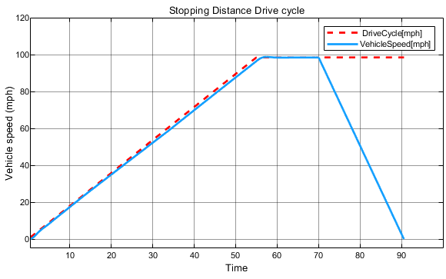
Figure 12. Brake performance test cycle at a single load

Results of performance brake tests

As per the BCU control algorithm when the brakes are pressed to 100% an emergency braking condition is triggered and to provide the stop at shortest possible distance only hydraulic braking is used. The vehicle stops within 67.02 m below the regulation mentioned standard of 171.52 m.

At various pedal rates and regenerative modes the energy conserved by regenerative braking is calculated, and this is shown in Figure 13 for a variety of different levels of regeneration. Logically, one would prefer to have minimum stopping distance together with the maximum energy conservation, which would indicate that points in the lower right part of the graph would be desirable. In the lower part of the graph, it is seen that there is a tradeoff between energy conservation and stopping distance, with greater stopping distance being the price of increased energy conservation. The medium and maximum regeneration are very similar to each other in this part of the graph, with only minimal differences between them as they trade off which curve is optimal in various ranges. It is also noted that, at a certain point, no further energy can be recovered; some pedal rates are not desirable, as they result in both less energy conservation and a longer stopping distance. At those lower pedal rates, the minimum regeneration gives better results than the medium or maximum regeneration, although overall even the “better” results are not optimal compared to those seen with higher pedal rates.

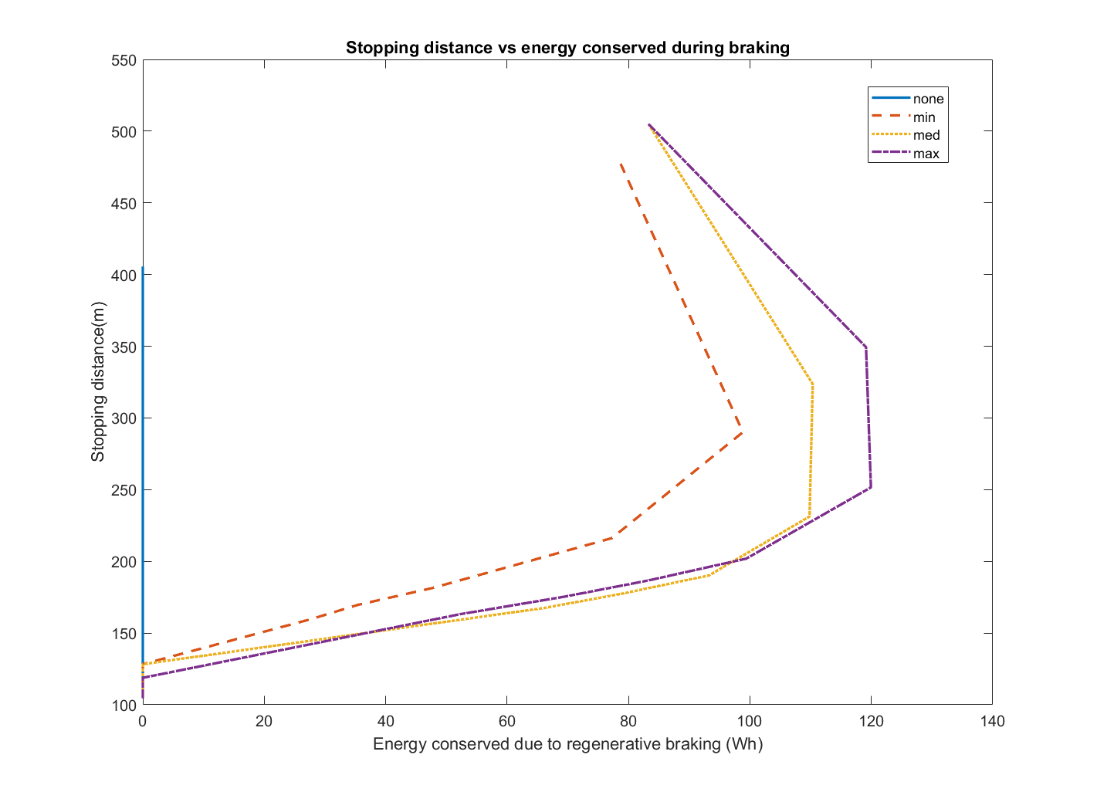
Figure 13 Vehicle stopping distance vs energy conserved during braking in different modes.

The HEV model was then tested for four different urban drive cycles: the Urban Dynamometer Driving Schedule (UDDS), New York City Cycle (NYCC), Japan 10-15, and Braunschweig city driving cycle. City cycles have been chosen to test the regenerative braking of the system, as they are expected to utilize the brakes to a greater extent than highway driving. The results of running each cycle are included in figures 14 - 17. The first plot in each figure, shown at the top, demonstrates that the speed of the vehicle in the model does match that of the commanded drive cycle. In the lower plot in the figures, the total braking force is shown. The majority of braking in these urban driving scenarios can be accomplished purely from regenerative braking, resulting in little wasted energy.

These cycles were simulated with and without regenerative braking in order to observe the change in energy consumption; this is shown in Table 2. The amount of energy recovered is expressed in percentage.

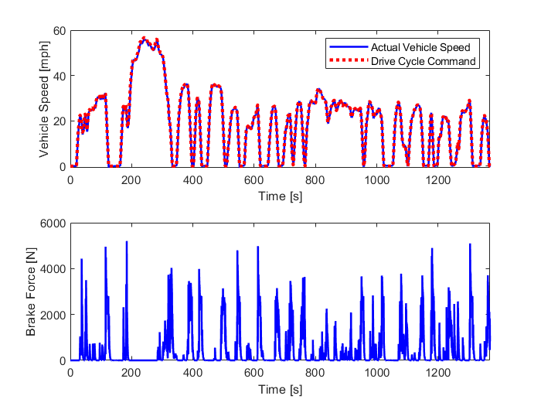
Figure 14 Vehicle velocity and total braking force delivered for UDDS drive cycle.

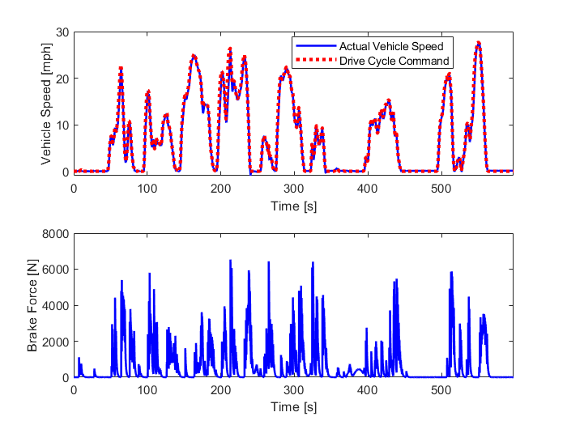
Figure 15 Vehicle velocity and total braking force delivered for NYCC drive cycle

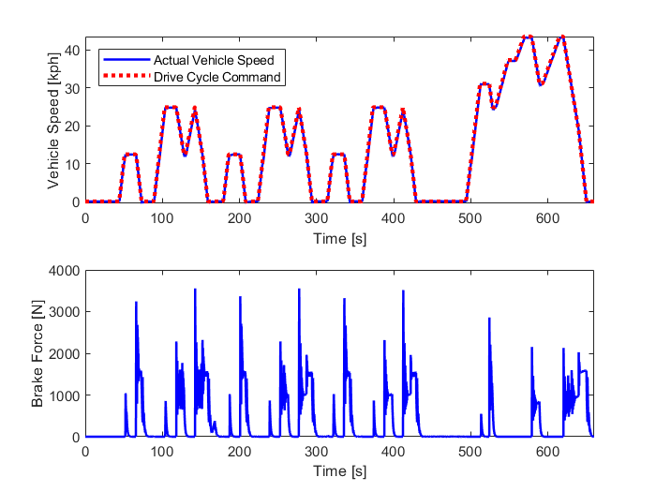
Figure 16 Vehicle velocity and total braking force delivered for Japan 10-15 drive cycle

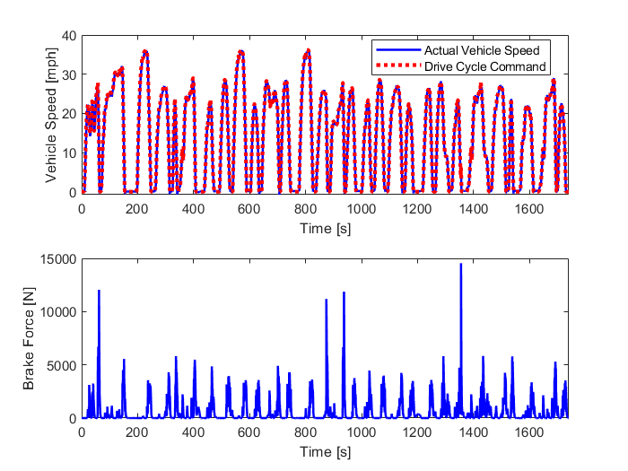
Figure 17 Vehicle velocity and total braking force delivered for Braunschweig city drive cycle.

Table 2 Comparison of Energy Consumption for Drive Cycles with and without Regenerative Braking

 |  | Drive Cycle
 | Unit | UDSS | NYCC | Japan 10-15 | Braunschweig city driving cycle
Time of drive cycle | sec | 1369 | 598 | 660 | 1740
Distance | km | 11.99 | 1.89 | 4.17 | 10.88
Energy consumed with only hydraulic braking system | kWh | 3.879 | 0.823 | 0.856 | 3.137
Energy conserved by minimum regenerative braking system | kWh | 0.761 | 0.190 | 0.276 | 0.778
Energy conserved with medium regenerative braking system | kWh | 0.851 | 0.219 | 0.283 | 0.833
Energy conserved with maximum regenerative braking system | kWh | 0.948 | 0.228 | 0.284 | 0.880
% change in energy conserved between minimum and medium regenerative braking | % | 12 | 15 | 3 | 7

Conclusion

Among all the different modes of regenerative braking tested, the medium regenerative braking system has the potential to provide sufficient braking force to safely drive the vehicle as well as increase the energy conserved in all driving cycles. The MIL simulation results for multiple city-driving cycles showcased the advantages of a regenerative braking control algorithm. The energy usage for vehicles with the minimum regenerative braking strategy in the NYCC was observed to be 15% less than the proposed regenerative braking algorithm. Similarly, when tested for other city driving patterns such as UDSS, Japan 10-15, and Braunschweig city driving cycle the energy usage of the minimum regenerative braking was observed to be 12%, 3% and 7% lower when compared to medium regenerative braking algorithm. The results shown here can be used to better design braking algorithms, in order to receive the maximum benefit from regenerative braking systems based on a particular vehicle and its use cases.

References

Boerboom, M., 1970. Electric Vehicle Blended Braking maximizing energy recovery while maintaining vehicle stability and maneuverability. Master’s Thesis. Chalmers University of Technology, Goteborg, Sweden.
Breuer, B.J. & Bill, K., 2008. Brake Technology Handbook. SAE International, Warrendale, PA.
Che, J. Tsou, P., Rose, L., & Jennings, M., 2009. Modeling and Simulation of the Dual Drive Hybrid Electric Propulsion System. SAE Technical Paper no. 2009-01-0147.
Ehsani, M. et al., 2019. Modern electric, hybrid electric, and fuel cell vehicles, Boca Raton: CRC Press/Taylor & Francis Group.
Gao, Y., Chen, L. & Ehsani, M., 1999. Investigation of the Effectiveness of Regenerative Braking for EV and HEV. SAE transactions, pp. 3184-3190.
Golbuff, S. (2006). Optimization of a plug-in hybrid electric vehicle. PhD Thesis: Georgia Institute of Technology, Atlanta, GA.
Ltd, I.R., Regulation No. 13-H-01: Passenger Car Braking. InterRegs. Available at: https://www.interregs.com/catalogue/details/ece- 13h01/regulation-no-13-h-01/passenger-car-braking/ [Accessed April 8, 2021].
Mechtenberg, A., 2009. Understanding the Importance of an Energy Crisis. PhD Thesis: University of Michigan, Ann Arbor, MI
Mechtenberg, A.R. & Peters, D.L., 2012. Control of a 36 Mode Hybrid Vehicle With Driver Option Selection: Incorporating Urban, Suburban, and Highway Driving. In Dynamic Systems and Control Conference (Vol. 45295, pp. 137-144). American Society of Mechanical Engineers.
Millo, F., Rolando, L. & Andreata, M., 2011. Numerical Simulation for Vehicle Powertrain Development. IntechOpen.
Raut, A., Phalke, S. & Peters, D., 2019. Modeling and Control of New Multi-Mode Plug-in Hybrid Electric Vehicle. In International Design Engineering Technical Conferences and Computers and Information in Engineering Conference (Vol. 59216, p. V003T01A042). American Society of Mechanical Engineers.

Biographies

ANEESH SURI is a Powertrain Engineer II at Mercedes-Benz Research & Development North America, Inc. He earned his B. Tech in Mechanical Engineering from GITAM University in 2014 and his MS from Kettering University in 2020. Mr. Suri may be reached at aneeshsuri1992@gmail.com.

DIANE PETERS is an Associate Professor of Mechanical Engineering at Kettering University. She earned her BS from the University of Notre Dame in 1993, her MS from the University of Illinois – Chicago in 2000, and her PhD from the University of Michigan in 2010. Dr. Peters’ research interests include combined design and control and autonomous vehicles. Dr. Peters may be reached at dpeters@kettering.edu.

