**# 016-x-22**

**Analysis of Cylinders for Printing Industry Equipment**

Khari Gray

Kettering University

[gray7444@kettering.edu](mailto:gray7444@kettering.edu)

Dr. Diane Peters

Kettering University

[dpeters@kettering.edu](mailto:dpeters@kettering.edu%20)

Dr. Yaomin Dong

Kettering University

[ydong@kettering.edu](mailto:ydong@kettering.edu)

**Abstract**

Throughout the printing industry, rotating cylinders are extremely common. In the actual printing presses, they typically transfer ink from an ink fountain onto the paper in order to print the desired text and images as paper travels through the equipment, whether as sheets or as a continuous web. In other parts of a printing plan, machines that apply glue, perforate or cut the paper, or perform other operations also make use of rotating cylinders of various sizes. While some of these cylinders are relative small, others can have a very large diameter, which leads to important design decisions that must be made. For optimal results, many different factors must be considered, including the power requirement when the equipment is operated. This is directly related to the moment of inertia associated with the printing cylinder while another factor, the rigidity, must be taken into account to ensure the cylinder is stiff and does not deform under the force applied. Accordingly, this paper considers different design configurations of the printing cylinder and analyses how each unique case varies from each other in regards to the weight and the deflection as well as the moment of inertia it experiences. The optimum design is proposed based on the Finite Element Analysis.

**Introduction**

While the process of printing has existed for a very long time, and the rotary printing press dates back to Richard March Hoe’s invention of 1843, which was later patented (Hoe, 1847; Hoe, 1871), there is relatively little academic research on many issues surrounding the printing industry, either the printing presses themselves or the machinery that processes the printed paper after it carries the image. This does not indicate a lack of innovation, as there are a variety of different patents throughout the years on different aspects of printing equipment (e.g., George & Richard, 1931; Stepanek & Jurny, 1970; Dahlgren, 1972; Kapolnek, Kapolnek, Kapolnek, Musgrave, Peters, & Troxel, 2011), and some academic research has been conducted (e.g., Anstice, McEnaney, & Thornton, 1980; Sanchez, Horowitz, & Tomizuka, 2010), but it does indicate that there are many opportunities for further research.

Both the printing presses and many of the other pieces of equipment that process printed paper webs utilize rotary cylinders, similar to those in the invention patented by Hoe (Hoe, 1847; Hoe, 1871). Paper passes between two cylinders which rotate in opposite directions. One cylinder has a printing plate, while the other acts to apply pressure. Similarly, in cutting applications (Martin, 1968), one cylinder will have a die or knife mounted on it, while the other cylinder acts as an anvil for the cutting process. In these applications, precision is important, and in particular, any significant deflection results in poor quality of printing or cutting and is unacceptable (Vitikáč Batešková & Panda, 2015). However, the need to produce very stiff cylinders can be in conflict with the wish to minimize the moment of inertia. There are many ways in which the moment of inertia can be determined, as well as many ways in which it impacts the operation of a piece of equipment (Ariefka & Pramudya, 2019). In this case, the moment of inertia impacts the size of the motor that must be used in order to drive the equipment and the amount of energy required to operate the machine. A larger motor increases costs, the footprint of the machine, and the amount of energy required, and therefore minimizing the moment of inertia of the cylinders is highly desirable if it can be done without compromising stiffness, and that is the topic of this paper.

In this work, sixteen unique cases of cylinder designs are modeled in Siemens NX software, and then FE analyses are carried out with appropriate loads to determine how the various designs perform. After running each simulation, the Von Mises stresses, total weight, total volume, moment of inertia along the cylinder’s length and maximum deflection are recorded for comparison purposes. A scatter plot is created to observe maximum deflection versus the moment of inertia as these are two critical factors, and the nature of the tradeoffs that may be present is noted.

**Designing the different cases**

In order to achieve a variety of simulation results, there had to be a variety of test cases. In total, there were sixteen unique cases of the interior configuration of the printing cylinder. These configurations ranged from a full, untouched, solid-bodied make-up of the printing cylinder, to having cylindrical cut-outs throughout varying wall thicknesses, to having a number of different wedge-shaped cut-outs. In general, the exterior of all printing cylinders remained the same; that is, if all sixteen-cylinder cases were observed strictly externally without any kind of sectioning, all cases would have been visually indistinguishable. The primary part of the printing cylinder had an external length of 40 inches and a diameter of 15 inches which is standard for the size of an actual cylinder used in equipment that one of the authors had worked with in the past in the printing/converting industry. The exterior of the cylinder is shown in Fig. 1, with key dimensions noted. Section line A-A indicates where all sixteen cases were cut, to provide a view of the cross-section of the cylinder. All dimensions shown are in inches throughout the figures shown.

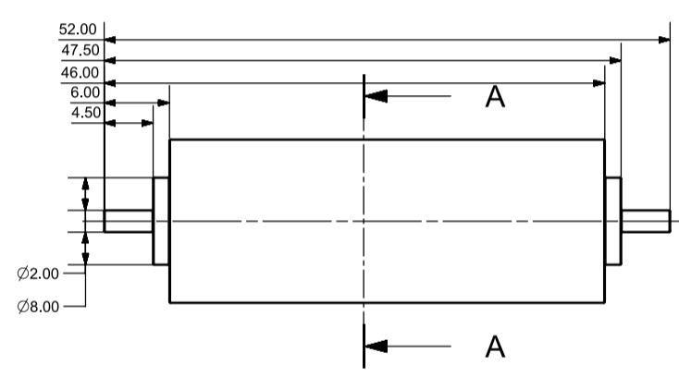

Figure 1. Drawing of the Exterior of the Printing Cylinder Used for All Cases in the NX Simulation. Note. A-A represents a section line looking in the direction of the arrows

*Case I*

The first design was a full, solid-bodied cylinder with absolutely no cut-outs. This is shown in Fig. 2 below. This serves as a baseline case, as it is the simplest internal profile possible.

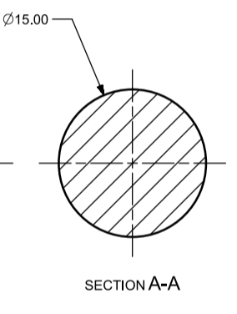

Figure 2. Drawing of Section A-A for Case I

*Case II*

The second design saw the main part of the cylinder completely hollowed out to leave a wall thickness of 1 inch along the curved face as well as the two flat faces. This is shown in Fig. 3 below.

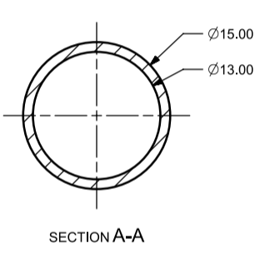

Figure 3. Drawing of Section A-A for Case II

*Case III*

The third design saw the main part of the cylinder completely hollowed out to leave a wall thickness of 3 inches along the curved face as well as the two flat faces. This is shown in Fig. 4 below.

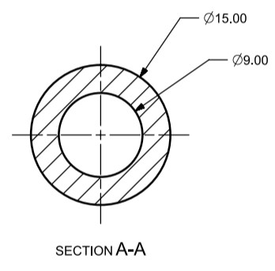

Figure 4. Drawing of Section A-A for Case III

*Case IV*

The fourth design saw the main part of the cylinder completely hollowed out to leave a wall thickness of 5 inches along the curved face as well as the two flat faces. This is shown in Fig. 5 below.

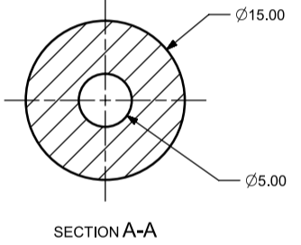

Figure 5. Drawing of Section A-A for Case IV

*Case V*

The fifth design saw the main part of the cylinder hollowed in three separate sections. The cross-sectional shape of the cut-out was a sector with an angle of 60º between the straight lines and a radius of 6 inches for the sector arc, in relation to the center axis of the main cylinder. The corner of the sector (where the straight lines met) sat on a 5-inch diameter circle, which was centered on the center axis of the main cylinder. The cross-sectional shape of the cut-out was radially patterned to produce three unique sectors, with each placed radially at 120º in relation to one another. The sectors were all extruded to be 32 inches long and then discarded, leaving a wall thickness of 8 inches (4 inches per side) on the flat face of the main cylinder. This is shown in Fig. 6 below.

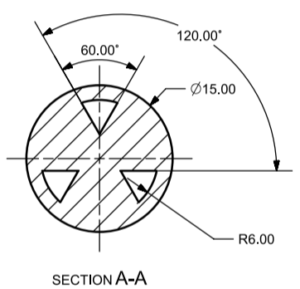

Figure 6. Drawing of Section A-A for Case V

*Case VI*

The sixth design saw the main part of the cylinder hollowed in six separate sections. The cross-sectional shape of the cut-out was a sector with an angle of 60º between the straight lines and a radius of 6 inches for the sector arc, in relation to the center axis of the main cylinder. The corner of the sector (where the straight lines met) sat on a 5-inch diameter circle, which was centered on the center axis of the main cylinder. The cross-sectional shape of the cut-out was radially patterned to produce six unique sectors, with each placed radially at 60º in relation to one another. The sectors were all extruded to be 32 inches long and then discarded, leaving a wall thickness of 8 inches (4 inches per side) on the flat face of the main cylinder. This is shown in Fig. 7 below.

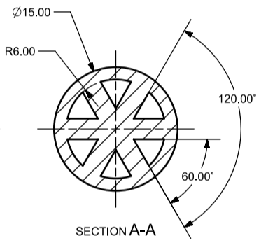

Figure 7. Drawing of Section A-A for Case VI

*Case VII*

The seventh design saw the main part of the cylinder hollowed in three separate sections. The cross-sectional shape of the cut-out was composed of two straight lines and two arcs concentric to the center axis of the main cylinder. The straight lines ran radially from the center axes of the main cylinder, with 36º separating them. Meanwhile, the inner arc had a radius of 3 inches while the outer arc had a radius of 6 inches, to complete the shape of the cut-out cross-section. The cross-sectional shape of the cut-out was radially patterned to produce three unique cut-outs, with each placed radially at 120º in relation to one another. The sectors were all extruded to be 32 inches long, which left a wall thickness of 8 inches (4 inches per side) on the flat face of the main cylinder. This is shown in Fig. 8 below.

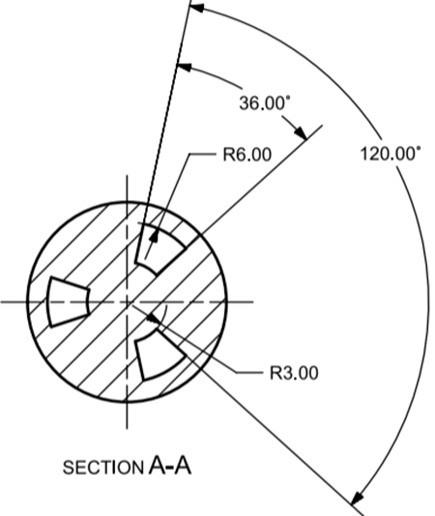

Figure 8. Drawing of Section A-A for Case VII

*Case VIII*

The eighth design saw the main part of the cylinder hollowed in six separate sections. The cross-sectional shape of the cut-out was composed of two straight lines and two arcs concentric to the center axis of the main cylinder. The straight lines ran radially from the center axes of the main cylinder, with 36º separating them. Meanwhile, the inner arc had a radius of 3 inches while the outer arc had a radius of 6 inches, to complete the shape of the cut-out cross-section. The cross-sectional shape of the cut-out was radially patterned to produce six unique cut-outs, with each placed radially at 60º in relation to one another. The sectors were all extruded to be 32 inches long, which left a wall thickness of 8 inches (4 inches per side) on the flat face of the main cylinder. This is shown in Fig. 9 below.

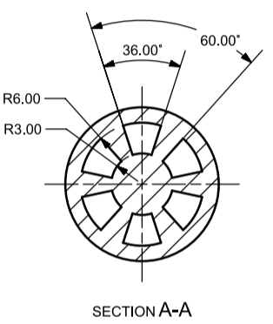

Figure 9. Drawing of Section A-A for Case VIII

*Case IX*

The ninth design saw the main part of the cylinder hollowed in twelve separate sections. There were two tiers of cut-outs: the inner tier and the outer tier. The cross-sectional shape of each cut-out was composed of two straight lines and two arcs concentric to the center axis of the main cylinder. The straight lines ran radially from the center axes of the main cylinder, with 36º separating them. For the inner tier, the inner arc measured 1.5 inches in radius while the outer arc measured 3 inches in radius. For the outer tier, the inner arc measured 4.5 inches in radius while the outer arc measured 6 inches in radius. This created two unique cutouts, one on the inner tier and the other on the outer tier. The cross-sectional shape of each cut-out was radially patterned to produce two unique sets of six identical cut-outs, with each placed radially at 60º in relation to one another. The sectors were all extruded to be 32 inches long, which left a wall thickness of 8 inches (4 inches per side) on the flat face of the main cylinder. This is shown in Fig. 10 below.

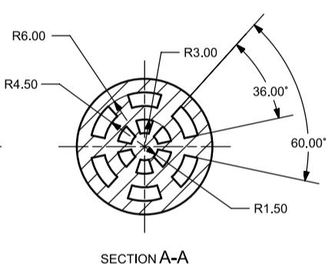

Figure 10. Drawing of Section A-A for Case IX

*Case X*

The tenth design saw the main part of the cylinder hollowed in eighteen separate sections. There were three tiers of cut-outs: the inner tier, the middle and the outer tier. The cross-sectional shape of each cut-out was composed of two straight lines and two arcs concentric to the center axis of the main cylinder. The straight lines ran radially from the center axes of the main cylinder, with 36º separating them. For the inner tier, the inner arc measured 1.5 inches in radius while the outer arc measured 2.4 inches in radius. For the middle tier, the inner arc measured 3.3 inches in radius while the outer arc measured 4.2 inches in radius. For the outer tier, the inner arc measured 5.1 inches in radius while the outer arc measured 6 inches in radius. This created three unique cutouts, one on the inner tier, one on the middle tier and the other on the outer tier. The cross-sectional shape of each cut-out was radially patterned to produce three unique sets of six identical cut-outs, with each placed radially at 60º in relation to one another. The sectors were all extruded to be 32 inches long, which left a wall thickness of 8 inches (4 inches per side) on the flat face of the main cylinder. This is shown in Fig. 11 below.

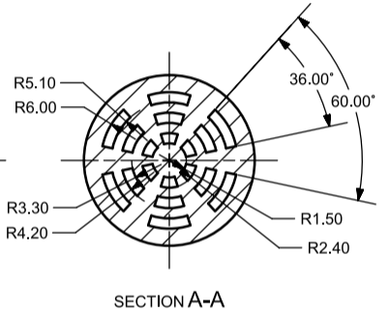

Figure 11. Drawing of Section A-A for Case X

*Case XI*

The eleventh design saw the main part of the cylinder completely hollowed out to leave a wall thickness of .5 inches along the curved face as well as the two flat faces. This is shown in Fig. 12 below.

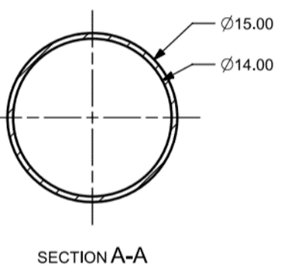

Figure 12. Drawing of Section A-A for Case XI

*Case XII*

The twelfth design saw the main part of the cylinder completely hollowed out to leave a wall thickness of 1.5 inches along the curved face as well as the two flat faces. This is shown in Fig. 13 below.

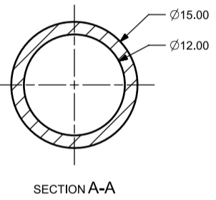

Figure 13. Drawing of Section A-A for Case XII

*Case XIII*

The thirteenth design saw the main part of the cylinder completely hollowed out to leave a wall thickness of 2 inches along the curved face as well as the two flat faces. This is shown in Fig. 14 below.

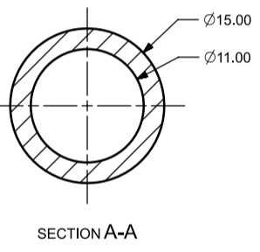

Figure 14. Drawing of Section A-A for Case XIII

*Case XIV*

The fourteenth design saw the main part of the cylinder completely hollowed out to leave a wall thickness of 2.5 inches along the curved face as well as the two flat faces. This is shown in Fig. 15 below.

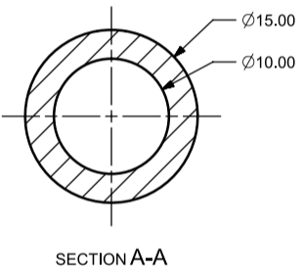

Figure 15. Drawing of Section A-A for Case XIV

*Case XV*

The fifteenth design saw the main part of the cylinder completely hollowed out to leave a wall thickness of 3.5 inches along the curved face as well as the two flat faces. This is shown in Fig. 16 below.

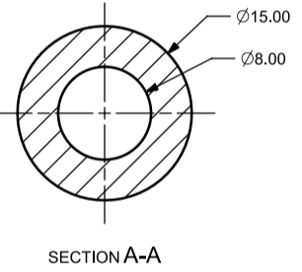

Figure 16. Drawing of Section A-A for Case XV

*Case XVI*

The sixteenth design saw the main part of the cylinder completely hollowed out to leave a wall thickness of 4 inches along the curved face as well as the two flat faces. This is shown in Fig. 17 below.

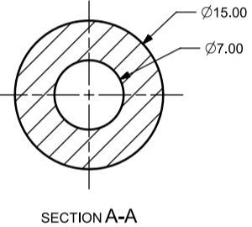

Figure 17. Drawing of Section A-A for Case XVI

**Creating Force Contact Surface Area**

It was assumed that the force applied on the cylinder during usage acted not strictly tangentially, that is, along one line along the cylinder’s length but instead, the force was spread out into a relatively thick strip of the main cylinder’s length. Therefore, on the external surface of the main cylinder for all sixteen cases, the curved face was divided into two, through the use of datum planes. One datum plane was placed at the top of the cylinder, tangential to the main cylinder and perpendicular to the Z-axis, and then the other was placed at a distance of 0.01 inches, into the body of the cylinder. This datum plane divided the body of the printing cylinder into two, and the curved, outer face of the smaller division became the contact surface area of the cylinder that the force was applied to when it was in operation. This is shown in Fig. 18.

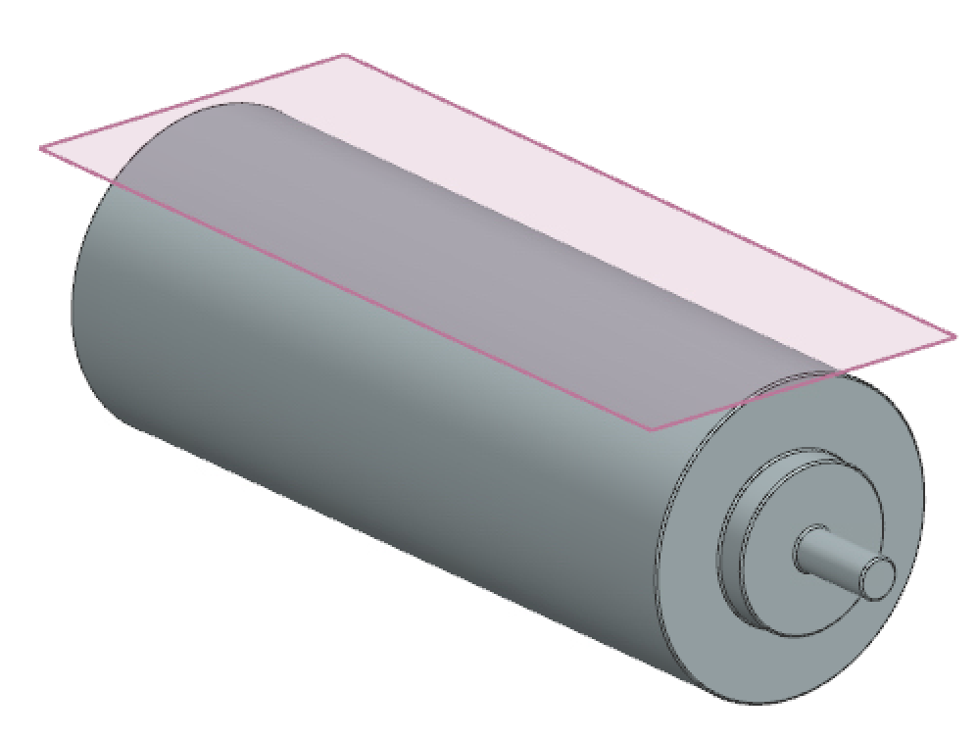

(a) NX Model Showing Tangential Datum Plane

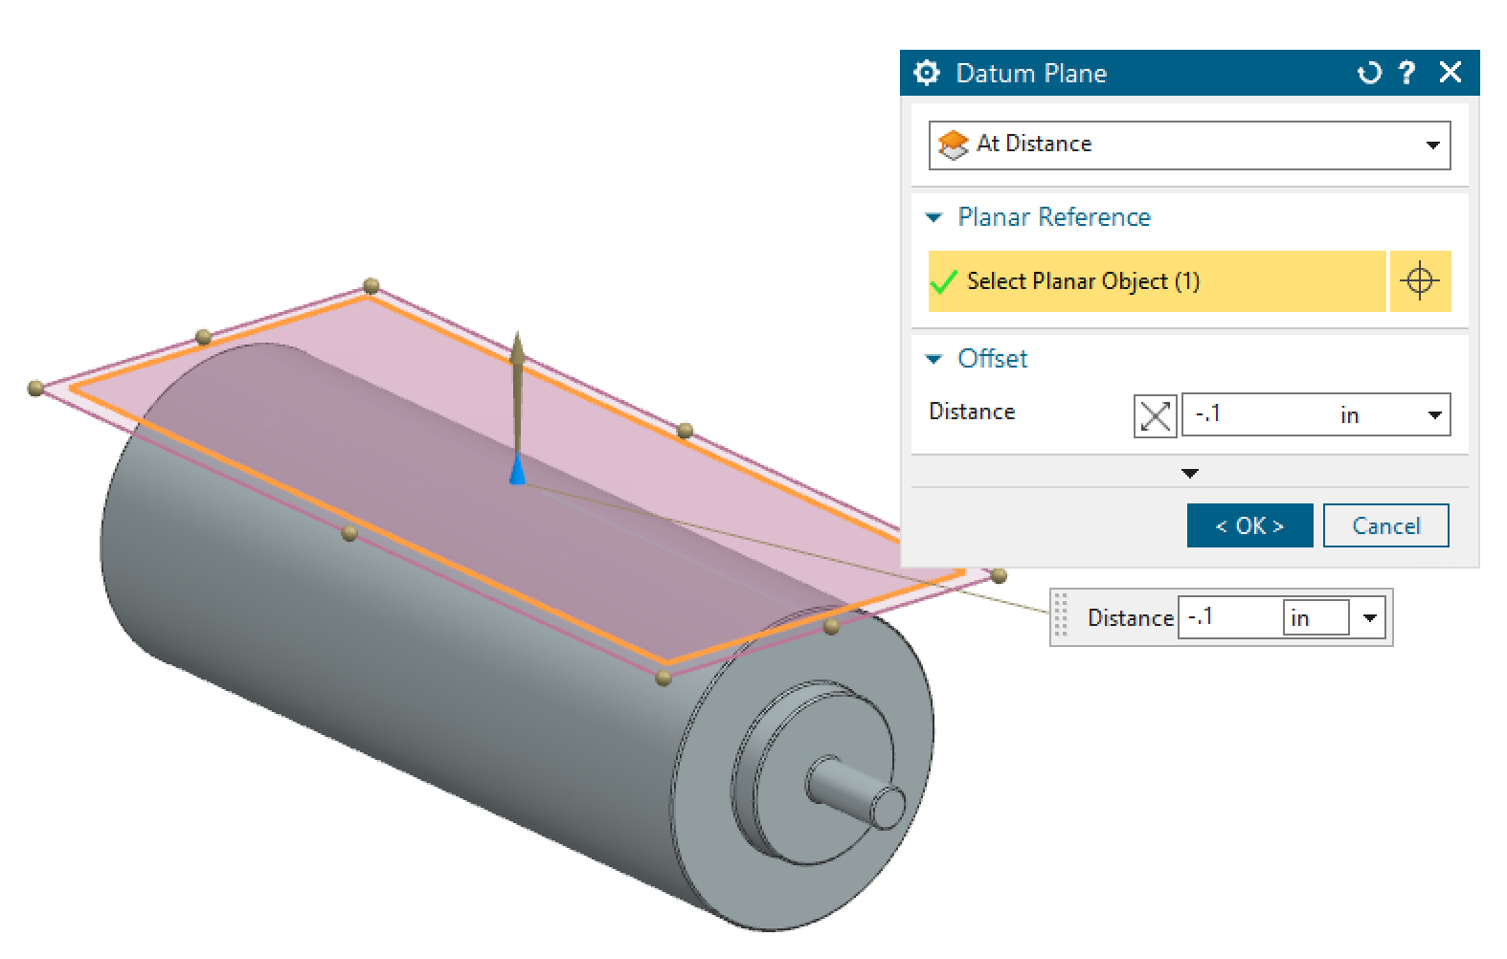

(b) NX Model Showing Datum Plane 0.1 Inches below the Tangential Datum Plane

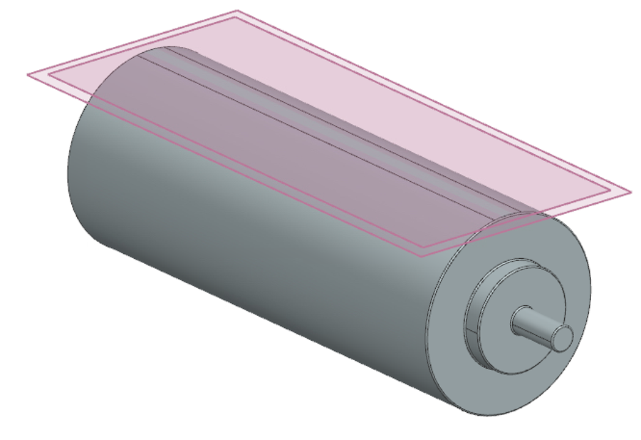

(c) NX Model Showing Divided Face for Force Contact Surface Area

Figure 18. Figures showing progression of force contract surface area creation

**Creating Support Contact Surface Area**

On both ends of the printing cylinder body, there are smaller cylindrical extensions that help to secure the cylinder and also allow it to roll in a single position. While the weight of the cylinder was acting downwards, these supports rested against the larger frame of the printer to support the cylinder’s weight. It was assumed that this support on both ends made constant contact with only half of the support extensions; that is, the extensions rested in a hemispherical cup, with which they maintained contact throughout the full use. Therefore, a datum plane was introduced to bisect the face of the extensions, so that the bottom half could have the upward force applied to it. This is shown in Fig. 19.

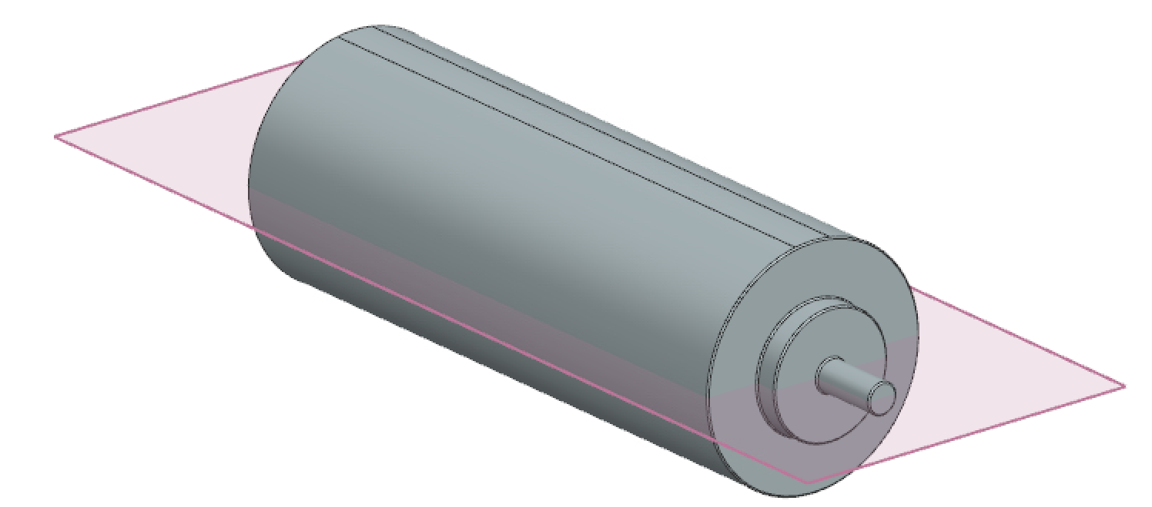

1. NX Model Showing Bisecting Datum Plane

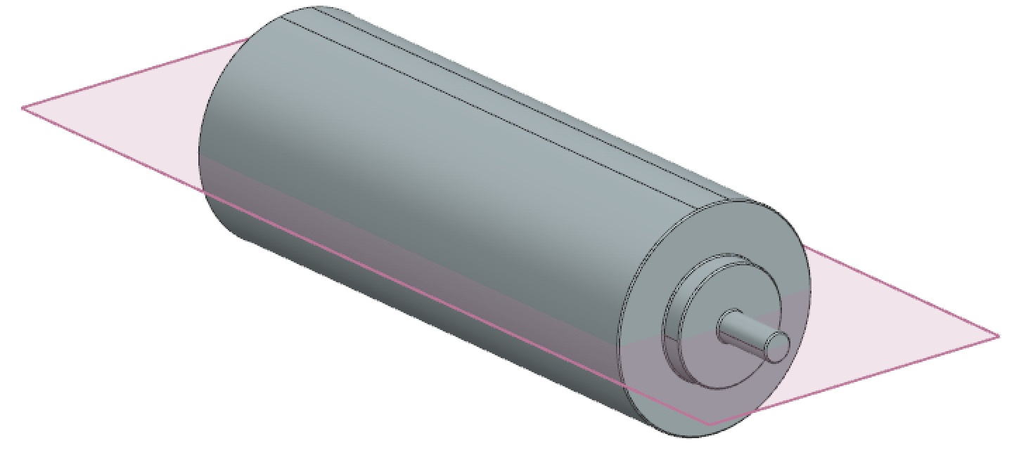

1. NX Model Showing Divided Face for Support Contact Surface Area

Figure 19. Figures showing progression of support contact surface area

**Managing Material and Mesh Size**

In NX, the application was changed from Modeling to Pre/Post, in order for the simulation to be done. Afterwards, a new FEM and simulation was created, along with an idealized part. The material that made up the body was then changed to be steel, as it was found that this was the most common material used to make printing cylinders. Next, the 3D tetrahedral mesh type was made to be CTETRA(10) and the element size was made to be one-half of NX’s size suggestion. NX’s recommended element size value for each individual case was derived by clicking the lightning icon in the dialogue box, after having the printing cylinder body selected. Again, this value was further divided into two, to arrive at the value used in the actual simulation. According to the NX documentation provided by Siemens (Siemens Digital Industries Software, 2013), the element size essentially regulates the length of an edge of a tetrahedral element throughout the entire solid body. As such, this value was chosen as it provided an appropriate compromise between accuracy and efficiency in the simulation. All of the cases had the same procedure done in order to achieve an appropriate element size in the mesh.

**Applying Load**

In addition to its own weight, there had to be some kind of load applied to the printing cylinder during usage. This applied load was appropriately chosen from the list in NX as being a force, and this force was assumed to be 5 lbf that acted directly down along the negative Z coordinate, similarly to how gravity would behave. The surface area across which this load was applied was the small strip that was created in part II of the method. This force was applied in the same way for all sixteen cases. This is shown in Fig. 20.

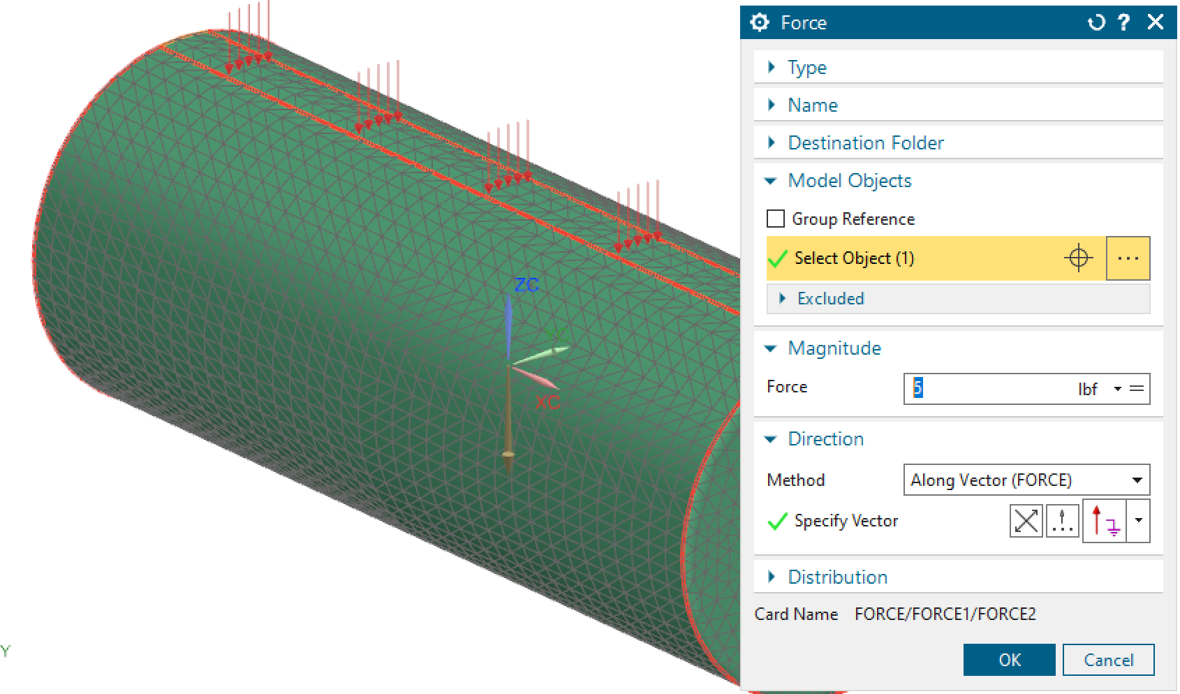

Figure 20. NX Model Showing Application of the 5lbf Downward Load

**Applying Constraints**

Intuitively, in order to counter the weight of the applied force and the cylinder’s natural weight, the supports on the ends of the cylinder became useful. In NX, a fixed constraint type was applied to the underside of the support cylindrical extensions on each side. This was done in order to mimic the cylinder sitting in its holder and having a free rotational range of motion, but not being able to translate. These constraints were applied in the same way for all sixteen cases. This is shown in Fig. 21.

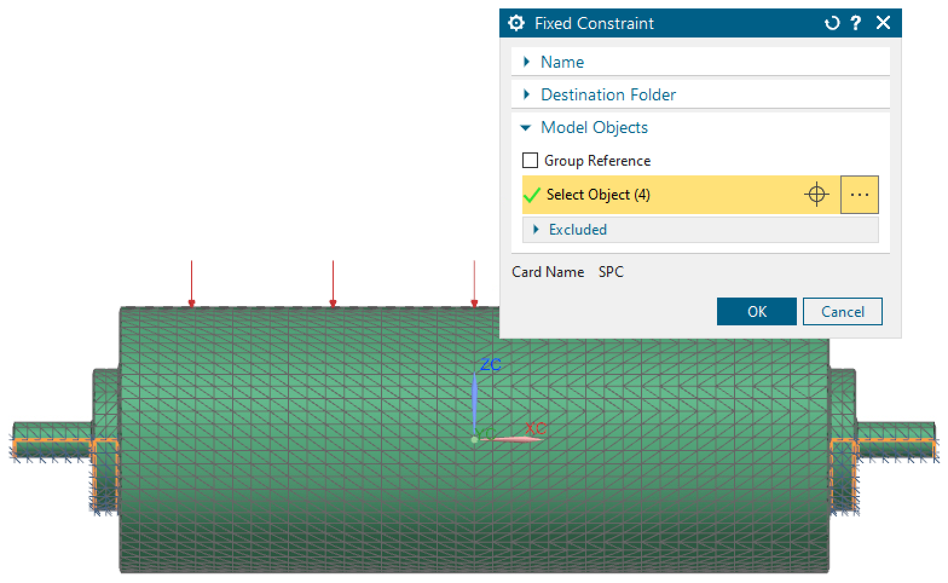

Figure 21. NX Model Showing Application of the Constraints

**Running Simulation**

After the constraints had been set, the next thing that was done was actually running the simulation but pressing the solve button. It took about 20 to 30 seconds for the solution to be completed. This is shown in Fig. 22.

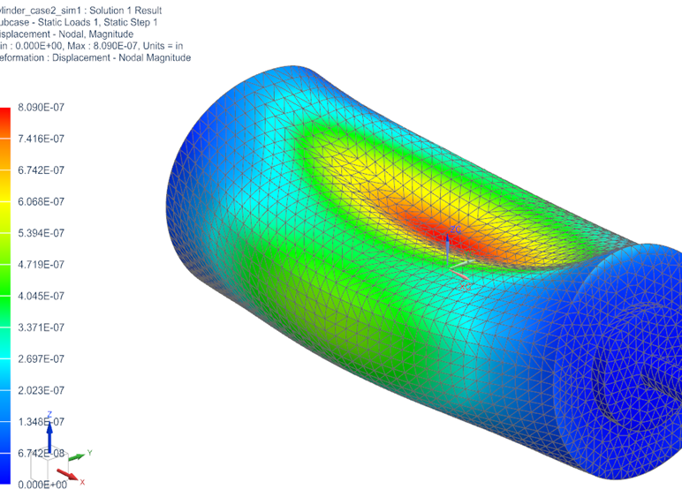

1. NX Model Showing Sample Results of the Deflection in Case II

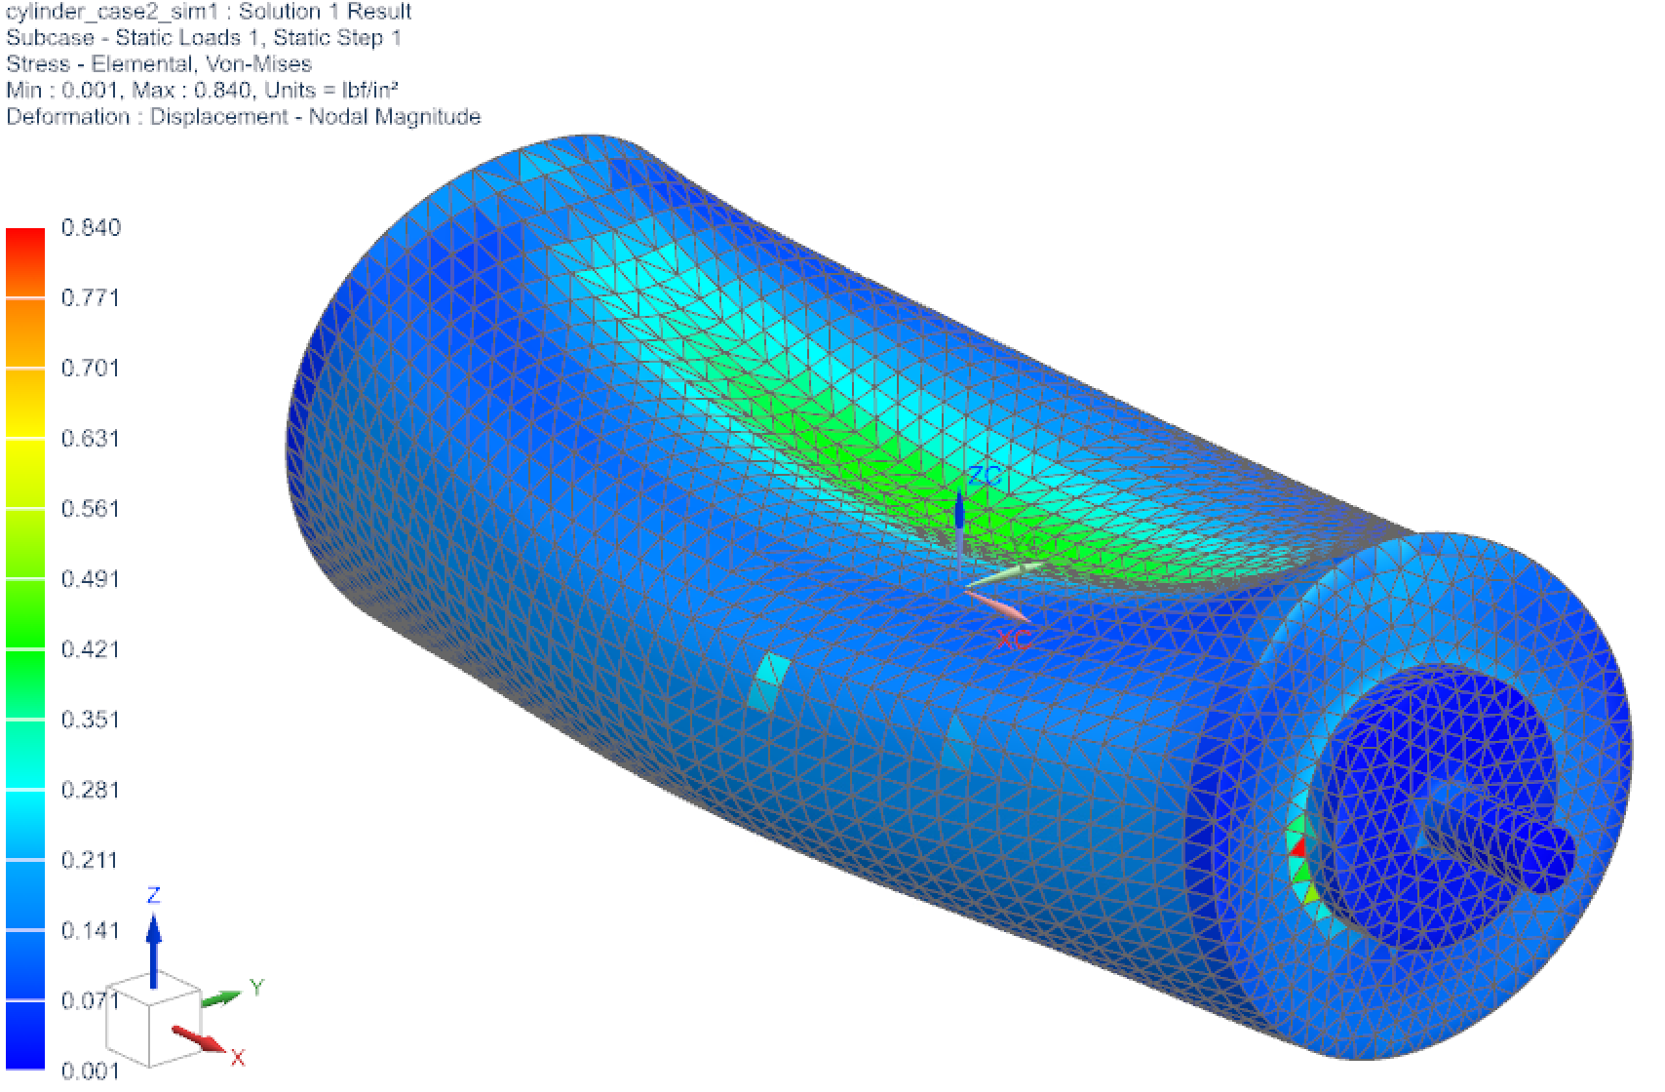

1. NX Model Showing Sample Results of the Von-Mises Stress in Case II

Figure 22. Figures Showing the Results for Case II, Deflection and Von-Mises Stress

**Summary of Results**

The displacement caused on the cylinder through the force acting on it could be determined from the results. For all sixteen cases, this unique value was recorded. Also, the moment of inertia along the appropriate axis was recorded. In the case of this experiment, the axis was chosen as being the X-axis, as the printing cylinder rotated in relation to this axis. Other useful information was recorded and tabulated such as the Von Mises stresses for the individual cases, as well as the total volume and weight for each case, as seen in Table 1. Finally, a graph of maximum deflection was plotted against the moment of inertia along the X-axis as seen in Figure 23. On the plot, cases that had a cylindrical cutout were given red data points while the non-cylindrical cases had blue data points.

Table 1. Results of the Experiment

|  |  |  |  |  |  |  |
| --- | --- | --- | --- | --- | --- | --- |
| Case no. | Min VM  [lbf/in2] | Max VM  [lbf/in2] | Moment of Inertia  [lbm-in2] | Max Deflection [in] | Volume  [in3] | Weight  [lbf] |
| I | .001 | .273 | 56583.7 | 7.04E-08 | 7247.5 | 2050.3 |
| II | .001 | .840 | 26440.5 | 8.09E-07 | 2203.6 | 623.4 |
| III | .001 | .365 | 50388.2 | 1.14E-07 | 5048.5 | 1438.4 |
| IV | .001 | .352 | 56063.0 | 7.68E-08 | 6658.4 | 1883.7 |
| V | .001 | .325 | 52246.8 | 8.75E-08 | 6607.6 | 1869.3 |
| VI | .001 | .408 | 47909.8 | 9.81E-08 | 5967.8 | 1688.3 |
| VII | .001 | .320 | 51400.5 | 9.05E-08 | 6433.2 | 1819.9 |
| VIII | .001 | .406 | 46217.3 | 1.05E-07 | 5618.9 | 1589.6 |
| IX | .001 | .798 | 48377.0 | 9.79E-08 | 5890.3 | 1666.4 |
| X | .001 | .839 | 49415.3 | 9.86E-08 | 6026.0 | 1704.8 |
| XI | .001 | 1.76 | 14972.6 | 5.56E-07 | 1243.9 | 351.9 |
| XII | .001 | .548 | 35274.9 | 3.40E-07 | 3026.9 | 866.5 |
| XIII | .002 | .476 | 41944.9 | 2.01E-07 | 3826.3 | 1082.4 |
| XIV | .002 | .527 | 46863.0 | 1.43E-07 | 4498.6 | 1272.6 |
| XV | .001 | .323 | 52829.0 | 9.73E-08 | 5588.7 | 1581.0 |
| XVI | .001 | .329 | 54449.8 | 8.73E-08 | 6016.0 | 1701.9 |



Figure 23. Scatter Plot Showing Maximum Deflection versus Moment of Inertia along the X-axis

**Discussion**

It is interesting that on first look at the graph, it is hard to miss the fact that the data points trend in an almost hyperbolic function, especially due to the fact that the designs were very randomly and haphazardly chosen. While most points roughly lie on the trend line, there is one particular data point that cannot go unnoticed. This point on the far left of the Fig. 26 graph corresponds to Case XI which has a maximum deflection of 5.56E-07 in and a moment of inertia of 14972.6 lbm-in2. This case has considerably less moment of inertia compared to the other fifteen cases, possibly because it is the lightest of the cases which makes it relatively much easier for the motor to rotate. On the other hand, it ranks high, comparatively, with its deflection value. This must be because it is the cylinder with the least volume. The cylinder is completely hollowed out with a wall thickness of 0.5 inches, and therefore does not have much internal support for an applied force.

Although not completely an outlier, as it lies on that trend line, the data point for Case II does lie quite far from the other data points on the trend line. Interestingly, this case corresponds to the case with the cylindrical cut-out with a wall thickness of 1 inch. In fact, if this trend is followed, it is seen where the next closest point to being an outlier corresponds to Case XII which again, is a cylindrical cut-out, and it has the next highest wall thickness. The trend suggests that, for cylindrical cases at least, as wall thickness decreases, there is a decreased moment of inertia but also an increased maximum deflection. For example, Case XVI which has a wall thickness of 4 inches has a maximum deflection of 8.73E-8 inches and a moment of inertia of 54449.8 lbm-in2 while Case I which has the lowest wall thickness of 0 inches, or in other words is solid-bodied, has a maximum deflection of 7.04E-08 inches and a moment of inertia of 56583.7 lbm-in2, while this is both good and bad, as a lower deflection means a lesser chance of the printing cylinder deforming but then the higher moment of inertia means that a larger torque will be needed. Perhaps in reference to wall thickness, the trend is held up until a specific wall thickness is reached and the system just doesn’t have enough support and so the surface deflects and caves inward.

As far as the non-cylindrical cut-outs go, which in the plot are labeled as being blue dots, it can be seen where they all have very similar maximum deflection values, however, vary quite a bit with the moments of inertia. These cases, five through to ten did not have their interior completely hollowed out and therefore, would be able to withstand considerably more force without caving in compared to their cylindrical cut-out counterparts. Meanwhile, the distribution of volume was consistently changing, accounting for the spread of moment of inertia values, the largest being 52246.8 lbm-in2 as in Case V and the smallest being 46217.3 lbm-in2 as in Case VIII. It is interesting also, how the cylindrical cases are a lot more widely dispersed compared to the non-cylindrical cases. This would imply that there is more area to varietize cases if a cylindrical design is employed.

As mentioned in the introduction, the ideal goal for this set of simulations and the experiment would be to achieve a case that produces a low deflection and a low moment of inertia. Again, this would mean the least bending of the cylinder and the least amount of energy required to make the cylinder spin. As seen from Fig. 1, there is no case that meets these requirements quite exactly. What happens is that a Pareto frontier is created, and points that are inside the frontier and closer to the origin are most desirable. Using this logic, it would suggest that Case XI is the best case given the options, since it lies within the Pareto frontier and theoretically, provides the best compromise between low deflection and low moment of inertia. Nonetheless, this is not fully conclusive as the choice of cylinder might have to consider other factors and ultimately arrive at some other trade-off.

**References**

Anstice, P. D., McEnaney, B., & Thornton, P. C. (1980). Wear of paper slitting blades: an examination of worn blades from paper mills. *Tribology International*. Vol. 13 (6) Pages 259-266, ISSN 0301-679X, https://doi.org/10.1016/0301-679X(80)90088-2.

Ariefka, R., & Pramudya, Y. (2019). The study of hollow cylinder on inclined plane to determine the cylinder moment of inertia. *Journal of Physics: Conference Series*, 1170, 012081. https://doi.org/10.1088/1742-6596/1170/1/012081

Dahlgren, H. (1972). Sheet feeder for printing presses. US Patent 3,853,315.

George, Q. C. & Richard, B. T. (1931). Web printing machine. US Patent 2,026,434.

Hoe, R. M. (1847). Improvements in rotary printing-presses. US Patent 5,199.

Hoe, R. M. (1871). Improvement in printing-presses. US Patent 113,769.

Kapolnek, P. G., Kapolnek, T. G., Kapolnek, D. J., Musgrave, M. K., Peters, D. L., & Troxel, K. M. (2011). Die holder assembly for rotary cutting system. US Patent 8,015,904.

Martin, M. D. (1968). Rotary die cutter. US Patent 3,380,328.

Sanchez, R., Horowitz, R., & Tomizuka, M. (2010). Full sheet control using steerable nips. In IEEE/ASME Transactions on Mechatronics, vol. 15, no. 1, pp. 48-58, doi: 10.1109/TMECH.2009.2015293.

Siemens Digital Industries Software. (2013). 3D Tetrahedral Mesh Dialog Box. Retrieved from NX 9 Help: http://www2.me.rochester.edu/courses/ME204/nx_help/index.html#uid:id627391

Stepanek, K. & Jurny, J. (1970) Apparatus for mounting rollers in offset presses. US Patent 3,709,048.

Vitikáč Batešková, E., & Panda, A. (2015). Elimination of pressure cylinder deflection on two cylinder bending machine. *Key Engineering Materials*, 669, 253–261. https://doi.org/10.4028/www.scientific.net/kem.669.253

**Biographies**

KHARI GRAY received his bachelor’s degree at Kettering University in 2021 and is currently pursuing his master’s degree in Mobility Systems at Kettering University.

DIANE L. PETERS is currently an Associate Professor of Mechanical Engineering at Kettering

University. She is a licensed professional engineer in Illinois and Michigan, a member of

ASME and SAE, a senior member of IEEE, and a Fellow of SWE. Dr. Peters may be reached

at [dpeters@kettering.edu](mailto:dpeters@kettering.edu).

YAOMIN DONG is currently a Professor of Mechanical Engineering at Kettering University.

He received his Ph.D. in Mechanical Engineering at the University of Kentucky in 1998. Dr.

Dong has extensive R&D experience in the automotive industry and holds multiple patents.

Dr. Dong’s areas of expertise include metal forming processes, design with composite

materials, computer graphics, computer-aided engineering and finite element analysis. Dr.

Dong may be reached at [ydong@kettering.edu](mailto:ydong@kettering.edu).