A study of elliptical delamination of a Sub laminate in a Quasi-Isotropic Composite Laminate: A fresh look at the solution method

Paul Akangah
North Carolina A&T State University
pmakanga@ncat.edu

MA Muktadir
North Carolina A&T State University
mmuktadir@aggies.ncat.edu

Abstract
Composite material (CM) has been used for manufacturing from small structures to complex structures such as aircraft, ships, and space vehicles to increase the structure's corrosion resistance and decrease the structure's weight compared to pure materials. During the production process or during assembly of the structures, delamination may occur between two layers in different shapes such as circular, spherical, eggs, or elliptical. This delamination is a common cause of failure in composite laminates of sandwich structures, which can become unstable under different loading conditions. Understanding this instability is essential in designing composite and sandwich structures. In this study, firstly, a literature review has been done to describe the effect of delamination in a composite structure. Secondly, the reasons and solutions have been depicted in the different studies. Finally, as stress and strain are critical factors in determining structural strength, strain and potential energy have been calculated from previous studies' equations using a novel algorithm (MATLAB) to analyze the effect of elliptical delamination in a quasi-isotropic composite material. The results also have been compared with the previously calculated results done by the finite element (FE) and Rayleigh-Ritz (R-R) method.
Introduction
Material composites are those composed of two or more materials bonded at their interfaces. The region is large enough to be considered continuous. Various materials like reinforced rubber and filled polymers, mortars and concrete, alloys, porous and cracked media, fiber composites, and polycrystalline aggregates (metals) fall into this category (Hashin, 1983). The history of composite material (CM) is not new; thousands of years ago, mankind used composite materials to reinforce sun-dried mud brick buildings; many of the earliest known civilizations in Mesopotamia at Sumer used straw to reinforce their constructions (Campbell, 2010). However, composite materials can now be produced that have advantages compared to those of competing materials thanks to advances in polymer chemistry and high-strength man-made fibers. These materials have many advantages, including enhanced strength and stiffness, longer fatigue life, corrosion resistance, and reduced assembly costs by using fewer details and fasteners. Fiber-reinforced composites, especially those with carbon fibers, have higher specific strengths and specific moduli than comparable metal alloys. As a result, vehicles and planes will have better performance, a greater payload, and a longer range (for vehicles) (Campbell, 2010). A buckled sublaminate is shown in Figure 1.

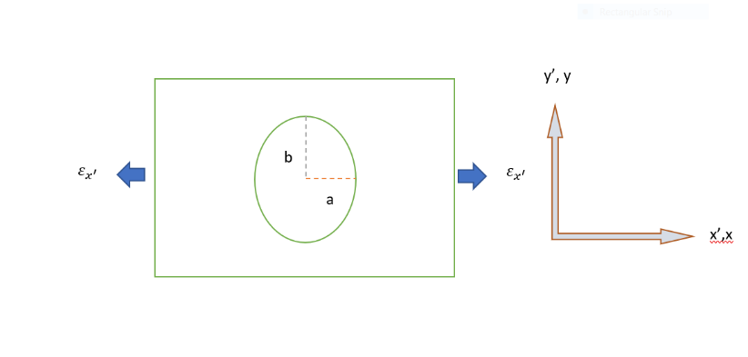
Figure 1. Plan view of a buckled sublaminate.
In addition to aircraft wings and fuselages, automobile body panels, and marine deck structures, carbon fiber reinforced polymer composites are used for a wide range of advanced structural applications. Compared to conventional aluminum alloys, composites have high specific strength and stiffness. This would result in a lighter structure and cost savings for the industry. It was reported that a weight reduction of 1 kg in an aircraft structure can save 2900 liters of fuel annually (Flower & Soutis, 2003). Especially for large engineering structures such as aircraft and ships, composite structures are increasingly being designed and analyzed. New Boeing and Airbus airliners use a greater proportion of composite materials, resulting in reduced structural weight and improved performance. In helicopters, composites are particularly useful for vibration/noise control. In the design of various types of aircraft, the increased use of composites has become an influential metric. It is possible to design more freely with anisotropic composites than with conventional materials. They have, however, encountered some difficulties in the structural analysis due to the increased number of design parameters. Composite laminated plates that are thin may buckle before reaching their strength limit as shell structures. Engineering structures can buckle in a variety of ways, such as global or local deflections, leading to the collapse of the structure. As a result, structural components must be designed to avoid buckling failures (Xu et al., 2013).
In laminated composites, however, delamination is generally recognized as one of the earliest failure modes. The reason for this is the relatively low interlaminar strength. A manufacturing defect or a low-velocity impact could cause delamination (Johar et al., 2017; Sellitto et al., 2019; Soutis, 2005; Turon et al., 2006). Delamination may be of different shapes, strips, rectangles, and ellipses. Figure 2 shows the 3D view of buckling in a sublaminate. In this study, only the ellipse shape has been considered for the new approach to the solution.
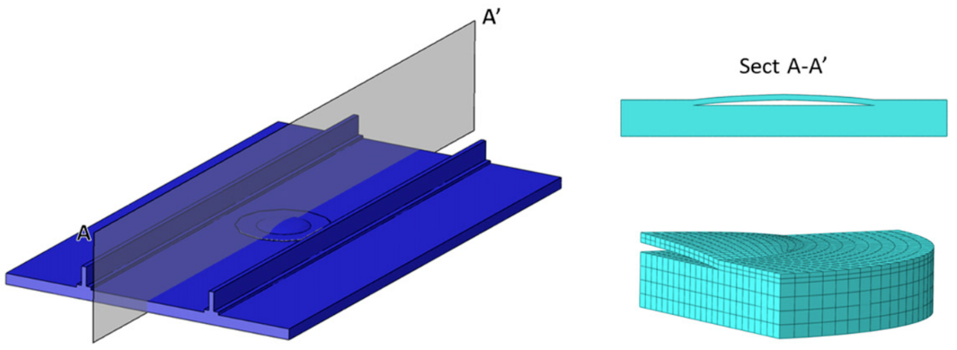

Figure 2. 3D view of buckled in a sublaminate (Sellitto et al., 2019).

Previous Studies

Delamination of composite panels is one of the most prevalent damage forms in composite structures, and it can significantly reduce their load-carrying capacity when caused by foreign objects or improper manufacturing. There is a risk of delamination cracks growing rapidly under compressive loads, unlike fatigue fractures in metallic materials, which occur under extensional loads (Xu et al., 2013). There is a tendency for composite structures to delaminate, reduce strength and stiffness, and limit the lifetime of the structure. The prevalence of composite material (CM) has caused designers to look for ways to delay or prevent delamination so that the structure's life and load-bearing capability will be increased (Garg, 1988). Among fiber-reinforced composites, delamination is a critical failure mode. Multiple delaminations can result from impact loading, as well as sublaminate buckling, significantly reducing residual compressive strength. Additionally, delamination plays an important role in in-plane failure by joining transverse matrix cracks. In quasi-isotropic laminates loaded in tension at an off-axis angle, a characteristic pattern of edge damage causes large reductions in in-plane strength. Delamination can still result in large strength reductions even when continuous fibers run in the loading direction, especially when plies of the same orientation are blocked together (Wisnom, 2012).

Moreover, the reduction of stiffness caused by delaminations reduces the natural frequency, which may cause resonance if the reduced frequency is close to the working frequency (Della & Shu, 2007). Another reason for delamination is the drilling process, which is a crucial final manufacturing step for composite laminates. Therefore, drilling-induced delamination is the most critical failure mode during drilling of composite laminates, resulting in heavy losses in the industry. According to reports, 60% of composite laminates are rejected during final assembly due to drilling-induced delamination damages (Al-Wandi et al., 2017; Fleischer et al., 2018; Geng et al., 2019; Stone & Krishnamurthy, 1996; Wang et al., 2018).

Detecting damage (delamination) and monitoring the health of composite structures are both critical needs and requirements (Zou et al., 2000). Vibration-based model-dependent methods are a promising option for composite structures incorporating piezoelectric sensors and actuators (Zou et al., 2000). In terms of the dynamic response parameters analyzed, these methods can be divided into modal analyses, frequency domain analyses, time domain analyses, and impedance domain analyses. The modal analysis provides information on global and local damage. These methods are relatively easy to use and cost-effective. However, these methods still face many challenges and obstacles before they can be implemented in practice (Zou et al., 2000). Under axial compression or lateral pressure, or even a combination of those two, an exact solution was derived for buckling of a circular cylindrical shell with many orthotropic layers and a large number of eccentric stiffeners. Due to the presence of eccentric stiffeners and different layers in the shell, the coupling between bending and extension can be studied using this theory (Jones, 1967).

In a study, it is shown that the governing equations of an anisotropic laminated plate are formulated using the basic assumptions of the thin-plate theory, including nonlinear terms. In addition, there is a closed-form solution for bending, flexural vibration, and buckling in laminates that exhibit unavoidable coupling between bending and stretching (Whitney & Leissa, 1969).
Using the Galerkin method, a research study examines the buckling problem of anisotropic composite plates. A plate is created from particulate or fiber-reinforced composite material, simply supported, and is subjected to a combination of uniform membrane loads. This study conducted to determine whether various coupling responses affect the buckling load of a plate and how the buckling interaction equation can be applied in different situations (Chamis, 1969). The Galerkin method is an effective algorithm for solving differential equations, and it can also be used to establish an eigenvalue problem for linear buckling analysis. Finite Strip Methods (FSM) are also being investigated as efficient methods to predict buckling loads. One of the most commonly used theories for the approximation of buckling analysis is the Rayleigh-Ritz method, based on energy variational theory. Choosing an appropriate displacement shape function is crucial for this method in order to properly describe the deflection of the plate in its buckled state and satisfy the boundary conditions at the same time (Xu et al., 2013). Using the Rayleigh-Ritz method, the following methodology sections describe the solution using MATLAB.
Methodology

A numerical calculation has been performed using the MATLAB algorithm, a novel solution approach.

Table 1. Nomenclature (Shivakumar & Whitcomb, 1985a).

Symbols | Represent | Unit
a | half-length of an elliptical sub laminate | m
b | the half-width of an elliptical sub laminate | m
w | transverse (in the z-direction) deflection | m
D's | flexural stiffness coefficients of the sublaminate | N/m
C₀ | generalized displacement | m
C_{1 ,} C₂ | generalized displacement | m⁻¹
x-y-z | sublaminate cartesian coordinate system
x', y',x' | base laminate cartesian coordinate system
A's | inplane stiffness coefficients of the sublaminate | N/m
$N_{x}$, $N_{y}$, $N_{xy}$ | sublaminate stress resultants | N/m
$$ε_{x, }ε_{y}, ε_{xy}$$ | sublaminate strain
$$θ$$ | angle between x and x' axes | degree
$$v$$ | poisson's ration of the laminate

The strain energy of the sublaminate can be written as follows (Ashton & Whitney, 1970; Shivakumar & Whitcomb, 1985b)

$U=\frac{1}{2}⋅\int_{-a}^{a}{\int_{-b}^{b}{\left\{D_{11}{\left(\frac{∂^{2}w}{∂x^{2}}\right)}^{2}+D_{22}{\left(\frac{∂^{2}w}{∂y^{2}}\right)}^{2}+2D_{12}\left(\frac{∂^{2}w}{∂x^{2}}\right)⋅\left(\frac{∂^{2}w}{∂y^{2}}\right)+4D_{66}{\left(\frac{∂^{2}w}{∂x⋅∂y}\right)}^{2}+4D_{16}\left(\frac{∂^{2}w}{∂x^{2}}\right)⋅\left(\frac{∂^{2}w}{∂x⋅∂y}\right)+D_{26}\left(\frac{∂^{2}w}{∂y^{2}}\right)⋅\left(\frac{∂^{2}w}{∂x⋅∂y}\right)\right\}}}dA$ (1)
where,
$w={\left[1-{\left(\frac{x}{a}\right)}^{2}-{\left(\frac{y}{b}\right)}^{2}\right]}^{2}⋅\left\{C_{o}+C_{1}{\left(\frac{x}{a}\right)}^{2}+C_{2}{\left(\frac{y}{b}\right)}^{2}\right\}$ (2)

for ellipse,$dA=π⋅dx⋅dy$, hence
$U=\frac{π}{2}⋅\int_{-a}^{a}{\int_{-b}^{b}{\left\{D_{11}{\left(\frac{∂^{2}w}{∂x^{2}}\right)}^{2}+D_{22}\left(\frac{∂^{2}w}{∂y^{2}}\right)+2D_{12}\left(\frac{∂^{2}w}{∂x^{2}}\right)⋅\left(\frac{∂^{2}w}{∂y^{2}}\right)+4D_{66}{\left(\frac{∂^{2}w}{∂x⋅∂y}\right)}^{2}\right\}}}dx⋅dy$ (3)

First, transfer the coordinate system into non-dimensionless coordinates by setting:
$$\frac{x}{a}=ς→x=aς \\ dx=adς \\ \frac{dw}{dx}=\frac{dw}{adς}$$$\frac{d^{2}w}{dx^{2}}=\frac{1}{a^{2}}⋅\left(\frac{d^{2}w}{dς^{2}}\right)$ (4)
Similarly, by setting$y=bη$,
$$\frac{dw}{dy}=\frac{dw}{bdη}$$
$\frac{d^{2}w}{dy^{2}}=\frac{1}{b^{2}}⋅\left(\frac{d^{2}w}{dη^{2}}\right)$ (5)
Now, equations (3) and (2) can be written as follows,

$U=\frac{π}{2}⋅\int_{-1}^{1}{\int_{-1}^{1}{\left\{\begin{aligned}D_{11}\frac{1}{a^{4}}{\left(\frac{∂^{2}w}{∂ς^{2}}\right)}^{2}+D_{22}\frac{1}{b^{4}}\left(\frac{∂^{2}w}{∂η^{2}}\right)+2D_{12}\frac{1}{a^{2}⋅b^{2}}\left(\frac{∂^{2}w}{∂ς^{2}}\right)⋅\left(\frac{∂^{2}w}{∂η^{2}}\right) \\ +4D_{66}\frac{1}{a^{2}⋅b^{2}}{\left(\frac{∂^{2}w}{∂ς⋅∂η}\right)}^{2}\end{aligned}\right\}}}a⋅b⋅dς⋅dη$ (6)

For a 1-term solution,

$w={\left[1-ς^{2}-η^{2}\right]}^{2}⋅\left\{C_{o}\right\}$ (7)

Using the MATLAB, from equations (6) and (7),

$U={\left[C\right]}^{T}\left[K\right]⋅\left[C\right]$ (8)
where,
${\left[C\right]}^{T}=\left\{C_{o}\right\}$ and K is the stiffness matrix
$\left[K\right]=D_{11}\left[K_{1}\right]+D_{22}\left[K_{2}\right]+2D_{12}\left[K_{12}\right]+4D_{66}\left[K_{66}\right]$ (9)
where,
$\left[K_{1}\right]$ = $\frac{bπ}{a^{3}} [10.67]$

$\left[K_{2}\right]$ = $\frac{aπ}{b^{3}} [10.67]$

$\left[K_{12}\right]$= $\frac{π}{ab} [41.24]$

$\left[K_{66}\right]$= $\frac{π}{ab} [56.89]$

The potential energy of applied loads can be written as follows (Ashton & Whitney, 1970; Shivakumar & Whitcomb, 1985).

$V=\frac{1}{2}\int_{-a}^{a}{\int_{-b}^{b}{\left[N_{x}{\left(w_{x}\right)}^{2}+N_{y}{\left(w_{y}\right)}^{2}+2N_{xy}\left(w_{x}⋅w_{y}\right)\right]}}⋅dx⋅dy$ (10)
where,
$N_{x}=A_{11}ε_{x}+A_{12}ε_{y}+A_{16}ε_{xy}$ (11)
$N_{y}=A_{12}ε_{x}+A_{22}ε_{y}+A_{26}ε_{xy}$ (12)
$N_{xy}=A_{16}ε_{x}+A_{26}ε_{y}+A_{66}ε_{xy}$ (13)
$ε_{x}=\left(\cos^{2}{θ}-v\sin^{2}{θ}\right)ε_{x^{'}}$ (14)
$ε_{y}=\left(\sin^{2}{θ}-v\cos^{2}{θ}\right)ε_{x^{'}}$ (15)
$ε_{xy}=-\left(1+v\right)\sin{2}θ⋅ε_{x^{'}}$ (16)
If we consider $θ=90 degree$
$ε_{x}=\left(-v\right)ε_{x^{'}}$ (17)
$ε_{y}=ε_{x^{'}}$ (18)
$ε_{xy}=0$ (19)

for ellipse,$dA=π⋅dx⋅dy$, and substituting, $x=aς$ and $y=bη$,
$\frac{dw}{dx}=\frac{dw}{adς}$ (20)
$\frac{dw}{dy}=\frac{dw}{bdη}$ (21)
Now, equation (10) can be written as,
$V=\frac{π}{2}⋅\int_{-1}^{1}{\int_{-1}^{1}{\left\{\begin{aligned}N_{x}\frac{1}{a^{2}}{\left(\frac{∂^{}w}{∂ς^{}}\right)}^{2}+N_{y}\frac{1}{b^{2}}{\left(\frac{∂^{}w}{∂η}\right)}^{2}+2N_{xy}\frac{1}{a⋅b}\left(\frac{∂^{}w}{∂ς^{}}\right)⋅\left(\frac{∂^{}w}{∂η^{}}\right) \\ \end{aligned}\right\}}}a⋅b⋅dς⋅dη$ (22)

For one term solution,
$w={\left[1-ς^{2}-η^{2}\right]}^{2}⋅\left\{C_{o}\right\}$ (23)

Using the MATLAB, from equations (19) and (20),

$V={\left[C\right]}^{T}\left[K_{V}\right]\left[C\right]ε_{x^{'}}$ (24)
where,
${\left[C\right]}^{T}=\left\{C_{o}\right\}$ and $K_{V}$ is the stiffness matrix.
$K_{V}=K_{V1}+ K_{V2}$ (25)

$\left[K_{V1} \right]=$ $\frac{bπ}{a} (A_{12}- A_{11}v)[1.73]$ (26)

$\left[K_{V2} \right]=$ $\frac{aπ}{b} (A_{22}- A_{12}v)[1.73]$ (27)

Now total potential energy is the sum of the U and V from equations (8) and (24)
$Π=U+V$ (28)

Using MATLAB and applying the Trefftz criterion (Lovell, 1975), after differentiating the potential energy with respect to $C_{o}$ (two times), that yields the following equation. Here, $ε_{x^{'}}$ is one term buckling strain,
$\left[K\right] + \left[K_{V}\right]ε_{x^{'}}$ = 0

$$ε_{x^{'}}=(-)\frac{\left[K\right]}{\left[K_{V}\right]}$$
$$ε_{x^{'}}=(-)\frac{D_{11}\left[K_{1}\right]+D_{22}\left[K_{2}\right]+2D_{12}\left[K_{12}\right]+4D_{66}\left[K_{66}\right]}{\left[K_{V1}\right]+[K_{V2} ] }$$

$$ε_{x^{'}}=(-)\frac{D_{11}\frac{bπ}{a^{3}} [10.67]+D_{22}\frac{aπ}{b^{3}} [10.67]+2D_{12}\frac{π}{ab} [41.24]+4D_{66}\frac{π}{ab} [56.89]}{ \frac{bπ}{a} (A_{12}- A_{11}v)[1.73]+\frac{aπ}{b} (A_{22}- A_{12}v)[1.73] }$$

$ε_{x^{'}}=\left(-\right)\frac{D_{11}\frac{b}{a^{3}} \left[10.67\right]+D_{22}\frac{a}{b^{3}} \left[10.67\right]+2D_{12}\frac{1}{ab} \left[41.24\right]+4D_{66}\frac{1}{ab} \left[56.89\right]}{ \frac{b}{a} \left(A_{12}- A_{11}v\right)\left[1.73\right]+\frac{a}{b} \left(A_{22}- A_{12}v\right)\left[1.73\right] }$(29)

Results and discussion
Equation (29) is the final equation for this study. Now consider the following data: a plot has been drawn using MATLAB to check the buckling strain by changing the width of b. Figure 3 shows the decreasing trend in strain while increasing the width of b.
b = 25 mm to 150 mm (range)
a = 25.4 mm
E = 68.95 GPa (Aluminium)
$$v= 0.31$$
$D_{11}=$ $\frac{h^{3}}{12}$ $\frac{E}{(1-v^{2})}$ ; h=0.51 mm
$$D_{22}= D_{11} \\ D_{12}= {vD}_{11}$$
$D_{66}=$ $\frac{(1-v)}{2}$ $D_{11}$
$A_{11}$ = $\frac{Eh}{(1-v^{2})}$
$A_{12}$ = $v$ $A_{11}$
$A_{22}$ = $A_{11}$
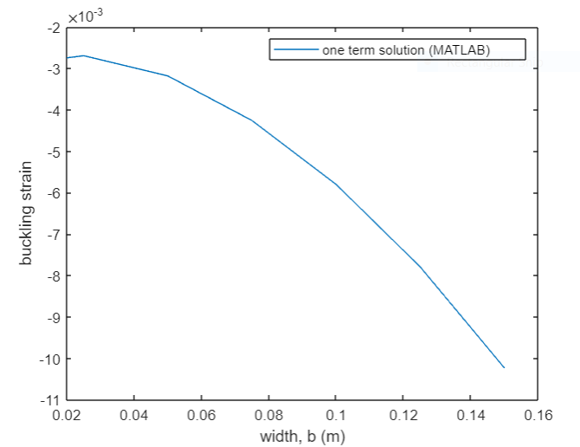
Figure 3. Buckling strain vs. width of aluminum sublaminate.
Conclusions and future work
This study mainly focuses on elliptical 90-degree sub-laminate buckling strain solutions for considering the one-term solution. Results might be different if three and six terms solutions have been considered. Results show different tread compared to the solution done by the same Rayleigh-Ritz Method. Finite element analysis can be used to numerically calculate different systems, for example, beam analysis (Hasan et al., 2022; Muktadir et al., 2021a; Muktadir et al., 2021b). In the future, the finite element approach will be considered to compare the results. As a novel algorithm has been developing, this study will be continued under the following conditions.
- FE analyses with ANSYS will be done to compare the results. In that analysis, the effect of material changes will also be analyzed.
- Two and three terms solutions will be completed and compared with the FE analyses.

Acknowledgments

This research was awarded funding by the US Department of Education (Award # P120A200056).

References

Al-Wandi, S., Ding, S., & Mo, J. (2017). An approach to evaluate delamination factor when drilling carbon fiber-reinforced plastics using different drill geometries: experiment and finite element study. The International Journal of Advanced Manufacturing Technology, 93(9), 4043-4061.
Ashton, J., & Whitney, J. M. (1970). Theory of laminated plates. Technomic.
Campbell, F. C. (2010). Structural composite materials. ASM international.
Chamis, C. C. (1969). Buckling of anisotropic composite plates. Journal of the Structural Division, 95(10), 2119-2140.
Della, C. N., & Shu, D. (2007). Vibration of delaminated composite laminates: A review.
Fleischer, J., Teti, R., Lanza, G., Mativenga, P., Moehring, H., & Caggiano, A. (2018). Composite materials parts manufacturing. CIRP Annals, 67(2), 603-626.
Flower, H. M., & Soutis, C. (2003). Materials for airframes. The Aeronautical Journal, 107(1072), 331-341.
Garg, A. C. (1988). Delamination—a damage mode in composite structures. Engineering Fracture Mechanics, 29(5), 557-584.
Geng, D., Liu, Y., Shao, Z., Lu, Z., Cai, J., Li, X., Jiang, X., & Zhang, D. (2019). Delamination formation, evaluation and suppression during drilling of composite laminates: A review. Composite Structures, 216, 168-186.
Hasan, M. N., Muktadir, M. A., & Alam, M. (2022). Comparative Study of Tapered Shape Bimorph Piezoelectric Energy Harvester via Finite Element Analysis. Forces in Mechanics, , 100131.
Hashin, Z. (1983). Analysis of composite materials—a survey.
Johar, M., Wong, K. J., & Tamin, M. N. (2017). Mixed-mode delamination failures of quasi-isotropic quasi-homogeneous carbon/epoxy laminated composite. Failure Analysis and Prevention.Rijeka: InTech, , 33-45.
Jones, R. M. (1967). No title. Buckling of Circular Cylindrical Shells with Multiple Orthotropic Layers and Eccentric Stiffeners,
Lovell, E. G. (1975). No title. Solid Mechanics: A Variational Approach: Clive L.Dym and Irving H.Shames.556 Pages, Diagrams, Illustrations, 6× 9 in.New York, McGraw-Hill, 1973.
Muktadir, M. A., Akangah, P., & Yi, S. (2021a). Comparative study of tangential stress in curved beams. Paper presented at the APS April Meeting Abstracts, , 2021 KP01. 038.
Muktadir, M. A., Akangah, P., & Yi, S. (2021b). Comparative Tangential Stress Analyses
of Curved Beams. International Journal of Modern Engineering, 22(1), 42-49. https://ijme.us/issues/fall2021/X__IJME%20fall%202021%20v22%20n1.pdf#page=44
Sellitto, A., Saputo, S., Damiano, M., Russo, A., & Riccio, A. (2019). Mixed-mode delamination growth prediction in stiffened CFRP panels by means of a novel fast procedure. Applied Sciences, 9(22), 4761.
Shivakumar, K. N., & Whitcomb, J. D. (1985a). Buckling of a sublaminate in a quasi-isotropic composite laminate. Journal of Composite Materials, 19(1), 2-18.
Shivakumar, K. N., & Whitcomb, J. D. (1985b). Buckling of a sublaminate in a quasi-isotropic composite laminate. Journal of Composite Materials, 19(1), 2-18.
Soutis, C. (2005). Fibre reinforced composites in aircraft construction. Progress in Aerospace Sciences, 41(2), 143-151.
Stone, R., & Krishnamurthy, K. (1996). A neural network thrust force controller to minimize delamination during drilling of graphite-epoxy laminates. International Journal of Machine Tools and Manufacture, 36(9), 985-1003.
Turon, A., Camanho, P. P., Costa, J., & Dávila, C. G. (2006). A damage model for the simulation of delamination in advanced composites under variable-mode loading. Mechanics of Materials, 38(11), 1072-1089.
Wang, G., Melly, S. K., & Li, N. (2018). Using dampers to mitigate thrust forces during carbon-fibre reinforced polymer drilling: experimental and finite element evaluation. Journal of Reinforced Plastics and Composites, 37(1), 60-74.
Whitney, J. M., & Leissa, A. W. (1969). Analysis of heterogeneous anisotropic plates.
Wisnom, M. R. (2012). The role of delamination in failure of.
Xu, J., Zhao, Q., & Qiao, P. (2013). A critical review on buckling and post-buckling analysis of composite structures. Frontiers in Aerospace Engineering, 2(3), 157.
Zou, Y., Tong, L., & Steven, G. P. (2000). Vibration-based model-dependent damage (delamination) identification and health monitoring for composite structures—a review. Journal of Sound and Vibration, 230(2), 357-378.

Biographies

PAUL AKANGAH is currently a Teaching Associate Professor of Mechanical Engineering at the North Carolina A&T State University. He earned his B.S. degree from Kwame Nkrumah University of Science &amp; Technology, Kumasi, Ghana, MS (Energy Engineering, 2005) from The Royal Institute of Technology (KTH), Stockholm, Sweden, and Ph.D. (Mechanical Engineering, 2011) from the North
Carolina A&T State University, Greensboro, NC. Dr. Akangah interests are in engineering pedagogy, metallic forms for structural and thermal applications, and advanced composites materials. Dr. Akangah may be reached at pmakanga@ncat.edu.

MA MUKTADIR is a Ph.D. Student of Mechanical Engineering at North Carolina A&T State University. His research interests include Robotics, Finite Element Analysis, Mechanical Design, Machine Learning, Image Processing, and Additive Manufacturing. Mr. Muktadir may be reached at mmuktadir@aggies.ncat.edu

