# 012-x-22
Multi-Semester Project-Based Building Design Activities by Using and Integrating Various Simulation and Animation Software

Negar Heidari Matin
University of Oklahoma
negar.matin@ou.edu

Ali Eydgahi
Eastern Michigan University
aeydgahi@emich.edu

Abstract

Cumulative learning is the cognitive process by which students can accumulate knowledge and abilities that serve as building blocks for their subsequent cognitive development. The training of students as innovative thinkers in dealing with today’s complexity of global challenges requires an integrated approach to educating students that integrates information, data, techniques, tools, perspectives, concepts, and theories from two or more courses and answers questions beyond the scope of a single course learning.
This paper proposes activities that can be used by both undergraduate and graduate students in architecture and interior design programs in multi-semester continuous courses. The proposed hands-on activities utilize a number of software for 2D-CAD drafting, 3D-CAD modeling, building information modeling (BIM), rendering and representation, building performance evaluation and visualization. Through these hands-on activities, students learn how to use various software including AutoCAD, Adobe Photoshop, SketchUp, Revit, Lumion, and Cove.tool. The effectiveness of the proposed activities was measured with open-ended interview questions that were distributed to the students at the end of semesters.

Introduction

Continuously accepting new information and unifying it with the existing knowledge is considered an essential feature of human learning (Thorisson, Bieger, Li & Wang, 2019). Students can use cumulative learning, as the cognitive process, for accumulating knowledge, skills, and abilities. These acquired skills and abilities will serve as building blocks for students’ subsequent cognitive development. Further, it helps students meet the fast-changing demands of working in the complex contemporary world. Building cognitive ability is essential; therefore, educators require to consider cumulative learning during course development activities to prepare students for lifelong learning.

On the other hand, in authentic learning, educators use problem-based, case-based, and project-based pedagogies, offering students real-life examples of the working practices (Bennett, Harper, and Hedberg, 2002). Engaging students in authentic learning activities adds a new layer to students’ prior experience (Herrington et al., 2004) that are considered to enable cumulative learning (Maton, 2009). Due to the authentic nature of the studio courses as the core of architecture/interior design education, cumulative learning could be considered as one of the core concepts behind the learning process in architecture studios.
Two types of knowledge structures are hierarchical and horizontal. A hierarchical knowledge structure is a hierarchically organized, coherent, explicit, and systematically principled structure. While hierarchical knowledge structures are developed through new knowledge integration and incorporation of previous knowledge, the horizontal knowledge structures focus on the accumulation and segmentation of knowledge (Maton, 2009; Maton, 2010).

In this study, the integration of accumulation and segmentation knowledge structure are used to design a set of cumulative learning knowledge that expose students to different types of activities based on both hierarchical and horizontal knowledge structures to promote cumulative learning in students. The goals of the activities are:
- To introduce various software that are used in building simulation and design,
- To enable students to use and work with the same tools in various related courses,
- To enable students to explore all aspects and features of the tools they use,
- To enable students to characterize different views and properties of a building,
- To improve students’ skills in evaluating the energy and lighting performance of a building,
- To engage students in analyzing the data obtained from the performance evaluation of a facade system with different characteristics and materials,
- To improve and advance student’s knowledge, understanding, and skills in using the same project in different courses.

A set of open-ended questions was created and given to the students at the end of semesters to determine the effectiveness of the proposed activities.

The Proposed Hand-on Activities

The proposed activities provide students with hand-on experience of 2D drafting, 3D modelling, presenting and evaluating design performances. Through these activities, students are trained to utilize various high-demand software including AutoCAD, Adobe Photoshop, SketchUp, Revit, Lumion, and Cove.tool. Figure 1 demonstrates the hierarchical relationship of the proposed multi-semester project and its corresponding activities for three courses.

The first three activities concentrate on the design and development of a sustainable residential building. The next six activities use the output of previous activities for 2D drafting, 3D modeling and advanced presentation of design including photorealistic renders, animation, and VR 360 panorama views. The last two activities use the architectural drawings options of the previous activities for determining building information modeling (BIM) and building performance evaluation. As shown in Figure 1, after obtaining the result of building performance evaluation, there might be a need for an iterative process to modify and revise the sustainable residential building to improve the performance of the designed building.

Description and Implementation of the Proposed Activities

The proposed hands-on activities were implemented in three courses of Communication Studio II, Communication Studio III, and Design Studio II at the Gibbs College of Architecture at the University of Oklahoma. The courses were offered in consecutive academic semesters and involved both undergraduate and graduate students in the process of design, presentation/visualization, and evaluation of a sustainable residential building.

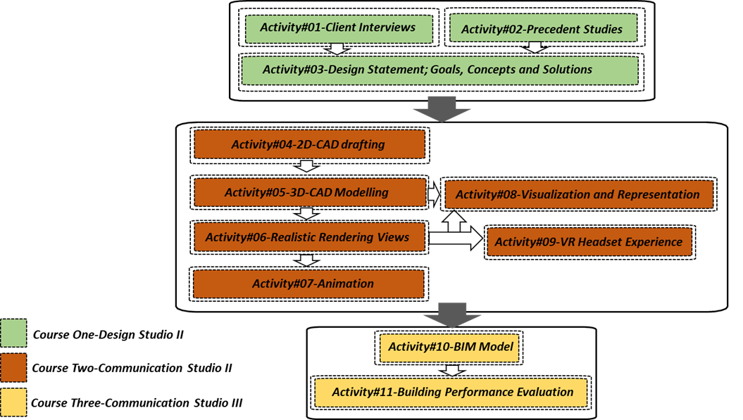

Figure 1. Relationship of the proposed activities for a multi-semester project in three courses

The first three activities were used in Design Studio II course. In this course, students are engaged in a design project focusing on a sustainable residential building. The course was developed with an emphasis on the issue of form, function, orientation, space, light, energy, and materials to meet assigned sustainability criteria.

Activities #4 to #9 were utilized in Communication Studio II course. This course introduces students to computer applications in drafting, modeling, rendering, and presenting. The purpose of the course is to enable students to develop skills for utilizing the computer as an efficient and innovative 2D and 3D tools. This course is structured to introduce software applications such as AutoCAD Architecture, SketchUp, Lumion, and Photoshop. Upon successful completion of this course, students will be able to read and interpret various types of architectural construction drawings. Also, students will learn how to produce computer-generated 2D architectural construction drawings and 3D models. Using advanced rendering tools, students will be able to develop photorealistic presentation renderings and animations as well as experience virtual reality technology.

The last two activities were implemented in Communication Studio III course. This course introduces students to Autodesk Revit as the foundation of a larger process called building information modeling. By completing this course, students can gain a robust understanding of Revit, its features, and capabilities from the fundamentals to the most sophisticated and complex topics. Also, students are introduced to the concepts and terminologies used in BIM and gain experience in creating an intelligent 3D model and extracting 2D drawings from it. In addition, since data can be generated, managed, stored, and exchanged in Revit, students can be involved in building performance modeling using Revit apps such as Cove.Tool. This course also trains students to utilize Cove. Tool for energy and light analyses.
For the multi-semester course project, students were supposed to design a one-story single-family house with 2,000-square-foot living space, three bedrooms, and two bathrooms in a newly developed neighborhood located in Ann Arbor, MI. It was assumed that the family living in the house is interested in a sustainable lifestyle and promoting sustainability by purchasing energy-efficient appliances, growing their own garden, recycling household trash, and caring about wildlife and native species. Then, students were asked to develop and present a complete design proposal for the project by using a formal client interview, personality observation, and conceptualization. The design proposal should have included the construction drawings, interior finishes, furniture/finishes, and a final proposal presentation.

The followings provide the details of each activity for the multi-semester course project:

Activity #01: Client Interview

In this set of activities, students were asked to identify a client who represents the building resident with specific characteristics such as having a sustainable lifestyle and caring about personal and societal environmental impacts. Then, students were asked to create a list of questions for an interview that will gather the necessary information for them as a designer to develop a design concept for the entire project. In addition, students needed to specify how these questions can help them in specific design concepts, design strategies, and programming. Students were engaged in recording information during interviews using sketches or diagrams as well as words.

Activity #02: Precedent Studies

Considering the essential role of precedent studies in a design process, students were asked to select at least three related residential buildings located in cold and humid climate regions constructed based on sustainable strategies. Students were supposed to analyze and interpret multiple aspects of precedent buildings using photographs, diagrams, doodles, and drawings. The design aspects that they needed to consider were building orientation and form, interior spaces sequences and arrangements, natural light penetration, natural air ventilation, interior circulation and exterior egress, number, shape, and direction of windows, finishing materials and furniture, and energy generation.

Activity #03: Design Statement, Goals, Concepts, and Solutions

After interpreting the information gathered via the client interview, students were asked to consider the client’s needs, preferences, and abilities for defining design statements. In addition, students were involved exploring active or passive sustainable strategies in order to incorporate them into the design of the residential building. The utilized sustainable strategies have consisted of passive heating, cooling, and ventilation strategies along with design strategies such as optimum form, location, orientation, shading, and material selection. As a result, the final design statement consisted of design goals and design concepts. The solutions contributed to both client’s needs and students’ acquired knowledge in sustainable residential design.

Activity #04: 2D CAD Drafting

In this set of activities, students are using AutoCAD software for creating 2D computer drafting. Considering drawing and modifying tools, annotations and dimension tools, layer management technique, sheets setting, and plotting setup. Students generated orthographic views of the sustainable residential buildings developing in graduate design studio I such as floor plans, interior and exterior elevations, sections, and details. Figure 2 shows a 2D drafting submitted by students as the result of this activity.

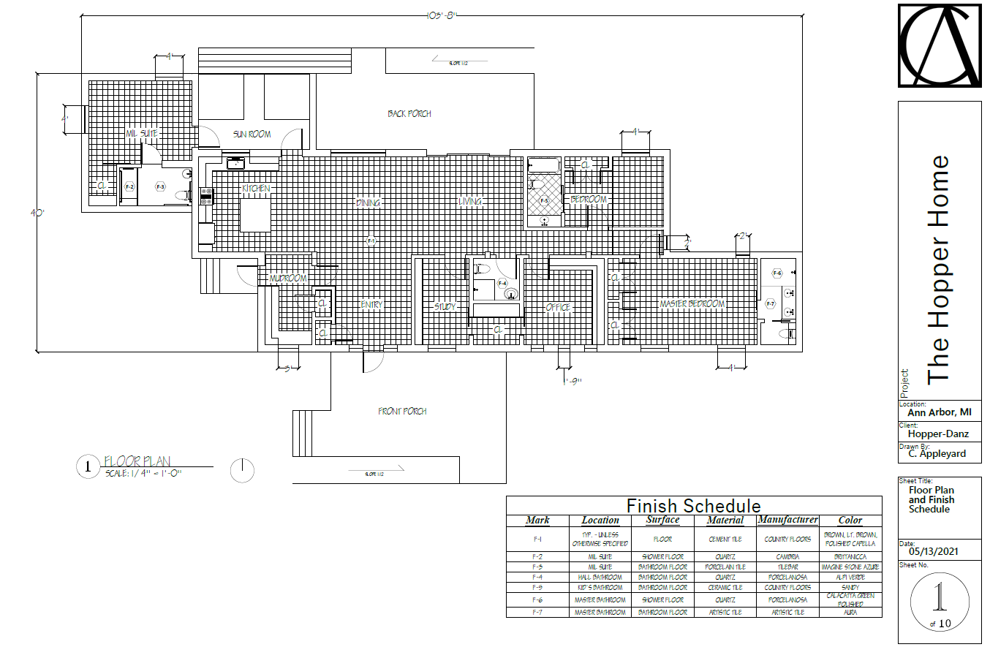

Figure 2. Example of 2D drafting submitted by students for activity #04

Activity #05: 3D-CAD Modeling

In this set of activities, students were introduced to the application of SketchUp software in 3D modeling. Students utilized 2D and 3D modeling tools, solid tools, sandbox, styles, material, texture, effects, and warehouse to simulate a 3D model of sustainable residential buildings. Since SketchUp software is compatible with AutoCAD, by completing these activities students learned how to transform 2D orthographic drawings to SketchUp software drawing, as the foundation of a 3D model, to make the 3D model of the sustainable residential building. Figure 3 shows the 3D model of the building created by students using SketchUp.

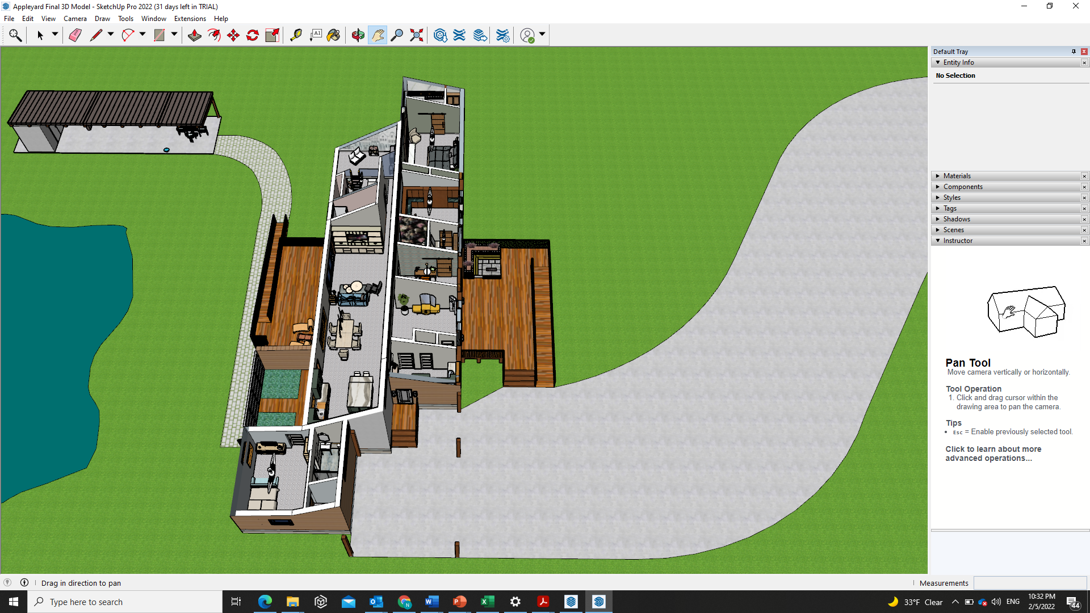

Figure 3. Example of 3D-modeling submitted by students for activity #05
Activity #06: Realistic Rendering Views

To bring students’ design to life, a new set of activities were developed to teach students how to use Lumion software. Lumion is architectural visualization and rendering software that enables students to create a world of context, capture the details of life, and convey realistic emotions and atmospheres; as a result, students can render realistic scenes without any specific rendering experiences or backgrounds. Due to the compatibility of Lumion software with almost every 3D and CAD program, students learn to import the 3D model created in SketchUp into Lumion. In addition, in case of having computers with high computation power and advanced graphic card, students are encouraged to use Lumion’s real-time rendering feature called LiveSync to create a live connection between Lumion and SketchUp for their rendering activities and further iterative modification actions. After learning about scenes navigation, landscape elements (terrain tools, trees, water, …..), environmental features (wind, sun, rain/snow, sky, fire….), lighting fixtures, 3D humans/animals, materials and furniture, student could generate different set of realistic rendering views. Figure 4 illustrates the rendering views generated by students in these activities.

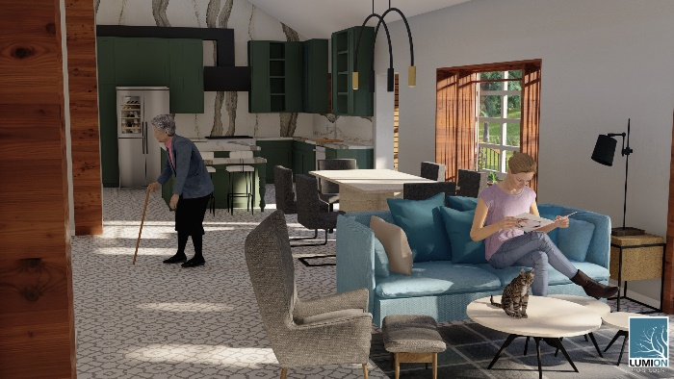
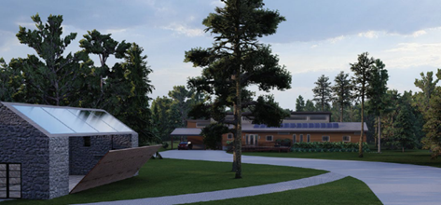

Figure 4. Examples of 3D modeling submitted by students for activity #06

Activity #07: Animation
In this set of activities, students are trained to create professional animations using Lumion software. After learning about planning a storyboard, setting a camera locations, movements, speeds, generating 3D humans/animals’ motions, adjusting animation effects, and adding sound effects, students were asked to generate an animation for bring life to the 3D model of sustainable residential building.

Activity #08: Visualization and Representation
This set of activities was aimed to make students familiar with the application of Adobe Photoshop software in architectural representation, visualization and postproduction. Students were trained to manipulate and elaborate the 2D images generated via AutoCAD and Lumion in order to deliver top-notch renderings and high-quality digital representations of their design. The designed activities engaged students in applying different visual properties such as color values, sharpness, saturation/hue, effects, and layers composition and adjustments. Figure 5 shows how the students utilize Adobe photoshop for creating the high-quality digital representation of the sustainable residential building.

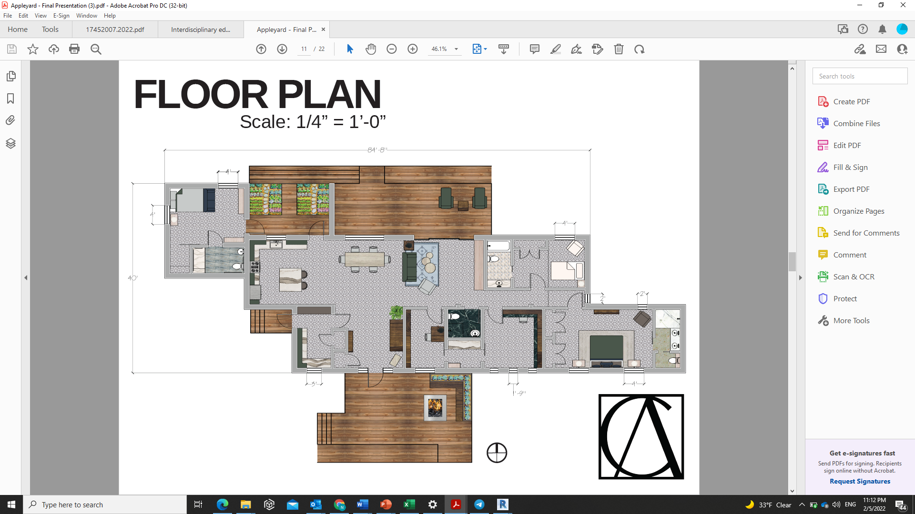

Figure 5. Example of digital representation submitted by students for activity #08

Activity #09: VR Headset Experience
In this activity, students learn how to generate 360 panorama views using Lumion and present them in a virtual reality headset as it is shown in Figure 6. Thus, students were provided Oqolus Quest 2 headsets to evaluate the panorama views that they had created by Lumion. Then, students are encouraged to re-evaluate their design by changing their design elements such as colors and hues of interior spaces, material and texture, lights and shadows, furniture and accessories, size, and dimensions during their virtual tour of the simulated building. This provides an opportunity for students to be involved in the iterative design process by modifying, revising, or changing their design projects. In addition, by using multiple headsets, the virtual tour experience with peers and instructor can be used for having critique sessions, class presentations, collaborative team works, and communication with peers.

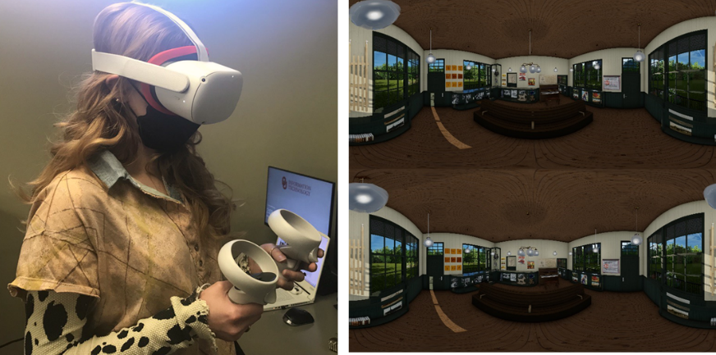
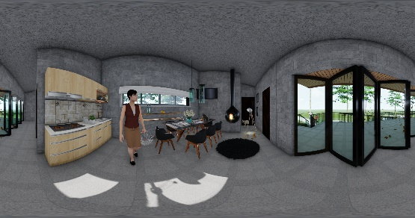
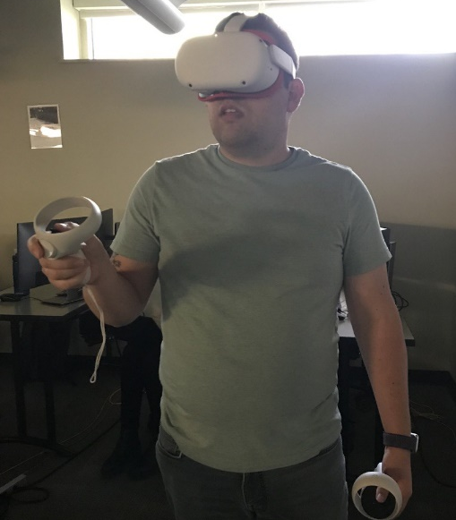

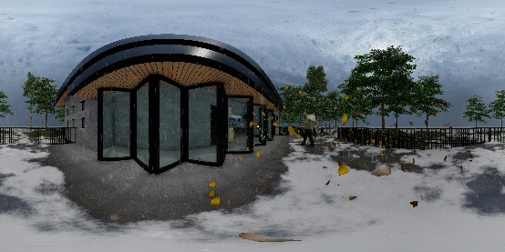

Figure 6. Examples of 3D modeling submitted by students for activity #09

Activity #10: BIM
During this set of activities, students are introduced to application of building information modeling using Autodesk Revit. After learning about placing and adjusting building elements such as walls, floors, ceilings, roofs, doors, and windows, students were asked to simultaneously generate floor plans, elevations, sections, schedules, 2D and 3D views for the sustainable residential building as it is shown in Figure 7. With the emphasis on the application data/information in Revit, students were able to run cost estimation analysis for the building considering quantities of building materials.

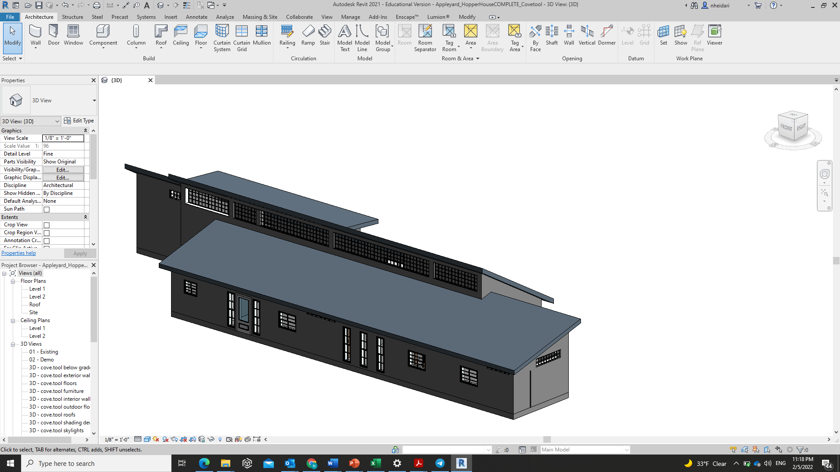

Figure 7. Example of BIM model submitted by students for activity #10

Activity #11: Performance Evaluation
In this set of activities, student use the building materials information to analysis building performance. Students were asked to utilize cove.tool, which is a compatible app with Autodesk Revit for light and energy analysis of the sustainable residential building. After learning about exporting the building 3D model created with Revit into the cove.tool app, students were encouraged to explore different tools related to thermal comfort analysis, energy analysis, CO2 emission elevation, and light analysis. Then, they were asked to choose a variable related to building elements or materials. By manipulating the variable for multiple times, students could record the changes occurred in energy and light performance. Then, students were required to deliver a report about the selected variable, the manipulation process used for the experiment, utilized metrics, and the results obtained. Figure 8 presents the green residential building in the cove.tool.

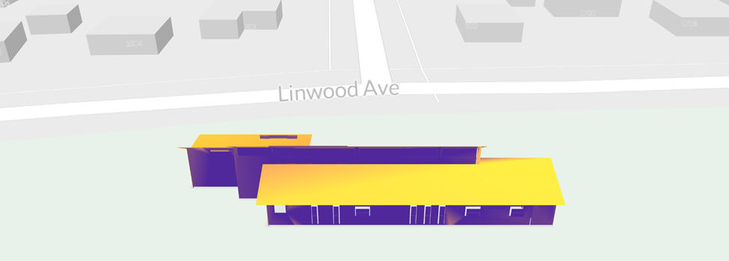

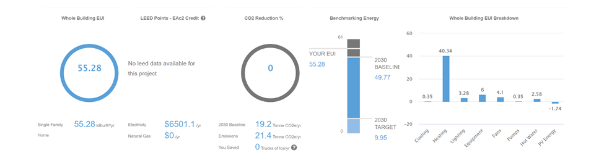

Figure 8. Example of performance evaluation submitted by students for activity #11

Finally, an open-ended interview questionnaire was developed to determine the role of proposed hands-on activities in constructing the new knowledge and connecting them to the students’ previous experiences, skills, and abilities. Based on the feedback received from students, the activities assisted students to develop self-confidence, occupational identity, problem-solving skills, and intellectual cognitive that will be very useful for their future careers.

Conclusion

This paper presented a set of hands-on activities, which are suitable for both graduate and undergraduate students in the architecture and interior design fields. The proposed hands-on activities were tested in three paralleled continuous courses including communication studio II, communication studio III and graduate studio II at the Interior Design Division at the Gibbs College of Architecture at the University of Oklahoma.

The collected student feedback showed that students were more engaged in the activities that are using the software and are less hesitant to initiate a project using various software. This indicates that students became more confident and ready to deliver required outcomes. These activities also assisted students to form a unified knowledge by using different pieces of skills and integrating them into one project and identifying their weaknesses, abilities, and area of interest. Furthermore, students indicated that after having these activities they were able to better understand steps of a project, which means that they pay more attention to details and to the overall picture of the project.

It was also noticed that the level of students’ confidence about their knowledge has improved and they explored more possible options without having any direct help from the instructor. Some students mentioned that the acquired skills in using multiple software provided internship opportunities for them and help them to make a better decision about their future career path.

References

Booth, C., & Kerns, K. A. (2009). Child-parent attachment relationships, peer relationships, and peer-group functioning. In K. H. Rubin, W. M. Bukowski, & B. Laursen (Eds.), Handbook of peer interactions, relationships, and groups (pp. 490-507). New York, NY: Guilford Press.

Thorisson, K., Bieger, J., Li, X., & Wang, P. (2019). Cumulative Learning. Artificial General Intelligence. DOI: 10.1007/978-3-030-27005-6_20.

Fei, G., Wang, S., Liu, B. (2016). Learning cumulatively to become more knowledgeable. Proceedings of the 22nd ACM SIGKDD International Conference on Knowledge Discovery and Data Mining. pp. 1565–1574.

Aljundi, R., Kelchtermans, K., Tuytelaars, T. (2018). Task-free continual learning. Computer Vision and Pattern Recognition Conference. DOI: 10.48550/arXiv.1812.03596.

Bieger, J.E., Thorisson, K.R. (2018). Task analysis for teaching cumulative learners. In: Proc. Artificial General Intelligence. pp. 21–31. Springer International Publishing.

Bennet, S., Harper, B., & Hedberg, J. (2002). Designing real life cases to support authentic design activities. Australasian Journal of Educational Technology, 18(1). https://doi.org/10.14742/ajet.1743

Herrington, J., Reeves, T. Oliver, R., & Woo, Y. (2004). Designing authentic activitiesin web-based courses. Journal of Computing and Higher Education, 16(1), 3-29.
Maton, K. (2009) Cumulative and segmented learning: Exploring the role of curriculum structures in knowledge-building, British Journal of Sociology of Education 30(1): 43–57.

Maton, K. (2010) Invisible tribunals: Progress and knowledge-building in the humanities, in Singh, P., Sadovnik, A. & Semel, S. (eds) Toolkits, Translation Devices and Conceptual Accounts: Essays on Basil Bernstein's sociology of knowledge (pp. 177–196). New York: Peter Lang.

Negar Heidari Matin & Ali Eydgahi (2019): Technologies used in responsive facade systems: a comparative study, Intelligent Buildings International, DOI: 10.1080/17508975.2019.1577213

Negar Heidari Matin & Ali Eydgahi (2019): Factors affecting the design and development of responsive facades: a historical evolution, Intelligent Buildings International, DOI: 10.1080/17508975.2018.1562414
Heidari Matin, N., & Eydgahi, A. (2019). Learning Modules for Geometric Pattern Identification and Mathematical Modeling of Façade Systems. 2019 ASEE Annual Conference & Exposition. Tampa. FL., USA.

Heidari Matin, N., Eydgahi, A., Shyu, S., & Matin, P. (2018). Evaluating Visual Comfort Metrics of Responsive Façade Systems as Educational Activities. 2018 ASEE Annual Conference & Exposition, Salt Lake City, UT, USA.

Heidari Matin, N., Eydgahi, A., Zareanshahraki, F. (2021). Interdisciplinary Educational Modules: Using Smart Colored Windows in Responsive Façade Systems, Technology Interface International Journal. 21 (2),11-20.

Biographies

NEGAR HEIDARI MATIN is an Assistant Professor of Interior Design at the Gibbs College of Architecture at the University of Oklahoma. She holds Ph.D. in technology from the College of Engineering and Technology at Eastern Michigan University, where she was selected as a doctoral fellow for five continuous years working on high-performance building systems and their impact on occupant comfort and building energy consumption. Her research interests include interdisciplinary areas between interior architecture, building science, and advanced technology. She is the recipient of various awards such as EMU Outstanding Ph.D. Student of the Year, GRC Outstanding Poster Presentation, and Jones Beckwith Advanced Graduate Studies scholarship. In 2021 Dr. Matin established the OU High-Performance Interior Architecture Laboratory (HPIA Lab) to constantly design high-performance building interiors to provide comfort and well-being for occupants with ultimate energy efficiency. Dr. Matin may be reached at negar.matin@ou.edu

ALI EYDGAHI started his career in higher education as a faculty member at the Rensselaer Polytechnic Institute in 1985. Subsequently, he has worked at the State University of New York, the University of Maryland Eastern Shore, and Eastern Michigan University. Between 2006 and 2010, he was Chair of the Department of Engineering and Aviation Sciences at the University of Maryland Eastern Shore. In 2010, he joined Eastern Michigan University as Associate Dean for the College of Technology, and is currently a professor in the School of Engineering. Dr. Eydgahi has served as a member of advisory and editorial boards for many international journals in engineering and technology, as a member of the review panel for NASA and the Department of Education, as a regional and chapter chairman of IEEE, SME, ASEE, and as a member of scientific and international committees for many international conferences. Dr. Eydgahi may be reached at aeydgahi@emich.edu.

