008-x-22

Design of a Vertical Stirred Ball Mill to Produce Flaky Metal Powder

A.H.M.E. Rahman
School of Science, Engineering and Technology, Pennsylvania State University – Harrisburg, Middletown, PA 17057
aer15@psu.edu
Issam-Abu Mahfouz
School of Science, Engineering and Technology, Pennsylvania State University – Harrisburg, Middletown, PA 17057
iaa2@psu.edu
Anil Attaluri
School of Science, Engineering and Technology, Pennsylvania State University – Harrisburg, Middletown, PA 17057
aua473@psu.edu

Abstract
Flaky metal powder provides the maximum contact areas with carbon nano tube (CNT) reinforcements in CNT reinforced metal matrix composites. The vertical stirred ball (VTB) mill turned to be effective to produce flaky metal powder. This project designed and tested a vertical stirred portable ball mill add-on to computer numerical control (CNC) mill to produce flaky powder from spherical powder. The VTB mill consists of a jar and stirring method made using primarily 304 stainless steel. The mill has a capacity of total volume of around one liter and tested using 304 stainless-steel grinding balls in a liquid media and aluminum powder. The stirring speed can be controlled using CNC mill and is limited by the CNC mill’s capacity. Scanning electron microscope analysis revealed the vertical stirred ball mill provided the necessary attrition action to produce flaky powder. The starting spherical powder average diameter was15 µm. After 4 hours milling the particles transformed into a flaky shape with average thickness of 1 µm.

Introduction
Comminution is the oldest technology to reduce the particle size. The energy efficiency of comminution is very low, and it requires more energy as the final particle size decreases. Grinding can reduce particle size, grow particle size, create mechanical alloying. It disintegrates, deforms or cold welds the impacted particles. Grinding can produce polymorphic transformation as well [3]. During the grinding process the disruption of a particle happens through several phases – localized concentrations of strains, formation of embryonic microcracks, formation of critical cracks by joining embryonic micro cracks, and finally, disruption into several small particles. During grinding process, the particles get trapped in between two colliding media (ball). This process is typically observed in tumbling, vibratory and attrition ball milling for both dry and wet milling condition.
Carbon Nanotube (CNT) are getting attraction as a reinforcement in aluminum matrix composites (AMCs) because of their superior mechanical properties [1]. However, there are some bottlenecks. One of the issues is the adhesion of CNTs to spherical aluminum (Al) powders. Adhesion is limited by spherical Al powders and created a curvature effect due to the morphological mismatch between CNTs and Al powder particles [2]. The size incompatibilities can be overcome by introducing flake-shaped powder particles. The flaky powder increases contact area to a great extent thereby reduces the curvature effect. Therefore, flake-shaped Al powders are commonly used to prepare CNT reinforced AMCs.
In the grinding process breakage is dominant mode of attrition where particles are fragmented due to the stress acting on a particle in between two grinding balls. The most important parameter is the stress intensity which determines the milling efficiency. There is another effect from the gravitation on the stress intensity for vertical stirred mill. This paper discusses the design of a batch vertical mill add-on to CNC mill to convert spherical powders to flake-shaped powder. The stirrer, mill jar and connection to CNC spindle were designed. The unit has been tested and validated for the performance.

Grinding Equipment and Techniques [4]
During the grinding process the grinding energy is transferred to the materials via grinding media which can be balls, pebbles, or rods. Based on the motion, the ball mill can be classified as tumbling ball mills, vibration mills and planetary mills. Tumbling ball mills are most widely used and operated continuously or in a batch both in wet and dry conditions. The charge can be small or large. The critical speed (rpm) can be calculated using the following equation:
$n=\frac{42.3}{\sqrt{D_{m}}}$ (1)
where D_{m} is the mill diameter in meters. The rotation should be set at 65-80% of the critical speed to avoid any centrifugation of balls to the wall. It should be noted that these data are approximate and may need to be adjusted specifically for metal particles tend to agglomerate. The size of the grinding media is calculated using the following equation:
$d_{b.min}=10d_{b.max}\sqrt[3]{\frac{σ^{2}}{{0.128Eρ}_{b}D}}$ (2)
where d_{b.min} is the minimum diameter of the ball (mm), d_{b.max} is the maximum size of feed (mm), σ is the compression strength (MPa), E is elastic modulus (MPa), ρ_{b} is the density of material of balls (kg/m³) and D is the inner diameter of the mill body (m). The advantages include universality and ease of operation. The shortcomings include large weight, high energy consumption and noisy.
In a vibratory ball mill, the motion of the media is oscillatory. The motion of the media and particles are determined by several factors such as speed, amplitude and curvature of mill chamber side walls. The balls move around the wall and horizontally in a spiral trajectory causing substantial shearing action, which is desirable in mixing process. The vibratory ball mill can produce an excellent soli state and dispersion strengthened alloys. The optimum milling condition is achieved at ball fill of 60-70% of the volume for a tube of 5 m diameter.
A planetary mill consists of a revolving base disk and rotating mill pots. The rotation of the base is in the opposite direction than that of the mill pots. The centrifugal force generated in this case is enormous and the acceleration can get as high as 150 times of earth gravitational g. Planetary ball mills are used in batch operation and more often used for research application. Grinding media and jars are available in different materials: silicon nitride, sintered corundum, zirconia, chrome steel, chrome–nickel steel, tungsten carbide, agate, and plastic polyamide.
The stirred mill has been proved to be very effective and are being integrated into the traditional grinding circuits. These mills are attractive because their energy consumption is 30-40% less than a conventional ball mills. The stirred mills can be broadly classified as vertical stirred mill and horizontal mills. The stirrer shapes are either a helical screw, a pinned shaft or disc. The rotation of the stirrer lifts the media charge in the center of the mill and then descend down the outside of the screw. It creates a violent centrifugal action on the grinding media and the slurry and promote the lifting and propelling of the contents through the mill. The kinetic energy generated produces the energy needed for abrasion of fine particles and helps size reduction.
CNC Add-on Vertical Stirred Mill Design
Design Constraints
The primary constraint for the proposed design of the mill was the height. The height was limited by the vertical space available between the CNC mill table and the spindle (tool holder). Another constraint imposed was the cost. The entire system was budgeted under $500. The system also must be able to be fixed onto the table of the milling machine in a repeatable way and must provide enough clearance between the tool and the unit to change tools and perform referencing cycles. The primary use of this mill was decided to be Al powder and in wet mill condition.
Design of Stirrer and Jar Assembly
The stirring method design specifications focused on the function and installation process. For these solution criteria, metrics for clearance, hardness, operating speed and installation time were established. Clearance is one of the most important specifications for this design. In vertical stirred ball mills, “dead zones” are created by inactivity at the inside surface and bottom of the jar, so this design aimed to get as close to the bottom and sides of the jar as possible [5]. There are two options for clearance related to the size of the grinding balls. The stirring system either must be a minimum of one diameter of the grinding balls or a maximum of one radius of the grinding balls away from any jar surface. If the distance from the stirrer to the jar is between the radius and diameter of the grinding balls, then the ball can get lodged between the stirrer and jar and cause catastrophic failure. The preferred distance is less than one radius to avoid dead spots completely ensuring that no grinding balls and therefore powder collects at the surface of the jar, but dangers can arise if there is significant wear in the jar or on the stirrer.
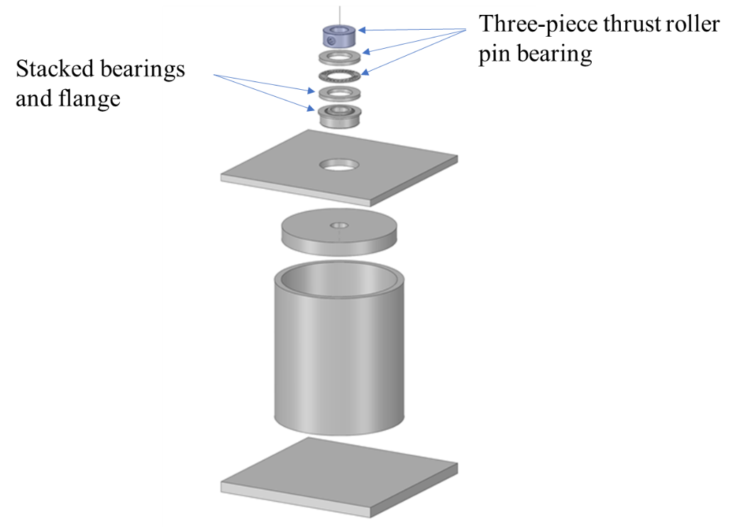
Figure 1: Jar assembly exploded view (screws and welds not included)

Figure 1 is a jar design with an exploded view without screws and welds. The components were pre-built and bought from vendors. The assembly was completed using welding and screws. The stacked bearings shown here consist of the flanged ball bearing which sits in the lid and keep the stirrer aligned and the three-piece thrust roller pin bearing which keeps the stirrer from falling deeper than intended into the jar. The top component is a set-screw collar that attach to the shaft of the stirrer and rest on the top thrust bearing washer providing axial support. This collar can easily be adjusted to meet clearance specifications, removed to swap stirring methods, or replaced for wear.
The position of the top blade of the stirrer placed closer to the bottom. This change would cause more necessary action in the mill and would be easier to machine. A standard ¼”-20 central screw was used as the method of fastening the different pieces of the stirrer together. This provided an easy method of centering of the pieces of the stirrer and allowed to not have to rely on welding or epoxy for critical stress points. This design also allows for adjustments and modifications. After the stirrer was screwed together, epoxy was used to seal the gaps between parts and to keep the parts from unscrewing for any reason. The entire bearing assembly and mill-to-stirrer adapter were standard parts. The deep socket in the middle of the model is transparent to show its torque transferring female components. The top of the stirrer shaft was machined down to a hexagon so the deep socket could sit on it. The top component is a sheared section of a socket extension to be used as the tool adapter. These components were inexpensive and allowed for the mill to breakaway safely from the unit if a malfunction should occur.
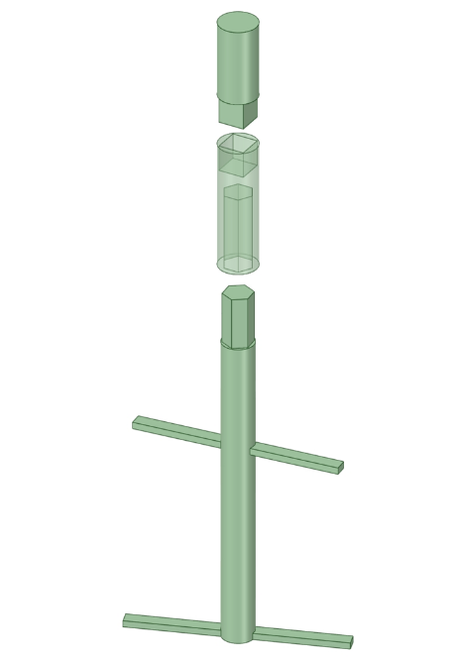
Figure 2: Stirrer and mill adapter exploded
Testing of the Completed Unit
Table 1: Prototype testing parameters.
Material | Mass (grams)
Aluminum Powder | 65.9
Stainless Steel Balls | 659
Isopropyl Alcohol | 491.46
Stearic Acid | 12.28
Total | 1228.64
The final assembled unit was set on the HAAS mini mill and tested for ball milling operation with a 250 rpm. The testing parameter is shown in Table 1. Aluminum powder with a size range of 10-14 micron spherical powder was used. Samples were collected during the cycle which ensured a uniform sample. The samples were taken using a syringe about an inch or two down from the surface of the slurry and placed into small containers. The alcohol was then evaporated from the samples and the samples were analyzed under an SEM.

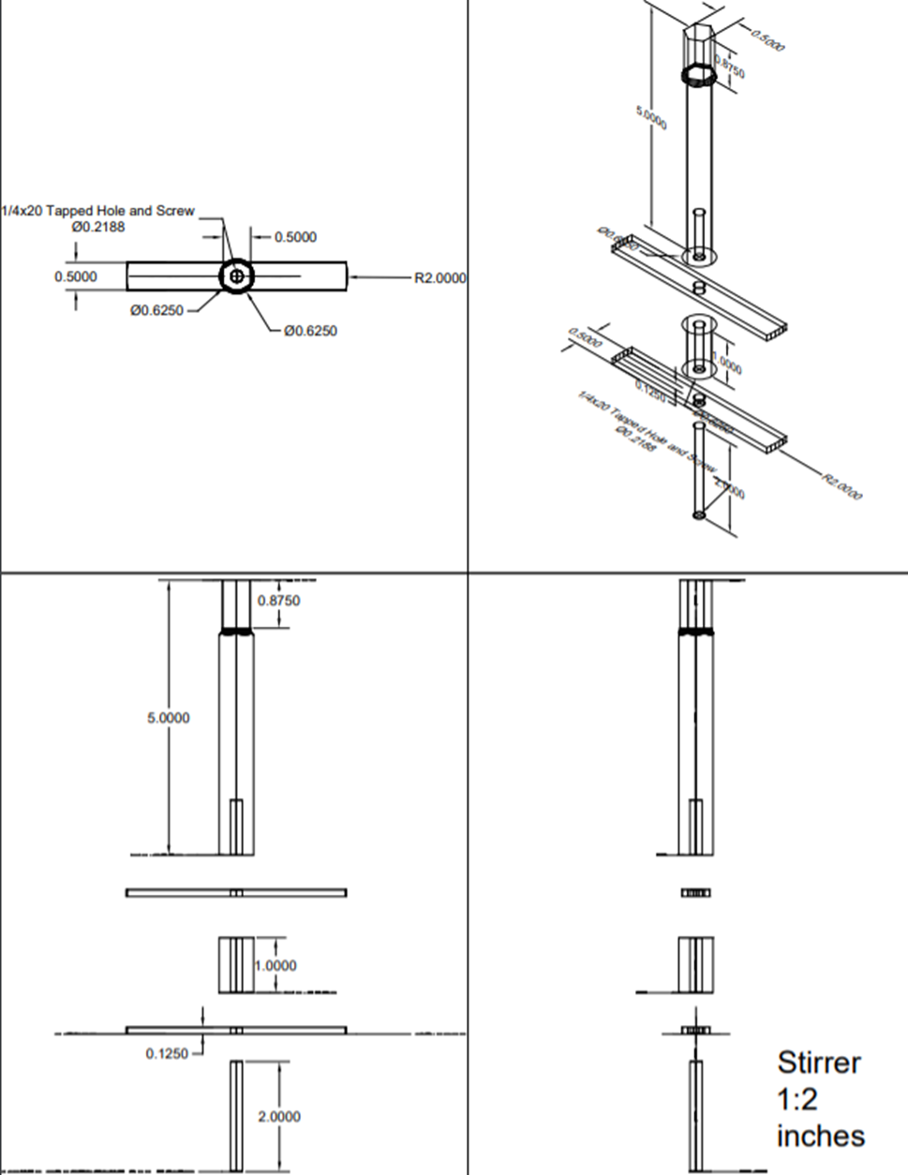
Figure 3: Optimized Design of Stirrer
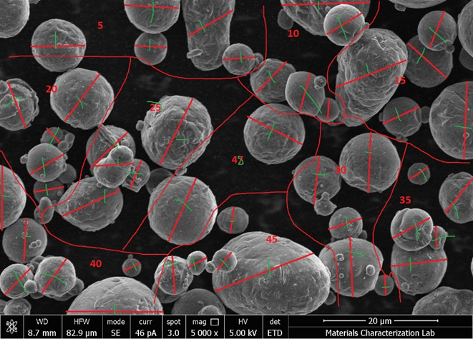
Figure 4: Sample 0 (control) example of diameter measurement method.
In control sample (Figure 4), the powder was clearly spherical. Average diameter was about 9.7 microns which gave an average volume of about 479 cubic microns and an average surface area of about 296 square microns. These measurements relatively match the labeled 10-14 micron size of the particles. The next sample was taken at one hour (Figure 5). SEM image showed flattening action had occurred relatively uniformly increasing. Average diameter increased to about 15.55 microns which gave an average thickness of about 3.8 microns and an increased average surface area of about 573 square microns using cylindrical property equations.
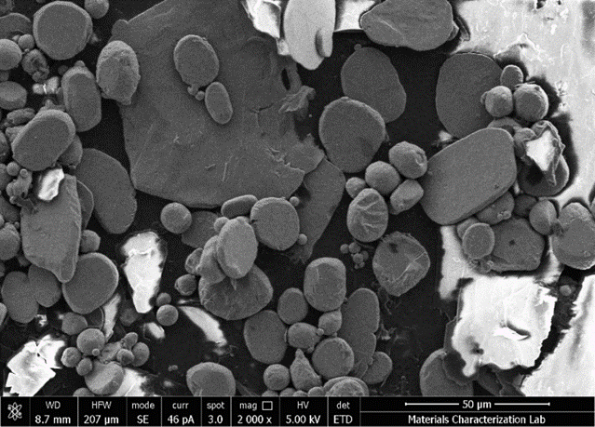
Figure 5: Sample 1 (1 hour).
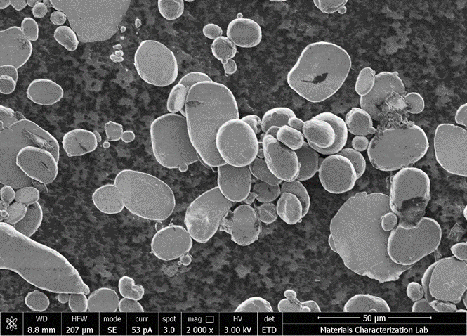
Figure 6: Sample 2 (2 hours).
After two hours (Figure 6), the particles continued to flatten. It was difficult to determine the differences between the first and second hour on sight and our measurements reflected this similarity showing a slight increase in both estimated surface area and thickness. Average diameter increased slightly to about 15.68 microns along with average thickness to about 4.2 microns. However, average surface area increased slightly to about 610 square microns. While it was difficult to tell from sight, measurements and calculations from the fourth hour sample showed the greatest jump towards our desired results (Figure 7). Average diameter increased to about 27.2 microns. Estimated average thickness dropped to below 1.4 microns; within 40% of our desired submicron thickness. Estimated average surface area increased by over 75% to about 1480 square microns.
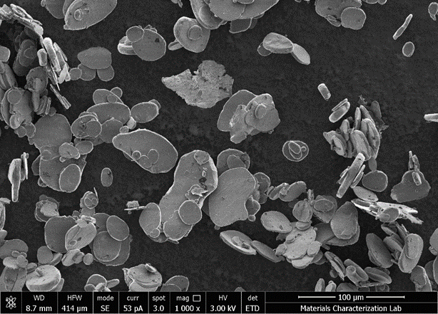
Figure 7: Sample 4 (4 hours).

Conclusions
This project built and tested the viability of vertical stirred ball mills to produce flaky aluminum powder from spherical aluminum powder for research in carbon nanotube-aluminum metal matrix composites. The ball mill’s versatility was tested using a HAAS CNC mini-mill. Scanning electron microscope analysis revealed the vertical stirred ball mill provided the necessary action on the aluminum particles, increased surface area and reduced width to near one micron on average. Even though the mill was able to produce flaky shaped powder from spherical shape but the flakes were not thin enough. However, the process parameters were not optimized. Moreover, the stirrer design needs to be improved.

Acknowledgments

This work was supported in part by the Multi-campus Research Experience for Undergraduate (MC-REU) at the University of Pennsylvania.

References
[1] 1. D. Singla, K. Amulya and Q. Murtaza, "CNT reinforced Aluminium matrix Composite-a review," in 4th International Conference on Materials Processing and Characterization, Delhi, 2015.
[2] L. Jiang, Z. Li, G. Fan, L. Cao, D. Zhang, The use of flake powder metallurgy to produce carbon nanotube (CNT)/aluminum composites with a homogenous CNT distribution, Carbon 50 (2012) 1993–1998.
[3] Senna, M., Kuno , H. , Polymorphic transformation of PbO by isothermal wet ball-milling . J. Am. Ceram. Soc., 1971, 54 (5).
[4] Oleg D. Neikov, Chapter 2: Mechanical Crushing and Grinding, Handbook of Nonferrous Metal Powders, 2009.
[5] FD. Daraio, J. Villoria, A. Ingram, A. Alexiadis, E. H. Stitt and M. Marigo, "Investigating grinding media dynamics inside a vertical stirred mill usingthe discrete element method: Effect of impeller arm length," Powder Technology, vol. 364, pp. 1049-1061, 2020.

Biographies

A.H.M.E. RAHMAN is an assistant professor of Mechanical Engineering at Pennsylvania State University – Harrisburg. He earned her BS from University of Engineering and Technology of Bangladesh in 2004, and PhD in Mechanical Engineering in 2013 from the University of North Dakota. Dr. Rahman research interests include light alloy technology, metal matrix composites, hybrid bio-composite, and diffusion bonding of specialty alloy. Dr. Rahman may be reached at aer15@psu.edu.edu.

ISSAM ABU-MAHFOUZ is an associate professor of Mechanical Engineering at Pennsylvania State University – Harrisburg. He has taught courses in computer aided design (CAD), finite element analysis (FEA), automatic controls, mechatronics, instrumentation, fluid power, design for manufacturability, dynamics, vibrations, optimization, energy systems, and smart systems. His research interests include machine condition monitoring, nonlinear vibrations, chaotic dynamics, machinery noise and vibration isolation, and the application of artificial intelligence to manufacturing processes. Dr. Abu Mahfouz continues to provide engineering consulting services in designing and developing new products, vibration and noise isolation, and machinery failure prevention. He is a licensed professional engineer.

ANIL ATTALURI is an assistant professor of Mechanical Engineering at Pennsylvania State University – Harrisburg. His research goal is to cure cancer with cost effective approaches that maintain a high quality of life. He develops novel devices and treatment planning systems for cancer treatments. Focusing on experimental, pre-clinical and clinical validation, this work resulted in novel applicators and pioneering data for improving magnetic nanoparticle hyperthermia.

