Simulation Study of a New Type of Learning Automata

Prateek S. Aggarwal
Boston University
prateekji@gmail.com

Chenhui Liu
Boston University
Dr.chenhui.liu@gmail.com

Lev Levitin
Boston University
levitin@bu.edu

Abstract

This paper presents numerical simulations of Probabilistically-Switch-Action-on-Failure learning automaton (PSAFA) in various stationary and non-stationary environments. The PSAFA is a novel fixed structure stochastic automaton (FSSA)framework, whose analytical model is presented in detail in our previous paper. The key differentiating feature of this automaton is that it allows action switching in every state. We anticipate that this feature attributes PSAFA dynamic properties that make certain aspects of its performance superior to other FSSA that do not possess this property.

In this paper, simulations of the PSAFA in comparison with other FSSA and variable structure stochastic automata (VSSA) are considered in two types of environments: a stationary environment (with fixed penalty probabilities) and a non-stationary environment, where the penalty probabilities are changing in time periodically as a sinusoidal function. In both cases the simulation demostrates a dramatic difference in performance for these types of learning automata. The PSAFA shows its huge advantage in adapatability that leads to a better performance for the length of the simulation up to 30,000-150,000 steps. Only for very long stationary conditions Tsetlin automata outperforms PSAFA. Also, we show that the PSAFA model responds quickly to drastic changes in the environment unlike the other automata. In the case of sinusoidal modulations, the PSAFA tremendously outperforms other types of FSSA for all modulation frequencies and for all depths D>3. The performance of PSAFA does not deteriorate with increasing modulation frequency, while other FSSA are not resilient to that increase. Also, the PSAFA is more adaptive where it has to select an action from multiple actions.

Introduction

The design of the Probabilistically-Switch-Action-on-Failure Automata (PSAFA) in (Aggarwal, Liu & Levitin, 2022) is motivated by the need for design of Fixed Structure Stochastic Automata (FSSA) that can possibly perform better than Star-automaton (Economides & Kehagias, 2002) and Tsetlin L_{2,2N} (Tsetlin, 1962) in non-stationary environments. As shown in Part 1, the PSAFA achieve ε-optimality with increasing depth according to a power law, rather than exponentially, unlike most learning automata. Thus, the convergence rate of the performance as a function of the depth is larger for Tsetlin and Star automata, than for the PSAFA. In other words, for a stationary environment, the minimum number of states required to achieve ε values lower than any given value, will be smaller for Tsetlin and Star automata, than for PSAFA. However, one can argue that the PSAFA design allows it to demonstrate better adaptability, and hence performance, in other, possibly non-stationary, environments, as well as in stationary environments for not extremely long periods of time.

An FSSA that is ε-optimal tends to occupy the terminal states of each branch, and an FSSA that is not ε-optimal tends to occupy the initial states in each branch. Thus, the behavior of a non- ε-optimal FSSA will not be affected by an increase of the depth beyond a certain value since the automaton will not fully utilize the newly added states. Therefore, the automata used in all the simulations are reformulated so that they are ε-optimal, so that their performance consistently improves with an increase in depth. The reformulation is performed by using the penalty-filtering technique presented in previous studies (Narendra & Thatachar, 2012), where a certain fraction of the penalties, selected randomly, are ignored, and deemed as rewards. These universally ε-optimal versions of pessimistic PSAFA, ambivalent PSAFA, and Tsetlin automata, are hereby referred to as univ-pess-PSAFA, univ-amb-PSAFA, and univ-Tsetlin automaton, for the purpose of conciseness. The optimistic PSAFA is referred as opt-PSAFA.

To assess the performance of different learning automata in stationary and non-stationary environments, previous researchers primarily considered environments where the penalty probabilities are stationary, and the automata are reset at different states at the start of the simulation or environments with periodically modulating or switching penalty probabilities (Narendra & Thatachar, 2012). The average penalty and rapidness of response of the different LAs were then compared. Simulations were also presented where penalty probabilities changed periodically from the highest to the lowest mean values.

Following a similar approach, we aim to quantify the performance of the PSAFA for two cases: (1) for fixed values of penalty probabilities, and (2) for sinusoidal modulation (within a broad range of frequencies) of the penalty probabilities. This approach should help us in understanding the relationship between the parameters of the different FSSA, and their performance in both stationary and non-stationary environments. First, the transient and steady state behavior of univ-Tsetlin automata and PSAFA were compared for constant values of penalty probabilities. Then, for the univ-Tsetlin, PSAFA and univ-STAR automata, the relationship between the depths of these automata and their performance in environments with periodically changing penalty probabilities was inspected.

An appropriately designed learning automaton should have its performance improve with increasing depth in any environment. Note that for all the FSSA discussed here the optimal behavior is achieved only when the depth is infinite. From a practical computational standpoint, it is very reasonable to simulate an automaton with a 32-bit variable. The number of different states in such an automaton is of the order of 10⁹. Thus, simulating a nearly infinite state FSSA is not difficult for practical applications. The real challenge is in designing a learning automaton whose performance consistently improves with increasing depth, in any environment.

With this viewpoint, we performed a set of experiments to understand the transient and the steady-state characteristics of the different FSSA. All simulations were performed in the MATLAB computing environment. The simulation and analysis for a stationary environment are described below. Simulation and analysis methods and results for non-stationary environments are presented after that. The interpretations and conclusions are described in the end.

Stationary Environments: Simulation & Analysis
Figure 1. P₁ i.e. probability of selection of action 1 in a two-action environment with c₂=0.5. Plots in (a) correspond to 400k steps while plots in (b) correspond to a higher resolution version of 200 steps. Both plots contain graphs for univ-Tsetlin automaton and opt-PSAFA of depth D=10.

Two different setups are used in the case of fixed penalty probabilities. In the first setup, the automata can perform two different actions, and at the start of the simulation each automaton occupies the first (initial) state of the branches with equal probabilities. We call this the equiprobable action simulation. In the second setup, in a two-action environment, all automata initially occupy the final (the deepest) state of the branch which has a higher penalty probability. It means the automata start with the most disadvantaged position. We call it position reversal simulation.

The goal in both cases is to study the automata performance in both the transient and the steady-state stages of the simulations. In particular, the second setup allows us to evaluate time (number of steps) needed for an automaton to switch its action in the worst-case scenario.

To compare the performance of different FSSA, all simulations were conducted for the same depth level, D=10. All simulations are in a two-action environment with fixed penalty probabilities c₁ and c₂ where c₂>c₁. Each simulation includes 100,000 trials. The fraction of trials P₁(n) at any given step n when the automaton performs the action with the smaller penalty probability c₁ is used as the measure of the automaton performance.

Results for Equiprobable Actions Simulation

Denote the probability of being at state (i,d) i.e. the d^{th} state in the i^{th} branch, at instant n as as π_{(i,d)}(n) and the probability of taking the action corresponding to branch i at instant n as P_{i} (n). For fixed penalty probabilities simulation, the FSSA were reset to occupy the initial state in each arm with equal probabilities so that π_{1,1} (0) = π_{2,1} (0) = ½ and P₁ (0) = P₂ (0) = ½.

Simulation results for values of c₁ = 0.2, 0.3, 0.4 and c₂ = 0.5 are presented in Figure 1. Results are plotted for different trial lengths to visualize the dynamics at different time scales. A step window of 400,000 steps is used in Figure 1a, while a step window of 200 steps is used in Figure 1b.

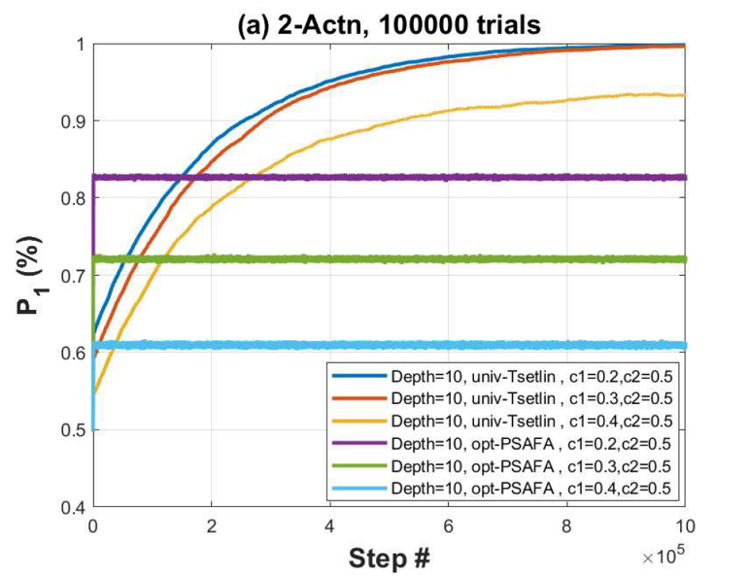
The results reveal a dramatic difference in the behavior of opt-PSAFA and univ-Tsetlin automata. It takes about 50 steps for opt-PSAFA to converge to the steady state, while univ-Tsetlin automata do not reach steady state even for 400,000 steps. In fact, univ-Tsetlin automata do not reach equilibrium (i.e. steady state) up to 10⁶ steps, as shown in Figure 2. As a result, opt-PSAFA outperform univ-Tsetlin automata for lengths up to 35,523 steps for c₁=0.4, 89,909 for c₁ = 0.3, and 143,960 for c₁ = 0.2. Thus, opt-PSAFA outperforms univ-Tsetlin for all realistic number of trials. It is very hard to find real-life scenarios where the decision system can wait to process >35,000 steps. So, for all practical purposes, opt-PSAFA is more suited to deliver satisfactory results for real-life scenarios.
Figure 2. P₁ i.e. probability of selection of action 1 in a two-action environment with c₂=0.5. Plots correspond to 1 million steps. The plot contains graphs for univ-Tsetlin automaton and opt-PSAFA of depth D=10.

Observing Figure 1b reveals another interesting facet of the behavior of the two FSSA. Note that the 200 steps in the plot of Figure 1b are just a high resolution depiction of the behavior of two types of FSSA in the first 200 steps of Figure 1a. The plot may create a wrong impression that univ-Tsetlin automaton converges to an equilibrium faster than the corresponding opt-PSAFA, but at a much lower performance level. However, Figure 1a tells us that in fact univ-Tsetln automaton is very far from the steady state for this range of steps. It continues0 to converge and eventually surpasses opt-PSAFA, albiet after enormously larger number of steps. It highlights the point that it is never advisable to assume convergence without thoroughly evaluating the full scope of the simulation results. Figure 1b clearly indicates though, that the convergence of opt-PSAFA requires approximately 50 steps.

Figure 2 is the same simulation as in Figure 1, but plotted up to 10⁶ steps. The plot with such a large step window reveals that the convergence of the univ-Tsetlin automaton of depth D=10 requires approximately one million steps vs the 50 steps required by opt-PSAFA.
Tsetlin Automata

Results for Position Reversal Simulation

As described earlier, for the second fixed penalty probability simulation, π_{2,10} (0) = 1 and P₂ (0) = 1. Then, just like in the above simulation, c₂ is set to 0.5 for all simulations and different values of c₁ are selected for different simulations. This simulation has been pursued in order to understand how the action-switching capability of opt-PSAFA plays a role in determining its performance.

Tsetlin Automata
Tsetlin Automata
Figure 3. P₁ i.e. probability of selection of action 1 in a two-action environment with c₂=0.5. Both plots (a) and (b) contain graphs for univ-Tsetlin automaton and opt-PSAFA of depth D=10, for automata which start with P₂(0) = 1 and π_{2,10} (0) = 1 in (a) for 1 million steps (b) 200 steps. It is clear that the time constant for the opt-PSAFA is of the order of 30 steps and the time constant for univ-Tsetlin is of the order of 200k steps for D=10. In (c) the same plot of univ-Tsetlin is shown as in (b), but with a greater P₁ resolution, spanning from 0 to 1.5x10⁻³

Figure 3 shows the performance results for the two types of FSSA in the position reversal simulation. Again, P₁ is plotted for different trial lengths. The results clearly show that the choice of the most disadvantaged initial position has little effect on the convergence of the PSAFA: it achieves the steady state after approximately 80 steps. In contrast, this “reversal” initial position has a devastating effect on the univ-Tsetlin automaton. Its probability to obtain a larger reward (minimum penalty) P₁ remains very close to zero for the first 200 steps (Figure 1b), and its approach to equilibrium is also substantially delayed.

Figure 3c reveals the dynamics of univ-Tsetlin automaton during the 200 steps. We can notice that for the first 17 steps, in any of the 10,000 trials, none of the univ-Tsetlin automata switch to action 1. This is the minimum time taken by the univ-Tsetlin automaton to traverse branch 2 before reaching the initial state of branch 1. Even after this initial interval, the rise in the fraction of automata switching to action 1 remains insignificant, below 0.12% for the 200 steps. Thus, action switching remains a challenge for univ-Tsetlin as compared to opt-PSAFA.

Non-Stationary Environment: Simulation & Analysis

An important characteristic of a non-stationary environment that affects the performance of any LA is how fast the penalty probabilities are changing in time. To evaluate that effect, we consider the most elementary situation when the penalty probabilities oscillate harmonically within a broad range of different frequencies.

In the non-stationary environment selected in this paper, the penalty probabilities for two of the multiple actions vary sinusoidally, and at opposite phase to each other, around an average value, while the penalty probabilities of other actions remain constant at the same average value. This allows us to assess the effect of different frequencies and different modulation-depths of the sinusoidal variation, as well as to compare the performance in two-action environments with the performance in environments with a larger number of actions. The simulations have been done for three different PSAFAs, univ-Tsetlin and univ-STAR automata with several values of depth D.

Performance measures used in these simulations have been defined based on the concepts of Perfect Predictor and Pure-Chance automata, as explained below. The Pure-Chance automaton was introduced previously as a benchmark for comparison of the behavior of different automata in a stationary environment (Economides & Kehagias 2002).

The Pure-Chance Automaton

The Pure-Chance automaton is defined as an automaton that chooses one of the available actions randomly with equal probabilities at each step. The Pure-Chance automaton provides a lower bound on the performance of any intelligent algorithm.

Perfect Predictor Automaton

The Perfect Predictor automaton (PPA) is defined as an automaton that has complete knowledge about the environment and can select the action with the least penalty probability at every step. The only hindrance in it getting rewarded for 100% of the trials is the stochastic nature of the environment. PPA sets an upper bound on the best possible performance possible for a learning automaton. In fact, this model is usually a very weak upper bound on the performance of any FSSA, but it does give insight into the limits of how well the different designs can perform.

Simulation Details for Sinusoidally Varying Penalty

Consider a two-action environment where the penalty probabilities vary according to the following

c₁ (k) = c + η sin(2πkf/N)
(1)
c₂ (k) = c – η sin(2πkf/N)

where k is the step number in a sequence of trials (k=1, 2, …, N), and f is the frequency, i.e., the number of periods of sinusoidal variation during the entire sequence of trials, consisting of N steps. This two-action model is a specific case of a more general r-action model. In the r-action model, the penalty probabilities of the first two actions vary sinusoidally and in opposite phase around an average value, c, and the penalty probabilities of the other actions remain constant at c. Note that the environment model contains two actions with sinusoidally varying probabilities to ensure that the set of penalty probabilities remains the same for any two steps that are one-half period apart. This condition ensures that the values of the output of the experiment, such as the probability of selecting the best action at any given step, and the probability of selecting a given action at a given step, can be compared, and interpreted, with other steps that are separated by multiples of half a period from the given one. Selection of an environment with only a single sinusoidally varying penalty probability would not provide this feature to the simulation results.

Each of our simulations is an ensemble of Z = 10,000 independent trial sequences. The performance of each LA is evaluated as follows.

Denote by ρ(k, f, z) the reward obtained by an automaton in the trial z (z=1,2, …, Z) at step k (k=1, 2, …, N) of the experiment performed with modulation frequency f. In fact, ρ(k, f, z) is a binary random variable that takes on values {0,1} with probabilities c_{i} and 1-c_{i} respectively, if the LA is in the branch i at step k.

Consider the average

ρ(f) = ρ(k, f, z) (2)

The empirical value of ρ(f), obtained in a simulation experiment can be used as an estimate of the expected value of the reward E[ρ(f) ] =1–M(f), where M(f) is the average penalty obtained by a given automaton in a non-stationary environment with periodically changing probabilities of penalty, according to (1). Note that the empirical values ρ(k, f, z) fluctuate quite broadly, depending on the whole history of automaton-environment behavior and interaction in any trial of simulation. Therefore, we repeat each experiment Z=10,000 times, with the view to make the estimate of ρ(f), as given by (2), closer to its expected value 1-M(f).

Denote by ρ_{PP}(f) the average reward obtained by the Perfect Predictor Automaton and by ρ_{PC}(f) the average reward obtained by the Pure-Chance Automaton. Then, the performance measure Ω(f) for an automaton obtaining the average reward ρ(f) _{is} defined by Equation 3.

Ω(f) = (3)

The simulations have been performed for two-action environment with the value of c = 0.5. The frequency f is varied from 3 to 30,000, with 35 approximately regularly spaced steps on a log scale, such that f is always an integer. The number of steps is N=100,000 in each of the experiments.

The performance, Ω(f), is calculated as a function of f, the frequency of penalty probability variation, by use of Eqs. (2) and (3).

To determine the effect of magnitude of variation of the penalty probabilities, we compute Ω (f) for two values of η, namely, for η = 0.5, and for η = 0.1. Comparison of the performance for these two cases should indicate the efficacy of the learning automata to track small changes in penalty probabilities. In a different experiment, simulations for ten-action environments have been performed, where the penalty probabilities of the other 8 actions, i.e., c₃, c₄ … c₁₀, are held constant at c = 0.5. The goal was to determine how the presence of multiple (possibly, non-optimal) actions confounds the performance level of the different learning automata. Although FSSA that are ε-optimal remain so irrespective of the number of actions, their performance in a non-stationary environment may deteriorate with increasing number of possible actions.
Figure 4. Performance (Ω(f)) as a function of frequency, for depth values of (A) D=3, (B) D=10 and (C) D=50. In (D) univ-Tsetlin with depth D=3 is compared with univ-Tsetlin having depth D=10 and with PSAF-opt with depth D=50.

Thus, the performance of each automaton is characterized in three different types of environments, namely, (a) a two-action environment with sinusoidally varying penalty probabilities, a (b) a two-action environment where the penalty probabilities vary within a smaller range, and (c) a ten-action environment. One may expect that, if an FSSA design is effective for these simple non-stationary environments, its performance should consistently improve with increasing depth D. The simulations results are presented below.

Two-Action Environments: Performance vs Frequency and Depth

Simulation results for Ω(f) in a two-action environment as described above, are shown for opt-PSAFA, and univ-pess-PSAFA, univ-amb-PSAFA, and univ-Tsetlin automata, for the depths D=3 (Figure 4a), D=10 (Figure 4b), and D=50 (Figure 4c).
Figure 5: Performance (%) as a function of frequency for the different ε-optimal automata, for three depth values, D=3, 10 and 50. (A) optimistic-PSAF (B) univ-PSAF-amb (C) univ-PSAF-pess, and (D) univ-Tsetlin.
Assume for convenience that the total time of an experiment is one second and f is measured in Hertz. It can be seen that the univ-Tsetlin automaton for D=3 (Figure 4a) performs better than others in the low frequency range (f<200 Hz). This value of f corresponds to 500 steps per modulation cycle period. However, the univ-Tsetlin performance drops below 80% of its maximum performance (Ω=77%) by 337 Hz (i.e., 297 steps/cycle). At the same time, opt-PSAF automata performance drops to Ω=78.4% only by 1628 Hz (61 steps/cycle). In the same environment, a pure-chance automaton would always have a percentage reward ρ of 50%, irrespective of the penalty modulation frequency value. The cutoff frequency i.e., the frequency at which an automaton performs worse than pure-chance automaton, of univ-Tsetlin L_{2,6} is about 1,200 Hz (83.33 steps/cycle) while that of opt-PSAF automata is more than 22,400 Hz (4.46 steps/cycle). Thus the PSAFA demonstrate a superior performance compared to univ-Tsetlin automata and univ-STAR automata for all frequencies f > 200 Hz, even for a small depth D=3.
Figure 6. Performance (%) as a function of frequency for depth values of D=3, 10, 50, while the penalty probabilities modulate with η = 0.1. (A) optimistic-PSAF (b) univ-PSAF-amb (c) univ-PSAF-pess, and (d) univ-Tsetlin.
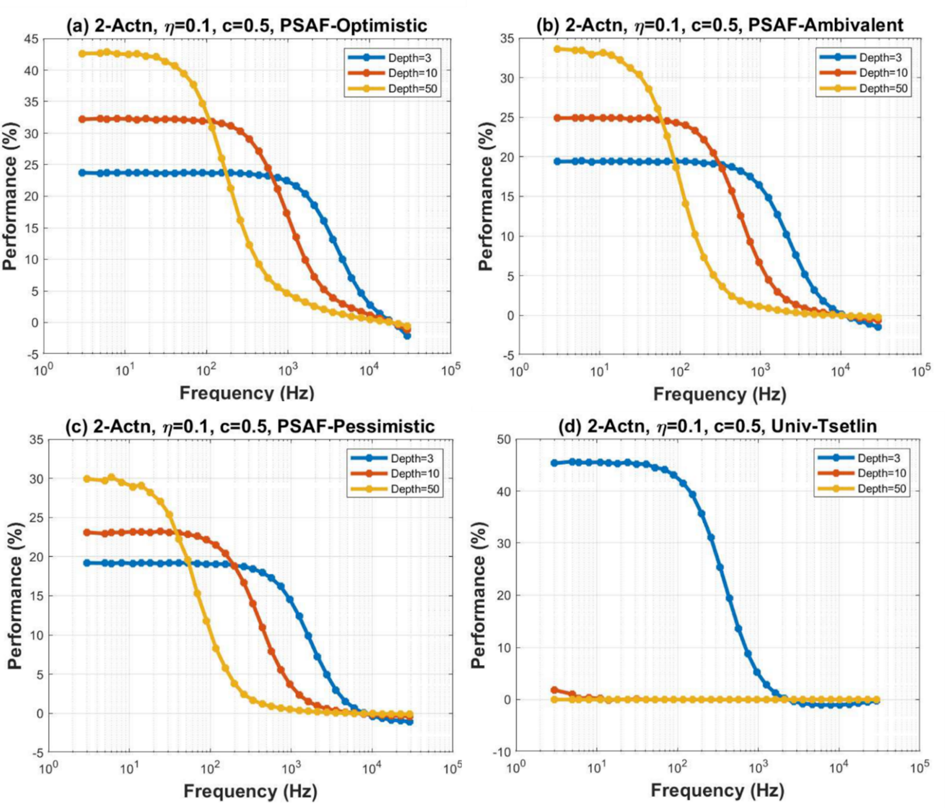
The drastic difference in behavior between PSAFA and other FSSA becomes even more profound for larger depths. The depths increase to D=10 has a positive effect on PSAFA, but it ruins the performance of the univ-Tsetlin and univ-STAR automata. The cutoff frequency for univ-Tsetlin and univ-STAR drops to 200 Hz (500 steps/cycle), while for opt-PSAFA it remains above 20,000 Hz (5 steps/cycle), With depth D=50, Tsetlin and STAR automata perform not better than Pure Chance automaton for all frequencies f > 7 Hz while opt-PSAFA keeps the cutoff point at about 20,000 Hz. In fact, the performance of opt-PSAFA at low frequencies (up to f = 200 Hz) improves with the increase of depth D.
As shown in Figure 4d, while the opt-PSAFA with D=3 has a higher working frequency range than all univ-Tsetlin automata of any depth, the opt-PSAFA of depth D=50 is superior to univ-Tsetlin automata with D≥5 for low as well as high frequencies. Thus, the opt-PSAFA design is wholly superior to univ-Tsetlin design in a non-stationary environment.

The relationship between frequency response and depth for different universally ε-optimal automata is further illustrated in Figure 5. It is seen from this figure that while the univ-Tsetlin automaton shows superior performance at depth of 3, its performance considerably deteriorates with increasing depth. Thus, the univ-Tsetlin automaton design does not fully capitalize on the increase in number of states in the automaton, while the opt-PSAFA design is more conducive to penalty modulated environments. Another observation is that for the PSAFA design, the cutoff frequency remains almost unchanged with increasing depth, which seems to be a distinctive property specific for the PSAFA design.
Figure 7: Performance (%) as a function of frequency for the different ε-optimal automata in a ten-action environment as described in section 4C.1 for depth values of (A) D=10 and (B) D=50
Two-Action Environment: 10% Modulation Amplitude

Simulation results for a two-action environment, with η = 0.1, are shown for the opt-PSAFA (Figure 6a), and univ-amb-PSAFA (Figure 6b), univ-pess-PSAFA (Figure 6c), and univ-Tsetlin (Figure 6d) automata, for depths D=3, D=10, and D=50.

It is seen that opt-PSAFA again has the best performance while univ-Tsetlin has much worse performance characteristics. In fact, a univ-Tsetlin automaton with a depth D=10 already has a nearly pure chance performance. This performance level is substantially worse than in the case where η=0.5 (Figure 5d) in the previous section. It becomes clear that the univ-Tsetlin automaton performance worsens in an environment producing small and slowly varying changes in penalty probabilities. Thus, the utilization of additional states by the univ-Tsetlin automaton design is even poorer for such environments. In this regard, the opt-PSAFA design is more conducive to penalty modulating environments with low modulation amplitudes, since its performance continues to show improvement similar to the kind of improvement it showed in high penalty modulation amplitude environment, with increasing depth. Again, the PSAFA design ensures that the cutoff frequency of the frequency response remains unchanged with increasing depth, irrespective of the penalty modulation amplitude.

Ten-Action Environment: Performance vs Frequency and Depth D

Simulation results for a ten-action environment as described earlier in this paper, are shown for Ж-opt, and univ-pess-PSAFA, univ-amb-PSAFA, and univ-Tsetlin automata, for D=10 (Figure 7a), and D=50 (Figure 7b). Note that the performance of the Perfect Predictor automaton should not be affected by the number of actions available.

The presence of many actions affects the LA performance negatively. Nevertheless, it can be seen that performance of PSAFA improves with increasing depth for the range of low frequencies while keeping the cutoff frequency almost unchanged at about f = 10,000 Hz. The Tsetlin automaton performance deteriorates to Pure Chance level for almost entire range of frequencies. Thus, the PSAFA design continues to capitalize on increasing depth in ten-action environment, while the performance of univ-Tsetlin automaton vs. depth gets worse in ten-action environment than in two-action environment.

Conclusions and Future Work

Simulation results of two-action and ten-action in non-stationary environments are presented in this paper. Penalty switching simulations reveal the fast convergence rate as well as the quick action switching property of PSAFA in comparison to other FSSA. These simulations clearly establish the benefits of using PSAFA in real-life situations since they require incomparably smaller number of steps to converge to the steady state than the univ-Tsetlin automaton and perform better than univ-Tsetlin automaton for a large range of number of steps. In fact, univ-Tsetlin automaton takes an unrealistic number of steps to outperform PSAFA.

Position reversal simulations presented in this paper further accentuate the difference in the convergence speed of PSAFA vs univ-Tsetlin automata. The motivation for position reversal simulations is also derived from real-life human decision-making behavior. In many scenarios, one finds that people who are extremely sure about a particular decision can struggle when the environment suddenly changes, and they need to switch their decision. On the other hand, other people find switching their decisions with changing environment to be much less taxing and they evolve quickly in a transient environment. Thus, learning automata models discussed in this paper could play a significant role in explaining differences in behaviors of different individuals in changing environments.

The sinusoidally modulated penalty probability simulations indicate that the performance of univ-STAR and univ-Tsetlin automata deteriorate substantially in simple non-stationary environments with the increase of depth. On the other hand, the PSAF automata show a nearly constant high-frequency response for increased depth, and an improved low frequency response. Thus, although the response of PSAFA may be worse than Tsetlin automata at very low depths, PSAFA is a more favorable candidate for an automaton that capitalizes on the increase of the number of states to improve performance.

This trend in performance is even more pronounced when the modulation amplitude fluctuations are small, or when environment provides many actions to choose from. All these observations indicate the strength of the PSAF framework in non-stationary environments. Another strength of the PSAFA design is the degree of flexibility in the assignment of the action switching probabilities. This flexibility creates many more design possibilities for future research.
There exists a general notion in FSSA research that the parameter D can be fine-tuned to provide the best tradeoff between optimality and speed of response to non-stationary environments. This notion is promulgated by the observation that the performance of classical FSSA designs in non-stationary environments degrades drastically with increasing depth [2]. Based on simulations in this paper, we know now that non-stationary environment performance degradation with depth is not necessary for every FSSA design. We propose that further research in the field of FSSA should focus on identifying FSSA designs that do not suffer from degradation in performance with the depth D at all, especially since, as mentioned in the previous paragraph, it is possible to simulate infinite state FSSA, that are optimal for stationary environments, by taking into consideration the finiteness of number of steps in real life scenarios.

The action-switching capability in every state for a PSAFA makes it comparable to VSSA in terms of its action switching capability. In a VSSA, action switching can occur at any time since the VSSA design does not commit to any one action but instead picks the next action from the basket using probability-based weighting. We intend to compare the performance of PSAFA with different VSSA designs in future work. We also aim to understand whether the simulations in simple non-stationary environments presented in this paper can be used to comprehend the behavior of these different learning automata in complex non-stationary as well as game-theoretic environments.

Future work intends to apply these novel designs of LA to deep learning and real-life challenging problems such as training deep neural networks and clustering (Guo, Li, Qi, Guo & Xu, 2020; Mofrad & Rezvanian, 2018), financial portfolio management (Sbruzzi, Leles & Nascimento, 2018), adaptive recommender system (Ghavipour & Meybodi, 2016), resource-efficient cloud computing and cost-efficient resource allocations (Yazidi & Hammer, 2018), wireless network design and management (Misra, Chatterjee & Guizani, 2015), stochastic queuing systems (Vahidipour & Esnaashari, 2018), machine vision (Damerchilu, Norouzzadeh & Meybodi, 2016) and optimization of cooperative tasks (Zhang, Wang & Gao, 2021), where efficient LA with fast convergence rate and assured 3-optimality or real-time reaction for each iteration are required.

References

Aggarwal, P. S., Liu, C., Levitin, L., (2022) A New Class of Learning Automata: The Probabilistically-Switch-Action-on-Failure Automaton: Part 1 – Analytical Models. Can be retrieved from https://www.techrxiv.org/articles/preprint/A_New_Class_of_Learning_Automata_The_Probabilistically-Switch-Action-on-Failure_Automaton_Part_1_Analytical_Models/19425761/1
Damerchilu, B., Norouzzadeh, M. S. & Meybodi, M. R. (2016) Motion estimation using learning automata, Mach. Vis. Appl., vol. 27(7), pp. 1047–1061, Oct. 2016.
Economides, A. A., & Kehagias, A. (2002) The STAR automaton: expediency and optimality properties, IEEE Transactions on Systems, Man and Cybernetics, Part B, vol. 32, pp.723 – 737, Issue: 6, Dec. 2002.
Ghavipour, M., & Meybodi, M. R. (2016) An adaptive fuzzy recommender system based on learning automata, Electron. Commerce Res. Appl., vol. 20, pp. 105–115, Nov. 2016.
Guo, H., Li, S., Qi, K., Guo, Y., & Xu, Z. (2020) Learning Automata Based Competition Scheme to Train Deep Neural Networks, IEEE Transactions on Emerging Topics in Computational Intelligence, vol. 4(2). pp. 151-158, April 2020.
Hasanzadeh-Mofrad, M. & Rezvanian, A. (2018) Learning automata clustering, J. Comput. Sci., vol. 24, pp. 379–388, Jan. 2018.
Misra, S., Chatterjee, S.S., & Guizani, M. (2015) Stochastic learning automata-based channel selection in cognitive radio/dynamic spectrum access for WiMAX networks, Int. J. Commun. Syst., vol. 28(5), pp. 801–817, 2015.
Narendra, K.S., & Thathatchar, M. A. L. (2012). Learning Automata: An introduction. Englewood Cliffs, NJ: Dover Publications, 2012.
Sbruzzi, E. F., Leles M. C. R., & Nascimento, C. L. (2018) Introducing learning automata to financial portfolio components selection, 2018 Annual IEEE International Systems Conference (SysCon), Vancouver, BC, Canada, pp. 1-6, doi: 10.1109/SYSCON.2018.8369522.
Tsetlin, M. L. (1962) On the behavior of finite automata in random media, Autom. Remote Control, vol. 22, pp. 1210–1219, 1962.
Vahidipour, M., & Esnaashari, M. (2018) Priority assignment in queuing systems with unknown characteristics using learning automata and adaptive stochastic Petri nets, J. Comput. Sci., vol. 24, pp. 343–357, Jan. 2018.
Yazidi, A. & Hammer, H. L., (2018) Solving stochastic nonlinear resource allocation problems using continuous learning automata, Appl. Intell., vol. 48(11), pp. 4392–4411, 2018.
Zhang, Z., Wang, D., & Gao, J. (2021) Learning Automata-Based Multiagent Reinforcement Learning for Optimization of Cooperative Tasks, IEEE Transactions on Neural Networks and Learning Systems, vol. 32(10), pp. 4639-4652, Oct. 2021, doi: 10.1109/TNNLS.2020.3025711.

Biographies

Prateek S. Aggarwal received his PhD in Biomedical Engineering from Boston University in 2003. He has been working as a data scientist in different companies since 2005 including Oracle Retail, Adobe and JP Morgan & Chase. He is currently employed as a senior data scientist with MasterCard. He is a member of IEEE.

Chenhui Liu is currently the Chief Scientist & Architect at Learning Equity, Inc. Her research interests include learning automaton design, efficient encoding and decoding of learning processes, AI and its applications to investment portfolio optimization and wealth management, default and bankruptcy prediction, and optimal design of learning paths with interactive cross-media systems. She received her Ph.D. in Computer Engineering from Boston University in 2006. She is a member of IEEE.

Lev Levitin is currently a distinguished professor of Engineering Science with the Department of Electrical and Computer Engineering at Boston University, Boston, MA. He has published over 200 papers, presentations, and patents. His research areas include information theory; quantum communication systems; physics of computation; quantum computing; quantum theory of measurements, mathematical linguistics; theory of complex systems; coding theory; theory of computer hardware testing, reliable computer networks, and bioinformatics. He is a life fellow of IEEE, a member of the International Academy of Informatics and other professional societies. Prof. Levitin may be reached at levitin@bu.edu

