**# 000-x-22**

*(All text and spacing should be 12-point font, Times New Roman, unless noted otherwise)*

*(one line space here of size 12 Times New Roman)*

***(Paper title should be 16-point Times New Roman font, bold, centered)***

**New Engineering Programs and University-Industry Collaboration in Engineering Education**

*(one line space here of size 12 Times New Roman)*

Name of First Author

First Author’s Affiliation

[first.author@myemail.edu](mailto:first.author@myemail.edu)

Name of Second Author

Second Author’s Affiliation

[second.author@myemail.edu](mailto:second.author@myemail.edu)

Name of Third Author

Second Author’s Affiliation

[second.author@myemail.edu](mailto:second.author@myemail.edu)

**etc.**

*(one line space here of size 12 Times New Roman)*

*(a second line space here of size 12 Times New Roman)*

**Abstract** *(section headers: 12-point Times New Roman, bold, left-justified)*

*(one line space here of size 12 Times New Roman)*

Engineering and technology software tools are used by professionals and companies worldwide, and in a university setting, students are given the opportunity to familiarize themselves with the operation of software packages that they will be using after they join the workforce. Many classroom projects in engineering technology curriculum that require the use of advanced software tools has increased in college and universities on both undergraduate and graduate levels. Emerging virtual applications enhance understanding both theoretical and applied experiences of engineering technology students by supporting laboratory experiments. MSC.Easy5, AMESim, SolidWorks, ProE, MATLAB, MultiSim and LabVIEWare some of the well-known system modeling, simulation and monitoring software tools that offer solutions to many problems in mechanical, thermal, hydraulics, pneumatics, electrical, electronics, controls, instrumentation and data acquisition areas. These virtual tools also help to improve the learning pace and knowledge level of students in many applied subjects.

**Introduction**

The development of educational and industrial software and simulation tools has been considerably increased by the development of high speed computers. Industrial applications now concentrate on replacing expensive equipment with software and simulations tools, while a number of educational institutions are preferring simulation tools instead of purchasing expensive test equipment for their laboratories. Universities, especially engineering education departments, are incorporating industry standard programming environment tools mainly in laboratory practices, but they are also being used in research and classroom education. There are a variety of research attempts to add simulation tools to laboratory experiments in engineering education courses. Virtual Control Workstation Design using Simulink, SimMechanism, and the Virtual Reality Toolbox was conducted in education to teach control theory principles as well as a test station for control algorithm development (Booth & Kerns, 2009). Authors used two workstations from Quanser Consulting for their electrical and computer engineering program student projects. Their claim was that incorporating a laboratory support into the engineering courses would enhance learning skills of the students. The discussion of the design and use of a low-cost virtual control workstation has been accomplished in the first undergraduate control theory course. The virtual workstation model from the physical, electrical, and mechanical parameters of a Quanser Consulting electromechanical system was built during the course period. The system has been used in over a dozen student projects and faculty research in the Electrical and Computer Engineering department at Bradley University. A capstone project was distributed to all faculty members. Also the learning curve of Simulink in senior capstone projects was tested by designing a six-week design project for a course that required system modeling using Simulink.

Other research incorporating the use of multimedia tools into a reverse engineering course has been presented by Madara Ogot (Ogot, 2008; 2017). The main goal of this study was to use multimedia as initiatives for the students to learn how to use main tools and use them in other academic activities beyond the reverse engineering class. Since a classic mechanical engineering curriculum may not offer instructions on the use of multimedia tools in the areas of computer illustration, animation, and image manipulation, this experience increased the major students’ interest in these topic areas. Instruction on the use of these tools was incorporated into a mechanical engineering course at Ruther University instructors plan to send out follow-up surveys at the end of the each semester to students who have taken the class. Following are some bullet points that have nothing to do with anything. They only show how the formatting should look.

• Bullet point number one (Note: only use periods in bulleted lists after complete sentences)

• Bullet point number two

• Bullet point number three

• Bullet point number four

Another study has been conducted to increase use of software tools such as PSCAD/EMTDC (Booth & Kerns, 2009), an electrical power and power electronics transient studies software tool for majors in the Electrical Engineering area. The aim of this study was to familiarize students with the electrical power systems without the cost and safety issues of actual power system simulators. Introduction of the PSCAD is usually introduced in the second week of an undergraduate power systems class and training starts with two basic sessions. For this purpose two case studies were presented on PSCADthat included the simulation of a three-bus system that allowed for independent control of voltage and phase on each bus in a way that clearly illustrates the principles of power flow control (Nala, 1998). The author’s objective in using digital simulation software tools in power systems is that “modern teaching facilities supported with digital simulation tools and well equipped laboratories have great impact in the development of engineering programs in power systems and energy technologies.”

**Software Tools in Technology Education**

The AMESim simulation package comes with very helpful demonstration models for a convenient initial start of modeling (Ramakrishna & Sundararajan, 2005; Kreyszig, (2006; Everett, 1998; Cobern & Wassell, 2005). This digital software tool offers an extensive set of application specific solutions which comprise a dedicated set of application libraries and focus on delivering simulation capabilities to assess the behavior of specific subsystems. Pro/ENGINEER Wildfire 2.0 and its “Mechanism” simulation application is used to demonstrate an interference problem between parts in the engineering assemblies by simulating the individual parts (Cipra, 2002). Pro/ENGINEER is another standard in 3D product design, featuring industry-leading productivity tools that promote practices in design while ensuring compliance with industry standards.

LabVIEW is another National Instruments graphical development environment to help create flexible and scalable design, control, and test applications (Egland, 1987; Beilke, 1997; Filho, Skrivener, England, & Ghavami, 2000; Gilles, 2003). With LabVIEW, engineering and technology students can interface with real-world signals from a variety of physical systems in all engineering areas; analyze data for meaningful information; and share results through intuitive displays, reports, and the Web. Although not covered in this paper due to the length of this paper, MATLAB has been one of the strongest mathematical tools in analog and digital signal and control systems design and simulation studies in the program at the University of Northern Iowa.

**Case Studies**

Six case studies are presented in this section of the paper. In the first case study, the angle of inclination of a plane will be determined for when the object starts moving if it is located on a flat inclined surface with a given static friction of coefficient. The second case study demonstrates how to determine the stopping distance and time of a vehicle model on inclined surfaces. The third case study is to solve interference problems between engineering models created by Pro/Engineer Wildfire based on Mechanism simulation application. The fourth case study describes Solid Works in a capstone design project to model and simulate floating calculations for a solar electric powered fiberglass boat developed at the University of Northern Iowa. The fifth case study is using MultiSim, Electronics Workbench in simple RLC circuits for measurement purposes. A low pass filter study, Bode Plot for stability, and full-wave bridge rectifier simulation studies by MultiSim are also briefly reported. The last digital tool covered in this paper is LabVIEW for data acquisition and instrumentation of a 1.5kW wind-solar power system where AC and DC voltage, current, power, wind speed values are monitored and recorded precisely.

**Angle of Inclination Study**

Figure 1 depicts a schematic of the simulated system. An object with mass, m, is located on a flat surface. One edge of the surface is lifted to form an angle, α, with the ground. The static friction coefficient, µs, is given. The purpose of this test is to determine the angle of inclination when the object starts the motion by using a digital simulation tool.

α

Fw = mg

m = 100 kg

µs = 0.6

Figure 1. Characteristics of an object on inclined surface.

LMS.Imagine.Lab 7b is used to simulate the system (Singh, 2019). In the mechanical library there exists a component called “linear mass with 2 ports and friction.” The user can apply external forces through the ports; for purposes of this study, the external forces are set to zero. Parameters of the mass component are populated as demonstrated in Figure 2. The first two parameters are state variables that are calculated internally; the user is supposed to provide only the initial conditions. Initial velocity and displacements are set to zero. As a selected mass of 100 kg starts the motion, initial velocity and displacement values are set to calculated values by the model. Since stiction force is good enough for calculations selected, the other three friction inputs, coefficient of viscous friction, coefficient of windage, and Coulomb friction force are all set to zero values. The stiction force is given in Equation 1:

*(one line space here of size 12 Times New Roman)*

*(all equations must be numbered and right-justified)*

*(all equations must be created using an equation editor, such as MathType)*

 (1)

where,

*µs* = 0.6 coefficient of friction

*m* = 100 kg mass

*g* = 9.81 kgm/s2 gravitational coefficient

*α* (degrees) angle of inclination

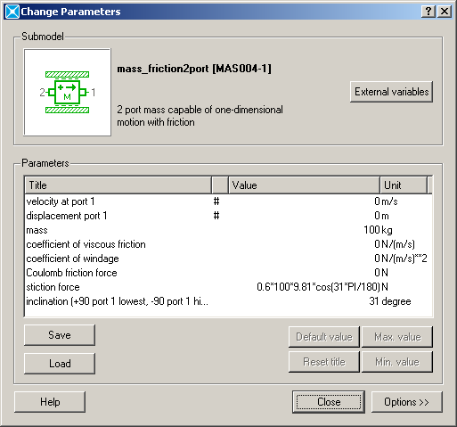

Figure 2. Parameters input to mass component.

The angle of inclination in the stiction force formula and the inclination in the following line must be identical. Several runs are conducted with different inclinations for 10 seconds and velocity of the mass has been observed to determine a motion, and can be determined using Equation 2:

 (2)

where, *µs* is the coefficient of friction and α (degrees) is the angle of inclination.

Since *µs* equals 0.6, the angle of inclination can be calculated as α = arctan(0.6) = 30.96°. This result validates the simulation model. This simple case and several other cases that are introduced in lectures and labs have alleviated the instruction of a complicated engineering software tool (such as AMESim) used students who are taking beginning level of engineering or engineering technology courses. It is observed that the modeling approach has helped students grasp of more advanced engineering subjects.

**Vehicle Traveling Distance Study**

Because it is an introductory level engineering technology course, the subject of the Power Technology class includes a basic level of mechanical power transmission calculations such as gears, pulleys, inclined plane, etc. Vehicle level design and analysis are generally covered in higher level courses at junior or senior levels. Moreover, testing such vehicles in labs or in the field is always hard to conduct for even an experienced technician and it is expensive to maintain such facilities for a teaching institute. Using software tools may improve instruction of more difficult subjects at lower level courses.

One of the problems presented as part of a computer lab assignment was determining stopping distance and time of a vehicle model on an inclined ground profile. The schematic of the problem is shown in Figure 3. An initial torque profile is applied to vehicle first 22s of the test, and the travel distance and the elapsed time until the vehicle comes to a complete stop must be determined at the given ground slopes of 5%, 10%, 15% and 20% (Toro, Bokszczanin, & Ornelas, 2008; Willis, 2006; Smith & James, 2004; Waldo, 2012). The vehicle model consists of an engine, vehicle, transmission, differential and tire components.

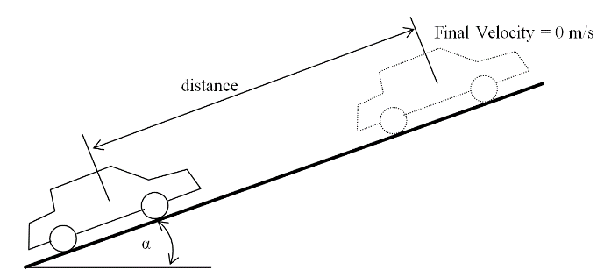

Figure 3. Schematic of vehicle and ground profile.

The AMESim simulation package offers an extensive set of application specific solutions which comprise a dedicated set of application libraries and focus on delivering simulation capabilities to assess the behavior of specific subsystems. The current portfolio includes solutions for internal combustion engines, transmissions, thermal management systems, vehicle systems dynamics, fluid systems, aircraft ground loads, flight controls, and electrical systems. AMESim comes with very helpful demo models for a convenient initial start of modeling. “VehicleTire.ame” is a demonstration model in their power train library which consists of differential, vehicle and tire models. While the engine has been represented by a simple torque curve, a transmission model has been completely ignored. For part of the lab work, the students were expected to integrate a transmission model to the demonstration vehicle model. They are instructed to use the variable gear ratio component from AMESim mechanical library for a simplified transmission model. The component allows the user to specify any gear ratio externally. An engine torque profile is shown in Figure 4.



Figure 4. Engine torque profile.

Interestingly, at 20% slope, the vehicle did not move towards up to hill, instead it moved back after the engine torque was released at a time of 22s of the simulation. This gives the student an opportunity to investigate the system capabilities. The model can be used further in a detailed discussion and analysis of the vehicle behavior. For example, the car body longitudinal velocity and acceleration for 5% ground slope. The vehicle is accelerating and reaches to maximum velocity until time 22 second when the engine torque is set to zero. The accelerating scheme during this period looks like a step function since gear ratios are suddenly increased at times of 5, 10, and 15 s of simulation. The slight decrease in acceleration through the end of each step is because of the drag losses that were set to nonzero by default.

**Solving an Interference Problem with Pro Engineer Wildfire 2.0**

Pro Engineer Wildfire 2.0 is an engineering modeling and design program capable of creating solid models, drawings, and assemblies. Pro/Engineer comes with different application program packages to help in the design and modeling process. Figure 5 shows a simulation model of the gear ratio of a transmission in a vehicle, while Figure 6 shows graphs of the car body’s longitudinal velocity and acceleration. Table 1 gives the results of the vehicle simulation model.

Table 1. Results of the vehicle simulation model.

*(one line space here of size 12 Times New Roman)*

*(all tables must be created in Word and enclosed on all sides)*

|  |  |  |
| --- | --- | --- |
| Ground Slope (%) | Stopping Distance (m) | Stopping Time  (s) |
| 5 | 1304 | 85.96 |
| 10 | 454 | 47.38 |
| 15 | 111 | 32.4 |
| 20 | n/a | n/a |



Figure 5. Gear ratio of a transmission in a vehicle simulation model.

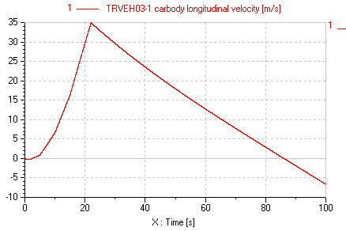

1. Velocity.

*(if a figure contains more than one image, each image must be placed separately—not joined or grouped with any other object—and have its own “minor” caption, as shown here)*

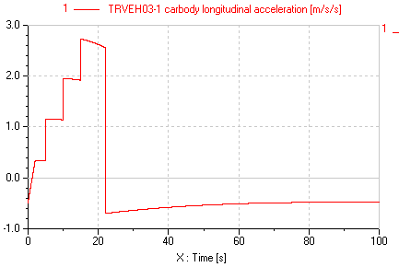

(b) Acceleration.

Figure 6. Car body longitudinal velocity and acceleration.

These application programs aid engineers in testing parts, models, and assemblies from early to advanced development stages. Applications include cabling, piping, welding, sheet metal, mechanica, mechanism, animations, plastic advisor, finite element analysis etc. Student groups who are familiar with Pro/Engineer can be divided into small interest groups to make projects using application packages depending on their area of interest. For instance, cabling applications can attract an electrical engineering major student to learn how to design an electrical cabling of the system. The piping application package can be an interesting part of modeling for students who want to model air, gas, hydraulic and fuel pipes and hoses for the automotive industry (Nala, 1998; Swift, 2001; Morgan, 2017; Rowe, 2002). In fact, learning fundamentals of how to use Pro/Engineer applications definitely enhance students’ knowledge. Fundamentals of each application help students to understand the basic terminology, tasks, and procedures so they can build their own models efficiently and share information, ideas, and processes with other students.

Figure 7 shows a pro-engineer assembly for testing interference control. Figure 8 shows the interference between the main plate and ball adapter without moving the parts. In this example, the 65-degree angle was given initially to indicate that the ball adapter is supposed to move a maximum 65 degree angle to avoid interference of other parts in the assembly.

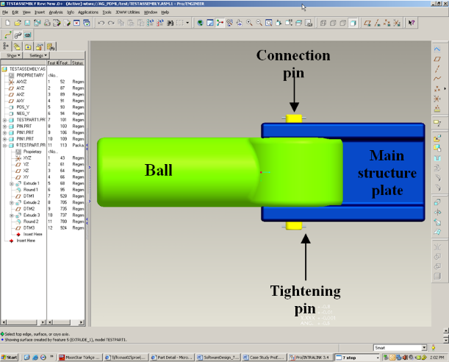

Figure 7. Pro-engineer assembly to test assembly for interference control.

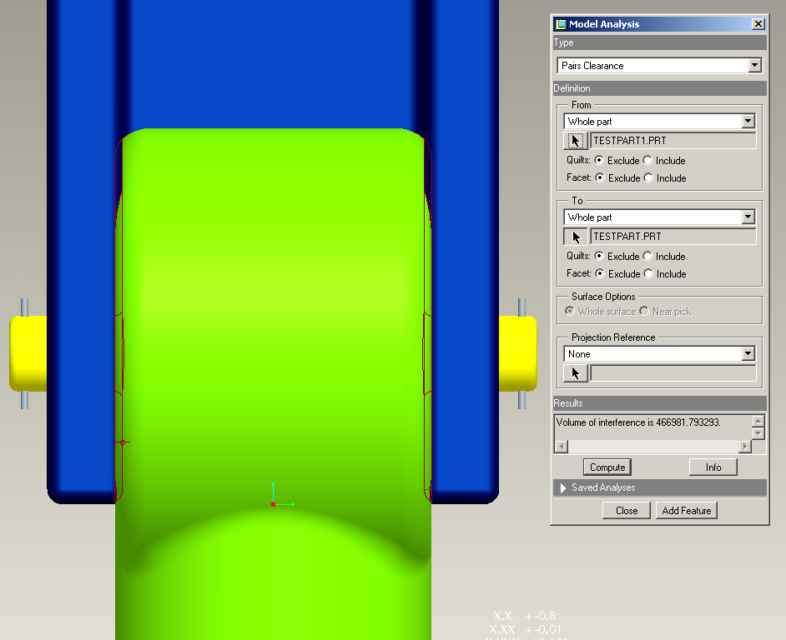

Figure 8. Interference between the main plate and ball adapter without moving the parts.

After diagnosing the interference problems, the thickness of the main structure plate and the diameter of the round shape of the ball adapter were decreased enough to avoid the problems. This case study motivated students to involve more model analysis with other applications of Pro/ Engineer. Students gained skills in how to model, assemble, and analyze their designs with Pro/Engineer and its applications.

**Using Solid Works in Solar Electric Boat Design and Floating Calculations**

The UNI solar electric boat team used both Solid Works and Pro-E to model the new solar electric boat in 2007. With the team’s extensive use of CAD, it was easiest to change the material of the hull to water and have Solid Works automatically to calculate the new mass by using properties of the assigned materials from library. The following is an example of how to insert a long quote—40 words or more—but in this case is not something Johnston et al. (2009) actually said.

*(long quotes—more than ~40 words—must be indented 1/2" from the left margin )*

This is an example of a long quote that is 40 words or more. Note that the reference to the author is made is the previous paragraph but not here. Make certain that you add ONLY the page number from which the quote was taken at the end of the quote like this. (p. 38)

Buoyancy is created by the displacement of water. As modeled, the boat displaces 288 pounds of water when submerged. Calculations by Solid Works indicate the weight of the hull composed of foam material to be only 40 pounds. With all other components taken into account, the assembly of the boat weighs approximately 230 pounds in race trim. This yields a safety factor (SF) as follows:

SF = (288 – 230) / 288 = 0.2014 or 20.1 %

These calculations together with SolidWorks modeling show that the UNI solar electric boat, in the event of capsizing, will not sink and has a safety margin of 20.1 %.

**Using NI MultiSim in a Variety of EET Applications**

Although actual hands-on analog laboratories must be included in EET curricula, students may also gain some initial skills without exposing themselves to the higher voltage/current values in the circuits. A number of circuit simulation tools now offer low-cost student versions that may provide user-friendly access from students’ personnel computers. Figure 9 shows the simulation and frequency response of a passive low-pass filter using MultiSim at a cut-off frequency of *fc* = 2,192 Hz.

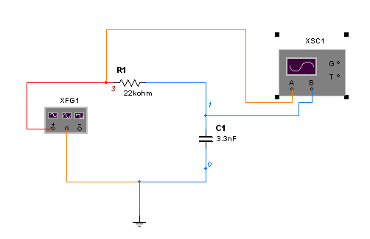

(a) A simple passive low-pass filter.



(b) Frequency response of the low-pass filter.

Figure 9. Simulating a passive low-pass filter using MultiSim.

Figure 10 indicates another example of MultiSim applied to the simulation of a full-wave bridge rectifier in a power electronics class. Students safely gain in-depth knowledge of a high-power AC/DC converter before ever entering the lab. This also includes instrumentation connections in a virtual environment, waveform monitoring and overall circuit operation in steady-state. Figure 11 depicts a DC waveform output with numerical readings from the same bridge-rectifier circuit shown in Figure 10.



Figure 10. A full-wave bridge rectifier in MultiSim.



Figure 11. DC output waveform of the bridge-rectifier circuit.

**Using LabVIEW in Computer-Based Data Acquisition and Instrumentation Classes and Capstone Design Projects**

The instrumentation phase of the wind-solar power station includes the following hardware: One CR4110-10 True RMS AC Current Transducer, one CR5210-50 DC Hall-Effect Current Transducer from CR Magnetics, voltage- and current-divider and scaling circuits, one wind-monitoring device called an anemometer, a LabVIEW Professional Development System for Microsoft Windows, one PCI-6071E I/O board, NI-DAQ driver software, one SH 100100 shielded cable, SCSI-II connectors, one NI SCB-100 DAQ (shielded connector block), one isolation amplifier circuit, and a PC. A Young 05103V anemometer provides two voltage signals corresponding to wind speed and wind direction. These wind signals are fed to AD21OAN isolation amplifiers and the output is applied to National Instrument’s SCB-100 data acquisition board (DAQ).

**Conclusions**

Computer-aided engineering education is a valuable solution for increasing the quality of laboratory environments of engineering education courses. The classroom education process, similar to laboratory exercises, may be further visualized by introducing more advanced simulation tools. Several case studies have been demonstrated using LMS Imagine. Lab AMESim—a professional grade, integrated platform for 1-D multi-domain system simulation, Pro Engineer Wildfire—a well-known three-dimensional CAD/CAE software tool, SolidWorks—another 3-D digital simulation tool, NI MultiSim—formerly Electronics Workbench software integrating powerful SPICE simulation and schematic entry into a highly intuitive user-friendly graphical-based electronics lab in digital environments, and LabVIEW—another National Instruments graphical development environment to help create flexible and scalable design, control, and test applications in electronics and electromechanical systems. Many students have found the software tools to be very helpful and user-friendly in understanding the fundamentals of physical phenomena in engineering technology areas. A number of students have increased their knowledge and experience with the aforementioned software tools as a valuable bridge to many internship and part-time student positions in local electronics and machinery manufacturing industries. The industrial advisory board members have repeatedly mentioned their satisfaction with student achievement and the valuable experience with digital modeling and simulation tools.

**Acknowledgments**

This work was supported in part by the National Science Foundation, CCLI-Phase I: Exploratory, under grant number DUE-0948152.

**References**

Booth, C., & Kerns, K. A. (2009). Child-parent attachment relationships, peer relationships, and peer-group functioning. In K. H. Rubin, W. M. Bukowski, & B. Laursen (Eds.), *Handbook of peer interactions, relationships, and groups* (pp. 490-507). New York, NY: Guilford Press.

Cipra, B. (2002). Pi in the sky. [Audio webcast]. Retrieved from <http://news.sciencemag.org/sciencenow/2002/12/16-04.html>

Cobern, M. E., & Wassell, M. E. (2005). Lab testing of active drilling vibration monitoring & control system. *AADE Paper 05-NTCE-25*, (pp. 1-14).

Egland, F. H. (1987). *Determinants of upper limits to sub-vectors of non-linear energy flows* (Master’s thesis). Retrieved from <http://proquest.umi.com/pqdweb?did=7755009&Fmt=7&clientid=9077&TYT=905&VName=EFH>

Everett, H. (1998, February-April). Breaking down the barriers. *Unmanned Vehicles,* *3*(1), 18-20.

Johnston, L. D., O’Malley, P. M., Backman, J. G., & Schulenberg, J. E. (2003). Monitoring the future: National survey results on drug use, 1975-2003. (Vols. 1-2). (NIH Publication No. 04-5507). Bethesda, MD: National Institute on Drug Abuse.

Kreyszig, E. (2006). *Advanced engineering mathematics*. (9th ed.). Wiley.

Morgan, J. R. (2004). *Working with the terminally ill: An integrated theoretical model*. Paper presented at the American Counseling Association World Conference, San Diego, CA, April 27-29.

Nala, A. (1998). Teaching vocabulary: Evidence from research in Pig Latin. *Language Today*, *12*(4), 56-60.

Ogot, M. (2008). Mutimedia in a classroom setting. *Media Today*, 22(4), 17-25.

Ogot, M. (2017). A revival of more traditional multimedia. *Media Retrospective*, *2*(1), 22-29.

Ramakrishna, G., & Sundararajan, T. (2005). Impact strength of a few natural fibre reinforced cement mortar slabs: a comparative study. *Cement and Concrete Composites*, *2*7(5), 547-553.

Rowe, M. (2005, November 22). She’s no homophobe. The Advocate. Retrieved from <http://www.advocate.com/>

Singh, R. (1969). Fibrous building materials produced from industrial wastes. *Building Today*, *12*, 78-81.

Smith, B., & Morgan, C. M. (2009, June). *The conservative current and Bob Jones University*. Paper presented at the American Convention for Contemporary Historical Studies, Boston, MA, June 15-17.

Swift, D. G. (1981). Review of fiber-cement research and development with particular reference to third-world applications. *Final Report of the African Regional Workshop on Natural-Fiber-Cement Construction Materials* (pp. 1-21). Nairobi, Kenya: Appropriate Technology Center.

Toro, P. A., Bokszczanin, A., & Ornelas, J. (2008, June). Prevalence of and public opinion on homelessness in nine nations*.* *Psychology Opinions*, *33*, 34-39.

Waldo, S. R., & Danedakar, V. (2012, January 4). Why medical school? *New York Times.* Retrieved from <http://www.nyt.com/med>

Wills, W., Backett-Milburn, K., Gregory, S., & Lawton, J. (2006, January). Young teenagers’ perceptions of their own and others’ bodies: A qualitative study of obese, overweight and “normal” weight young people in Scotland. Social Science & Medicine, 62, 396-406.

**Biographies**

**FIRST AUTHOR’S NAME** is an assistant professor of industrial technology at This State University. She earned her BS from State University in 2000, MS in computer science in 2005 from City College of New York, and PhD in electrical engineering in 2008 from the University of Northern Michigan. Dr. Lastname’s research interests include energy harvesting, conversion, and storage systems for renewable energy sources. Dr. Lastname may be reached at [thisemail@school.edu](mailto:thisemail@school.edu)

**SECOND AUTHOR’S NAME** is ……………..…use the same format as above.

**THIRD AUTHOR’S NAME** is …………………….use the same format as above.